This document was archived in February 2016 because it is no longer current.

Talking the talk in modern languages: Wildern School

URN: 136654
Local authority: Hampshire
Date published: 22 October 2012
Reference: 120325
Brief description

This example shows how Wildern School uses effective strategies to engage students in modern languages, especially boys, and to promote spontaneous use of the target language by all students.
Overview – the school’s message


‘Our aim is to create language learners who, above all else, interact confidently and spontaneously in the target language. This dynamic approach is informed by the principles and practice of the award-winning Group Talk project. We needed to raise motivation and make the languages department a place where students wanted to be. Since we introduced the methods, GCSE outcomes have risen consistently, especially for boys.
Students’ enthusiasm for learning is engendered through the use of varied and innovative teaching methods and a range of appealing resources. We aim to provide a lot of motivational moments, where activities are seen as a challenge and not a chore.’
Hazel Mair, Greg Horton and Liz Hall, subject leaders for modern languages
The good practice in detail

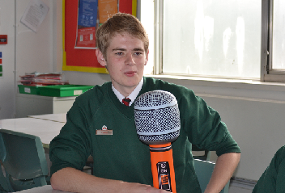
The challenge to improve students’ speaking skills has been a topic for keen discussion for all those involved in the teaching of modern languages for many years. A recurring theme in the last two Ofsted subject reports: Modern languages: achievement and challenge 2007-2010 and The changing landscape of language has been the underuse of the language being studied or target language, to manage the activities in modern language classrooms. The most challenging aspect of the debate centres on how to encourage students to use the target language when speaking to each other. Scripted role plays do not necessarily support students’ spontaneity and for many students, especially boys, can be a significant barrier to enjoyment and commitment in lessons. This modern languages department has successfully raised the level of students’ speaking, improved outcomes in GCSE examinations and motivated boys in particular by making discussions meaningful and relevant to students, by providing the resources and technical support needed, and by ensuring high expectations and a high level of consistency from all teachers.
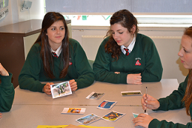
Students are encouraged to use the target language as the primary means of communication. To support this aim, the stock cupboards are crammed full of props such as wigs and giant microphones. Students talk best when the context for learning is both engaging and meaningful, so topics are selected to stimulate discussion – opinions about unusual sports such as baby sumo wrestling, the advantages of one make of personal computer over another, and guessing the meaning of French mobile telephone text. As well as using the target language to express routine needs, students are taught how to collaborate effectively in discussions and debates. Students enjoy this approach because: ‘We pick up new words from other people and are not afraid to have a go. It feels like you’re teaching yourself.’ Classrooms are set up cabaret-style to facilitate collaborative learning. Lists of the necessary structures to keep the conversations going are provided on tables, walls or the interactive whiteboard. Students appreciate this: ‘It helps to learn new vocabulary with the conversational language on the side. Half the time it doesn’t seem like we’re learning. We get to argue with the teacher which is fun.’
Time for the discussions is kept short to keep students focused on the target language. Rules establish clearly who should go first, so the activities have a prompt start. Teachers accept and encourage creative attempts to provide an answer in the target language before providing the unknown words. They model, sign or use visuals for making the meaning of new language or instructions clear. If a translation becomes necessary to sustain the pace of the activity, it is sought from another student, but the original sentence is then repeated so it will be recognised in the future.
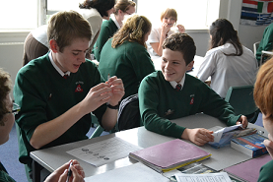
From Year 7, students are taught to use phrases expressing an opinion wherever possible. For example, when checking answers from an exercise, they have to start with the relevant phrase in the target language for ‘I think that it is …’ Teachers encourage natural responses including one-word answers if that would be more appropriate. One student said that this ‘teaches you how to naturally respond to questions and statements but we are shown how to make whole sentences too’. Students take part in carefully scaffolded conversations, then support is gradually reduced and opportunities to personalise and substitute are introduced. One student was proud of the fact that he goes home and talks ‘to my mum and dad in German because you’re used to speaking to people randomly.’
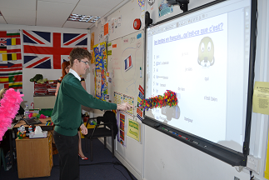
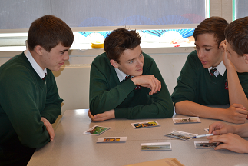
Spontaneous use of the target language does not just happen. Teachers plan group speaking activities with great care and according to the principles set out in the target language policy. The department’s aspirations for the use of the target language by students and teachers are clearly articulated, as are the circumstances where a limited amount of English is acceptable. This ensures a high level of consistency across the department. A particularly effective strategy used by all members of the department is the use of laminated cards showing the flag of the target language country on one side and a combination of that flag plus a Union Jack on the other. Teachers stick the card on the board and turn it over, depending on the language that must be used by everyone. A key feature is that even in the activities where some English is permitted, everyone in the classroom is reminded that the target language should also be used if possible. A teacher who recently qualified explained: ‘You know the majority has to be in German but you see you can use English as well if it’s more complicated – it’s really tempting to just use English, but the flags remind you to keep trying when it’s a bit harder’.
Subject leaders do not underestimate the challenge posed by maximising target language use. Teachers need to develop a new skill and can feel superfluous once it is being successfully implemented. Nevertheless, the benefits are clear and students can often be heard in their modern language lessons using the target language spontaneously and with great enjoyment.
The school’s background

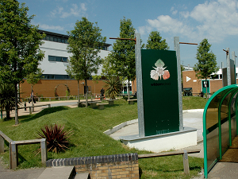
Wildern School is a large secondary school for students aged 11 to 16 with specialist areas in the performing arts and system leadership. As a community school it is open seven days a week providing a range of facilities and activities for local adults and young people. In April 2011 the school became an Academy.
Are you thinking of putting these ideas into practice; or already doing something similar that could help other providers; or just interested? We'd welcome your views and ideas. Get in touch here.
To view other good practice examples, go to: www.ofsted.gov.uk/resources/goodpractice

