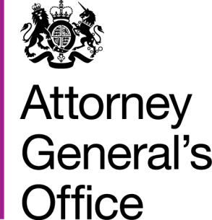 |  |  | www.gov.uk/ago
 | FOI|49|15 |  | March 2015
Freedom of Information Request

You requested:
* 1. In 2014 (calendar year), how much did the department spend on public relations? This should include (but not be limited to): salaries for communications and press office staff, advertising, marketing, publicity, and payments to third parties for communications/advertising/PR services.
2. How many 'communications' staff are currently employed by the department? This should include (but not be limited to) staff covering public relations, press office, communications, advertising, marketing and publicity.
3. Please provide a list of all third-party communications companies that were paid/contracted by the department in the calendar year 2014. This should include (but not be limited to) all external organisations providing services for public or press relations, marketing advertising and publicity. For each company, please state: (a) the company's name, (b) the total amount that was paid to the company in the 2014 calendar year.
I have now been able to consider your request, and I can confirm the following information under section 1 (1) (a) of the Act:
- The AGO spent £138,759.73 on Press Office salaries in 2014.
- The Attorney General’s Office has a Press Office that provides a shared service to the Attorney General’s Office, Treasury Solicitor’s Department and HM Crown Prosecution Service Inspectorate it currently employs two members of staff and one agency staff member.
- We do not hold this information.

