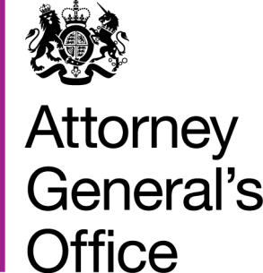 |  |  | www.gov.uk/ago
 | FOI|127|15 |  | June 2015
Freedom of Information Request

You requested:

Please could you tell me how many Laptops, Mobile Phones and Tablets/iPads have been provided by your organisation to staff members as of 1st January 2015.

I have now been able to consider your request, and I can confirm under section 1 (1) (a) of the Act that the AGO does not hold the information of 1st January 2015 but the most recent information held on Laptops, Mobile Phones and Tablets issued to AGO staff are:

Laptops - 29
Mobile phones - 20
Tablets - 6

