Critical issues in the provision of youth work for young disabled people
Survey findings
This survey reports on young disabled people’s access to youth work and its impact on their lives. Inspectors undertook a sample of 18 visits to local authorities, charities and voluntary and community sector organisations, each of which were promoting work of this nature. The findings are reported in three separate resources:
The survey findings
Discussion materials in the four critical issues identified
Good practice case studies.


Published: January 2013
Reference no: 130018
Contents

Introduction 3
The scope of the survey 5
Survey findings 6
Taking youth work for disabled young people forward: rising to the challenge 9
Discussion materials on the four critical issues in the provision of youth work for young disabled people 9
Good practice case studies 10

Introduction

This survey reports on young disabled people’s access to youth work and its impact on their lives. Youth work is delivered through a complex network of providers: local authorities; large voluntary and community sector organisations (including faith based, specialist, uniformed); charities; training agencies; single interest and advocacy groups; and independent local neighbourhood initiatives. Its purpose is to enable young people to develop holistically, working with them to facilitate their personal, social and educational development, to enable them to develop their voice, influence and place in society, and to reach their full potential (Ref 2008 National Occupational Standards).
Befriending has helped me to be more confident in myself. It has helped me to start to be able to trust other people that I haven’t met before. Amy has shown me that in actual fact other people do care about me and they are and have been there for me when I have needed them most. A big, big, big thank you! Love Laura xxx Age: 14 years.

See good practice case study: Befriending and buddying for young disabled people: Kent County Council. www.ofsted.gov.uk/resources/120399.

The scope, reach and nature of youth work provision are largely determined locally. Statutory guidance requires local authorities to ‘secure, so far is reasonably practicable, equality of access for all young people to the positive, preventative and early help they need to improve their well-being. This includes youth work and other services and activities’. Local authorities therefore have a strategic leadership role. They are expected to involve young people in service design, delivery and governance, but government does not prescribe which services and activities for young people local authorities should fund or deliver, or to what level.
Beyond the legislation which applies to disabled young people’s compulsory education the Learning and Skills Act 2008 gives local authorities responsibility for completing the multi-disciplinary learning difficulty assessment for those learners identified by their school as requiring support at the end of their schooling. Assessments are intended to take account of all local provision available and make recommendations that embrace the learning and support needs and the aspirations of the young person. In its report Progression post-16 for learners with learning difficulties and/or disabilities, Ofsted found that these arrangements were not working effectively.
No central national authoritative data are available in relation to the uptake by disabled young people of youth work provision. However, local authorities are responsible, under the general equality duty contained in the Disability Discrimination Act (1995), for promoting equality of opportunity for disabled people, encouraging participation by disabled people and considering disabled people’s disabilities in respect of the services that they provide. Therefore, in providing services such as youth centres, local authorities should be considering the needs of the disabled young people that use them.

According to local data, participation by disabled young people is poor, albeit that individuals and projects do not always seek to identify young people by their disability. The reported proportions of disabled young people who access local authority youth work provision in the work seen ranged from 4% to 6%. In 2007, according to the National Youth Agency source, some
15% of the youth population overall were engaged with the local youth service. Charities too were dealing with a small proportion of young people with particular needs. Provision tended to be located primarily in areas which have succeeded in securing funding. There were indications that sharper commissioning was informing the location and nature of work being offered.
‘Effective and inclusive curriculum delivery enabled young disabled people to attend ‘‘in their own right’’.’

A young disabled person strenuously made the point that his disability was an irrelevance and that he simply benefited from the same activities which all others enjoyed.
Participation data alone give only a partial picture since the work can be staffing intensive; nor do data account for developmental work which youth services and charities undertake with, for example, special schools.
It was known that working definitions of disability and service priorities within local authority areas and among charities differ, often for good reason. Against this backdrop, inspectors took as a guide The Disability Discrimination Act (1995) and the subsequent Special Educational Needs and Disability Act (2001) which define disability as ‘having a physical or mental impairment which has a substantial and long term adverse effect on the ability to carry out normal day to day activities’.

The scope of the survey
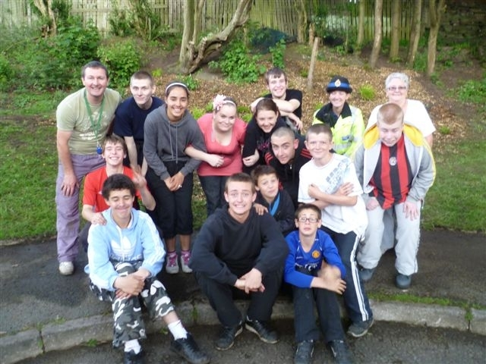
This survey therefore considers the effectiveness of the work of a sample of local authorities and charities with strategic roles in promoting youth work. It also reports on the face-to-face practice within small specialist organisations. In the main, the provision viewed was outside of a young person’s formal education and training. Variously, this was described as: youth work; ‘positive activities’; personal and social development; or well-being opportunities. For the purpose of this report the term ‘youth work’ is used to cover the whole range. While inspectors explored the effectiveness of links between formal and informal activities, they operated on the premise that youth work is primarily a voluntary activity undertaken in a young person’s leisure time. Visits also distinguished between three types of activity:
- projects which were specialist, insofar as they worked primarily with young people with a particular disability
- ‘open access’ clubs attracting a broader and non-specific range of disabled young people
- integrated provision for all young people.
In each of the local authority areas visited, inspectors observed directly provided youth work as well as a mix of sessions run by voluntary and community organisations independently or in some form of partnership with the local authority. They also visited provision run by independent charities which operated autonomously to local authorities. Visits were identified as a result of prior knowledge and intelligence held by inspectors or as a result of a ‘call for evidence’ by Ofsted. Inspectors visited 18 projects in all.
Inspectors visited a rich range of projects:
- ‘young inspectors’
- drama groups
- award schemes
- outdoor challenges
- active campaigning and ‘youth voice’ groups
- vocational programmes
- residential experiences
- youth club provision.

Survey findings
Much of the work seen was successful in its primary purpose to develop young people’s autonomy while fostering a range of practical, personal and social skills. In the projects visited, inspectors found that the majority of disabled young people who accessed youth work enjoyed a supportive, enjoyable and beneficial experience. Indeed, its informal settings and often relaxed approached proved highly conducive to their social development, work readiness, enjoyment and learning. Young disabled people had a say in what they did. Involvement in youth work very often opened new doors that allowed progression to new opportunities. The most effective work, where practical, gave weight to the development of young people’s personal, social, political, and work-related skills and aptitudes. However, in the few instances where inspectors found that young disabled people were not benefiting enough from their involvement in youth work, expectations of what they could achieve were too low.
One of the key elements of the best work-based projects was supported and bespoke work placements. Undertaken in collaboration with local employers, these were enabling young people to gain work experience and help them, where practical, to become more prepared for the eventual transition to the world of work.

Overall participation rates were low and those young people not known to services, and who would benefit from the opportunities and support that youth work affords, were clearly less well served. Inspectors found that the youth work offer for disabled young people was inconsistent across the sample of local authorities visited. Too much of the provision seen was largely historical, often including a portfolio of inherited clubs, centres and programmes originally founded by parents, support groups or youth workers. Insufficient attention was given to the needs of individuals and groups who did not access opportunities. There were only a few instances, for example, where sufficient consideration was being given to accommodating the cultural needs of minority ethnic families.
The national imperative, that youth services focus on targeted provision, was leading, in the majority of the local areas visited, to a greater proportion of their available resources being directed towards young disabled people than was the case in the recent past. Although in most of the youth services visited there was a clear desire to move this work forward, they all reported a year on year reduction of overall resources. Managers reported that the lack of regional or national comparative data on the take-up of youth work inhibited planning.
The respective merits of integrated and non-integrated provision remain a matter of great debate in the youth work sector and among young people themselves. Providers of youth work often asserted that they met the needs of disabled young people as part of their ‘open access’ or integrated work, but in reality few did so. The complexities and barriers faced by young people in these settings required skill and sensitive handling. Inspectors found that in the provision visited, practitioners often struggled to devise practical strategies to overcome them. Equally, there were instances where the impact of youth provision provided by specialist charities, for example solely aimed at autistic young people, was weakened by the lack of skills in areas such as programme planning and group work.
Against this backdrop, and at a time of diminishing resources, the best local authorities and charities visited were often able to devise creative ways to support young disabled people’s learning and development. Where senior local authority managers were particularly effective in communicating the impact of involvement in youth activities on young people’s well-being, this area of work had a high strategic priority. The effect of this was to encourage more meaningful and creative links at local level between various agencies and charities. Forward-looking partnership arrangements within local authorities and between them and the voluntary and community sectors were therefore essential in bringing about improvements in the quality, reach and effectiveness of youth work and in the identification of need. In addition, sharper commissioning practice was increasingly shaping the nature and location of what was offered.
Acting as ‘young inspectors’, many commented critically on access to leisure services or on the quality of youth provision. They quickly learned the skills of diplomacy and how to devise strategies to raise the profile of disabled young people well.
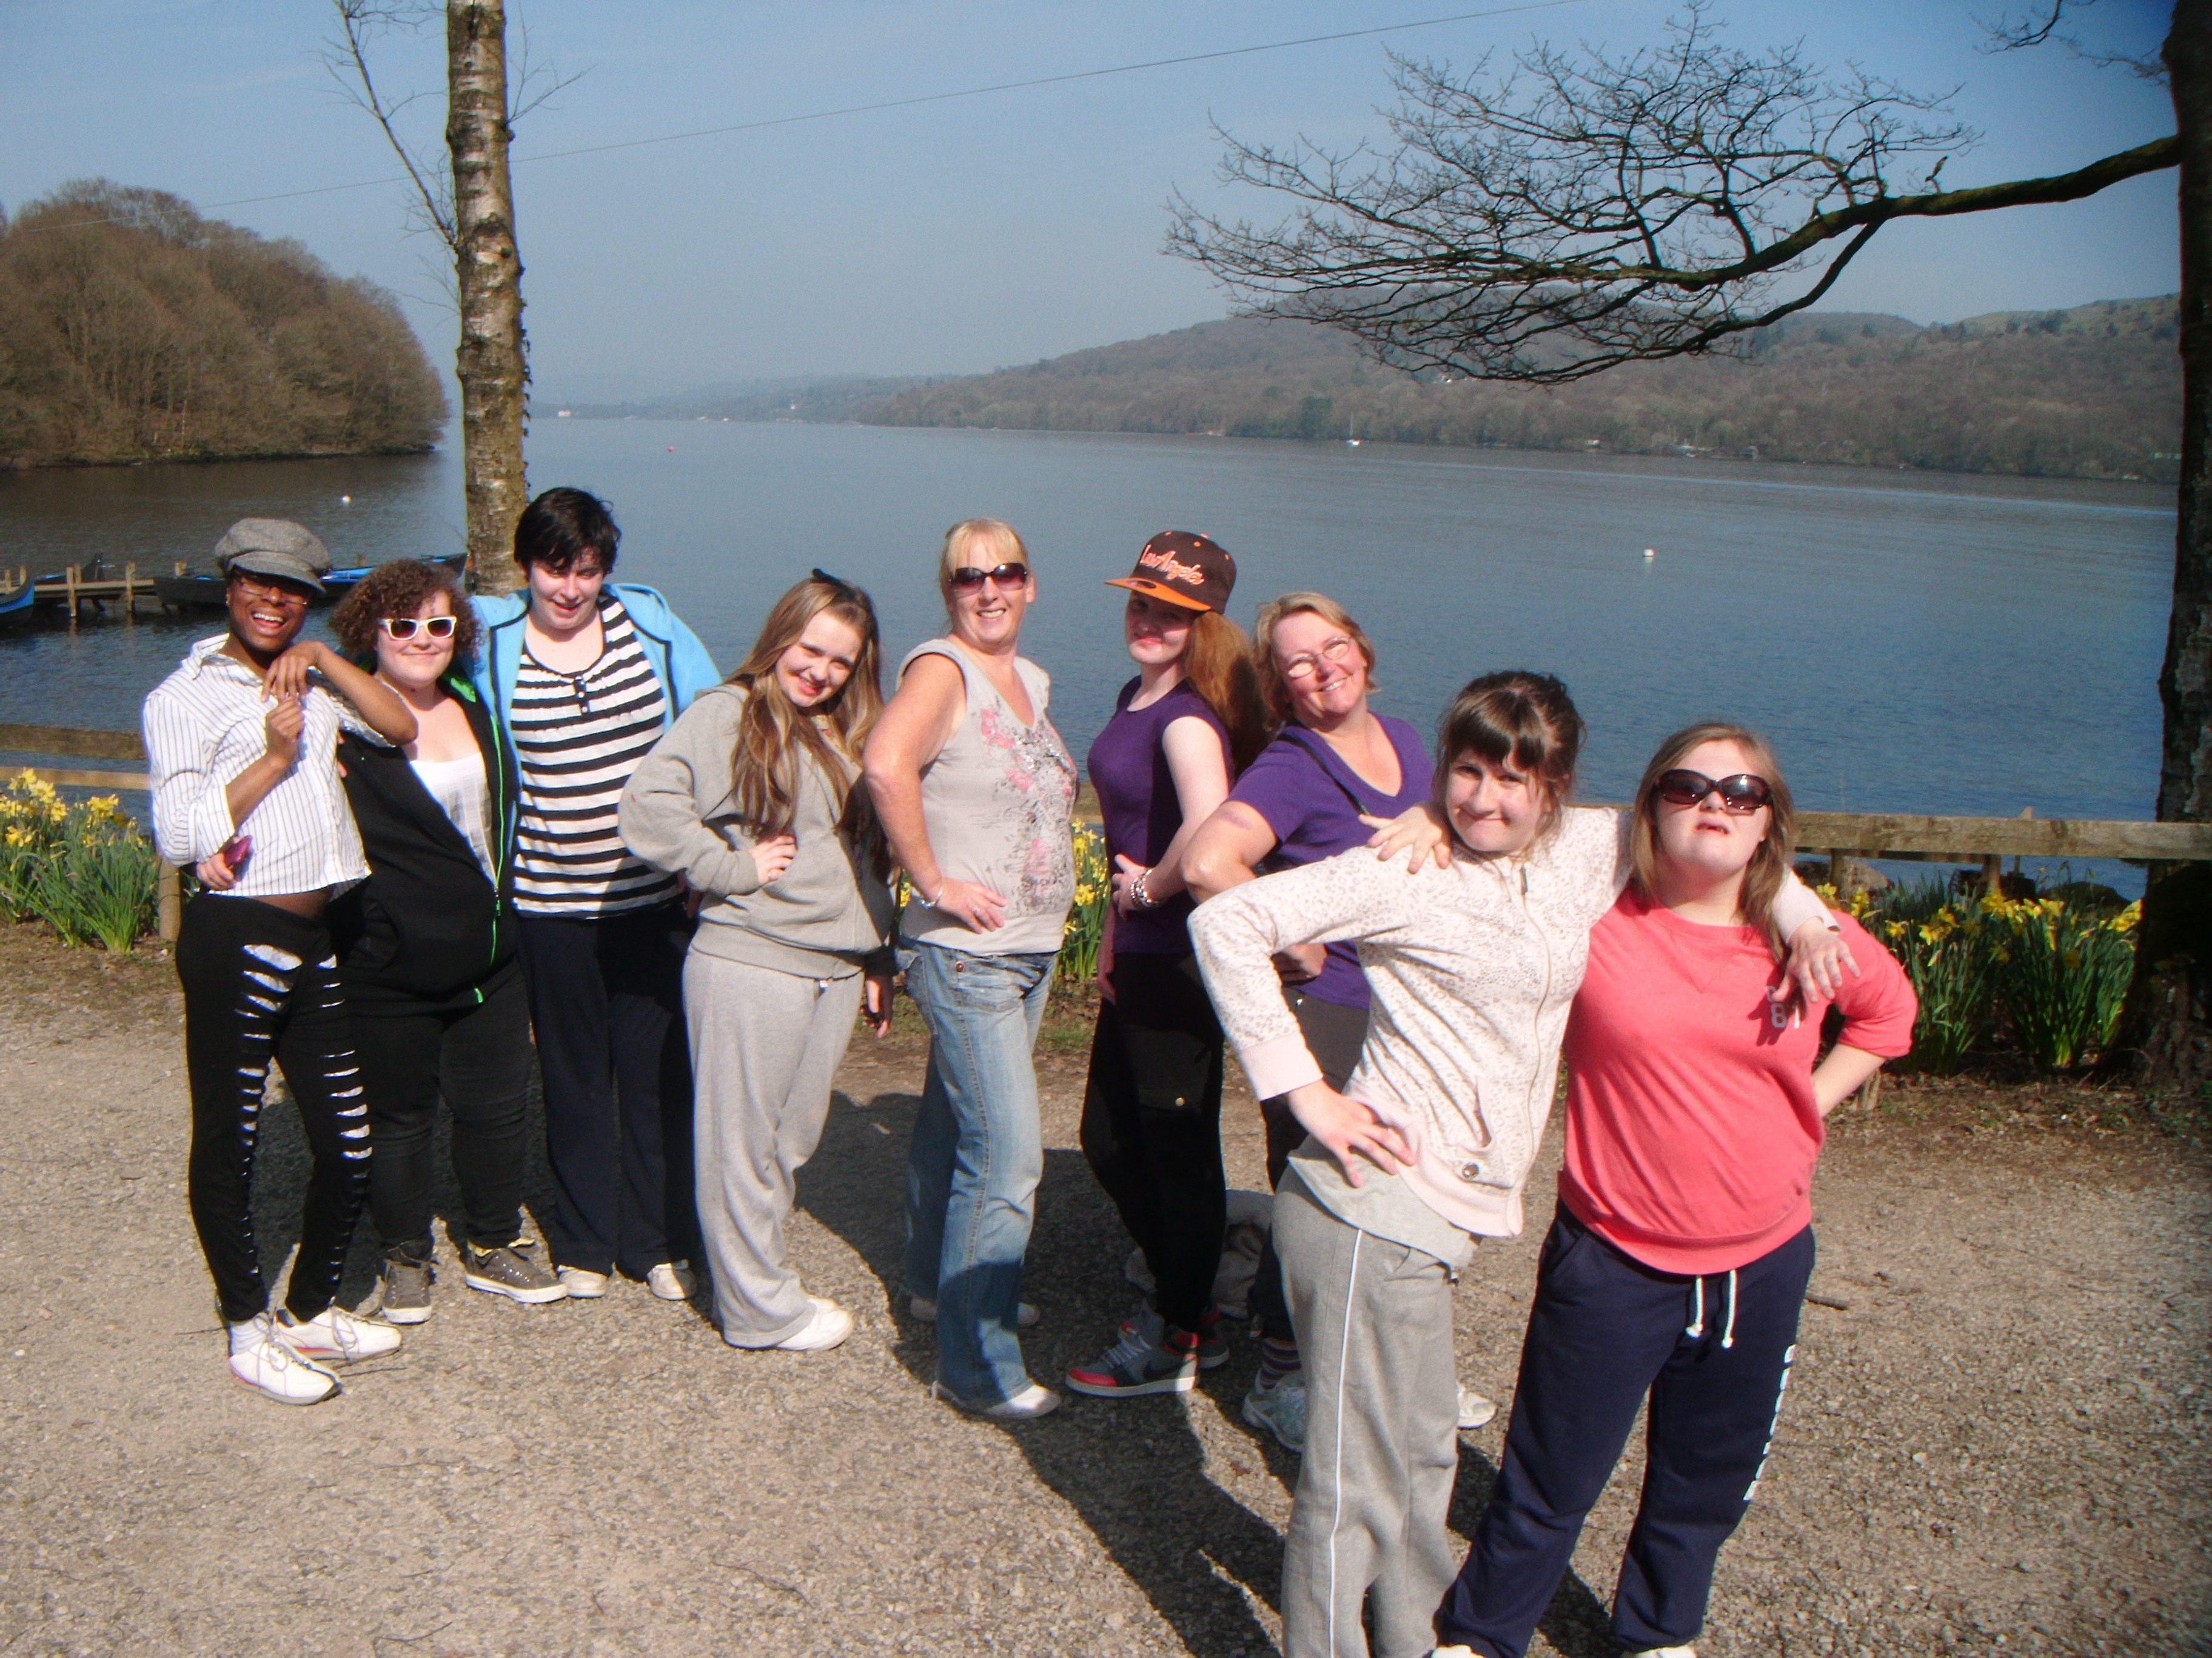
In relation to priority groups, most of the youth services visited were managing an inherited portfolio of work, at least in part, which included clubs originally founded by parents, support groups or youth workers. Some youth work projects had grown out of vocational, recreational or leisure-time projects. The inclusion and exclusion of certain groups were therefore more on the basis of pragmatism and use of existing resources, plant and valued voluntary effort than on agreed strategic priorities.
Much face-to-face youth work practice is good. In the most effective practice, specialist disability staff and generic youth workers combine their skills and experience to good effect.
One local area used the term ‘additional needs’, while for others the focus was on young people excluded from mainstream school on the grounds of behaviour often associated with autism or acute special educational needs. In two instances, the strategy was not to duplicate provision, but to focus on the gaps: severe and complex needs and physical disabilities. In another area, the policy was to support disabled young people over the age of 16 who had left full-time education. Across the sample of local authorities overall, there was no common strategic approach other than what could best be described as endorsing and supporting local initiatives. Moreover, while local authorities had carried out some form of needs assessment in relation to children and young people for whom they had a statutory responsibility, the actions arising out of this process seldom sufficiently incorporated broader leisure time activities.
A particularly positive feature of the youth work seen was the broad cross-section of adult workers including volunteers, parents, young ‘buddies’, sessional workers, professionally qualified youth workers and specialist disability staff. Each brought a wide range of often invaluable perspectives, experiences and strategies and they were keen to extend their practice. However, inspectors found that many of them lacked the particular skills to do so and opportunities for further training were generally lacking. In just under half of the local authority areas visited, professional development needs were being addressed well through a combination of training and deployment of specialist workers into youth settings.

Inspectors found other critical factors which shaped adversely the nature and quality of young people’s learning and engagement, as well as the reach of provision. These included lack of effective strategic planning and limited arrangements for quality assurance. Weak practice included workers advocating that young people be challenged and free to take risks, but failing to demonstrate this in their own approach.

Taking youth work for disabled young people forward: rising to the challenge
There are a number of interrelated factors in securing and sustaining provision locally for young disabled people. Arguably, these mirror the challenges found in the provision of youth work generally. This small-scale survey, however, suggests that consideration of each of these factors, and actions arising from them, is critical in moving the work forward, particularly at a time when material resources are stretched.
Young disabled people told inspectors that expectations of what they could achieve in their day to day lives were often too low. Good youth work had the benefit of developing young people’s resilience, aptitudes and drive and provided them and their peers with challenge. In a very practical way, this had an impact on their personal, social, political, and work-related skills. Structuring programmes well ensured that young people enjoyed a balance of enjoyment and learning, especially where they had a say in what they did.
Strategic managers within children’s services had a key lead role in avoiding siloes and ensuring an ‘area-wide’ perspective. Crucially, it was also the case that service improvement and development was ‘in the gift’ of front-line practitioners. Uniquely, youth work draws on the skills and experience of a broad cross-section of adult workers, volunteers, professionally qualified youth workers and specialist staff from education and health. Given the particular needs of disabled young people, the best work, and that most likely to be sustained, had a role for each.
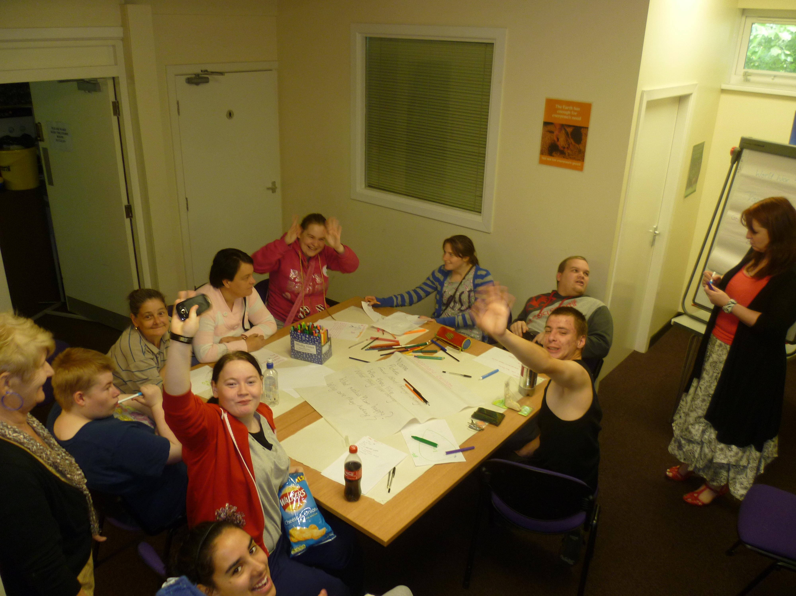
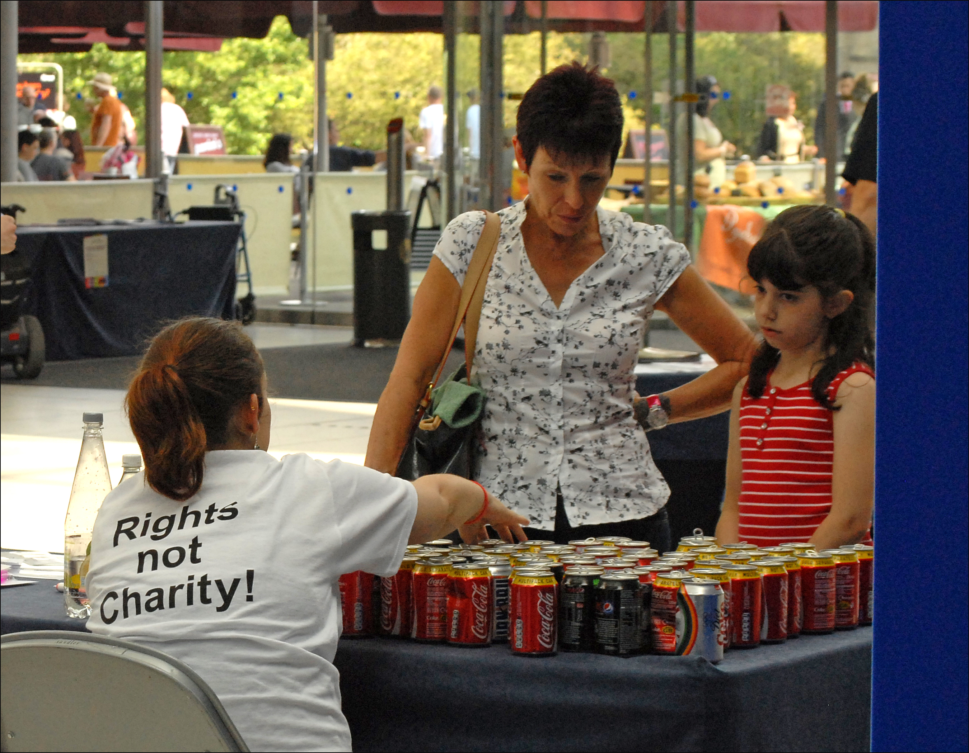

Discussion materials on the four critical issues in the provision of youth work for young disabled people
Ofsted has published four sets of discussion materials – one on each of the four critical issues. The individual sets contain summary findings of each of the four critical issues identified in the survey and suggest specific questions for discussion. These are of course not exhaustive, but it is hoped that youth work commissioners and their partners will use the questions as prompts to evaluate the services they currently provide for young disabled people. This may lead to identifying and sharing good practice, as well as priorities for improvement. You can take the issues in any order and spend as long as you like on each one. However, we suggest that at some stage you find time to look at all four.

Issue 1: Enjoyment and learning – curriculum structure and design

Issue 2: The benefits of youth work

Issue 3: Managing disabled young people’s engagement and achievement

Issue 4: Youth workers and other practitioners – professional matters

Good practice case studies
Seven examples of good practice in youth work for young disabled people have been published on the Ofsted website:
People power: Norfolk Coalition of Disabled People; www.ofsted.gov.uk/resources/120400.
Befriending and buddying for young disabled people: Kent County Council; www.ofsted.gov.uk/resources/120399.
Helping disabled young people achieve well through effective work-placement schemes; Whizz-Kidz; www.ofsted.gov.uk/resources/120398.
Responsive youth club work: Rochdale Youth Service; www.ofsted.gov.uk/resources/120397.
Young disabled champions rule: Birmingham City Council; www.ofsted.gov.uk/resources/120375.
Effective professional development in youth services: Bath and North East Somerset Council; www.ofsted.gov.uk/resources/130024.
SPLICE night – inclusive youth services: Merseyside Youth Association; www.ofsted.gov.uk/resources/120376.

The Office for Standards in Education, Children's Services and Skills (Ofsted) regulates and inspects to achieve excellence in the care of children and young people, and in education and skills for learners of all ages. It regulates and inspects childcare and children's social care, and inspects the Children and Family Court Advisory Support Service (Cafcass), schools, colleges, initial teacher training, work-based learning and skills training, adult and community learning, and education and training in prisons and other secure establishments. It assesses council children’s services, and inspects services for looked after children, safeguarding and child protection.
If you would like a copy of this document in a different format, such as large print or Braille, please telephone 0300 123 1231, or email enquiries@ofsted.gov.uk.
You may reuse this information (not including logos) free of charge in any format or medium, under the terms of the Open Government Licence. To view this licence, visit www.nationalarchives.gov.uk/doc/open-government-licence/, write to the Information Policy Team, The National Archives, Kew, London TW9 4DU, or email: psi@nationalarchives.gsi.gov.uk.
This publication is available at www.ofsted.gov.uk/resources/130018.
To receive regular email alerts about new publications, including survey reports and school inspection reports, please visit our website and go to ‘Subscribe’.
Piccadilly Gate  Store Street  Manchester  M1 2WD  T: 0300 123 1231  Textphone: 0161 618 8524  E: enquiries@ofsted.gov.uk  W: www.ofsted.gov.uk  No. 130018 | 
© Crown copyright 2013

Statutory guidance for local authorities on services and activities to improve young people’s well-being, Department for Education, 2012; www.education.gov.uk/a00204650/launchofconsultationondraftyouthguidanceforlas.
Progression post-16 for learners with learning difficulties and/or disabilities (100232), Ofsted, 2011; www.ofsted.gov.uk/resources/100232.
Local Authority Youth Services Annual Audit, National Youth Agency, 2009; www.nya.org.uk/policy/annual-audit.
Discussion materials on the four critical issues in the provision of youth work for young disabled people, Ofsted, 2013; www.ofsted.gov.uk/resources/130018.

