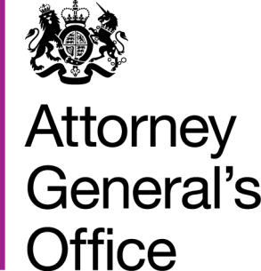 |  |  | www.gov.uk/ago
 | FOI|121|15 |  | June 2015
Freedom of Information Request

You requested:

I would like information on whether the Attorney General’s Office has a system in place that deletes emails around the three month mark? If this is the case, when was it introduced and under whose direction? If it is not in place, is there a process in place for the deletion of emails at any period of time and if not is there a plan for this type of process in the future?
I have now been able to consider your request, and I can confirm under section 1 (1) (a) of the Act the AGO does not have a system in place of deleting emails after three months. The AGO has a policy to delete emails older than two years.

