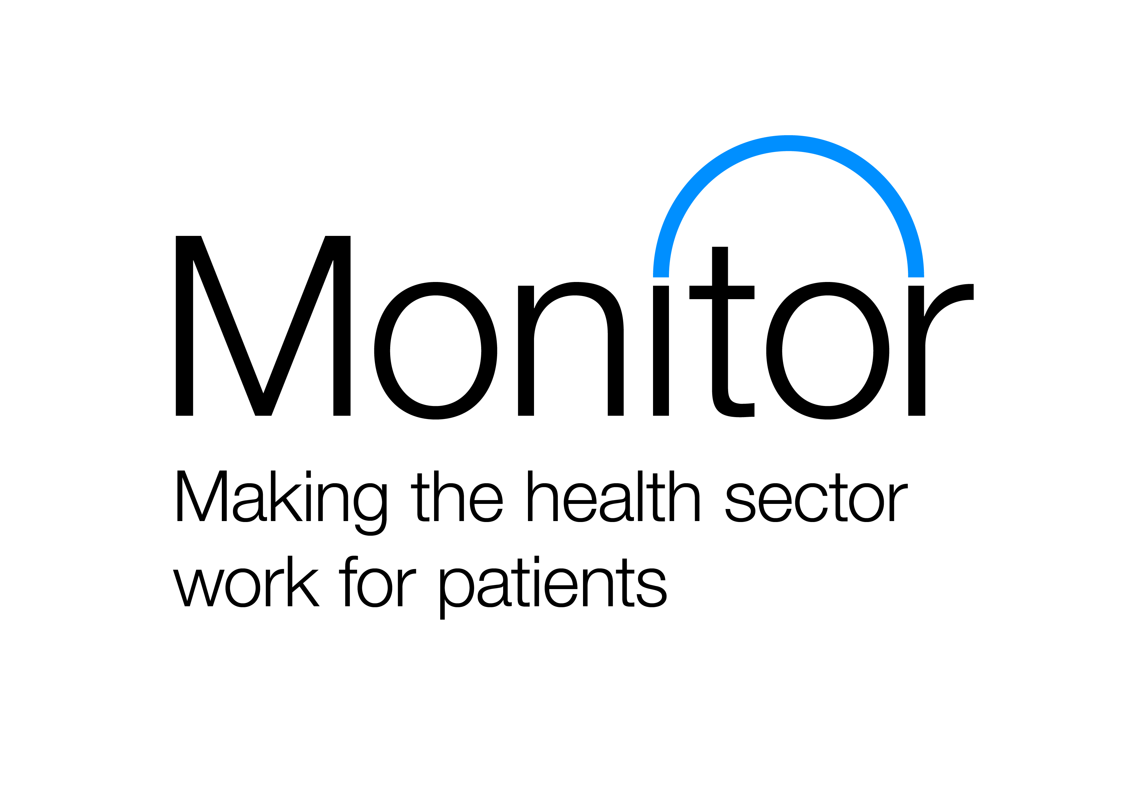
FRAMEWORK APPROVALS APPLICATION
Framework operator
Registered address
Company registration number (if applicable)
Contracting authority
Website address
Framework name
Staff group provision
Self-assessment authorised by:
Point of contact
Job title
Telephone number
Email address
Completing the form
Framework operators are asked to seek approval from Monitor/TDA for all framework agreements that supply agency staff to the NHS.
Framework operators are encouraged to apply by 3 March 2016, using this application form. Based on applications received by this date, we will publish a list of approved framework agreements in the week beginning 14 March 2016.
After this we will review applications on an ongoing basis. We encourage applicants to apply at the earliest possible date.
Framework operators are required to seek approval for each of their framework agreements that provide agency staff to NHS trusts and foundation trusts. This includes all nursing framework agreements, as existing conditional approval for nursing frameworks will expire on 31 March 2016.
Framework operators should submit one application form per framework agreement. We recognise that framework operators may be submitting applications for more than one framework agreement. Evidence of requirements in Table 2 (conditions on framework operators) can be cross-referenced between application forms.
Please see the framework approvals guidance before completing this application form. It sets out the conditions and evidence required for approval.
Framework agreements will be approved at the point of application where Monitor/TDA are satisfied that:
  - the framework agreement meets all the conditions set out in Table 1; and
  - the framework operator commits to, and provides, a detailed plan which sets out how they intend to meet the conditions in Table 2 by 1 April 2016 at the latest. This includes ensuring maximum compliance with the price caps to the extent the framework terms and conditions permit; and

  - the framework operator commits to, and provides, a detailed plan which sets out how they intend to put in place a framework agreement that fully meets the conditions in Table 3 as soon as possible and by 1 November 2016 at the latest. This includes ensuring the Monitor/TDA caps are contractually embedded into the framework agreements as well as any call-off terms under the framework agreement.
The applicant should complete each section of this application form and should refrain from comments such as “see point …etc”.
Applicants should use this form to demonstrate how they meet the conditions. Please embed or hyperlink any supporting evidence into the document with clear guidance on or signposting to where the information is contained in the supplied evidence.
Where the documents cannot be embedded or provided through hyperlink, the supporting evidence should be provided electronically and named as follows:
(date)(framework name)(evidence name)
Where data is required, eg rate cards, this should be supplied in an Excel document, and where the applicant has the information stored on several documents they must ensure this is merged into one document before sending to Monitor/TDA.

Completed application forms and supporting evidence should be sent to agencyrules@monitor.gov.uk

Authorisation Process

Monitor/TDA may contact applicants and request further information or in certain circumstances invite the applicant for teleconference or interview.

Where the applicant fails to provide the further information required either through submission or interview within the required timescales, the application will be considered purely on the information originally provided.

Applicants will be informed of the final decision in writing by week beginning 14 March 2016.

 | Description | Table 1 requirements: applicant to provide evidence on how they currently meet the conditions
Agreement | Framework agreements must be live and procured in accordance with the EU public contracts directives as implemented by the Public Contracts Regulations 2006 or the Public Contracts Regulations 2015 (the ‘Regulations’)
Table 1
 | Self-assessment: do you meet the conditions?
 | Yes/No
Agreement | Transparent and value for money rates of pay to the worker and agency fee, with no hidden charges or fees, and with pay to worker identified separately
Table 1
 | Self-assessment: do you meet the conditions?
 | Yes/No
Agreement | Transparency of agencies on the framework, including key subcontractors
Table 1
 | Self-assessment: do you meet the conditions?
 | Yes/No

Agreement | Assurance on quality of supply under the framework agreement and control on cost of agency supply under the framework agreement
Table 1
 | Self-assessment: do you meet the conditions?
 | Yes/No
Agreement | Agencies have capability to supply high quality, trained and fully vetted temporary staff and effective framework processes to ensure they maintain NHS-required standards for workers.
Table 1
 | Self-assessment: do you meet the conditions?
 | Yes/No
Agreement | Audits/review of invoicing, ensuring management information is high quality and fit for purpose, and separately identifies worker pay and agency fee
Table 1
 | Self-assessment: do you meet the conditions?
 | Yes/No

Agreement | Robust performance management and monitoring of agencies
Table 1
 | Self-assessment: do you meet the conditions?
 | Yes/No
 | Description | Table 2 requirements: applicant to provide evidence on how they currently meet the conditions or plan to meet them as soon as possible and by 1 April 2016 at the latest
Owner | Support trust negotiations with framework agencies and therefore play an important role in promoting trusts and agencies to meet Monitor/TDA’s caps as far as possible within the terms and conditions of the framework and more widely, helping trusts deliver actual savings on their agency expenditure
Table 2
 | Self-assessment: do you meet the conditions?
 | Yes/No
Owner | Communicate to trusts the agencies whose standard rates are equal to or below the price caps set by Monitor/TDA
Table 2
 | Self-assessment: do you meet the conditions?
 | Yes/No

Owner | Development of agency comparison tables to ensure trusts can easily understand the rates payable on the framework with different agencies
Table 2
 | Self-assessment: do you meet the conditions?
 | Yes/No
 | Description | Table 3 requirements: applicant to provide evidence on how they currently meet the conditions or plan to meet them as soon as possible and by 1 November 2016 at the latest
Agreement | Maximum worker pay rates, at rates specified by Monitor/TDA, are contractually embedded into the framework agreements so that the framework agreement (and any call-off terms therein) do not permit any amount paid in excess of these maximum worker pay rates (which are to be published on 1 April 2016), other than through the override process
Table 3
 | Self-assessment: do you meet the conditions?
 | Yes/No
Agreement | Framework agreements must also ensure that the total trust charge for an agency worker per hour is no more than the corresponding Monitor/TDA price caps throughout the life of the framework. This requirement should also be contractually embedded in the framework agreement (and any call-off terms therein)
Table 3
 | Self-assessment: do you meet the conditions?
 | Yes/No

Agreement | Framework agreements need to include a mechanism for trusts to stay on framework where trusts have to override the Monitor/TDA caps to secure a worker on exceptional patient safety grounds. Such a mechanism must be on a shift basis. There should be no other means of escalation within the framework
Table 3
 | Self-assessment: do you meet the conditions?
 | Yes/No
Owner | Framework operators must ensure that agencies on the framework agreements are seeking regular assurances from workers that workers are complying with IR35 legislation when engaging with a trust via a personal service company (PSC). Agencies should seek these assurances to be eligible for a place on the framework agreement
Table 3
 | Self-assessment: do you meet the conditions?
 | Yes/No

