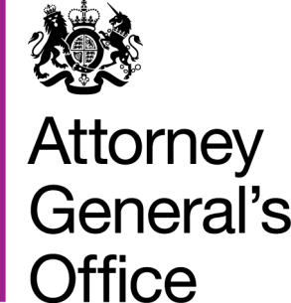 |  |  | www.gov.uk/ago
 | FOI|72|15 |  | April 2015
Freedom of Information Request

You requested:

“1. How much of the departmental budget was allocated to litigation (fees to legal services, settlement awards, court costs, etc) in the financial years 2008-09 and 2013-14?

2. How many litigation claims were brought against the department in the financial years 2008-09 and 2013-14?”
I have now been able to consider your request, and I can confirm the following information under section 1 (1) (a) of the Act:
1. The Attorney General’s Office has a public interest budget which the costs of fees to legal services, settlement awards, court costs, etc. are paid from. The AGO holds the following information on the size of the public interest budget in the financial years 2008-09 and 2013-14:

2008/09 – do not hold
2013/14 – £1,000,000

2. The AGO does not hold any centralised record of the number of litigation claims which were brought against the department in either of the two date ranges you specify.

