Inspection of non-association independent schools
A report on the responses to the consultation
This is a report on the outcomes of the consultation about the new framework for inspecting non-association independent schools to be introduced in April 2014.

Published: March 2014
Reference no: 140051

Contents
Introduction 4
Background to the consultation 4
The consultation 5
Summary of responses 6
Responses in full 6
The way forward 10

Introduction
- Between 18 December 2013 and 21 February 2014, Ofsted consulted on proposals to introduce a new framework for inspecting non-association independent schools.
- The consultation sought to gather views of independent schools, and those who have an interest in them, including pupils and their parents, and local authorities that place and fund children in independent schools. This report summarises the responses to the consultation and how they have informed our proposals for change.

Background to the consultation
- Ofsted inspects independent schools under section 162A of the Education Act 2002, as inserted, at the request of the Department for Education (DfE) which is the registration authority for all independent schools.
- The current framework for inspecting non-association independent schools was introduced in January 2013 in order to:
- check and report on the school’s compliance with the Education (Independent Schools Standards) (England) Regulations 2010, as amended by The Education (Independent School Standards) (England) (Amendment) Regulations 2012
- produce an evaluative report that informs the school, parents and carers, pupils and wider community about the quality and impact of the school’s provision
- bring about school improvement.
- Although our inspection reports and data show that the current framework is raising standards in independent schools, we want to bring about greater improvement. We also want to make it easier for parents, carers and placing authorities to compare schools by bringing inspections more into line with those of maintained schools, non-maintained special schools, academies and free schools. We believe that all schools in England inspected by Ofsted should be judged in the same way. These are the main reasons for consulting on a new inspection framework for independent schools.

The consultation
- We introduced our proposals for change to schools in a series of conferences held in November 2013, which were attended by a total of 385 representatives from schools. The consultation period ran from 18 December 2013 to 21 February 2014. An online survey for adults was open for the duration of this period, and a version for children and young people was launched on 10 January 2014.
- All non-association independent schools were invited to respond to the consultation. We also invited responses from directors of children’s services and other interested parties through newsletters, the Ofsted website and Ofsted’s Twitter account.
- The surveys asked four specific questions and also gave respondents the opportunity to comment on the proposals. The questions were:
Q1. To what extent do you agree or disagree that the same judgements should be made on independent school inspections as those made on inspections of maintained schools, non-maintained special schools, academies and free schools?
Q2. To what extent do you agree or disagree that the grade ‘adequate’ should be replaced by ‘requires improvement’?
Q3. To what extent do you agree or disagree that an independent school judged as requires improvement or inadequate should be re-inspected within two years of its previous inspection?
Q4. To what extent do you agree or disagree that independent schools judged as requires improvement or inadequate should be challenged to improve through frequent improvement inspections by inspectors as described above?
- We received 132 responses to our online survey for adults, and a further 16 from children and young people. Many respondents were headteachers of independent schools, but parents, teachers, other members of school staff, proprietors and inspectors also gave their views.

Summary of responses
- Overall, the responses to the consultation were strongly in favour of all Ofsted’s proposals. Most positively supported was the proposal to increase the frequency of re-inspecting schools judged inadequate or requires improvement from within three years to two years, with 82% of adult respondents in agreement or strongly in agreement.

Responses in full
Q1. To what extent do you agree or disagree that the same judgements should be made on independent school inspections as those made on inspections of maintained schools, non-maintained special schools, academies and free schools?

- In total, 69% of adults agreed or strongly agreed that the same judgements should be made on independent school inspections as those made on inspections of maintained schools and academies. Nine out of 16 of the children and young people who responded to our survey also supported the proposal.
Main consultation
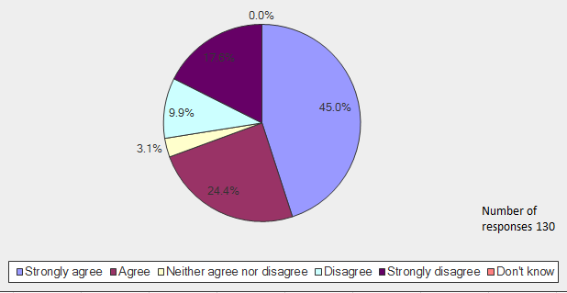
- Many respondents who commented agreed that ‘All schools should be inspected the same way’. Others stated that the proposal will bring about greater clarity, with one stating that ‘For comparison purposes there must be the same framework and the same rigour’. Some noted the diversity of the schools already subject to the same inspection judgements. One stated:
‘Given that although there is an increasing diversity in governance arrangements and statutory requirements for schools maintained, non- maintained academies and free schools all share a common inspection framework, it makes sense to bring non association independent school in line and ensure that judgements about [the] quality of education received is explained using the same terms irrespective of the institution in which the young people [are] educated.’
- A few respondents who either agreed or disagreed with the proposal cautioned that the framework will need to take into account the differences between maintained and independent schools, including funding arrangements, the ethos of independent faith schools and the structure of schools catering for children with disabilities and special educational needs.
- One respondent who disagreed with the proposal stated that, ‘Independent schools should be judged on their own merits, to compare them against maintained schools defeats the object for an independent type school’. Another reflected that the: ‘diversity of the British education system is a considerable strength; if all schools are judged by the same criteria they will become uniform and government led.’
- Others commented that parents who choose to send their children to independent schools may compare Ofsted’s judgements to judgements made about other independent schools that are inspected by the approved independent inspectorates.
Q2. To what extent do you agree or disagree that the grade ‘adequate’ should be replaced by ‘requires improvement’?

- In total, 60% of adult respondents agreed or strongly agreed that we should replace the grade 3 ‘adequate’ with ‘requires improvement’. Ten out of the 16 children and young also supported the proposal. Only four disagreed, and two recorded that they were ‘in the middle on this one’.
Main consultation
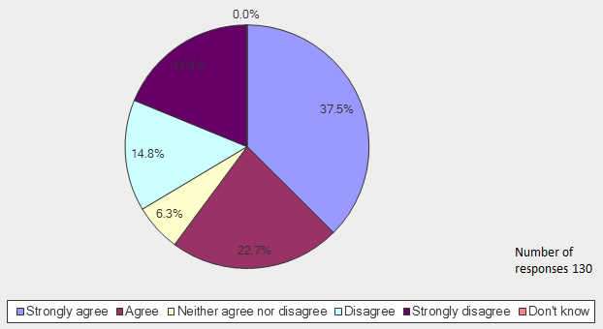
- Comments from respondents who agreed with the proposal noted that the terminology clearly shows that improvement is needed. One stated, ‘no school should be satisfied to remain providing a merely adequate provision’, and another, ‘As a [parent] I would presume that adequate meant that I should have no concerns about the school… The grade name should reflect this.’
- Of the 34% of the adults who disagreed or strongly disagreed with the proposal, some commented that the terminology sounds ‘negative’, with one stating that: ‘Schools should be encouraged and supported, not condemned and humiliated’. Another commented that it will cause ‘confusion in comparing Ofsted reports with those of other inspectorates’.
- Comments from inspectors reflected that the change has had considerable ‘impact in the maintained sector’ and ‘will allow parents and carers to make a fair [judgement about] the quality of education in a school. ‘Adequate' is not good enough.’
Q3. To what extent do you agree or disagree that an independent school judged as requires improvement or inadequate should be re-inspected within two years of its previous inspection?

- Overall, 82% of adults and 13 out of the 16 children/young people agreed or strongly agreed that Ofsted should re-inspect schools judged as requires improvement or inadequate within two years. Some comments suggested inspecting even more frequently, with one simply stating: ‘If not sooner’.
Main consultation
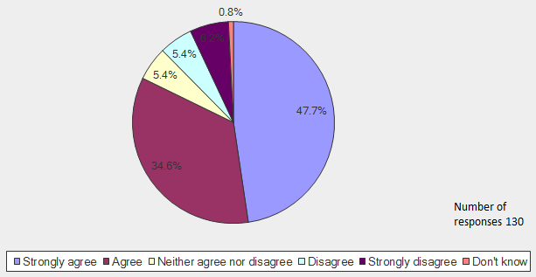
- Some respondents in agreement commented that the proposal will benefit the pupils in such schools. One noted:
‘This can work two ways – in favour of the school and DfE. Improving the school within a two year time frame means the school has to have a clear and time bound action plan for improvement. This can only be beneficial all round, but particularly for students. If the school demonstrates improvements, a two year period for publishing these improvements is better for the school.’
- Of the 12% of adults who did not agree with the proposal, one commented that, ‘Schools that have safeguarding issues require close scrutiny’, but questioned whether other schools should be subject to ‘such repeat inspections’.
- However, some of the respondents who disagreed also suggested that re-inspections should happen sooner than we propose, with one commenting, ‘more check ups are needed to see if these improvements are being implemented before the two years to see better problem solving and concerns are not just ignored’. Another remarked, ‘They should have to face an unannounced improvement inspection within 6 months of the last inspection to promote keenness in wanting to improve.’
Q4. To what extent do you agree or disagree that independent schools judged as requires improvement or inadequate should be challenged to improve through frequent improvement inspections by inspectors as described above?

- Overall, 77% of adults and eight of the 16 children and young people supported the proposal to introduce ‘improvement inspections’ to schools that are judged as requires improvement.
Main consultation
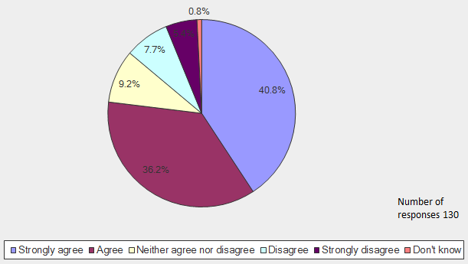
- Comments made by respondents were largely positive. One respondent commented,
‘For too long adequate schools have just muddled along even once improvement notices have been issued. This has to change and frequent inspection could improve outcomes far quicker.’
- Ten per cent of adult respondents were unsure of the proposal, either answering ‘don’t know’ or ‘neither agree or disagree’, and commented that the burden of increased frequency of inspection might be ‘counterproductive’. One of the 13% who disagreed or strongly disagreed commented that it would be better to ‘offer schools in this position some assistance to improve rather than increasing the frequency of inspection’.
- These views were echoed by respondents who agreed or strongly agreed with the proposal, with several commenting that ‘frequent improvement inspections can help the school’, but should ‘focus on providing support and advice’. One noted:
‘While these sort of inspections can put a lot of pressure on a school, invariably they are helpful in motivating staff, providing good external information for governors and… reassuring (or not) parents.’

The way forward
- We are grateful to all respondents who took part in our consultation and appreciate the insightful comments, which will inform the development of the new framework.
Question 1
- The large majority of respondents to question 1 (that is 69%) agreed or strongly agreed to the proposal that the same judgements should be made on independent school inspections as those made on inspections of maintained schools. We therefore intend to revise our framework and guidance so that we inspect and report against the same judgements as those made on inspections of maintained schools, non-maintained special schools, academies and free schools. This will apply to inspections from 28 April 2014 as proposed in our consultation document.
- One respondent commented on the importance of reporting on pupils’ spiritual, moral, social and cultural development, stating: ‘This is the heart of any school, hugely important for the development of contributors to society and, currently, largely lost/relegated to a sentence in maintained school reports.’ Under the new framework for inspecting independent schools, inspectors will check compliance with the paragraphs in part 2 of the independent school standards (pupils’ spiritual, moral, social and cultural development). Compliance will directly inform the judgement on leadership and management and will be clearly reported in this section of the report.
29. One young person pointed out that other schools ‘measure progress against league tables which we [independent schools] do not’. We will make sure that the grade descriptors make clear that, when making judgements on pupils’ achievement, inspectors will consider comparisons with national standards where a school makes this available, but will take into account pupils’ progress over time as shown by the school’s records and by any evidence or analysis by the school of pupils’ progress overall.
- We also intend that schools cannot be judged as outstanding for overall effectiveness unless they have outstanding teaching. This will bring inspection of independent schools into line with maintained schools in and academies in this respect.
Question 2
- The majority of respondents to question 2 (that is 60%) agreed or strongly agreed to the proposal that the grade ‘adequate’ should be replaced by ‘requires improvement’. We therefore intend to replace the grade 3 ‘adequate’ with ‘requires improvement’ and revise our guidance accordingly. This will apply to inspections from 28 April 2014 as proposed in our consultation document.
- In response to the proposal to replace the grade 3 adequate with requires improvement, one respondent who disagreed with the proposal commented, ‘I would rather see developmental points listed with this grading.’ Guidance and training will be provided for inspectors so that inspection reports clearly state any unmet independent school standards and the matters that schools must improve in order to become good.
- A judgement of requires improvement overall will signal that a school requires improvement to become good. A school judged as requires improvement may meet all of the independent school standards, but may not demonstrate the characteristics of a good school.
- This will be because one or more of the four underpinning judgements will be judged as requires improvement and/or there will be weaknesses in the overall provision for pupils’ spiritual, moral, social and cultural development. This accords with comments made by some respondents who were concerned that we will not make a separate judgement on pupils’ spiritual, moral, social and cultural development.
- Any independent school standards that are not met by schools judged as requires improvement will be judged by inspectors to be minor, easy to rectify, and to not have a serious impact on pupils’ welfare, health and safety, academic or personal development.
- In line with maintained school inspection, if a school is judged as requires improvement at two consecutive standard inspections and is still not good at a third standard inspection, it is likely to be deemed ‘inadequate’.
Question 3
- Most respondents to question 3 (that is 82%) agreed or strongly agreed to the proposal that the an independent school judged as requires improvement or inadequate should be re-inspected within two years of its previous inspection. We will therefore be taking forward with DfE our intention that an independent school judged as requires improvement or inadequate should be re-inspected within two years of its previous inspection. We intend to issue a policy statement in due course.
- Similarly, we will also take into account comments about the increased frequency of re-inspecting schools judged as requires improvement or inadequate, in the development of training and guidance: ‘I agree in principle, but it must be understood that whilst some improvements can be put in place very rapidly, others will take time to have the desired impact, there should be means to recognise that the school is now heading in the right direction even if it hasn't met the criteria for a judgement of good in all aspects.’
Question 4
- The large majority of respondents to question 4 (that is 77%) agreed or strongly agreed to the proposal that Ofsted should challenge independent schools judged as requires improvement or inadequate to improve through frequent improvement inspections by inspectors. We therefore intend to take forward with the DfE our proposal that Ofsted should challenge independent schools judged as requires improvement or inadequate to improve through frequent improvement inspections by inspectors. We intend to issue a policy statement in due course.
- We would envisage the first improvement inspections to commence from around five months from being judged as requires improvement in line with similar visit to maintained schools and academies.
- Independent schools that are found to be inadequate will continue to be subject to the statutory action planning process and, where appropriate, progress monitoring inspections, as at present. For those judged to be inadequate from September 2014, progress monitoring inspections may then be succeeded by improvement inspections if the school meets the independent school standards but still requires improvement to become good.
- In relation to improvement inspections, we will be working with the DfE to determine the reporting requirements and will publish a policy statement in due course.
- Regarding the proposal to introduce improvement inspections to schools judged as requires improvement, one respondent noted that, ‘Positive support to improve will [improve] the outcomes in a shorter time frame. It is easy to make a judgement, walk away and then just keep popping back to confirm your initial judgement was right… but much harder to be supportive.’ We will ensure that training and guidance for inspectors on conducting improvement inspections clearly sets out how inspectors will support schools to improve to become good.
- Another respondent commented, ‘Schools that have safeguarding issues require close scrutiny’ but questioned whether other schools should be subject to ‘such repeat inspections’. We will consider this in the development of the evaluation schedule, in particular how compliance with the independent school standards informs the judgement on behaviour and safety.

Ofsted inspects around half of the independent schools in England, known as non-association independent schools. All instances of ‘independent schools’ in this report refer to non-association independent schools.
The conferences were attended by representatives from non-association independent day, boarding and residential special schools. There were also representatives from independent schools whose education provision is inspected by the Bridge Schools Inspectorate or the School Inspection Service, but whose boarding or residential provision is inspected by Ofsted. Representatives from maintained boarding and residential special schools and academies with boarding provision also attended.
Percentages are rounded and may not add up to 100%. Pie charts have not been included for the children and young people’s consultation, as the response rate was low.
Ofsted inspects non-association independent schools. All other independent schools are inspected by one of the approved independent inspectorates: the Independent Schools Inspectorate, Bridge Schools Inspectorate or the School Inspection Service.
The framework for school inspection (120100), Ofsted, 2014; www.ofsted.gov.uk/resources/120100.
The Department for Education (DfE) issues schools that are judged to have not met the standards with a statutory notice to improve, requiring them to submit a statutory action plan to address the unmet standards. The DfE normally commissions Ofsted to evaluate the action plan, to inform their decision to accept (with or without modifications) or reject it. Normally, DfE will commission Ofsted to conduct one or more progress monitoring inspections to assess progress made in implementing the action plan, and whether the unmet standards are now met.

