This document has been archived because it is no longer current.

Developing children's learning through work in the natural environment: Preesall Fleetwood’s Charity Church of England Primary School

URN: 119558
Local authority: Lancashire
Date published: 28 March 2011
Reference: 130082

Brief description
The 'forest school' provides an inclusive and stimulating setting and the children’s enjoyment and commitment to it is evident in all aspects of school life. It’s part of the reason why attendance is above average and overall standards have improved since the last inspection.
Overview – the school’s message

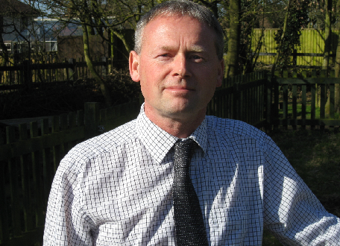
‘The initiative started as a way of engaging a small group of boys who were underachieving and were not keen to be at school. These boys showed an interest in the natural environment and we capitalised on this by providing practical learning sessions working outdoors in the school grounds and woods. The results were fabulous. They continued to work in the school grounds during their lunch periods and they had a reason to come to school. Their attitudes improved, which carried over into their school work and their achievement at Level 4 was better than expected. The “forest school” and wider environmental work are now integral parts of this school’s work.’
John Belshire, Headteacher
The good practice in detail

Inspectors identified the ‘forest school’ as an outstanding feature of environmental education at the school. All the children are involved in activities in the outdoors and in the woodland, but it is the youngest and oldest children who spend most time there.

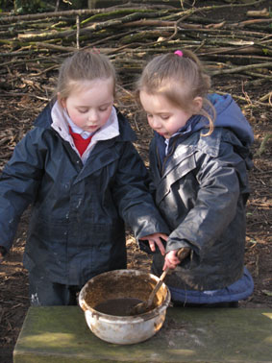
Children are allowed to climb trees and build fires. They listen to the heartbeat of trees (sap rising), and identify bird songs. They make and use tools ranging from potato peelers to knives, axes and mallets. They make environmental art, maintain the grounds and plant trees. There is a thriving ‘bug hotel’ and older children are involved in more complex tasks such as hedge-laying and pond maintenance.
While it’s clear that pupils’ knowledge and understanding of the environment improves, Julia Crompton, the school’s ‘forest school’ teacher, identifies the real benefits of this outdoor learning as: increased self-esteem; improved social skills; the development of language and communication skills; improved physical motor skills; and improved motivation and concentration.
Ben, Daniel and Max particularly enjoy building dens, playing with mud and cooking over an open fire. ‘We are learning lots of different things,’ says Ben.
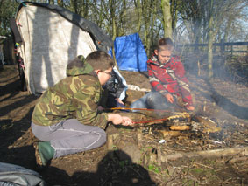
‘We are privileged to have such a great site,’ says John Belshire. ‘We focused on the natural environment provided by the school grounds as a learning opportunity and a way to enrich children’s experiences. The grounds were originally established about 15 years ago but had not been actively used by the children. They were used for science lessons and the greenhouse was used for growing some plants but we found opportunities to do much more. It has been made easy by the enthusiasm and the expertise of staff and is now a regular part of this school’s work.’
But it’s not just about the ‘forest school’. John says: ‘Currently we are concentrating on the “forest school” initiative but our work with the children goes beyond this. They are involved in pond dipping – we have some rare great crested newts - and growing vegetables and fruit in raised beds for use in the school kitchens. We also get involved in whole school activities linked to Springwatch and the RSPB Birdwatch. Reception children can watch blue tits nest, hatch eggs and raise chicks via a webcam from a nesting box in the school grounds.’
So what are the key features of this success?
When John and Julia reflect on the journey they emphasise the following key ingredients:
- Engage pupils from the start; their involvement and ownership is essential
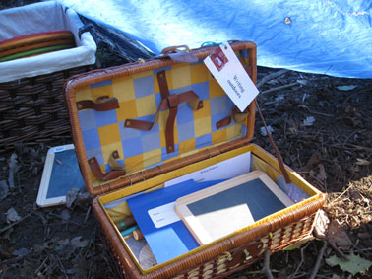
John believes a key feature of the success has been the involvement of the children. ‘We have engaged the children throughout. They have been involved in the planning of the grounds making suggestions and using art work showing what they would like the grounds to look like. Our eco council contributes ideas and where practicable we use these ideas. They learn from this process even if their ideas cannot always be executed.’
- Grow slowly and involve all staff
The project started with one group and one member of staff and has evolved into a whole-school approach. All staff have had an introduction to ‘forest school’ techniques and have been trained to use the environment effectively to enrich the curriculum.
- Use the expertise of parents, carers, grandparents, volunteers and community groups
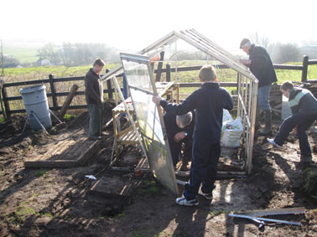
The natural environment is a way of increasing community engagement. The school involves parents, carers, grandparents and other volunteers. The Wyre Countryside Rangers also lead groups in practical tasks.
Recently the rangers helped the pupils to construct a dead-hedge around the school which serves a dual purpose of providing a wildlife habitat and deterring larger animals from pushing in through the fence. The rangers are also a source of advice about the pond and the countryside trail. The gardening club also plants flowers in the village.
- Find your own way using your own strengths
Julia says, ‘Having this great site is what made us think we should do more, but it’s not necessary to have large grounds or woods. Use what you’ve got and be innovative! Raised beds, greenhouses and “bug hotels” can be constructed even on concrete yards. Bring the outdoors indoors.’ John says, ‘For us, curriculum development followed the grounds development, but this needn’t be the case. Resources can be developed to support the environmental curriculum.’
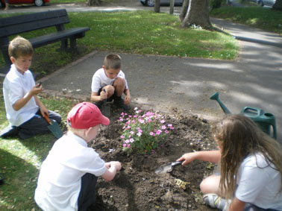
- Don’t feel restricted by the primary curriculum
The school was a finalist in a national environmental competition which really excited the children. John says, ‘Leading this development has been easy because staff have seen how much the children enjoy the practical work and teachers have been able to use this enthusiasm to stimulate learning across the primary school curriculum. They come up with fresh ideas and, as Head, my role has often just been to allow them to go ahead and try it!’
- Overcome the barriers, such as concerns about health and safety and risk assessment
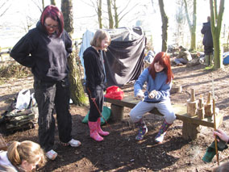
Children enjoy taking risks, but the school recognises that safety is paramount. Skills are learnt carefully and safety equipment is always used. John Belshire says, ‘By its nature, practical work is not a mass participation activity. Children work in groups of around six at a time to ensure that they have a quality learning activity which is safe. Once the children have been taught to use tools, they will expand the quality of their ideas and plans because the range of what they perceive to be possible has expanded.’

The school’s background
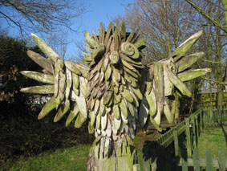
Preesall Fleetwood’s Charity Church of England Primary School is a small school whose pupils come from the villages of Preesall, Knott End, Stalmine and the surrounding area. The proportion of pupils receiving free school meals is below average. Most pupils are white British and few speak English as an additional language. About 10% of pupils are of Irish Traveller Heritage. The school has gained a number of awards including Healthy School, Eco-Schools Green Flag, Activemark and the ICT Quality Mark.

Are you thinking of putting these ideas into practice; or already doing something similar that could help other providers; or just interested? We'd welcome your views and ideas. Get in touch here.
To view other good practice examples, go to: www.ofsted.gov.uk/resources/goodpractice

