Further education and skills inspections and outcomes

This release contains:
- final data for the most recent inspection outcomes as at 29 February 2016
- final data for inspections conducted between 1 September 2015 and 29 February 2016

Sixty-seven per cent of providers were judged good or outstanding between 1 September 2015 and 29 February 2016 | At the mid-year point, the proportion of providers judged good or outstanding was 18 percentage points higher than the last full reporting year.  This is largely due to inspecting a higher proportion of previously good providers and those providers then remaining good at inspection.
Figure 1: Overall effectiveness of further education and skills providers, by reporting year
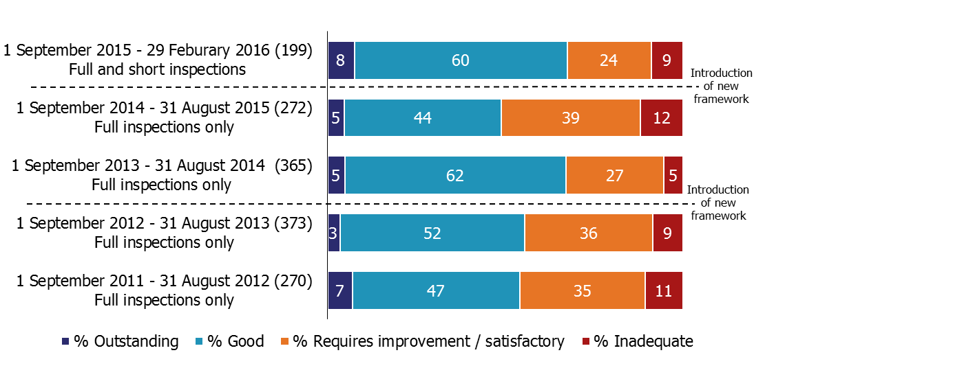

1. Percentages are rounded and may not add to 100.
The most recent overall effectiveness for general further education colleges judged good or outstanding has continued to decline | The proportion of general further education colleges judged good or outstanding declined by one percentage point from 31 August 2015, to 76% as at 29 February 2016. This is a continuation of the declining trend reported last year.
Contents
Key findings 3
In-year inspection outcomes 3
Most recent inspection outcomes 4
General further education colleges 5
Independent learning providers (including employer providers) 5
Community learning and skills providers 5
Revisions 7
Notes 8
Acknowledgements 8

Note

These statistics will be different when compared with those published in previous years because:
- The introduction of the new Common Inspection Framework has changed the way we view and report on overall effectiveness;
- The methodology used to aggregate the key inspection judgements for ‘all providers’ has changed and historical in-year figures have been revised to reflect these changes;
- The provider types included within the ‘colleges’ group have changed, with independent specialist colleges now excluded;
- The underlying historic database has been cleansed (see the revisions section on page seven for more details).

Full details of these changes can be found in the accompanying consultation document.

The consultation for these statistics will remain open until 29 July 2016.

Key findings

In-year inspection outcomes

Between 1 September 2015 and 29 February 2016, 199 further education and skills providers were inspected. This included 60 inspections of colleges, 71 inspections of independent learning providers (including employers) and 38 inspections of community learning and skills providers. Ofsted also contributed to the inspections of 22 prison and young offender institutions, where the reports were published between 1 September 2015 and 29 February 2016.

The inspections were conducted under the new Common Inspection Framework, which introduced the possibility of a short inspection for previously good providers. Over this period there were 147 full inspections and 52 short inspections, of which five converted to a full inspection. The converted inspections resulted in three providers remaining good and two declining to requires improvement.

Figure 2: The number of short inspections and their outcomes

Between 1 September 2015 and 29 February 2016, 67% of further education and skills providers were judged good or outstanding (see Figure 1). This was 18 percentage points higher than the last full reporting year.

In previous years, approximately a third of the inspections conducted were of previously good providers. This year, between 1 September 2015 and 29 February 2016, just over half of the providers visited were previously good.

The combination of inspecting more previously good providers, with those providers then remaining good at inspection (see Figure 3), has led to the proportion judged good or outstanding to be higher this year.

Figure 3: Proportion of previously good further education and skills providers that improved, stayed the same or declined at their next inspection

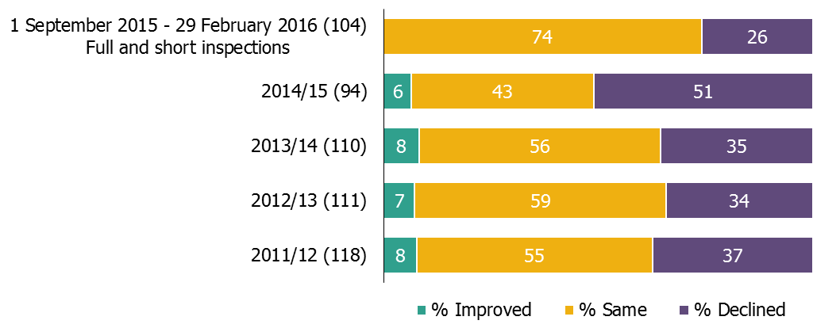
- Percentages are rounded and may not add to 100.

Most recent inspection outcomes

At the end of February 2016, the percentage of further education and skills providers judged good or outstanding at their most recent inspection was 84%.

Figure 4: Most recent overall effectiveness of further education and skills providers, as at 29 February 2016
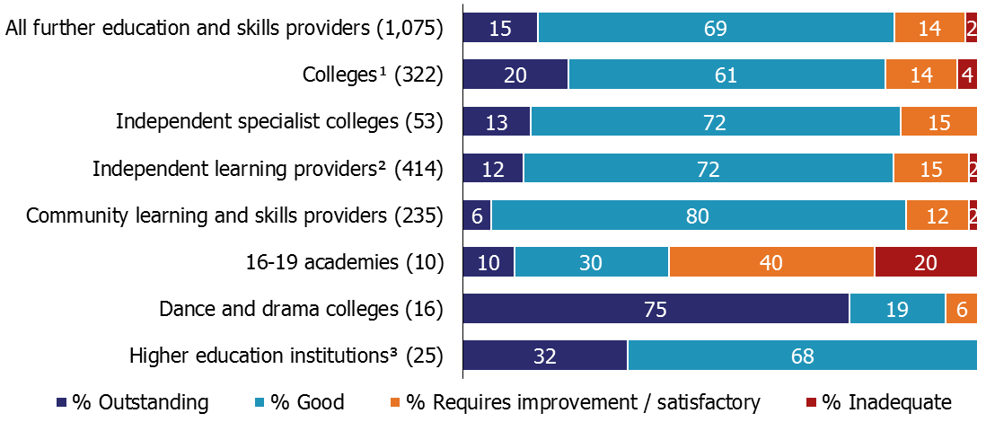

- Includes general further education colleges, sixth form colleges and specialist further education colleges.
- Includes employer providers.
- Inspection of further education provision only, not provider as a whole.
- Percentages are rounded and may not add to 100. Where the number of providers is small, percentages should be treated with caution.

This is not directly comparable with the 82% of providers judged good or outstanding as at 31 August 2015, due to a change in the methodology whereby higher education institutions and National Career Service contractors are now included. For figure 5, to allow most of the provider groups to be comparable between the 31 August 2015 and 29 February 2016, the 31 August 2015 published statistics have been adjusted to remove the providers that had ceased to be funded or were closed on that date. Four out of these seven provider groups saw an increase in the proportion judged good or outstanding between 31 August 2015 and 29 February 2016.

General further education colleges

The proportion of general further education colleges judged good or outstanding at their most recent inspection has continued to decline, from 77% to 76%. This decline was caused by:
- Eight previously good or outstanding colleges declining to requires improvement or inadequate this reporting year, compared with seven colleges improving to good;
- One good college merging with another college;
- Gaining one college that required improvement, which had been previously been categorised as a sixth form college.

Independent learning providers (including employer providers)

The proportion of good or outstanding independent learning providers (including employer providers) increased by three percentage points, to 84%. This was caused by the majority of the providers who were inadequate on 31 August 2015 losing their funding or closing down and a large majority of the previously grade 3 providers improving to good.

Community learning and skills providers

The proportion of community learning and skills providers judged good or outstanding at their most recent inspection declined for the first time since reporting began from 88% to 86%. The reasons behind this decline were based on a changing composition of the providers included and a decline in the in-year inspection outcomes:
- Eight previously good providers declined to requires improvement or inadequate, with just two providers improving to good;
- Three providers (one requiring improvement and two good) ceased to be funded either novating their contracts or transferring funding to a partner provider.

Figure 5: Percentage of providers judged good or outstanding at their most recent inspection
Provider types/groups that are comparable between years | As at 31 August 2015¹ |  | As at 29 February 2016 |  | Percentage point difference
 | No. | % | No. | %
General further education colleges | 215 | 77 | 215 | 76 | -1
Sixth form colleges | 94 | 88 | 92 | 92 | +4
Specialist further education colleges | 15 | 100 | 15 | 100 | 0
Independent specialist colleges | 55 | 84 | 53 | 85 | +1
Independent learning providers (including employer providers) | 419 | 81 | 414 | 84 | +3
Community learning and skills providers | 238 | 88 | 235 | 86 | -2
16-19 academies | 10 | 30 | 10 | 40 | +10

- These statistics have been adjusted from the previously published data to only include those providers that were open and funded as at 31 August 2015.
- The percentage point difference is calculated using unrounded numbers. Where the number of providers is small, percentages should be treated with caution.

Revisions

In September 2015 Ofsted changed how it records and stores all of its inspection information, with the introduction of a new database. As part of the data migration one missing inspection and a small number of missing judgements were identified and have been corrected. Details are below:

Revision 1
There has been one addition to the in-year historical inspection outcomes for 2013/14. This inspection was for an independent learning provider that was judged to be inadequate for overall effectiveness.

The impact of this revision is that the proportion of independent learning providers (including employer providers) judged to be inadequate between 1 September 2013 and 31 August 2014 rose by one percentage point, to 9%. This did not affect the proportions judged to be outstanding, good or requiring improvement.

The revision also changed the number of previously grade 3 providers that improved, stayed the same or declined during 2013/14, but did not affect the percentages reported.

Revision 2
As at 31 August 2015, 47 providers that were last inspected between 2006 and 2009 did not have an ‘outcomes for learners’ judgement recorded (these judgements were made at the time of inspection, under the old judgement ‘achievement and standards’). Out of the 47 providers, 40 were found to be outstanding and seven good. This revision has no impact on the previously published key findings or ‘tables and charts’ files.

These outcomes have now been added to the underlying data supporting this Official Statistics release and a separate data set will be published amending the underlying data for the 31 August 2015.

Revision 3
As at 31 August 2015, 58 providers that were last inspected between 2006 and 2009 did not have a ‘teaching, learning and assessment’ judgement recorded (these judgements were made at the time of inspection, recorded in the text under the old judgement ‘quality of provision’). Out of the 58 providers, 40 were found to be outstanding, 17 good and one satisfactory. This revision has no impact on the previously published key findings or ‘tables and charts’ files.

These outcomes have now been added to the underlying data supporting this Official Statistics release and a separate data set will be published amending the underlying data for the 31 August 2015.

Notes

- For 2015/16, the most recent inspection outcomes include providers wholly or partly funded by the Skills Funding Agency or the Education Funding Agency at that point in time. Before 2015/16 the most recent inspection outcomes included: 1) providers wholly or partly funded by the Skills Funding Agency or the Education Funding Agency at that point in time, and 2) providers who had lost funding or closed during the stated reporting year.

- Short inspections of previously good providers can either confirm that the provider is still good overall, or the lead inspector can choose to convert the inspection to a full inspection where: there is insufficient evidence to confirm that the provider remains good; there are concerns that there is evidence that the provider may no longer be good (which may include concerns about safeguarding); or if there is sufficient evidence of improved performance to suggest that the provider may be judged outstanding. As a result of the converted inspection the provider could improve, decline or remain the same.

- The quality report for these official statistics contains an explanation of the methodology used and the relevant inspection frameworks, along with other useful information, such as where to find previously published further education and skills Official Statistics. It is available from:
https://www.gov.uk/government/statistics/further-education-and-skills-inspection-and-outcomes-as-at-29-february-2016

If you have any comments or feedback on this publication, please contact Sarah Pearce on 03000 130 632 or Sarah.Pearce@ofsted.gov.uk

Acknowledgements

Thanks to the following for their contribution to this statistical release: Marc McGreavy, Francesca Thompson and Charlie Ogilvie.

© Crown copyright

You may re-use this information (not including logos) free of charge in any format or medium, under the terms of the Open Government Licence. To view this licence, visit http://www.nationalarchives.gov.uk/doc/open-government-licence/ or write to the Information Policy Team, The National Archives, Kew, London, TW9 4DU or e-mail: psi@nationalarchives.gsi.gov.uk

