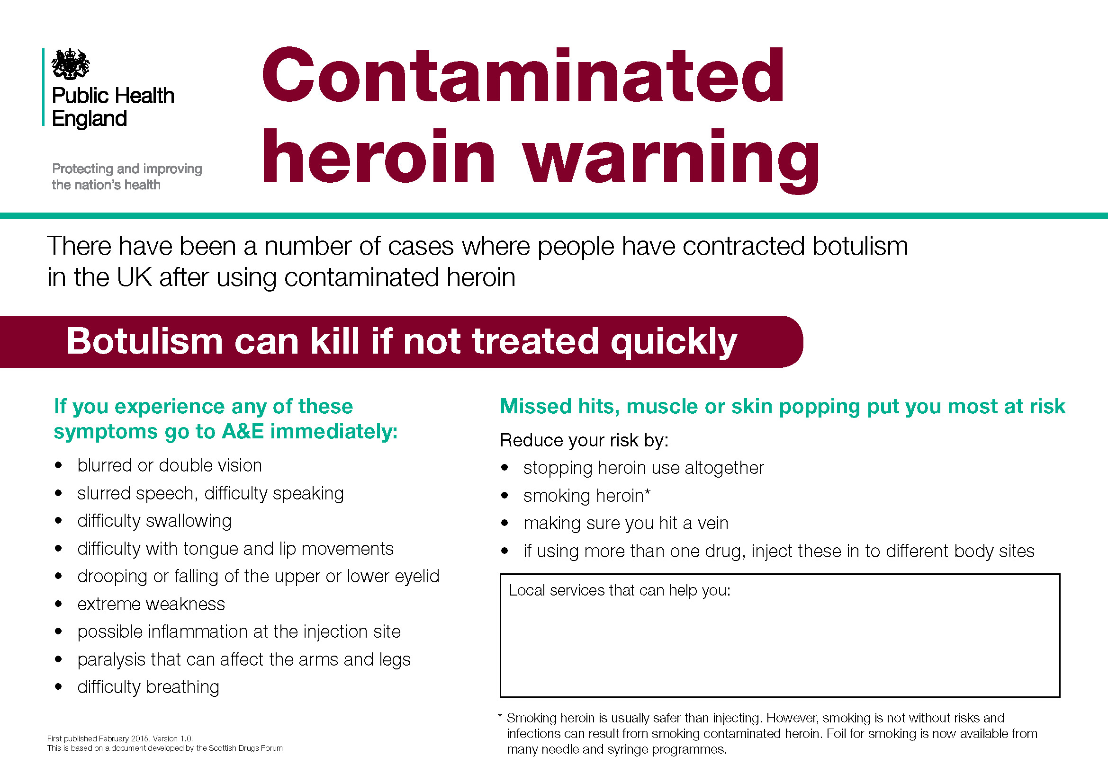
Type here to add details of local services
X
X
X

