SPORTS GROUNDS SAFETY
AUTHORITY

Annual Report and Accounts 2015/2016

Presented to Parliament pursuant to paragraph 24 of
Schedule 1 of the Sports Grounds Safety Authority Act 2011

Ordered by the House of Commons to be printed on
5 July 2015

HC 225

© Sports Grounds Safety Authority 2016
The text of this document (this excludes, where present, the Royal Arms and all departmental or agency logos) may be reproduced free of charge in any format or medium provided that it is reproduced accurately and not in a misleading context.
The material must be acknowledged as Sports Grounds Safety Authority copyright and the document title specified. Where third party material has been identified, permission from the respective copyright holder must be sought.
Any enquiries related to this publication should be sent to us at info@sgsamail.org.uk
This publication is available at https://www.gov.uk/government/publications
Print ISBN 9781474132176
Web ISBN 9781474132183

Printed in the UK by the Williams Lea Group on behalf of the Controller of Her Majesty’s Stationery Office

ID P002807687 07/16
Printed on paper containing 75% recycled fibre content minimum

Contents
Chairman’s Foreword 4
Chief Executive’s Introduction 5
Performance Report

Overview 6
Performance analysis 6

Accountability Report

Corporate Governance report 14
Remuneration and staff report 14
Parliamentary accountability and audit report 14

Financial Statements
Statement of Comprehensive Net Expenditure 25
Statement of Financial Position 26
Statement of Cash Flows 27
Statement of Changes in Taxpayers’ Equity 28
Notes to the accounts 29
CHAIRMAN’S FOREWORD

I am delighted to introduce the Annual Report and Accounts of the Sports Grounds Safety Authority (SGSA) for 2015/16 to coincide with my first full year in office, one spent getting out and about and meeting stakeholders as well as spending time in the boardroom. I have witnessed the huge commitment and dedication of safety teams across the divisions in my visits to sports grounds.
During the year of the now concluded Hillsborough Inquests, we are reminded of the importance of our mission and the need for all people and organisations involved in managing sports grounds to ensure that safety is at the top of their agenda and that complacency does not set in. We must never take for granted our position as one of the safest countries in the world to watch live sport.
The Board, Inspectors and staff have all been involved in developing our ambitious new 5 year strategy, approved by the Secretary of State, a summary of which you can find on page 7. Importantly it sets out our values of excellence, independence, integrity and partnership and our vision for the Authority. We will not lose focus on our core statutory duties in football but we will share our expertise for the benefit of more spectators in more sports at home and around the world. In doing this we will operate in a more commercial way and reduce our burden on the tax payer.
The year has also seen a number of changes in staff and Board Members. Karen Eyre-White was recruited as Chief Executive and joined the Authority in July, with Rick Riding very capably stepping up as Interim Chief Executive during the recruitment period. Brendon Batson, our longest serving Board Member, retired from the Board and I would like to thank him for the exceptional contribution he made to the Authority during his term of office. We have recruited four new Board Members, and I have appointed Peter Rowley as Lead Non-Executive Board Member as we modernise our governance procedures to include Board appraisal.
The SGSA’s success is critically dependent on positive relationships with local authorities, sports governing bodies and clubs and other stakeholders. As I have seen at first hand we have an outstanding group of people led brilliantly by Karen Eyre-White. On behalf of the Board, I would like to thank all of them for their hard work, professionalism, and ongoing support and commitment to the SGSA.
All of us, Board and staff, look forward to delivering our strategy and to keeping safety at sports grounds a key priority in the boardroom of clubs and governing bodies, as well as in the control room.

Alan Coppin
Chair
Sports Grounds Safety Authority

Chief Executive’s Introduction
The year began with a changing of the guard at the SGSA as Ruth Shaw left the post of Chief Executive. I commend Ruth for her dedication, and in particular her leadership of the SGSA through a time of considerable uncertainty around its status. I am grateful to Rick Riding for his commitment as he stepped up to the role of Interim Chief Executive until I arrived in July.
This has been an exciting year for the SGSA as we secured a positive spending review outcome and published a new, ambitious five year strategy. In so doing we have clarified our vision to be the world’s leading authority in spectator safety, and we’ve taken some important steps towards that goal.
Our world-class expertise continues to be sought-after both in this country and internationally. We have worked with a range of sports, countries and organisations to share our advice on safety design and management, always keeping our values of integrity, excellence, independence and partnership working in mind. We have continued to provide an excellent service in our regulatory role to oversee local authorities in England and Wales, including attending 220 Safety Advisory Groups and 177 match visits.
The attempted attack at the Stade de France in November reminded us all that sports grounds can be a high-profile target for terrorists. We have worked with the National Counter Terrorism Security Office to share messages about what sports grounds can do to prepare, and to make sure that the interaction between safety and security is well managed and understood.
A significant amount has happened in the months since the end of the 15/16 year. The conclusion of the Hillsborough Inquests in late April has placed renewed focus on the importance of the work we do to keep spectators safe. This was a timely moment to bring the sector together for our second annual conference, Spectator Safety in a Changing World, which was a valuable opportunity for safety professionals to discuss everything that is changing in the world and how, together, we can adapt and respond. In April I appointed Ken Scott as Chief Inspector to lead the SGSA’s Inspectorate, a position which will play a crucial role in delivery of our new strategy.
Next year we will build on this year’s achievements. We will expand in order to make the most of opportunities to share our expertise internationally, and continue with the 6th edition of the Green Guide. We will work with Government to enable a more commercial approach for the benefit of the taxpayer. We will continue to give advice to sports other than football, and we will agree a more formal role to support sports grounds in becoming more accessible. And we will keep our important statutory role for football front and centre and ensure that all spectators can enjoy watching sport in safety.

Karen Eyre-White
Chief Executive
Sports Grounds Safety Authority
Performance Report
Overview
We are the UK Government’s expert body on safety at sports grounds. We write guidance including the Guide to Safety at Sports Grounds (the “Green Guide”) and carry out a range of statutory functions in relation to football in England and Wales and advisory functions in relation to other sports both within the UK and internationally. Our core statutory functions are set out in the Football Spectators Act 1989 and the Sports Ground Safety Authority Act 2011.

We have an important statutory responsibility to regulate local authorities in their oversight of safety at the 92 football clubs in the Premier League and the Football League, and at Wembley and the Principality Stadium. We also issue licences to those 94 stadia to enforce the Government’s
all-seater policy.

Since 2011 our expanded remit allows us to share our expertise and support not only with football in England and Wales, but with other sports and across the world. We aim to share our expertise as widely as we can, whilst remaining focused on our purpose and keeping our statutory role front and centre.

Going concern

The annual accounts have been produced on a going concern basis. The SGSA received a funding settlement covering the financial years 2016-17 to 2019-20. It is therefore appropriate to present the 2015-16 accounts on a going concern basis.
Five Year Strategy
In February 2016 we published our new five year strategy which set out the Authority’s vision and explained how we will share our expertise for the benefit of more spectators and more sports around the world. A one page summary of the strategy is reproduced below.
The SGSA’s purpose to ensure all spectators can enjoy watching sport in safety is unchanged and we have a new ambitious vision to be the world’s leading authority on sports grounds safety. We will do this by sharing our expertise as widely as possible with other sports and countries, continuing our valuable work in football and always putting spectators at the heart of what we do. We will be guided by our simple purpose to ensure all spectators can enjoy watching sport in safety and our values of excellence, independence, integrity and partnership.
Our commitment to our statutory responsibility in football is as strong as ever, and we will continue to work with the football authorities, clubs and local authorities on this important work. Our statutory role is to regulate local authorities in their oversight of safety at the 92 football clubs in the Premier League and Football League, and at Wembley and the Principality Stadium.
A full account of our approach to and policies for the management of risk are covered in the Governance Statement.
Performance analysis
In consultation with the Department for Culture, Media and Sport (DCMS) we identified two key performance indicators for the organisation for 2015/16: that licences for all Premier League, Football League and international football grounds in England and Wales would be issued prior to the commencement the football season; and, the amount of income generated by the SGSA in relation to advisory functions. This report sets out how we have performed and what we have achieved over the past year in three main areas of work: football activity; other sports activity; and, international activity.

Football activity
For the top four leagues of English professional football and Wembley and the Principality Stadium, we operate a licensing scheme to regulate spectator viewing accommodation. We also regulate local authorities in their oversight of safety at the 92 football clubs in the Premier League and the Football League, and at Wembley and the Principality Stadium.
Much of this work is undertaken directly by our team of Inspectors through discussions with local authorities, clubs and other interested parties, and visits to football grounds on match/event days and non-match/event days. Inspectors advise and assist clubs and local authorities on a wide range of ground and spectator safety issues, and they monitor how local authorities are discharging their safety certification responsibilities. In 2015/16 this work included:

- Undertaking 177 match day visits (compared with 180 in 2014-15) and attending 220 Safety Advisory Group meetings (compared with 237 in 2014-15). We received notification of 187 during performance inspections from the local authorities we monitor (compared with 162 in 2014-15).

- We have continued to deliver the Government policy on spectator accommodation through our licensing scheme. We considered licence applications from all twenty Premier League clubs and all seventy two Football League clubs, plus Wembley and the Principality Stadium. Licences for the 2015/16 season were issued to all grounds by the deadline of 31st July 2015.

- By 31 March 2016, there were 72 all-seated Premiership, Football League and international football grounds.

- We continue to collate and publish annual injury statistics, which showed that the number of reported spectator injuries for the 2014/15 season was 1,001, an 8% reduction from the 1,088 reported in 2013/14. The reported overall injury ratio per spectator was one injury per 34,234 spectators.

- We continued to encourage a move to risk based safety certification, which places the responsibility for determining how to provide for spectator safety with ground management rather than being prescribed by local authorities. By 31 March 2016, 25 clubs had moved to this approach, and a further 18 planned to do so by 2017.

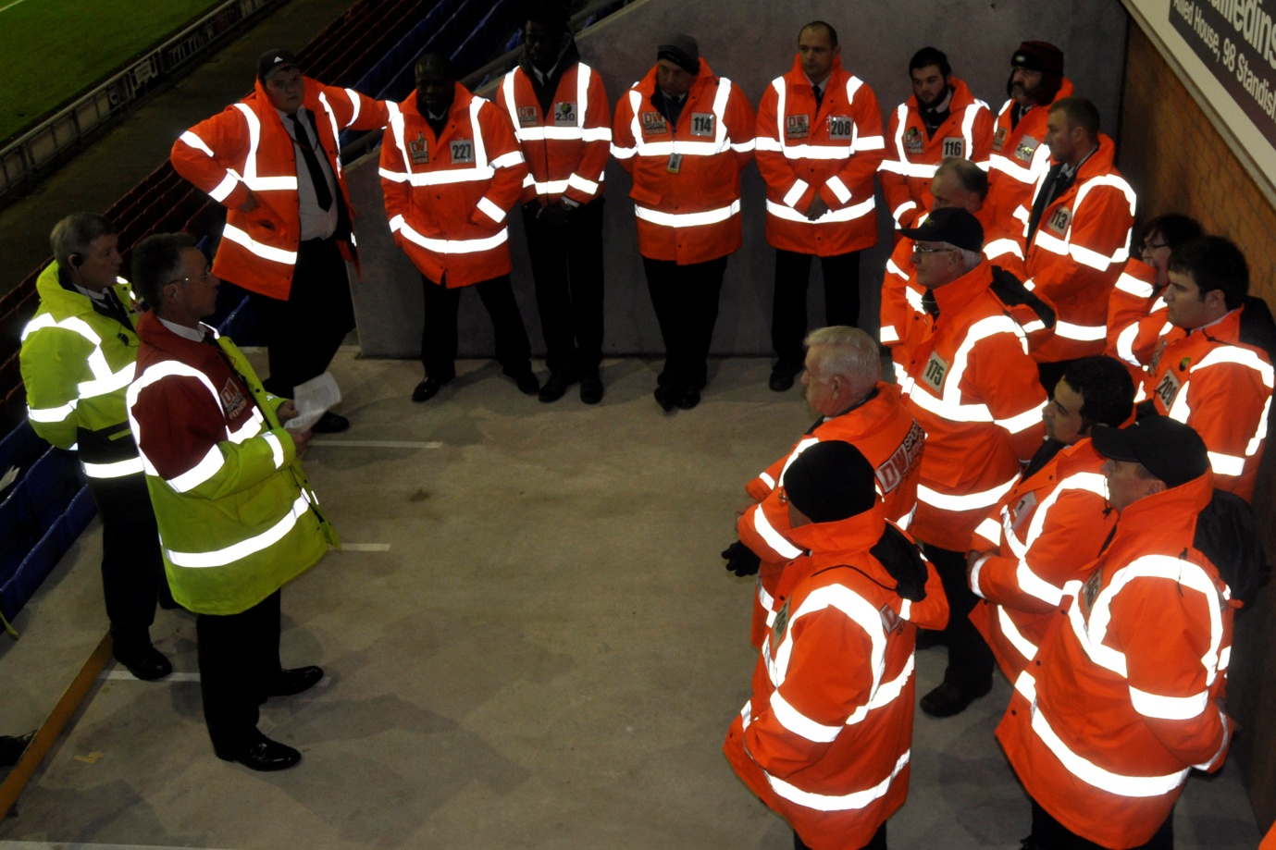

Other sports activity
We are able to offer advice and guidance in respect of spectator safety at any sports ground. This allows us to share good practice with, and observe and learn from, other sports, whether at a local or national level. Below is a selection of some of the activity we have undertaken outside of football in 2015/16.

Cricket
In the summer of 2015 we continued our work in partnership with the England and Wales Cricket Board (ECB), identifying and encouraging safety management good practice at first class county cricket grounds. During the season we visited thirteen grounds, observing safety management at four major and nine domestic games. Our feedback was presented to all participating grounds and discussed with the ECB and Cricket Safety Officers. In April 2016, agreement was reached with the ECB for a four year partnership to build on this work with a further round of visits and associated work scheduled for the next four cricket seasons. We will again attend a mixture of high profile international and domestic fixtures, presenting a series of reports to local ground management and the ECB.

Northern Ireland

Towards the end of 2015 the SGSA finalised agreements to work with Sport Northern Ireland (SNI) and the Department of Culture, Arts and Leisure Northern Ireland (DCALNI).

For SNI, SGSA Inspectors monitored the implementation of the Safety of Sports Grounds Order by District Councils at venues that have been designated under the provisions of the Safety of Sports Grounds (NI) 2006 and related legislation.

With DCALNI, the SGSA provided advice and support to the Casement Park and Windsor Park Safety Technical Group as an advisor to the group with regard to spectator safety matters. In December 2015 the Chief Executive and the Chief Inspector appeared as witnesses at a meeting of the Northern Ireland Assembly’s Committee for Culture and Arts Inquiry into Issues around Emergency Exiting Plans, including their Impact on Stadium Capacity, for the Redeveloped Casement Park Stadium.

Rugby Union

Inspectors attended a number of Rugby World Cup 2015 games and associated Safety Advisory Group meetings in the build up to the tournament.

Training and presentations

We were invited to present at a number of ‘Policing at Major Sporting Events’ courses around England, providing a safety management perspective to Police Officers who would have responsibility for policing at sporting events. SGSA Inspectors also spoke at a number of Public Safety at Sports Grounds and Events courses run by the Emergency Planning College, attended by local authority officers with responsibility for sports grounds in their area.

SGSA Inspectors attended and/or gave presentations at a number of industry gatherings including the meetings of the football, cricket, rugby union and rugby league Safety Officers Associations, the UK Venue Managers Association conference and various local government, academic and emergency service training events. These included events in Scotland and Northern Ireland.

Multi Agency work with the Police

During the year we were again active participants within the UK Football Policing Unit (UKFPU) Multi Agency Group and participated in the development of the UKFPU Multi Agency Action Plan, aimed at dealing with football violence and emerging trends. This work included discussing as a group how we could reduce the unlawful use of pyrotechnics and drones.

Security

Following the terrorist attack at the Stade de France in November 2015, we began working with security partners to share messages across sports and ensure that the interactions between safety and security are understood and well managed.
Accessibility
We worked with Level Playing Field to raise awareness of the legal requirement to provide accessible spectator accommodation at football grounds. We undertook a review of the guidance document Accessible Stadia and published supplementary guidance in 2015 which reflects changes in legislation, societal expectations and improvements in technology and is freely available to the public.
The 6th Edition of the “Green Guide”

Work began on the 6th edition of the Guide to Safety at Sports Grounds, the “Green Guide”. Following a successful consultation process, the project to produce the new edition began in earnest in March 2015. It is hoped that the 6th edition will be published in 2017/18.

Publication of “Alternative Uses of Sports Grounds” – October 2015 saw the publication of Alternative Uses of Sports Grounds, the latest in the Sports Grounds and Stadia Guide series. This new guidance aims to assist stadium owners, operators, local authorities, promoters and event organisers in the use of sports stadia for activities other than those for which they were originally built, such as pop concerts or other sporting events.

Newsletter
Our monthly email newsletter continues to provide useful practical advice and guidance on a wide variety of topics as well as keeping our readers up to date with recent SGSA activity. Through the newsletter we reach a wide variety of readers, including many representatives from sports other than football and outside of the UK.
International activity
Outside of our domestic regulatory and advisory functions, we are able to provide advice and guidance on spectator safety at sports grounds overseas, on matters such as safety design and management. In order to help establish and maintain effective safety cultures internationally we play an active role in European and wider international programmes and initiatives. 2015/16 was a busy year with a wide range of international activity, including:
Australia - In April and October 2015, Rick Riding continued to provide peer review advice for the design and construction of a new 80,000 capacity stadium in Perth Western Australia. This involved providing expert advice on Green Guide compliance, construction standards, fire engineering and crowd modelling.
China - Rick Riding took part in a visit organised by UK Trade and Investment (UKTI) in Beijing aimed at facilitating discussions on how the UK and China can work together to support China’s football development agenda, including stadia development and an integrated approach to safety management.

Comité Européen de Normalisation (CEN - European Standards body) - CEN is made up of representatives from European national standards bodies, including the British Standards Institution (BSI). An SGSA Inspector represents the BSI on CEN, and this year attended meetings in Brussels, Cologne, Madrid and Milan, contributing to consideration of European Standards, most notably the various Parts of BS EN 13200 – Spectator Facilities.

Council of Europe (CoE) – the Chief Executive and Inspectors attended Council of Europe meetings in Strasbourg and Paris to review and develop safety standards, and Mark Smith contributed to a consultative visit to Romania assisting with the development of professional qualifications for safety staff.
European Stadium and Safety Management Association (ESSMA) – we signed a memorandum of understanding (MOU) with ESSMA to encourage collaborative working, sharing good practice and working together for the benefit of spectator safety, setting out a number of objectives to work together for the shared goal of ensuring the safety of spectators at sports grounds. ESSMA is a not for profit association that allows stadium, safety and head grounds managers to exchange knowledge and expertise. Ken Scott represented the SGSA at ESSMA summits in both Bilbao and Stuttgart, delivering presentations on the Guide to Safety at Sports Grounds, the “Green Guide”.
India – Rick Riding took part in a visit organised by UKTI to engage with organisations involved in the Indian Super League this included a match visit at Balewadi Stadium, Pune and attendance at the Football Movement 2015 conference in Mumbai.

Qatar – In September 2015 Martin Girvan developed and presented a training event in Doha in association with the Al Josoor Institute which provided a senior manager and director viewpoint of spectator safety and services.
Uruguay – Following up on a visit earlier in 2015, Martin Girvan and Geoff Galilee visited Montevideo to deliver a five day Safety Manager training course to representatives of the Association of Uruguayan Football (AUF) and the country’s leading football clubs.
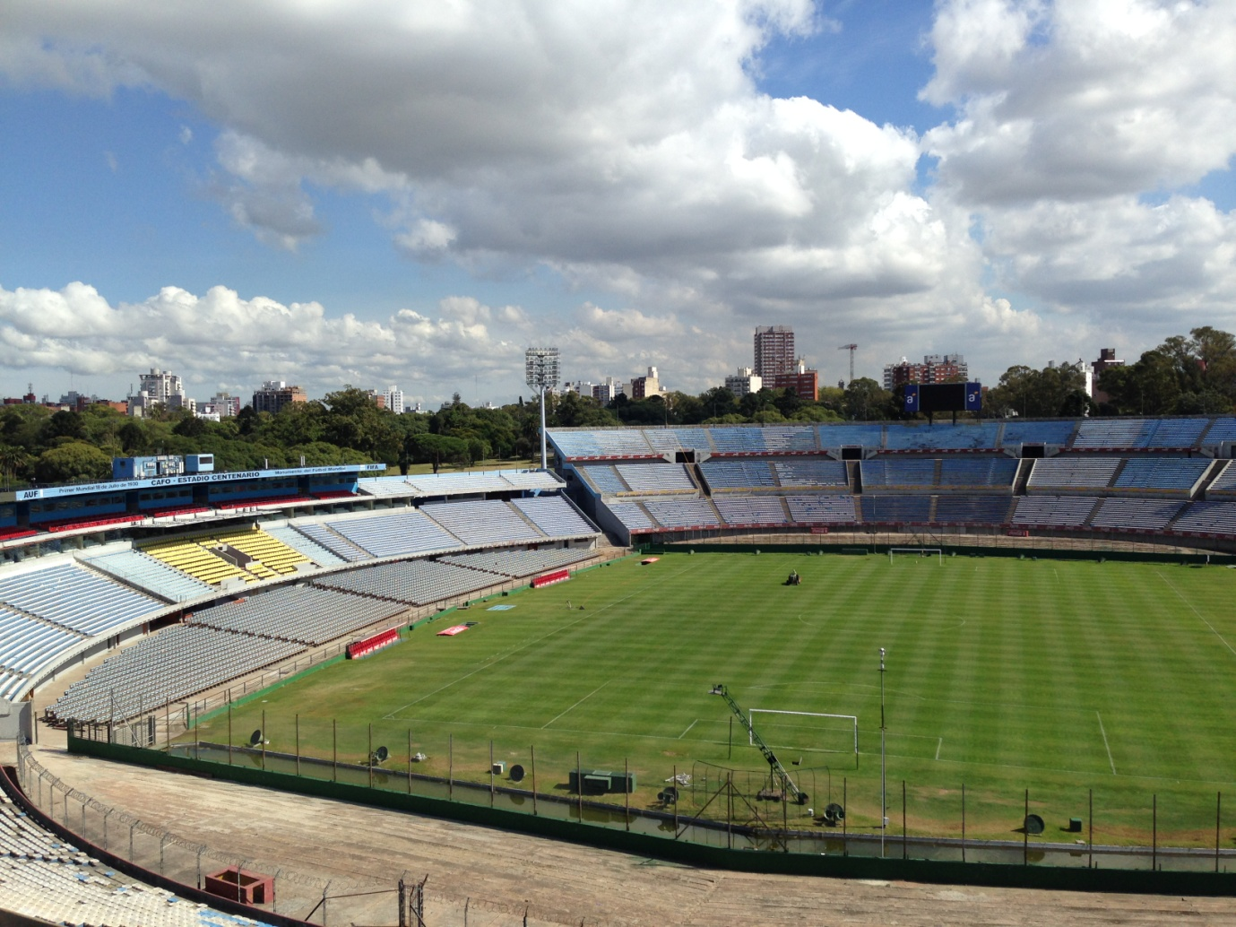
Translation of “Safety Management” – During 2015/16 the SGSA’s guidance document Safety Management was translated into Hindi and Chinese. Though not yet publicly available, these two further translations add to the editions available in Arabic, Latin American Spanish, Russian and Brazilian Portuguese, offering more safety practitioners around the world greater access to this key document.
Financial overview
The accounts have been prepared in accordance with the Accounts Direction given by the Secretary of State for Culture, Media and Sport under the Sports Grounds Safety Authority Act 2011. We continued to operate within a prudent financial framework. Net expenditure for the year amounted to £998,156 (£1,064,838 in 2014/15) against an expenditure limit set by DCMS of £1,062,000. The Statement of Financial Position at 31 March 2016 shows net assets of £351,688 (£347,844 in 2014/15). We generated £91,526 of income through activity relating to non-statutory functions. Full details of our expenditure, receipts, assets and liabilities are contained in the Accounts.
A new Management Agreement was finalised with DCMS in March 2016.
Sustainability issues

We are committed to improving our environmental performance. During the year waste paper, plastics, cardboard and other materials were recycled under the processes managed by the Department for Business, Innovation and Skills (BIS) at Fleetbank House. Individual environmental performance indicators for the SGSA are therefore not available. As the SGSA occupies less than 1,000m² and has less than 250 staff we fall within the exemption criteria of the Greening Government Commitment and are not required to produce a sustainability report.

KAREN EYRE-WHITE
Chief Executive
XX June 2016

Accountability Report

Corporate Governance Report

Director’s Report

The SGSA Board Members during 2015/16 were:

Alan Coppin Chairman
Brendon Batson OBE Appointment ended 7 January 2016
Joyce Cook OBE
Susan Johnson OBE
Philip Kolvin QC
Dr Pauleen Lane CBE
David Mackinnon
Peter Rowley
Ronald Wilkie LVO SBStJ MBA FBIFM Resigned 12 May 2015
Derek Wilson

At 31 March 2016 our executive staff were:

Karen Eyre-White Chief Executive and Accounting Officer
Caroline Hale Head of Media, Marketing and Communications
Guy Longhorn Finance and Office Manager
Nikki Rutherford Licensing, safety casework and information
Jason Clotworthy ICT Manager
Stephen Podd Deputy Finance and Office Manager and administrative support

At 31 March 2016 our Inspectors were:

Lou Elliston MA
Geoff Galilee CMIOSH
Martin Girvan BSc MILAM
John Perkins
Rick Riding MRICS MIFireE MBEng MBA
Keith Sears
Ken Scott FRICS
Ian Smith MRICS DMS MCIM
Sue Storey Dip.EP, MEPS
They were assisted by Mark Smith (Assistant Inspector) who also undertook some Inspector duties

Developments since 1 April 2016
In May 2015 we agreed to renew our partnership with the ECB to review and raise standards of safety and security at First Class County (FCC) cricket venues.
On 18 April Ken Scott was appointed as the SGSA’s first Chief Inspector.
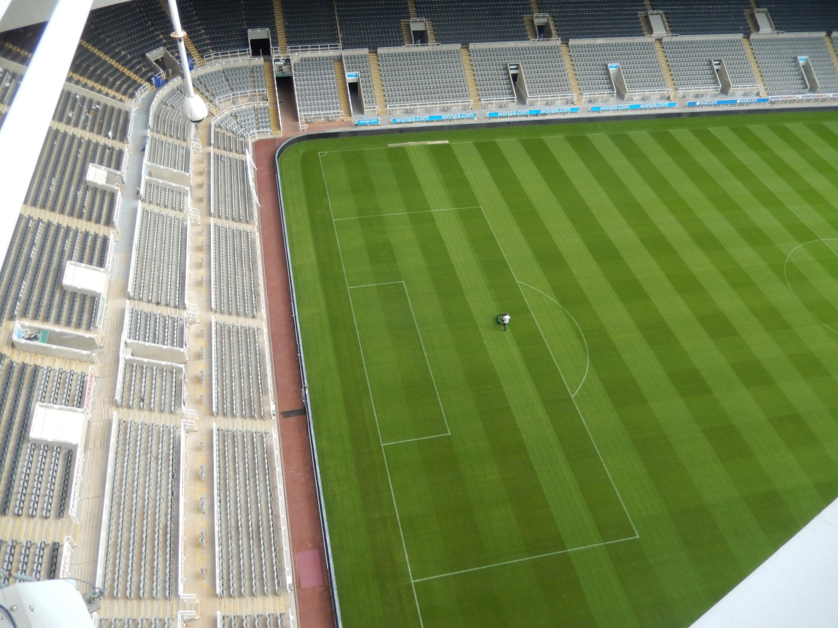
Prompt payment
We support the principles of the Prompt Payment Code. In every case during the past year we have paid in full within the previously-agreed period, subject only to satisfactory performance by the supplier and the timely presentation of an accurate invoice. The SGSA dealt with 100% of such invoices within 30 days (2014/15 100%).

Data loss disclosure
The Sports Grounds Safety Authority has suffered no protected personal data incident during 2015/16 or prior years and has not reported any such incident to the Information Commissioner’s Office.
Tax Assurance
The SGSA has no off payroll appointments.
Monitoring Spending on Consultancy and Temporary Staff
The SGSA has incurred no expenditure on consultancy services or temporary staff.

KAREN EYRE-WHITE
Chief Executive
XX June 2016
Statement of responsibilities
Statement of responsibilities of the Sports Grounds Safety Authority and its Chief Executive with respect to the accounts
Under section 22 of schedule 1 to the Sports Grounds Safety Authority Act 2011, the Secretary of State for Culture, Media and Sport, with the consent of HM Treasury has directed the Sports Grounds Safety Authority (SGSA) to prepare for each financial year a statement of accounts in the form and on the basis set out in the Accounts Direction.

The accounts are prepared on an accruals basis and must give a true and fair view of the state of affairs of the SGSA and of its income and expenditure, changes in taxpayers’ equity and cash flows for the financial year.

In preparing the accounts, the Accounting Officer is required to comply with the requirements of the Government Financial Reporting Manual and in particular to: observe the Accounts Direction issued by the Secretary of State for Culture, Media and Sport, including the relevant accounting and disclosure requirements, and apply suitable accounting policies on a consistent basis; make judgements and estimates on a reasonable basis; state whether applicable accounting standards as set out in the Government Financial Reporting Manual have been followed, and disclose and explain any material departures in the annual accounts; and prepare the annual accounts on a going concern basis.

The Accounting Officer of the Department for Culture, Media and Sport has designated the Chief Executive as Accounting Officer of the SGSA. The responsibilities of an Accounting Officer, including responsibility for the propriety and regularity of the public finances for which the Accounting Officer is answerable, for keeping proper records and for safeguarding SGSA assets, are set out in Managing Public Money published by HM Treasury.

There is no relevant audit information of which the entity’s auditors are unaware. I have taken all the steps to make myself aware of any relevant audit information and to establish that the entity’s auditors are aware of that information. The annual report and accounts as a whole is fair, balanced and understandable. I take personal responsibility for the annual report and accounts and the judgments required for determining that it is fair, balanced and understandable

KAREN EYRE-WHITE
Chief Executive
XX June 2016

Governance Statement

Compliance with the Corporate Governance Code

A review of compliance with the Government’s Corporate Governance Code of good practice 2011 (the Code) concluded that the Authority has complied with the areas applicable to the SGSA as a Non-Departmental Public Body (NDPB).

Governance Framework

The Accounting Officer of the SGSA and her predecessors were accountable to the Secretary of State for the Department for Culture, Media and Sport and the Permanent Secretary of DCMS, as its Accounting Officer, in their responsibility for maintaining sound systems of governance, risk management and internal control. These systems support the achievement of SGSA policies and strategic objectives, while safeguarding the public funds and assets for which they were personally responsible, in accordance with the responsibilities assigned to them in the Treasury guidance “Managing Public Money”. They were also responsible for using the public funds and assets assigned to the SGSA economically, efficiently and effectively.

The SGSA Board comprises the Chair and seven Members appointed by the Secretary of State for Culture, Media and Sport in accordance with the requirements of the Sports Grounds Safety Authority Act 2011. The Board receives key reports from management including the SGSA management accounts and updates from the Audit and Risk Committee on risk, IT security and the Annual Report and Accounts. The SGSA Board has a corporate responsibility for:
- ensuring that the SGSA complies with any statutory and administrative requirements for the use of public funds and does not exceed its statutory powers or delegated authority;

- ensuring that high standards of propriety and corporate governance are observed at all times;

- establishing the overall direction of the SGSA within the policy and resources framework agreed with the Secretary of State; and

- overseeing the delivery of planned results through the monitoring of performance against objectives.

The Board meets regularly, providing leadership and advice on strategic and operational issues and scrutiny and challenge to the Authority’s policies and performance. Specifically the Board has considered the Government Spending Review and new SGSA Strategy, the SGSA’s remit in relation to sports other than football and plans to re-write the Guide to Safety at Sports Grounds.
The Board is supported in fulfilling its responsibilities by the SGSA Audit and Risk Committee. The Committee has responsibility for issues of risk, control and governance, reviewing the comprehensiveness of assurances in meeting the Board’s and the Accounting Officer’s assurance needs and reviewing the reliability and integrity of these assurances. Both the Board and Audit and Risk Committee are serviced by the SGSA executive which provides the information to be considered. In its light touch review of the Effectiveness of the Audit and Risk Committee in 2014, the Committee confirmed it was satisfied with the quality of the data it received and the structure of meetings.

In 2015-16 the Board met on five occasions, the Audit and Risk Committee on three. Details of Board Member attendance are shown in the table below.

Board Member | Board meetings attended | Audit and Risk Committee meetings attended
Alan Coppin | 5 | 1 *
Brendon Batson | 4 | 2
Joyce Cook** | 1 | n/a
Susan Johnson** | 1 | n/a
Philip Kolvin** | 1 | n/a
Pauleen Lane | 5 | n/a
Peter Rowley | 4 | 3
David Mackinnon** | 1 | n/a
Ronnie Wilkie | 1 | 0
Derek Wilson | 4 | 2

* The Chair’s attendance at A&RC meetings is optional and not expected
**Appointed 8 February 2016

The background and registered interests of Board Members are published on our website. Further details about the Board and other corporate governance information are available in the “About Us” section of the website.

The Corporate Governance framework and processes are reviewed annually by our internal auditors, providing independent assurance that they are appropriate for the organisation. The reviews conducted in 2015/16 found the SGSA’s systems “provide significant assurance that there is a generally sound system of internal control, designed to meet the SGSA’s objectives, and that controls are generally being applied as intended.”

The Audit and Risk Committee

The Audit and Risk Committee operates in accordance with the principles and good practice described in the HM Treasury Audit Committee Handbook. In 2015-16 there were four members: Peter Rowley (the Chair), Brendon Batson, Ronnie Wilkie and Derek Wilson, all of whom were Members of the SGSA’s Board. Mr Wilkie stood down from the SGSA Board in May 2015 and his place on the Committee was taken by Mr Wilson. The Committee normally met three times. All meetings were attended by the Chief Executive and Finance Manager and two by representatives of the internal and external auditors. The Committee reports on its work to the full Board. In 2015-16 the Committee considered a range of issues including the SGSA Risk Register, business continuity, internal audit arrangements and the reviews provided by the internal auditors, as well as regular financial management issues and the Annual Report and Accounts. The Terms of Reference of the Audit and Risk Committee are available to the public on demand.

Following the appointment of new members of the Board to the Committee in February 2016, a review of the Committee's effectiveness will be undertaken before the end of the current financial year.

The Committee provides the Board with reports on governance, internal control and risk management issues. The Committee’s opinion for 2015/16 is as follows:

SGSA Audit and Risk Committee opinion to the Board 2015/16

Having taken account of:
- its work throughout the year;
- assurances received through the Committee’s discussions with the Chief Executive and SGSA staff on risk management;
- the formal opinions of the internal auditors (who identified no significant issues of internal control in 2015-16) on the effectiveness of the SGSA’s framework for corporate governance, business continuity and financial systems; and
- the formal opinion on the accounts and the management report of the external auditors following the audit of the accounts.

It is the opinion of the Audit and Risk Committee that the SGSA’s arrangements for its own corporate governance, internal control, risk management and financial systems are sound. The Committee is satisfied that the accounts can be relied upon, that the Accounting Officer is entitled to rely on the assurances she has received from the internal auditor and that the Board can approve the accounts for 2015-16.

In accordance with good practice, the executive inform the Audit and Risk Committee of changes to operating practices, particularly those connected to the recommendations of the Government’s Security Policy Framework. In 2015/16, there were no incidents or losses of data that required a report to the Information Commissioner’s Office.

The risk and control framework

As part of its oversight of spectator safety at football grounds that host designated matches, the SGSA is required to manage risks which may have an impact upon the public. In this context it ensures that local authorities issue, monitor, review and enforce safety certificates to a reasonable standard. Its Inspectors undertake visits to grounds both on match days and when they are empty to ensure that responsibility for spectator safety is taken seriously. They also consult with the relevant local authorities as part of their work. The majority of the risks faced by the SGSA are framed within this context. Among the specific risks considered by the Authority during the year were potential safety failures at sports grounds, the pressures resulting from reduced resources and the ability of the Authority to capitalise on the opportunities resulting from the its expanded role.

The SGSA's management of risk is embedded in policymaking, planning and delivery as follows:

- The risk management policy recognises that the SGSA works in a complex multi-stakeholder environment, whereby external events have an impact on our purpose and organisational objectives and create risks which we must manage to the best of our ability. Our role is as a regulator, advisor and facilitator on matters of spectator safety and as such many operational risks are not within our direct control;

- The risk register identifies the risks that might prevent us from achieving strategic priorities and/or the opportunities of which we might take advantage. Our objective must be to bring each risk down to a reasonably acceptable level at which it can be managed or controlled; and

- The SGSA does not hold any confidential personal information other than that relating to staff and applicants for employment. In 2015/16 the SGSA’s IT systems, data security and procedures were subject of a follow up review by the internal auditors. The Authority suffered no data losses during 2015/16.

Approach to risk management

As the Accounting Officer I oversee a review of risks on a regular basis. This examines both the risks to the SGSA from its policies and operations and those related to its constitution and internal management. The risk register sets out responsibility within the SGSA for the management of risk, assigning risk owners within the SGSA and identifying measures that have been taken and are yet to be taken to mitigate each one. The register is presented to the Audit and Risk Committee and Board for approval.

Review of effectiveness

As Accounting Officer, I also have responsibility for reviewing the effectiveness of the system of internal control. My review of the effectiveness of the system of internal control is informed by the work of the internal auditors and the SGSA’s executive managers who have responsibility for the development and maintenance of the internal control framework, and comments made by the external auditors in their management letters and other reports. I have been advised on the implications of the result of my review of the effectiveness of the system of internal control by the SGSA Board and the Audit and Risk Committee.
For the year 2015-16 the SGSA’s internal auditors carried out reviews of key financial controls, corporate governance, safety certification and a follow up of previous reviews. Overall they concluded that the SGSA’s system of internal control was sound, provided significant assurance, was designed to meet the SGSA’s objectives and that controls were generally being applied consistently.
During the year we have responded to thirteen requests under freedom of information, all of which were responded to within the prescribed time limits.
I have considered the evidence provided with regards to the production of the Annual Governance Statement. The conclusion of the review is that the overall governance and internal control structures have been appropriate for SGSA’s business and have worked satisfactorily throughout 2015-16.

Corporate Governance
The accounts have been prepared in the form directed by the Secretary of State for Culture, Media and Sport, with the approval of the Treasury, in accordance with paragraph 22 of Schedule 1 to the Sports Grounds Safety Authority Act 2011. The SGSA can supply a copy of the accounts direction on request. The accounts were approved by DCMS Ministers.
The Comptroller and Auditor General is the appointed auditor of the SGSA. The Annual Report and Accounts are laid before Parliament by the Secretary of State in accordance with paragraph 24(b) of Schedule 1 to the Sports Grounds Safety Authority Act 2011.

As Accounting Officer, as far as I am aware, there is no relevant audit information of which our auditors are unaware. I have taken all reasonable steps as Accounting Officer to make myself aware of any relevant audit information and to establish that our auditors are aware of that information.

No non audit work was undertaken by our auditors.

KAREN EYRE-WHITE
Chief Executive
XX June 2016
Remuneration and staff report
Statement of policy on the remuneration of senior members
For the purposes of the Remuneration and staff report, the senior managers of the Sports Grounds Safety Authority are the Chairman, Board Members and the Chief Executive. All the figures below have been audited by the National Audit Office.

Chairman
The Chairman’s salary of £18,130 (FTE £90,650, unchanged from 2014-15) for the year is based on a commitment of 1 day a week, any increases are informed by the recommendations of the Senior Salaries Review Body. During 2015-16 the Chairman attended all five Board meetings and one Audit and Risk Committee meetings and represented the SGSA at a number of other meetings and events.

The Chairman receives normal travel and subsistence expenses as required but does not receive any benefit in kind. The post does not carry any entitlement to pension.

Board Members
Board Members are appointed by the Secretary of State for terms of no more than 3 years, and, in line with the Commissioner for Public Appointments’ 2012 Code, no individual may serve in any one post for more than ten years. In 2015-16 Members were paid a daily fee of £265 for attending SGSA meetings (unchanged from 2014-15) and other events at which they represented the Authority. The fee is authorised by DCMS and any increases are informed by the recommendations of the Senior Salaries Review Body.

Board Members receive travel and subsistence payments where appropriate but do not receive any benefit in kind. In 2015-16 Board Members’ travel and subsistence totalled £6,499 (£4,146 in 2014-15). Board Members do not have any entitlement to a pension. The following sections have been subject to audit. Details of the daily fees paid to Board Members are as follows:

 | 2015-16 | 2014-15
Board Member | £ | £
Mr B Batson | 1,855 | 2,385
Ms J Cook | 265 | n/a
Mrs S Johnson | 530 | n/a
Mr P Kolvin | 530 | n/a
Dr P Lane | 2,120 | 1,987
Mr D Mackinnon | 265 | n/a
Mr P Rowley | 1,987 | 1,987
Mr R Wilkie | 265 | 1,590
Mr D Wilson | 1,590 | 3,445

Chief Executive
The former Chief Executive Ruth Shaw was a senior civil servant originally seconded to the SGSA from DCMS for three years from November 2010. In November 2013 this was extended to 30 April 2015. From that date SGSA Inspector Rick Riding undertook the Chief Executive role for an interim period until the appointment of the current Chief Executive, Karen Eyre-White, in June 2015. The Chief Executive receives a salary recommended by the Chair of the SGSA. Any pay award and bonus are based on agreed performance indicators. None of the former, interim or current Chief Executive received any benefit in kind.

The Chief Executive is eligible for a pension provided by the Principal Civil Service Pension Scheme. The scheme is an unfunded multi-employer benefit scheme. Employers’ contributions are assessed by the Scheme Actuary and are based on a percentage of pensionable pay, according to pay bands. Full details of the former, interim and present Chief Executives’ pay and pension costs are as follows:

 | Ruth Shaw  Chief Executive  Until 30 April 2015 |  | Rick Riding  Interim Chief Executive  From 1 May until 31 July 2015 |  | Karen Eyre-White  Chief Executive  From 29 June 2015
 | 2015-16 | 2014-15 | 2015-16 | 2014-15 | 2015-16 | 2014-15
Salary Details | £ (k) | £ (k) | £ (k) | £ (k) | £ (k) | £ (k)
Salary | 5-10 | 75-80 | 15-20 | n/a | 45-50 | n/a
Performance Bonus | 5-10* | 5-10** | n/a | n/a | n/a | n/a
Total Pay | 10-15 | 85-90 | 15-20 | n/a | 45-50 | n/a
Full year salary equivalent | 75-80 | 75-80 | 60-65 | n/a | 65-70 | n/a
Pension Details | £ (k) | £ (k) | £ (k) | £ (k) | £ (k) | £ (k)
Real increase in pension at 60 | 0-2.5 | 0-2.5 | 0-2.5 | n/a | 0-2.5 | n/a
Real increase in pension lump sum at 60 | 0-2.5 | 5.0-7.5 | 0-2.5 | n/a | 0-2.5 | n/a
Pension at 31 March 2016 | 15-20 | 15-20 | 30-35 | n/a | 5-10 | n/a
Lump sum at 31 March 2016 | 45-50 | 45-50 | n/a | n/a | n/a | n/a
Cash equivalent transfer value at 31 March 2015 | 191 | 156 | 408 | n/a | 64 | n/a
Cash equivalent transfer value at 31 March 2016 | 194 | 191 | 424 | n/a | 77 | n/a
Real increase in cash equivalent transfer value | 1 | 23 | 15 | n/a | 4 | n/a
Pension benefits accrued during the year | 0-5 | 45-50 | 20-25 | n/a | 20-25 | n/a
Total remuneration | 15-20 | 130-135 | 35-40 | n/a | 65-70 | n/a

*Bonus paid in 2015/16 based on 2014/15 performance.
**Bonus paid in 2014/15 based on 2013/14 performance.
Salary

Total pay includes salary, non-consolidated performance-related pay and payment for untaken annual leave. It does not include employer pension contributions and the cash equivalent transfer value of pensions. The SGSA did not offer any benefits in kind or pay any severance payments to senior managers in the year.

Cash Equivalent Transfer Values (CETV)
This is the actuarially assessed capitalised value of the pension scheme benefits accrued by a member at a particular point in time. The benefits valued are the member’s accrued benefits and any contingent spouse’s pension payable from the scheme. A CETV is a payment made by a pension scheme or arrangement to secure pension benefits in another pension scheme or arrangement when the member leaves a scheme and chooses to transfer the pension benefits they have accrued in their former scheme. The pension figures shown relate to the benefits that the individual has accrued as a consequence of their total service, not just their current appointment. CETVs are calculated in accordance with The Occupational Pension Schemes (Transfer Values) (Amendment) Regulations 2008 and do not take account of any actual or potential reduction to benefits resulting from Lifetime Allowance Tax which may be due when pension benefits are taken.
Real increase in CETV
This is the element of the increase in accrued pension funded by the Exchequer. It excludes increases due to inflation and contributions paid by the individual. It is worked out using common market valuation factors for the start and end of the period.
Staff

The SGSA Chief Executive and staff are covered under the provisions of the Principal Civil Service Pension Scheme and the Civil Servants and Others Pension Scheme, details of these schemes and how we treat pension liabilities is provided in Notes 1c and 2 of the Notes to the Accounts. Total permanent staff pay costs for 2015-16 were £753,436.

Under the Equality Act 2010 we are required to have due regard to the need to eliminate unlawful discrimination in our recruitment and employment policies and to provide equality of opportunity for all staff. The gender breakdown of SGSA staff at 31 March 2016 was as follows:

Gender Chief Executive Inspectors Other staff
Males 0 7 4
Females 1 2 2

The SGSA is committed to equality and valuing diversity within its workforce. Our goal is to ensure that these commitments, reinforced by our values, are embedded in our day-to-day working practices with all our customers, colleagues and partners. We will provide equality of opportunity and will not tolerate discrimination on grounds of gender, gender identity, marital status, sexual orientation, race, colour, nationality, religion, age, disability, HIV positivity, working pattern, caring responsibilities, trade union activity or political beliefs – or any other grounds.

Sickness data
The average number of day’s sickness for staff in the SGSA in the financial year was 2.2, compared with 3.5 in the previous year.
Highest paid – Median pay ratio

We are required to disclose the relationship between the remuneration of the highest-paid director in their organisation and the median remuneration of the organisation’s workforce.

During the period the full time equivalent banded remuneration of the highest-paid director in the SGSA in the financial year 2015-16 was £80-85k (£85-£90k in 2014-15). This was 1.8 times the median remuneration of the workforce which was £46.40k (1.9 times the median remuneration of £45.8k in 2014-15).

In 2015-16, no other SGSA employees received remuneration in excess of the highest-paid director (2014-15, also none). Remuneration in the organisation, not including the highest paid director, ranged from £20-25k to £45-50k (£20-25k to £50-55k in 2014-15). Total remuneration includes salary and non-consolidated performance related pay. It does not include employer pension contributions and the cash equivalent transfer value of pensions.

KAREN EYRE-WHITE
Chief Executive
XX June 2016

Parliamentary Accountability and Audit Report
THE CERTIFICATE AND REPORT OF THE COMPTROLLER AND AUDITOR GENERAL TO THE HOUSES OF PARLIAMENT
I certify that I have audited the financial statements of the Sports Grounds Safety Authority for the year ended 31 March 2016 under the Sports Grounds Safety Authority Act 2011. The financial statements comprise: the Statements of Comprehensive Net Expenditure, Financial Position, Cash Flows, Changes in Taxpayers’ Equity; and the related notes. These financial statements have been prepared under the accounting policies set out within them. I have also audited the information in the Remuneration Report that is described in that report as having been audited.

Respective responsibilities of the Sports Grounds Safety Authority, Accounting Officer and auditor

As explained more fully in the Statement of Responsibilities, the Sports Grounds Safety Authority and the Accounting Officer are responsible for the preparation of the financial statements and for being satisfied that they give a true and fair view. My responsibility is to audit, certify and report on the financial statements in accordance with the Sports Grounds Safety Authority Act 2011. I conducted my audit in accordance with International Standards on Auditing (UK and Ireland). Those standards require me and my staff to comply with the Auditing Practices Board’s Ethical Standards for Auditors.

Scope of the audit of the financial statements

An audit involves obtaining evidence about the amounts and disclosures in the financial statements sufficient to give reasonable assurance that the financial statements are free from material misstatement, whether caused by fraud or error. This includes an assessment of: whether the accounting policies are appropriate to the Sports Grounds Safety Authority’s circumstances and have been consistently applied and adequately disclosed; the reasonableness of significant accounting estimates made by the Sports Grounds Safety Authority; and the overall presentation of the financial statements. In addition I read all the financial and non-financial information in the Strategic Report and Director’s Report sections of the Annual Report to identify material inconsistencies with the audited financial statements and to identify any information that is apparently materially incorrect based on, or materially inconsistent with, the knowledge acquired by me in the course of performing the audit. If I become aware of any apparent material misstatements or inconsistencies I consider the implications for my certificate.

I am required to obtain evidence sufficient to give reasonable assurance that the expenditure and income recorded in the financial statements have been applied to the purposes intended by Parliament and the financial transactions recorded in the financial statements conform to the authorities which govern them.

Opinion on regularity

In my opinion, in all material respects the expenditure and income recorded in the financial statements have been applied to the purposes intended by Parliament and the financial transactions recorded in the financial statements conform to the authorities which govern them.

Opinion on financial statements

In my opinion:

- the financial statements give a true and fair view of the state of the Sports Grounds Safety Authority’s affairs as at 31 March 2016 and of the net expenditure for the year then ended; and

- the financial statements have been properly prepared in accordance with the Sports Grounds Safety Authority Act 2011 and Secretary of State directions issued thereunder.

Opinion on other matters

In my opinion:
- the part of the Remuneration Report to be audited has been properly prepared in accordance with Secretary of State directions made under the Sports Grounds Safety Authority Act 2011; and
- the information given in the Strategic Report and Director’s Report sections of the Annual Report for the financial year for which the financial statements are prepared is consistent with the financial statements.

Matters on which I report by exception

I have nothing to report in respect of the following matters which I report to you if, in my opinion:
- adequate accounting records have not been kept or returns adequate for my audit have not been received from branches not visited by my staff; or
- the financial statements and the part of the Remuneration Report to be audited are not in agreement with the accounting records and returns; or
- I have not received all of the information and explanations I require for my audit; or
- the Governance Statement does not reflect compliance with HM Treasury’s guidance.

Report

I have no observations to make on these financial statements.

Sir Amyas C E Morse
Comptroller and Auditor General

National Audit Office
157-197 Buckingham Palace Road
Victoria
London
SW1W 9SP

Financial Statements
Statement of Comprehensive Net Expenditure
For the year ended 31 March 2016
 | Note | 2015-16 | 2014-15
 |  | £ | £
Expenditure
Staff costs | 2 | 782,704 | 794,687
Depreciation and amortisation | 5&6 | 30,133 | 11,392
Other expenditures | 3 | 276,845 | 326,559
 |  | 1,089,682 | 1,132,638
Income
Income from activities | 4 | 76,249 | 60,454
Income from sale of publications | 4 | 15,277 | 7,346
 |  | 91,526 | 67,800
Net expenditure for the financial year |  | 998,156 | 1,064,838
All income and expenditure relates to continuing activities

The notes on pages XX to XX form part of these Accounts

Statement of Financial Position
As at 31 March 2016
 |  | 2015-16 | 2014-15
 | Note | £ | £
Non-current assets
Property, plant and equipment | 5 | 89,893 | 118,391
Intangible assets | 6 | 272 | 1,907
Total non-current assets |  | 90,165 | 120,298
Current assets
Trade and other receivables | 8 | 34,328 | 44,016
Cash and equivalents | 9 | 318,531 | 287,016
Total current assets |  | 352,859 | 331,032
Current liabilities
Trade and other payables | 10 | 91,336 | 103,486
Total current liabilities |  | 91,336 | 103,486
Assets less liabilities |  | 351,688 | 347,844
Taxpayers’ equity
General reserve |  | 351,688 | 347,844

The financial statements on pages XX and XX were approved by the Board on 14 June 2016 and were signed on its behalf by:

KAREN EYRE-WHITE
Chief Executive

XX June 2016

The notes on pages XX to XX form part of these Accounts

Statement of Cash Flows
For the year ended 31 March 2016
 |  | 2015-16 | 2014-15
 | Note | £ | £
Cash flows from operating activities
Net expenditure |  | (998,156) | (1,064,838)
Adjustments for non cash items | 3 | 30,133 | 11,392
(Increase)/Decrease in trade and other receivables | 8 | 9,688 | (29,968)
Increase/(Decrease) in trade payables | 10 | (12,150) | (17,820)
Net cash outflow from operating activities |  | (970,485) | (1,101,234)
Cash flows from investing activities
Purchase of property, plant and equipment | 5 | 0 | (90,780)
Intangible assets | 6 | 0 | 0
Net cash outflow from investing activities |  | 0 | (90,780)
Cash flows from financing activities
Grants from parent Department |  | 1,002,000 | 1,178,000
Net cash inflow from financing activities |  | 1,002,000 | 1,178,000
Net financing
Net increase/(decrease) in cash and cash equivalents in the period |  | 31,515 | (14,014)
Cash and cash equivalents at the beginning of the  Period |  | 287,016 | 301,030
Cash and cash equivalents at the end of the  Period | 9 | 318,531 | 287,016

The notes on pages XX to XX form part of these Accounts

Statement of Changes in Taxpayers’ Equity
For the year ended 31 March 2016
 |  | General
 |  | Reserve
 | Note | £
Balance at 1 April 2014 |  | 234,682
Net expenditure for 2014/15 |  | (1,064,838)
Grant in aid |  | 1,178,000
Balance at 31 March 2015 |  | 347,844
Net expenditure for 2015/16 |  | (998,156)
Grant in aid |  | 1,002,000
Balance at 31 March 2016 |  | 351,688

Notes to the Accounts
1. Statement of accounting policies

These financial statements have been prepared in accordance with the 2015-16 Government Financial Reporting Manual (FReM) issued by the Treasury. The accounting policies contained in the FReM apply International Financial Reporting Standards (IFRS) as adapted or interpreted for the public sector context. They are also prepared in accordance with the Sports Grounds Safety Authority Act 2011 and directions issued by the Secretary of State for Culture, Media and Sport. Where the FReM permits a choice of accounting policy, the accounting policy which is judged to be most appropriate to the particular circumstances of the SGSA for the purposes of giving a true and fair view has been selected. The particular policies adopted by the SGSA are described below. They have been applied consistently in dealing with items that are considered material to the accounts. No statement of other comprehensive expenditure has been prepared as all income and expenditure is reported in the statement of comprehensive net expenditure.

1.a Going concern

The annual accounts have been produced on a going concern basis. The SGSA received a funding settlement covering the financial years 2016-17 to 2019-20 and the Government has confirmed that the SGSA will be retained as a public body in its own right and not have its functions moved to another body. It is therefore appropriate to present the 2015-16 accounts on a going concern basis.
1.b Accounting convention

These accounts have been prepared under the historical cost convention modified to account for the revaluation of property, plant and equipment, intangible assets and inventories.

Government Grants
All income and expenditure is accounted for on an accruals basis, net of VAT. The Treasury has judged that grant in aid should be recognised as financing and therefore credited directly to reserves as opposed to income.

Revenue Recognition
Revenue represents the fair value of consideration received or receivable for services provided and goods sold. All revenue is recognised on an accruals basis.

Property, Plant and Equipment & Intangible assets
Property, plant, equipment and intangible assets above £500 are capitalised. Items of property, plant, equipment and intangible assets are initially recognised at cost. They are subsequently carried at fair value. The Members of the Audit and Risk Committee are of the opinion that the depreciated historical cost of property, plant and equipment provides a suitable proxy for fair value given their low value.

Depreciation
Depreciation is provided on all plant and equipment so as to write off the cost of each asset in equal instalments over its estimated useful life. Depreciation is applied to new assets pro rata in the year of purchase. The rates used were as follows:
Fixtures and fittings - 10%
Plant and machinery - 25%

Amortisation
Amortisation is provided on intangible assets so as to write off the cost of each asset in equal instalments over its estimated useful life. Amortisation is applied to new assets pro rata in the year of purchase. The rate used was:
Intangible assets - 25%

Operating Leases
Operating lease rentals are charged to the profit and loss account in the period to which they relate. There are no finance leases.

International Financial Reporting Standards issued but not yet effective
The IASB have issued certain standards and interpretations with an effective date after the date of these financial statements. The SGSA has not adopted these standards and interpretations early and their adoption is not expected to have a material impact on the SGSA's reported income or net assets in the period of adoption.

1.c Pensions

Past and present employees are covered by the provisions of the Principal Civil Service Pension Scheme and the Civil Servants and Others Pension Scheme. These are unfunded multi-employer defined benefit schemes. The SGSA’s share of net assets and liabilities cannot be separately identified. The SGSA accounts for the pension costs as a defined contribution scheme (see Note 2).

2. Staff numbers and related costs

Staff and Board costs comprise:

 |  | 2015-16
 | £ | £ | £
 | Permanently | Others
 | Employed | (Chair and
 | Staff | Board) | Total
Wages, salaries and fees | 574,126 | 27,537 | 601,663
Social security costs | 53,265 | 1,731 | 54,996
Other pension costs | 126,045 | 0 | 126,045
Total costs | 753,436 | 29,268 | 782,704

 |  | 2014-15
 | £ | £ | £
 | Permanently | Others
 | Employed | (Chair and
 | Staff | Board) | Total
Wages, salaries and fees | 592,986 | 29,525 | 622,511
Social security costs | 51,602 | 1,688 | 53,290
Other pension costs | 118,886 | 0 | 118,886
Total costs | 763,474 | 31,213 | 794,687

From 1 April 2015 a new pension scheme for civil servants was introduced – the Civil Servants and Others Pension Scheme or alpha, which provides benefits on a career average basis with a normal pension age equal to the member’s State Pension Age (or 65 if higher). From that date all newly appointed civil servants and the majority of those already in service joined alpha. Prior to that date, civil servants participated in the Principal Civil Service Pension Scheme (PCSPS). The PCSPS has four sections: three providing benefits on a final salary basis (classic, premium or classic plus) with a normal pension age of 60; and one providing benefits on a whole career basis (nuvos) with a normal pension age of 65.
These statutory arrangements are unfunded with the cost of benefits met by monies voted by Parliament each year. Pensions payable under classic, premium, classic plus, nuvos and alpha are increased annually in line with Pensions Increase legislation. Existing members of the PCSPS who were within 10 years of their normal pension age on 1 April 2012 remained in the PCSPS after 1 April 2015. Those who were between 10 years and 13 years and 5 months from their normal pension age on 1 April 2012 will switch into alpha sometime between 1 June 2015 and 1 February 2022. All members who switch to alpha have their PCSPS benefits ‘banked’, with those with earlier benefits in one of the final salary sections of the PCSPS having those benefits based on their final salary when they leave alpha. (The pension figures quoted for officials show pension earned in PCSPS or alpha – as appropriate. Where the official has benefits in both the PCSPS and alpha the figure quoted is the combined value of their benefits in the two schemes.) Members joining from October 2002 may opt for either the appropriate defined benefit arrangement or a ‘money purchase’ stakeholder pension with an employer contribution (partnership pension account).
Employee contributions are salary-related and range between 3% and 8.05% of pensionable earnings for members of classic (and members of alpha who were members of classic immediately before joining alpha) and between 4.6% and 8.05% for members of premium, classic plus, nuvos and all other members of alpha. Benefits in classic accrue at the rate of 1/80th of final pensionable earnings for each year of service. In addition, a lump sum equivalent to three years initial pension is payable on retirement. For premium, benefits accrue at the rate of 1/60th of final pensionable earnings for each year of service. Unlike classic, there is no automatic lump sum. classic plus is essentially a hybrid with benefits for service before 1 October 2002 calculated broadly as per classic and benefits for service from October 2002 worked out as in premium. In nuvos a member builds up a pension based on his pensionable earnings during their period of scheme membership. At the end of the scheme year (31 March) the member’s earned pension account is credited with 2.3% of their pensionable earnings in that scheme year and the accrued pension is uprated in line with Pensions Increase legislation. Benefits in alpha build up in a similar way to nuvos, except that the accrual rate is 2.32%. In all cases members may opt to give up (commute) pension for a lump sum up to the limits set by the Finance Act 2004.
The partnership pension account is a stakeholder pension arrangement. The employer makes a basic contribution of between 3% and 12.5% up to 30 September 2015 and 8% and 14.75% from 1 October 2015 (depending on the age of the member) into a stakeholder pension product chosen by the employee from a panel of providers. The employee does not have to contribute, but where they do make contributions, the employer will match these up to a limit of 3% of pensionable salary (in addition to the employer’s basic contribution). Employers also contribute a further 0.8% of pensionable salary up to 30 September 2015 and 0.5% of pensionable salary from 1 October 2015 to cover the cost of centrally-provided risk benefit cover (death in service and ill health retirement).
The accrued pension quoted is the pension the member is entitled to receive when they reach pension age, or immediately on ceasing to be an active member of the scheme if they are already at or over pension age. Pension age is 60 for members of classic, premium and classic plus, 65 for members of nuvos, and the higher of 65 or State Pension Age for members of alpha. (The pension figures quoted for officials show pension earned in PCSPS or alpha – as appropriate. Where the official has benefits in both the PCSPS and alpha the figure quoted is the combined value of their benefits in the two schemes, but note that part of that pension may be payable from different ages.)
Further details about the Civil Service pension arrangements can be found at the website www.civilservicepensionscheme.org.uk

Average number of persons employed

The average number of whole-time equivalent persons employed during the year was as follows.

2015-16 | Permanent Staff | Total
Directly employed | 12.2 | 12.2
Seconded | 0.8 | 0.8

2014-15 | Permanent Staff | Total
Directly employed | 12.2 | 12.2
Seconded | 1.0 | 1.0

3. Other Expenditure

 | 2015-16 | 2014-15
 | £ | £
Running costs
Travel and subsistence* | 90,254 | 105,521
Rent and rates | 64,809 | 63,723
Training and recruitment | 5,365 | 5,106
Accommodation, cleaning, heating and lighting | 17,274 | 16,682
External audit fees | 11,000 | 11,000
Internal audit fees | 11,630 | 10,146
Other professional fees | 19,199 | 31,141
Postage and telephone | 14,550 | 14,611
Office supplies, printing and stationery | 42,644 | 68,565
(Profit)/Loss on foreign exchange | 120 | 64
Total other operating payments | 276,845 | 326,559
*includes Board Member travel and subsistence of £6,499 (£4,146 in 2014-15).
Non-cash items
Depreciation and amortisation | 30,133 | 11,392
Total | 306,978 | 337,951

4. Income

 | 2015-16 | 2014-15
 | £ | £
Sale of publications | 15,277 | 7,346
International projects | 17,648 | 8,800
Other income | 58,601 | 51,654
Total | 91,526 | 67,800

2015-16 Income by geographical area

 | 2015-16 | 2014-15
Area | £ | £
UK | 70,385 | 59,000
Other countries | 21,141 | 8,800
Total | 91,526 | 67,800

Income from international projects derives from activities resulting from the expanded remit of the SGSA. This income and that for UK work is charged for on a cost recovery basis.

UK income includes £850 from the sale of redundant IT equipment to staff at fair value.

The SGSA charges for the issue of licences to admit spectators to watch designated football matches. In the year ended 31 March 2016 94 licences were issued to clubs/stadia for a fee of £100 each. In accordance with the SGSA’s Financial Memorandum, these fees have been paid into the Consolidated Fund via the Department for Culture, Media and Sport and are therefore not recognised as income in the SGSA’s accounts.

5. Plant and equipment

2015-16 | Plant and | Furniture and
 | Machinery | Fittings | Total
 | £ | £ | £
Cost or valuation
At 1 April 2015 | 130,076 | 44,321 | 174,397
Additions | 0 | 0 | 0
Disposals | (18,605) | (3,194) | (21,799)
At 31 March 2016 | 111,471 | 41,127 | 152,598
Depreciation
At 1 April 2015 | 37,521 | 16,461 | 53,982
Charged in year | 25,284 | 3,214 | 28,498
Disposals | (16,581) | (3,194) | (19,775)
At 31 March 2016 | 46,224 | 16,481 | 62,705
Net book value at 31 March 2015 | 92,555 | 27,860 | 120,415
Net book value at 31 March 2016 | 65,247 | 24,646 | 89,893
All assets are owned by the SGSA.

2014-15 | Plant and | Furniture and
Restated | Machinery | Fittings | Total
 | £ | £ | £
Cost or valuation
At 1 April 2014 | 62,269 | 41,154 | 103,423
Additions | 76,923 | 13,857 | 90,780
Disposals | (9,116) | (10,690) | (19,806)
At 31 March 2015 | 130,076 | 44,321 | 174,397
Depreciation
At 1 April 2014 | 40,751 | 25,304 | 66,055
Charged in year | 7,910 | 1,847 | 9,757
Disposals | (11,140) | (10,690) | (21,830)
At 31 March 2015 | 37,521 | 16,461 | 53,982
Net book value at 31 March 2014 | 21,518 | 15,850 | 37,368
Net book value at 31 March 2015 | 92,555 | 27,860 | 120,415

6. Intangible assets

2015-16 | Software licences | Total
 | £ | £
Cost or valuation
At 1 April 2015 | 6,540 | 6,540
Additions | 0 | 0
Disposals | 0 | 0
At 31 March 2016 | 6,540 | 6,540
Amortisation
At 1 April 2015 | 4,633 | 4,633
Charged in year | 1,635 | 1,635
Disposals | 0 | 0
At 31 March 2016 | 6,268 | 6,268
Net book value at 31 March 2015 | 1,907 | 1,907
Net book value at 31 March 2016 | 272 | 272

2014-15 | Software licences | Total
 | £ | £
Cost or valuation
At 1 April 2014 | 6,540 | 6,540
Additions | 0 | 0
Disposals | 0 | 0
At 31 March 2015 | 6,540 | 6,540
Amortisation
At 1 April 2014 | 2,998 | 2,998
Charged in year | 1,635 | 1,635
Disposals | 0 | 0
At 31 March 2015 | 4,633 | 4,633
Net book value at 31 March 2014 | 3,542 | 3,542
Net book value at 31 March 2015 | 1,907 | 1,907

7. Financial instruments

As the cash requirements of the SGSA are met through Grant in Aid received from the Department for Culture, Media and Sport, financial instruments play a more limited role in creating risk than would apply to a non-public sector body of a similar size. The majority of financial instruments relate to contracts to buy non-financial items in line with the SGSA’s expected purchase and usage requirements and the SGSA is therefore exposed to little credit, liquidity or market risk. As the SGSA is now able to undertake work for organisations outside of England and Wales there is a small exposure to risk of loss on foreign exchange transactions. In 2015-16 the SGSA suffered a loss on foreign exchange transactions or £120 (2014-15 £64).

8. Trade receivables and other current assets

 | 2015-16 | 2014-15
 | £ | £
Amounts falling due within one year:
Prepayments* | 17,914 | 22,100
Other receivables | 16,414 | 21,916
Total | 34,328 | 44,016
* All of which relates to goods and services.

9. Cash and cash equivalents

 | 2015-16 | 2014-15
 | £ | £
Balance at 1 April | 287,016 | 301,030
Net change in cash and cash equivalents | 31,515 | (14,014)
Balance at 31 March | 318,531 | 287,016
The following balances at 31 March were held at:
Commercial banks and cash in hand | 318,531 | 287,016
Balance at 31 March | 318,531 | 287,016

10. Trade payables and other current liabilities

 | 2015-16 | 2014-15
 | £ | £
Amounts falling due within one year:
Other taxation and social security* | 31,754 | 35,545
Trade payables | 15,313 | 24,672
Accruals | 28,815 | 27,423
Accrued annual leave | 15,454 | 15,846
Total | 91,336 | 103,486
*due to Central Government bodies

11. Commitments under leases

Total future minimum lease payments under operating leases are given in the table below for each of the following periods.

 | 2015-16 | 2014-15
 | £ | £
Obligations under operating leases comprise:
Not later than one year | 85,831 | 82,214
Later than one year and not later than five years | 3,622 | 0
Total | 89,453 | 82,214

12. Contingent liabilities
There were no contingent liabilities at 31 March 2016 (31 March 2015, £23,225 in relation to a dispute in relation to the level of occupancy costs for Fleetbank House).
13. Capital commitments

There were no capital commitments at 31 March 2016 (31 March 2015 none).

14. Related-party transactions

The SGSA is a Non Departmental Public Body of the Department for Culture, Media and Sport which is regarded as a related party with which the SGSA has had various material transactions during the year. In addition the SGSA had a small number of material transactions with HM Revenue and Customs, the Department for Business, Innovation and Skills and the Cabinet Office. These transactions were at arms length and in the normal course of business.

No Board Members, key manager or other related party has undertaken any material transactions with the SGSA during the year.

15. Events after the end of the reporting period
There were no events that had a material effect on the accounts after the end of the reporting period.
16. Preparation of accounts

The Accounting Officer authorised the accounts for issue on the date they were certified by the Comptroller and Auditor General.

