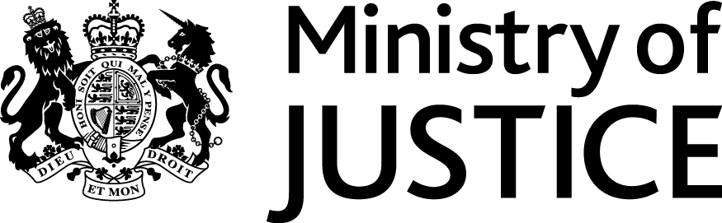
 | Our Reference: 573-16 FOI 108222 |  | November 2016

Freedom of Information Request

You asked for the following information from the Ministry of Justice:

Since 1997, what prosecutions have been brought for treason, with the available details of each prosecution. If there have been none since 1997, when was the last one and what details are held on that?

Your request is being handled under the Freedom of Information Act 2000 (FOIA). I can confirm that the department holds information that you have asked for.

The information you requested is exempt under section 21 of the FOIA because it is reasonably accessible to you.

The information can be found in the Hansard link below to Justice Questions on 9 September 2014, in which an exchange between Philip Hollobone MP and then Justice Minister Simon Hughes revealed the date of the most recent prosecution for treason. https://hansard.parliament.uk/commons/2014-09-09/debates/14090934000016/Treason

Section 21 of the FOIA exempts disclosure of information that is reasonably accessible by other means, and the terms of the exemption mean that we do not have to consider whether or not it would be in the public interest for you to have the information.

