Further education and skills inspection outcomes

This release contains:
- revised data for the most recent inspection outcomes completed as at 31 August 2014
- provisional data for the most recent inspection outcomes completed as at 28 February 2015
- inspections completed between 1 September 2014 and 28 February 2015, published by 31 March 2015

82% of further education and skills providers were judged good or outstanding at their most recent inspection | This is the highest proportion judged good or outstanding at their most recent inspection since August 2010, but represents only a modest increase from 31 August 2014.
Figure 1: Most recent overall effectiveness of further education and skills providers¹ ²

Position as at, (number of providers in brackets)

percentage

- Data as at 28 February 2015 are provisional.
- Excludes Higher Education Institutions and National Careers Service.
- Percentages are rounded and may not add to 100.
Only 42% of providers have been judged good or outstanding during this reporting year so far | During 2013/14, 66% of further education and skills providers were judged to be good or outstanding. This has fallen substantially to 42% for those providers inspected between September 2014 and February 2015.
Providers previously graded good or outstanding were more likely to decline this reporting year, based on inspection evidence so far | Between September 2014 and February 2015, 57% of providers previously judged as good or outstanding declined at their latest inspection, compared with 45% during 2013/14.

Key findings
At the end of February 2015, the percentage of further education and skills providers judged good or outstanding at their most recent inspection had increased by one percentage point, from 81% as at 31 August 2014 to 82%. This compares with a 10 percentage point increase between 31 August 2013 and 31 August 2014 (Figure 1 above).

In the period September 2014 to February 2015, there were 139 inspections of further education and skills providers in England that were published by the end of March 2015. This included 41 inspections of colleges, 59 inspections of independent learning providers and 34 inspections of community learning and skills providers. Ofsted also contributed to the inspections of 27 prison and young offender institutions where the reports were published between 1 September 2014 and 28 February 2015.

Figure 2 shows that the percentage of further education and skills providers judged good or outstanding between September 2014 and February 2015 has fallen substantially when compared with the previous reporting year (2013/14). The percentage of colleges which were judged good or outstanding for overall effectiveness has fallen from 66% to 37%, the percentage of Independent Learning Providers judged good or outstanding has fallen from 62% to 41% and the percentage of Community Learning and Skills providers judged good or outstanding has fallen from 73% to 56%.

Figure 2: Overall effectiveness of further education and skills providers inspected between 1 September 2014 and 28 February 2015 (provisional)
(number of providers in brackets)
percentage
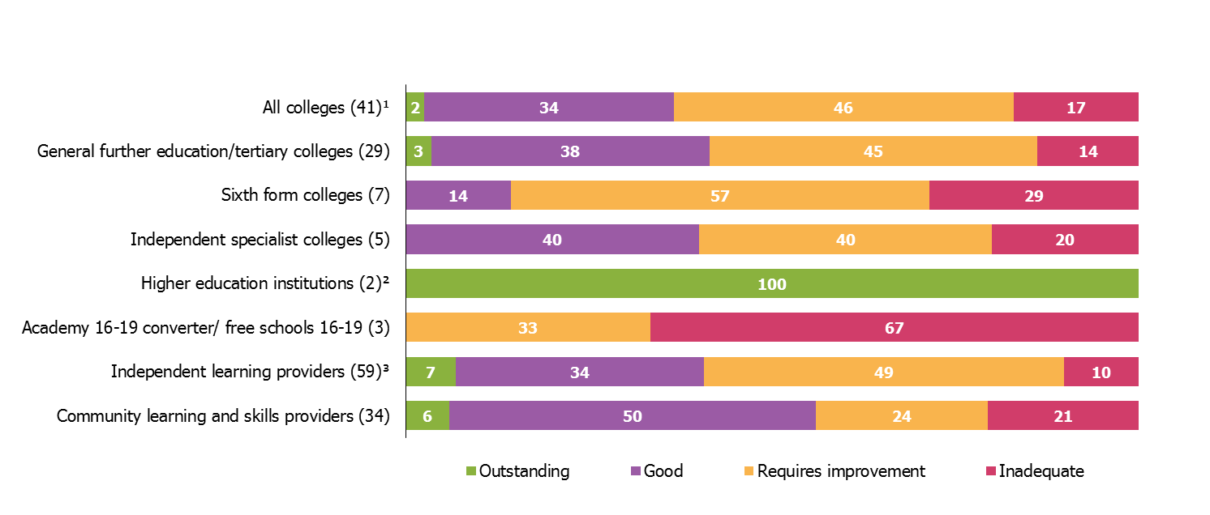
- Includes general further education/tertiary colleges, sixth form colleges, specialist further education colleges and independent specialist colleges.
- Overall effectiveness grades relate to further education provision only.
- Includes employer providers.
- Percentages are rounded and may not add to 100. Percentages should be viewed with caution where the number of providers is small.
The proportion of grade 3 further education and skills providers improving to good or outstanding has fallen in the first six months of this reporting year, with almost half of these providers remaining as ‘requires improvement’. Those providers that had previously been judged good were also more likely to decline during the 2014/15 reporting year, compared with those inspected during 2013/14 (see Figure 3 below). However, it is important to note that the figures for September 2014 to February 2015 represent only half of the 2014/15 reporting year and may change as more inspections are carried out throughout the year.

Figure 3: Proportion of previously good further education and skills providers¹ that improved, declined or stayed the same at their next inspection
(number of providers in brackets)
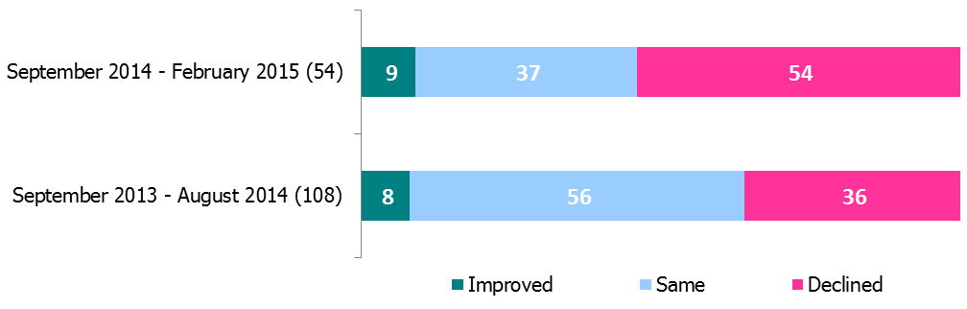
percentage

- Excludes Higher Education Institutions and National Careers Service.
- Percentages are rounded and may not add to 100. Percentages should be viewed with caution where the number of providers is small.

Revisions to previous release

The revised data for inspections as at 31 August 2014 incorporates:
- six providers which were not included in the provisional statistics; and
- the removal of ten providers, as they have now been identified as not receiving funding within 2013/14.

Notes

- The overall aim of inspection is to evaluate how efficiently and effectively the education and training provision meets learners’ needs. The inspection arrangements – together with other government initiatives – are intended to speed up improvement in the quality of the further education and skills sector. Data on inspection outcomes (as contained in this release) are used to assess the overall quality of the sector, and can be compared across different time periods.

- Data on inspection outcomes use a snapshot of data to identify providers wholly or partly funded by the Skills Funding Agency or the Education Funding Agency at that point in time.

- There are four main areas against which a provider is assessed:
  - Overall effectiveness
  - Outcomes for learners
  - The quality of teaching, learning and assessment
  - The effectiveness of leadership and management

- There are four judgements a provider can receive against these areas: outstanding, good, requires improvement or inadequate.

- Data for the reporting year 2013/14 are available here; https://www.gov.uk/government/statistics/further-education-and-skills-inspection-outcomes-september-2013-to-august-2014

Data and information prior to June 2014 can be found here: http://webarchive.nationalarchives.gov.uk/20141124154759/http://www.ofsted.gov.uk/resources/statistics
Additional tables providing more detailed breakdowns are available here:
https://www.gov.uk/government/collections/further-education-and-skills-inspection-outcomes

If you have any comments or feedback on this publication, please contact Sarah Pearce on 03000 130 632 or Sarah.Pearce@ofsted.gov.uk

Acknowledgements
Thanks to the following for their contribution to this statistical release: Grant Kelly and Zara Yates-Vanhorne.

© Crown copyright
You may re-use this information (not including logos) free of charge in any format or medium, under the terms of the Open Government Licence. To view this licence, visit http://www.nationalarchives.gov.uk/doc/open-government-licence/ or write to the Information Policy Team, The National Archives, Kew, London, TW9 4DU or e-mail: psi@nationalarchives.gsi.gov.uk

Excludes Higher Education Institutions and National Careers Services.

