Private fostering: better information, better understanding
Ofsted has conducted some further inspections of local authority private fostering arrangements. Analysis of these has identified several ways in which arrangements for collecting and managing information about private fostering could be improved so that, nationally, we would have a better understanding of this area. Current requirements for authorities to make an annual review of their arrangements could also, with some adjustments, be more effective in improving quality.

2 May 2014

An error was discovered in this report, which was originally published on 28 January 2014. It was taken down from the Ofsted website on 7 March 2014.

The original publication mis-reported data from the Department for Education in Figure 7 and paragraphs 9 and 10 about changes in the number of private fostering arrangements in several named local authorities between 2010 and 2012. Figure 7 has now been removed from the report and these paragraphs amended in line with the published data. Some other minor amendments have also been applied to ensure that the messages of the report are clear.

This correction does not affect the key findings or recommendations of the report.

Ofsted apologises for any inconvenience.

For further information please contact publishing@ofsted.gov.uk.

Age group: 0–18
Published: January 2014
Reference no: 130249

Contents
Introduction 4
Key findings 4
Recommendations 5
Part A: What do we know about private fostering? 7
National data 7
What do we know about the accuracy of the data ? 13
Who notifies or refers? 14
Who are the privately fostered? 16
What do we know about the ‘unknowns’ or unsafe placements? 22
Education guardianship companies 23
Part B: The work of local authorities 24
What do we know about private fostering in local authorities? 24
The quality of local analysis 26
What works in promoting awareness of private fostering? 28
Disqualification and prosecution 31
Difficulties of the work 31
Appendix: categories 33

Introduction
Ofsted conducted a further round of inspections of local authority (LA) private fostering arrangements in 2012–13. Twelve authorities were inspected.
A private fostering arrangement is one that is made privately (without the involvement of a local authority) for the care of a child under the age of 16 years (under 18, if disabled) by someone other than a parent or close relative, in their own home, with the intention that it should last for 28 days or more.
Current arrangements for the regulation of private fostering originate from concern following the death of Victoria Climbié in 2000. Victoria was privately fostered by her great aunt. Arrangements were codified in the Children Act 2004. Following this, the Children (Private Arrangement for Fostering) Regulations 2005 set out the duties of local authorities in their arrangements for private fostering, and national minimum standards for local authorities were published in 2005.
Given concerns about the level of ‘hidden’ private fostering, local authorities were asked to concentrate on ‘awareness-raising’ among professionals and the general public. From 2005 the Commission for Social Care Inspection was given the duty of inspecting LA arrangements with the intention of facilitating improvement. Following the amalgamation of inspectorates, in 2007–08 Ofsted inspected 82 LA arrangements.
Given the concern raised by these inspections, in 2009 Ofsted agreed with the then Secretary of State for Children, Schools and Families to conduct a further round of inspections under section 135 of the Education and Inspections Act 2006. By November 2011 we had carried out six inspections of local authority private fostering services. The Parliamentary Under-Secretary of State for Children and Families asked that we inspect a total of 12 such services by April 2013. The remaining six inspections were completed by March 2013.
Local authorities are required to complete an annual review of their private fostering arrangements and to submit this to the local safeguarding children board (LSCB). A small proportion of authorities also publish these reviews. Data on private fostering are gathered annually by each authority and published nationally by the Department for Education.

Key findings
- Of the 12 local authorities inspected in 2011–13, only one third were judged good.
- Huge variations in the proportionate changes in new notifications by region suggest that there must be extensive ‘unknown’ private fostering in many areas. There would appear to be very low reporting from the many language colleges in London compared with other areas; the lack of any overall increase in reporting for 2008–12 in London is a clear concern.
- Almost no progress has been made in increasing the number of notified private fostering arrangements when the much higher numbers from a small proportion of LAs are set aside. Although numbers for England have increased by 25% between 2009-10 and 2011-12, this is largely due to the South West and South East regions. The East has experienced a sharp fall.
- The annual DfE data collection misses opportunities to ask more sharply focused questions that would improve its value; it currently produces little useful information and does not help to manage risk. There is the chance to improve the process without adding to the workload.
- Large numbers of placements for language colleges and other educational purposes swamp the national figures for private fostering; the extent of privately arranged placements, including of the more vulnerable such as disabled young people, is difficult to identify given current methods of data collection.
- Performance measures for LAs over-emphasise timely completion of set tasks rather than focusing on trends in the overall impact of LA private fostering arrangements.
- There is little evidence that ‘awareness-raising’ campaigns have any impact on self-referrals by the public, although strategies can help to raise awareness among professionals, language colleges and other organisations; some authorities provided specific evidence that these types of campaign had no impact beyond that on their own staff.
- Local authorities are required to make annual reports on their private fostering arrangements; these are rarely of any significant value and do not address important strategic issues, such as how well they are doing compared with others, or form an effective means of self-evaluation.
- A better system of classifying types of private fostering arrangements is well within the capabilities of most LAs and some already practise this helpful extra analysis.
- Risk-assessment is hampered by the weakness of national data and the poor quality of local authority self-evaluation.

Recommendations
Local authorities, local safeguarding children boards (LSCBs) and the Department for Education (DfE) should work together to improve current processes so that there is a greater level of assurance and capacity for self-improvement, by:
- improving data collection and use through:
- the DfE refocusing its annual data returns on key areas that provide better information about the effectiveness of the private fostering arrangements
- the annual data collection including a question about how notifications/referrals were first made, and another categorising types of young person by reason for placement; this is essential to enable the separation of high- and low-risk groups
- data including how long individuals were living in their family placements before referral
- DfE and stakeholder groups working together to agree categories of placement
- neither DfE nor Ofsted using ‘statistical neighbour’ comparisons because normal comparisons are invalid for this work
- the proportion of self-referring cases (adults who are voluntarily contacting local authorities to say they are privately fostering) being seen as the key indicator of effectiveness, with allowances made for distortion by the language school market
- schools being required to clarify numbers of children not living with their parents as part of the admissions process and annual returns
- improving arrangements for the self-evaluation of private fostering services through:
- ‘re-branding’ LA annual reports on private fostering as self-evaluation and publishing them in full on the LA and LSCB websites
- better targeting of ‘raising awareness work’ by local authorities through:
- placing the emphasis on key contact points such as school enrolment and general practitioners, verifying that children are, in fact, living with their parents
- making regular contact with all language colleges in the authority area to check whether they have relevant young people on roll and where they are living
- local authorities proactively reviewing such arrangements at regular intervals, in partnership with the service provider, in order to evaluate the level of assurance.

Part A: What do we know about private fostering?

National data
- This is a longstanding challenge where there is great opportunity to achieve improvements even though it has defeated others:
‘In 1991 in the face of falling numbers and serious doubts about the reliability of the information, the Department of Health stopped collecting data on private fostering.’
- Although some national data are collected by the DfE, these data can be very misleading and their value is limited by a key weakness – they do not help us to identify the extent of ‘hidden’ private fostering.
- DfE national data for the number of new notifications each year indicate a rising trend (Figure 1).
Figure 1: Numbers of new private fostering notifications 2009–13
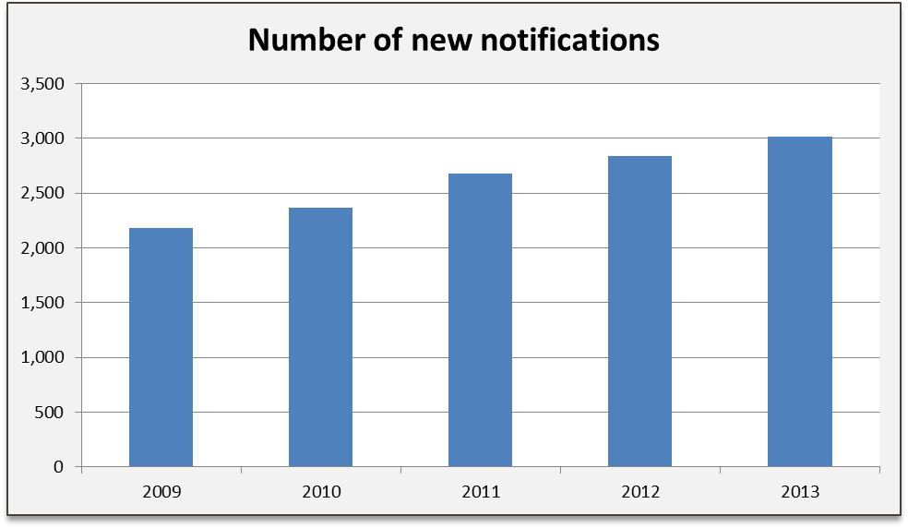
Source: Department for Education.

- However, at the same time: ‘Most regions saw a fall in the number of arrangements at 31 March 2012 compared with 31 March 2011, with only three regions seeing an increase.’ This is because increased registration of short-stay language college arrangements in the South West swamped the ‘new notification’ figures for the rest of the country; such arrangements tend to be seasonal in nature.
Figure 2: Number of children under private fostering arrangements at 31 March, 2008–13
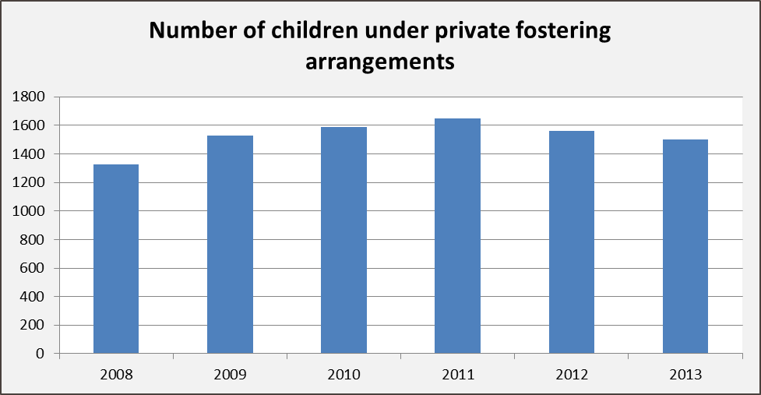
Source: Department for Education.

- This contrast can also be seen at regional level (Figure 3). The success of the South West in increasing its known arrangements and numbers of new notifications is in contrast to the trend in other regions over five years. In this period new notifications in the South West more than doubled, whereas in London and in the East Midlands they barely changed. This raises significant concerns about ‘hidden’ private fostering of all types in London; this is worthy of closer investigation.
Figure 3: Regional change in private fostering
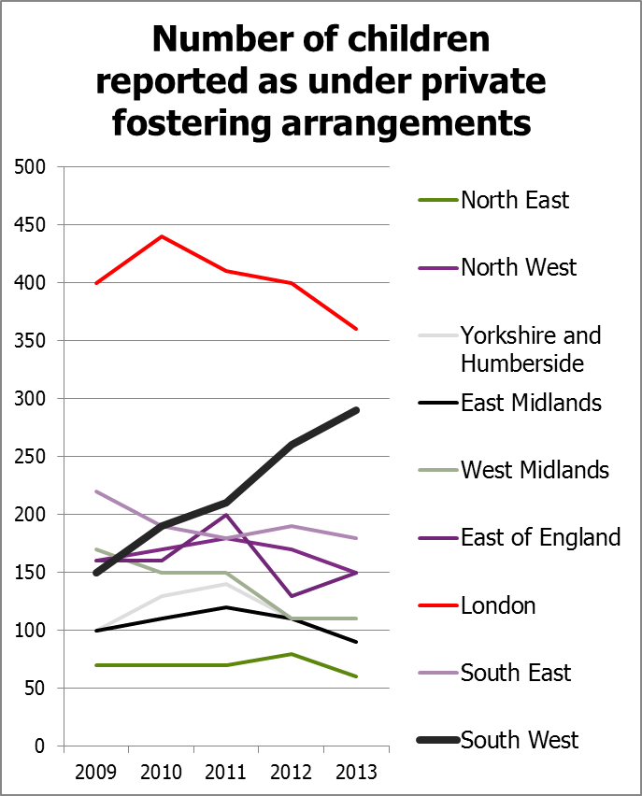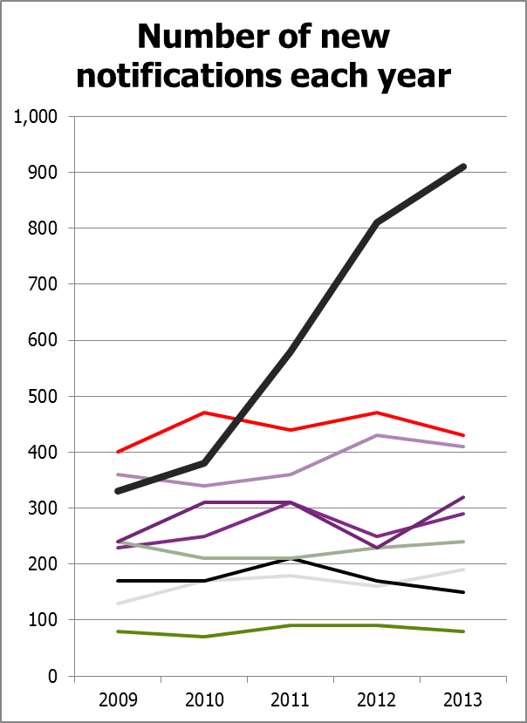
Source: Department for Education

- The most likely factor for variation in known placements is the language colleges market. The volume of the language college market is such that it distorts the figures. In 2011–12 there was a large increase in the proportion of privately fostered children aged 5 to 9, from 9% in 2011 to 19% in 2012. This change was ‘due to one LA who reported a large number of new arrangements, all of which were language students aged 5–9’.
- The language college effect has a major influence on where notifications are found nationally (Figure 4).
Figure 4: New notifications of private fostering arrangements 2011–12
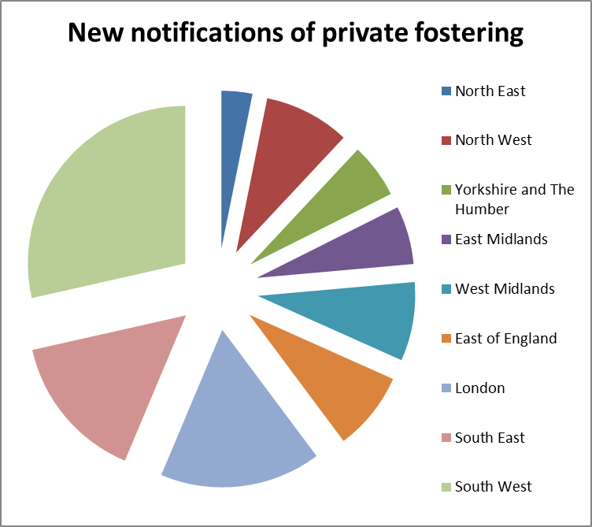
Source: Department for Education.

- The significant position of the South West, due largely to its language colleges, will be noted. Approximately one quarter of all new notifications were in this region. This seems disproportionate, as the South West has fewer British Council accredited language colleges than London or the South East, although it should be noted that language courses are also provided by some independent or maintained schools.
Figure 5: Location of British Council accredited language colleges
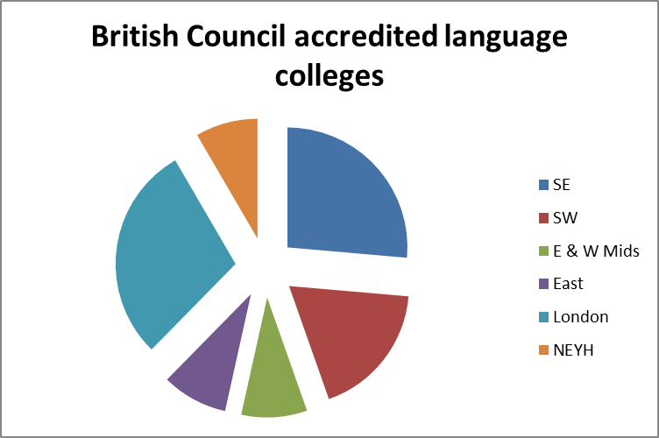
Source: British Council website, evidence sourced as at July 2013.
In fact, looking even closer, the substantial representation of the South West in these figures largely reflects the language college market in just two authorities (Figure 6).
Figure 6: New notifications 2011–12 in South West authorities
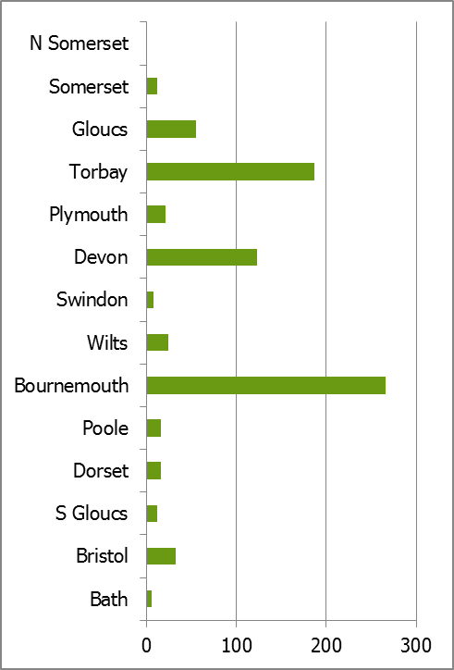
Source: Department for Education.

- A detailed comparison of the 2009-10 and 2011-12 new arrangements data from DfE shows remarkable inconsistency which continues to cast doubt upon the veracity of the figures. Within London the boroughs of Southwark, Croydon, Barking and several others reported sharp falls in their volumes, but Enfield saw large rises. Some local authorities reported figures which were too low to be listed.
- Some LAs reported huge increases in notifications between the 2009-10 and 2011-12 periods, with four recording increases well over 100%. Others reported sharp volume falls – eight fell by 50% or more. In just under half of the authorities a comparison was not possible since there was no published data for either one year or the other, or both.
- The rest of the data collected nationally is focused on issues such as age, the geographical origin of young people, and LA processes for handling cases within set timescales.
- There is no data collected that helps us understand the extent of ‘unknown’ private fostering arrangements being uncovered because these are not identified separately. As we shall see, if the emphasis is on ‘awareness-raising’ then the data could be improved if the following question was added:
‘What proportion of new cases arose through self-referral either by adult carers or a managing/placing organisation?’

- It would be possible to answer this through wider use of practices already being used by some authorities. This question would then reveal how effective the LA is being – because all others will have been discovered by other professionals, having not been notified properly. An opportunity is currently missed to insist on self-referral data indicating the type of referral, for example language college or family friend. However, as we shall see, there are doubts about whether ‘awareness-raising’ with the general public is the best way of approaching private fostering.
- Therefore we are still in the same position as described in the report No simple answers:
‘But we do not know how many children are privately fostered at any one time; nor how many children have had this experience in their childhoods. We do not even have a good basis from which to extrapolate numbers. We do not know how many may require support or safeguarding; nor do we know how the outcomes for different groups of ‘privately fostered’ children compare with those children living at home and those in public care.’

What do we know about the accuracy of the data ?
- There is wide acceptance that the national and local ‘volume’ figures are not the full picture. They merely represent the number of private fostering cases known to the local authority and may not even represent the full number of ‘known’ arrangements:
‘We suspect that we have just a handful of children to deal with and many others are known to health, education and childcare colleagues but not to ourselves.’
‘The number of private fostering cases in Trafford remains low but this is in line with the experience of other authorities. There is a belief nationally that there is widespread under-reporting of private fostering arrangements…’
‘Notifications of private fostering arrangements in Herefordshire remain low, with only three currently known about. It is thought that this number is not a true reflection and therefore work will be ongoing into 2012–13 to promote the need for practitioners and the public to notify children’s services…’
- Local authorities have noted that their efforts do not always yield results – as was recorded in one inspector’s notes:
‘For example, the LA has recognised that there has been a fall in the number of notifications and taken action to try and improve this by raising awareness among partner agencies as well as through induction training of the council’s own staff. Despite this, the number of notifications received has not increased, so further work is planned to try and understand the reason for this and to continue to raise awareness with faith and community groups.’
- Some authorities have noted that their figures fell during 2011–12 and 2012–13. This pattern of being surprised by a fall was not unusual and official figures show that broadly half of authorities experienced a net decline in new notifications during 2009–12. This has left some mystified:
‘There have been 24 notifications of new private fostering arrangements received in 2011–2012. This is half the number of notifications received in 2010–2011. At present it is not clear what the cause has been for this significant reduction in notifications.’
- One authority attributed this recent fall to its success in awareness-raising in previous years, which it thought ‘mopped up’ hidden cases so that there was a short-term ‘peak’.

Who notifies or refers?
- Research conducted on behalf of DfE and published in 2010 concluded that:
- practitioners report an increasing profile for private fostering since 2005
- the majority of notifications are made by professionals who notice that a child is not living with his or her parents
- parents and carers rarely notify local authorities as required by law; most notifications by parents, children or carers occur when problems emerge.
- Although the evidence from this latest review is far from comprehensive, it is clear that this pattern still exists. Typically, Suffolk reported that all of its 52 cases were notified by professionals; the inspector noted that ‘the number of late notifications indicates continued poor awareness of private fostering amongst the general public’ despite there being ‘a strong commitment to awareness-raising’ in the authority. In Havering, where there were eight new notifications, six were made by Havering staff and two by other LAs. Norfolk said that most notifications came from education guardianship agencies. However LA cross-boundary notifications do not always work, as one fosterer commented:
‘It took a long while for anyone to contact us. When we moved…… the social services said they would notify our new authority. When we heard nothing we rang…’
- One authority that had only two cases found:
‘There was one notification of an arrangement made by a carer, who was a professional working within the local authority. In the other arrangements the department became aware once the placement had been made and following a referral by the carer to a Locality Team requesting assistance when the arrangement was becoming difficult.’
- The best information on actual patterns comes when LAs themselves see the importance of knowing about the routes used. North Yorkshire gives details:
‘8 – parent/family/carer
2 – police
4 – school/colleges
3 – health professionals – CAMHS/hospital/CPN
2 – OLA social workers
2 – language school Scarborough
7 – education guardianship agency
1 – another language agency – staying for more than 28 days.’
- The interesting element here is that many of these are self-referrals – the ideal outcome – although it may be assumed that half are not and ‘came to light’ through other agencies.
- However, other areas, such as Bury, had not kept a record of referrals and could only comment, ‘The very few queries that we have come from schools.’ Trafford were able to say they had ‘two or three self-referrals’, but this amounted to all the cases they had, suggesting that other routes were not effective.
- The greatest concern comes when referrals are only made after some considerable time. In one case, a referral came from a mother who wanted their child back after three years, while in another case a boy who came to study for religious reasons was discovered due to a police matter. In Plymouth, ‘most referrals’ came from schools, education welfare officers and child protection nurses in hospitals. In Norfolk a referral arose from a school raising a child protection case. Such cases are indicative of ‘hidden’ private fostering, but the extent of this is impossible to quantify given the almost random nature of some discoveries and the lack of national data.
- There are also cases where private fostering came to light only when the UK Borders Agency or the Home Office raised an issue, although the child’s school had not.
- There were almost no cases of referrals by the general public.
- This all suggests that efforts to send out leaflets and target specific communities are largely wasted. Wolverhampton had just such a campaign after which it received three referrals – all from professionals. Surrey had one carer and one parental notification out of 24 received.

Who are the privately fostered?
- We can only answer this by saying ‘who are the notified privately fostered’, because some types are not statistically visible. Current arrangements do not require any categorisation even of the ‘known’ cases, so although we know that there were 266 new cases in Bournemouth last year, further research is necessary to identify what types these were. However, some authorities do classify their cases and this makes some assessment possible. Overall, it appears that there are four main categories:
- language college students, intending to return to their own countries
- other educational placements
- ‘sofa hoppers’ or those making alternative family arrangements
- children who have been sent to England to live and intend to stay, often with relatives and/or for religious reasons.
- The balance between categories varies between local authorities but local patterns can easily be swamped by language colleges and other educational placements. In Torbay, where there has been considerable success in registering language college cases, education is the dominant factor; but for a small authority a substantial number of alternative family arrangements are still being made:
- 17 local young people who, for a variety of reasons, were living apart from their parents
- 18 international students placed by White House Guardianships
- 53 international students studying for short periods (four to eight weeks) at local language schools – mainly during the summer months
- 22 international students studying long-term at one local language school
- three other international students studying at local state and independent schools, where arrangements have been made by other organisations.
- The language college trade is a clear driver of statistics and increasingly involves large businesses that arrange placements. Essex reported some pupils at the Anglo-European School and two language colleges, though the latter mainly came ‘just below’ the four-week limit. However it was not clear how many of the 31 placements were language-related. In Ealing, two out of 14 were language-college related., including a 15-year-old from China. This area of work causes problems for LAs as it is often seasonal; although Bournemouth had 266 new cases in the year, it only had 20 at the time of its inspection and the report indicated that agency staff had to be brought in during ‘peak’ periods to make the required visits. All 20 ‘live’ Bournemouth cases at the time of inspection were language school ones, while Devon also reported a large preponderance of these. A number of language students came for short periods and unless cases were pre-notified, the processes were not completed before they returned home. The current time period for notifications causes problems in some areas where pre-notification is not common.
- Of course most language students are over 16, but this can result in some lack of clarity about under-16s, as cases are not precisely classified:
‘During 2011, Gloucestershire County Council was notified of 63 referrals for privately fostered children. Of these, five were under 11 years of age and of the remainder 26 were from the UK, but 32 were from Asia and Europe, reflecting the high number of students from abroad studying in the UK and staying with host families, and children sent from overseas to stay with extended family members. Gloucestershire is host to a number of private schools and has always had higher numbers of foreign students than most neighbouring counties.’
- It might be assumed that language college placements are ‘low risk’; in general they appear to be, and risk will reduce as the practice becomes more professionalised and advance placements become common. However, things still go wrong, as inspectors noted:
‘[The LA] accepted that early notifications from the language schools would reduce the likelihood that children might be placed in unsafe households (five placements which ended due to safeguarding concerns were discussed).
In one, the private foster carer had a history of self-harm and mental ill health and there were also other concerns about the stepfather visiting the house. In the other, there were concerns about the behaviour of the son of the private foster carer. Neither of these assessments contained sufficient analytic depth regarding the safeguarding of children or the suitability of the placements.’
- It is clear that not all language colleges and their agencies are yet effective at pre-notification. Although Suffolk has several language-related placements, in 2012 it noted that pre-placement notifications had increased, late ones increased and all came from ‘professionals’. In Bournemouth most cases were still late referrals but there had been an increase in self-notification.
- Torbay provides an interesting insight into the fluid nature of this area:
‘One of the factors affecting the increased notifications from the language schools was one school realising that arrangements they made for ’27 nights’ constituted private fostering, when both the days of arrival and departure were taken into account. With regard to international students who come to the language schools in the summer months, many arrangements are frequently confirmed only a short time before the young people are due to arrive and the schools continue to hold little personal information about these children – typically name, age, country of origin and usually (but not always) date of birth. The language schools use overseas agents to make the bookings and any concerns about the young people are dealt with via the agents.’
- One London borough reported that it had noted it had a low number of language college referrals (only two) and was prioritising this area. As we have seen, the numbers in London are very low compared with Bournemouth and Torbay.
- However there may also be fewer notifications because organisers take action to avoid needing to notify:
‘Referrals from organisations arranging educational and cultural pupils have been made on a regular basis over the past three years. These referrals go directly to the Looked After Team as generally the organisers are able to provide three months’ notice of placement. However, this year no referrals were received so contact was made with that organisation and any others advertising placements in this area. This was undertaken in March 2010 and it was found that the majority of the organisations ensure children under 16 do not have placements that exceed 28 days or placements that will exceed 28 days prior to the child’s 16th birthday are not made.’
- There are also examples of children being sent to English state schools, including from European countries, to improve their English. Some pupils at boarding schools also remain in England during the holidays and therefore count as privately fostered.
- The term ‘sofa hoppers’ is commonly used and the extent of this varies, though it is the most common form of indigenous private fostering; we might term this ‘alternative accommodation arrangements’. Many of these are children estranged from their parents and who have often chosen to go and live somewhere else, but there are also children who for reasons such as their parents’ illness, death or work habits have been placed with another family – often related. One local authority gave an example of a girl whose mother had died, so she had gone to her mother’s friend. This authority lists ‘children whose parents have died’ as one of its categories, but also classifies ‘teenagers who have (temporarily) broken ties with their parents and are staying in the short term with friends and non-relatives’. Another authority had two cases – one a girl who lived with another family for two months while their mother was ill, and a second case where the parents had a history of alcohol abuse and the child went to live with a friend of her mother. Plymouth reported that almost three quarters of its cases were temporary accommodation arrangements.
- One urban authority listed 11 ongoing cases as at 31 March 2012. Of these, six were clearly alternative family arrangements including one where the mother had died; another where the mother had been ‘in rehab’; a third where the mother had been in prison; and a fourth listed as ‘left home to friends following alleged abuse’.
- In Plymouth these cases overlap with other children whose parents appear to be working abroad and are left at home, presumably for reasons of schooling. However, in Ealing none of the 14 cases were seen as ‘sofa hoppers’ although one was described as ‘a child who could no longer live with her parents’ who is now in the care of her stepmother’, suggesting that this is being under-reported. Although one official said that ‘99% of cases are young people moving themselves’, this was not fully supported by other data and gives a false impression of the young person having genuine choice in the matter. Many young people are more or less forced to seek new places but a few appear to make their own decisions with various degrees of freedom:
‘Young person went to live with next-door neighbour after father received a short prison sentence – adamant did not want to live with mum… Arrangement deemed as suitable by social worker although young person is sleeping on a sofa. However he is adamant he is not going to be moved. Mother in agreement with the arrangements…
‘This young person (R) has had a long history of involvement with Children’s Targeted Services dating back to January 1999 due to issues of parental alcohol misuse. R went to live with a friend’s family with mother’s agreement. The local authority continues to monitor and support the private fostering arrangement.’
- In another case, the mother of 18-month-old twins died and the father placed them in another family of his own choice; one of this family then gave cause for a child protection investigation. Wolverhampton gave examples of individuals:
- ‘mother in rehab’
- ‘mother in prison’
- ‘left home to go to friends due to alleged abuse’
- ‘mother released from prison’.
- In an example of exemplary practice, Torbay breaks all its cases down into the details:
‘Issues for the local young people were: teenagers being asked to leave the family home; parent being in prison, in hospital or homeless; child placed in private fostering arrangement to avoid becoming accommodated by the local authority; parent having left the area and young person wishing to remain to complete GCSEs; parents with alcohol-related problems; child placed with member of extended family; child running back to Torbay. Most of these arrangements were unplanned or were spontaneous responses to perceived problems within the family. Additionally, many of these arrangements were effectively made by the young people themselves, although the parents’ consent was always sought, albeit after the child had moved.’
- The final type is children being brought into the country to be placed with extended family or others, sometimes for religious or economic reasons. In Ealing these were the large majority of the 14, including individuals from Afghanistan, Sierra Leone and Ivory Coast. Several authorities accepted they were not ‘reaching’ all communities, with the Polish and Lithuanian communities mentioned, although no one seemed to be aware of whether there were cases within these groups. One local authority told inspectors that Eastern Europeans were an ‘untapped’ group. Some migration cases concern a child who has been sent to the UK to stay with friends or relatives to get a ‘better life’ or education:
‘We worked with this case for 13 months. J was living with her cousin while she attended school. J and her mother had visited Britain from Nigeria and while here J expressed a wish to stay here which was agreed by her mother. This was a case where it was hard to get definitive and clear information and there was a lot of liaison with the UK Border Agency, the mother in Nigeria and the cousin to try to get clarity.’
- Southwark reports a high level of cases:
‘The school admission process is the most likely area where private fostering arrangements are identified… High proportions of the known privately fostered children in Southwark have entered the UK from abroad and have no legal status.’
- There is some limited evidence that children are classified as privately fostered because adults have brought them into England from overseas with a view to adoption. This is one of the categories used by North Yorkshire. Local authorities are aware that children may not be brought into England for legitimate purposes:
‘There is possible connection between some private fostering arrangements and the trafficking of children. We continue to monitor closely the journey of privately fostered children as a way of tracking any links to trafficked children. We have so far identified one child who has been trafficked, but there is reason to believe that in the unidentified population there may well be trafficked arrangements.’
- Football clubs show generally good awareness – they are high profile ‘targets’ for local authority private fostering teams to contact, and usually have sound safeguarding arrangements. Clubs often have designated proactive safeguarding staff:
‘We have also had an approach via Safeguarding from Wolves Football club for advice about their plan to use families to care for children on their intensive training programmes.’
- Surrogacy is an entirely new area for private fostering. One case came to light in North Yorkshire:
‘Notification made by the matron, safeguarding/child protection at hospital in Manchester... Baby is in the care of people who are not related to and have no PR. Was a surrogacy arrangement.’

What do we know about the ‘unknowns’ or unsafe placements?
- Unknown placements only come to light when a problem is discovered, usually by a professional. Norfolk refers to one case of an illegal placement requiring emergency safeguarding. Suffolk reported one case uncovered by the Children in Need team (out of 52 new cases).
- Case studies provide helpful insight into how things really operate:
‘Young male Portugal – dad in prison – came to visit godmother in this country & stayed. Placement discovered because of involvement of team re HIV of godmother.’
‘Notified by MOTHER who wanted child back after 3 years – suggests publicity was not working – especially as child is dual heritage British/African and ethnicity of carers is white British; different surname. Notification came from mum who came in to the team to say that she wanted her son back. She had handed him over to her friend when he was two. He was now 5 and she wanted him returned. This was the first alert the service had to the situation – although child at school, they were not aware either of the situation.’
‘Came to UK in March 2007 from Russia, came to police attention in March 07 that came via police referral. At time he was only 12 years. Went to Jewish school – was in education studying to be a rabbi, staying with a friend of family.’
- In these examples, the arrangement only came to light because other services were involved for wholly unrelated reasons:
‘“A”, 9-year-old Nigerian boy privately fostered with his older stepsister (now at university) by birth father’s female cousin. Living in UK and at school for 3 years (PF arrangement not picked up by school but by Home Office).’
‘“F”, 4 years old white/Portuguese. Carer is a 31-year-old single male fosterer who presented to the police as homeless. He stated that he was the child’s godfather. He stated that he received a weekly telephone from the birth mother but didn’t have a contact number for her.’

Education guardianship companies
- Although education guardianship companies offer the chance to develop expertise in the sector, they vary in effectiveness and are unregulated. In North Yorkshire one had to be advised about private fostering rules by a teacher at a sixth form college. It appears to be a growing sector:
‘There continues to be a significant number of foreign students coming to stay with host families in the county in arrangements made by educational guardianship companies in the private sector. Two new companies began to operate in Suffolk this year including one who plans to bring between 10–15 new students into Suffolk in September 2013.’
- One authority had quite negative views, which inspectors recorded in their notes:
‘Concerns about education guardianship companies. There are real potential issues with education guardianship companies – lots are in it for money and don’t fulfil responsibilities.’
- However, others appear to be better prepared:
‘DJK AGED 15 PLACED WITH JS. DJK is Swiss-placed for 5 months & 6 days. He came to England to improve his English by attending High school – this was accomplished – maintained constant contact with mother, father & sister by phone & Facebook. Notification of prospective PFA completed 31/8/12 – notification made by guardianship company.’
- Many of these cases are ones that go just over the time limit, and often the children had returned home before anything else has been arranged.
- Guardianship companies are not registered with the state but AEGIS (the Association for the Education and Guardianship of International Students) acts as a membership body with regulations and inspection. Some of these organisations charge a fee to find a placement in an English state school for pupils from the European Union.

Part B: The work of local authorities

What do we know about private fostering in local authorities?
- On first sight, the grades for the services inspected are disappointing, as none were judged outstanding and two thirds were less than good (Figure 7).
Figure 7: Judgements on LA private fostering arrangements 2012–13
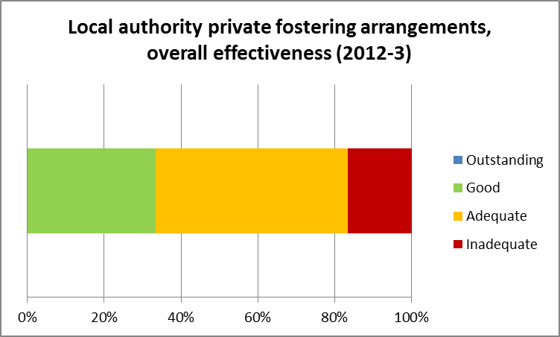

- However, the 2012–13 Ofsted inspections included five authorities that were targeted because they were previously inadequate, of which four had improved to adequate and one to good. Two previously adequate authorities declined to inadequate. Overall, the same number improved and declined so there is no clear evidence of change in the sector. The reports show that some local authorities lack:
- the correct types of information in order to evaluate their own effectiveness
- a clear commitment from leaders and managers, in some cases as a result of challenging decisions about how to target limited resources
- an appropriate level of experienced/knowledgeable staff to effectively support the arrangements, exacerbated by the seasonal nature of some of the work; for example, in one of the inadequate authorities the work is done by a part-time member of staff (without back-up) who is also deployed to other work
- effective management of monitoring and tracking systems
- clarity of sign-off procedures/processes (or procedures not consistently being followed)
- consistent and maintained engagement with all relevant partner agencies and groups to raise awareness
- certainty over which strategies are most effective
- appropriate systems for analysing and learning from the work being undertaken or the cases arising.
- There are examples to show that:
- engagement with faith and community groups is not well developed; a few authorities have demonstrated innovative good practice to increase awareness within these groups, but overall this is not the case and it has limited impact
- annual reports are not always being submitted to the LCSB in reasonable time (and in one example, at all), weakening the ability of the LSCB board members to take action in their individual agencies and of the board to challenge and support, leading to a lack of targeted action plans to improve the arrangements; when submitted, some reports are poor and lack effective analysis
- there are some delays within the statutory responsibilities: for responding to notifications; checks; visits; and decisions; in one of the inadequate authorities an unsuitable assessment model is being used, resulting in serious delays.
- in addition it is clear that some authorities are becoming disillusioned with the efficacy of recognised ‘awareness-raising’ methods; although impact on professionals can be good, there is little evidence that these approaches yield results with the general public in uncovering hidden private fostering cases.

The quality of local analysis
- Each local authority is required by national minimum standards to make some local analysis each year:
‘7.9 The local authority provides a written report each year, for consideration by the Director of Children’s Services, which includes an evaluation of the outcomes of its work in relation to privately fostered children within its area.
7.10 The local authority reports annually to the Chair of the Area Child Protection Committee (or its successor body, the Local Safeguarding Children Board) on how it satisfies itself that the welfare of privately fostered children in its area is satisfactorily safeguarded and promoted, including how it cooperates with other agencies in this connection.’
- Ofsted’s review of available resources in this area showed that:
- the quality of reviews available to us was highly varied and they lacked a consistent approach in analysing information; as a result, the process is unlikely to have sufficient impact on improvement
- there is too little transparency; in too many cases, neither the local authority nor the LSCB published the review of private fostering on its website.
- There are two obvious areas in which the better collection and recording of data would aid improved reporting and self-evaluation. These are:
- the classification of new cases by type
- the recording of the way in which each case is notified, with a clear indication of self-referral.
- In Plymouth the local authority provided the inspector with helpful information about the types of case:
‘In the year up to 31 March 2012, Plymouth City Council received 21 notifications of new private fostering arrangements, 72% of which involved adolescents temporarily estranged from their parents. In the same period, Plymouth City Council received nine notifications of the termination of a private fostering arrangement. At the time of the inspection, there were 12 children and young people placed in 11 private fostering arrangements. Four of these children had parents who were living overseas.’
- The annual reports of Torbay and North Yorkshire also showed more extensive analysis, seeking to explain in detail the nature of their referrals and in some places to comment on the learning from how referrals take place. However a number of other reports were markedly poor, merely repeating legal information pasted in from elsewhere and then doing little more than reporting data already available from the DfE survey return. The extent to which such reports can lead to improvement is questionable.
- Devon local authority also collects and reports data in a helpful way (Table 1 ), though it will be noted that the headings used vary between authorities:

Table 1: Private fostering arrangements Devon local authority
Private fostering arrangements starting 2012–13: reason for private fostering arrangement | Number of children | Percentage of total
Overseas child where parents not UK resident (e.g. Whitehouse Guardianship school study programme) | 113 | 61%
Overseas child attending language school | 49 | 26%
Child temporarily separated from parents | 22 | 12%
Child going to live with extended family/ friends | 2 | 1%
Total children starting a private fostering arrangement during 2012–13 | 186

- This type of analysis is very helpful and shows that LAs are capable of providing much better data nationally than they are being asked for. However the first category is broad and could include a wide variety of circumstances.
- Surrey’s was a more carefully produced report with charts showing the referral route for cases (Figure 8).
Figure 8: Source of new private fostering notifications, Surrey 2011–12
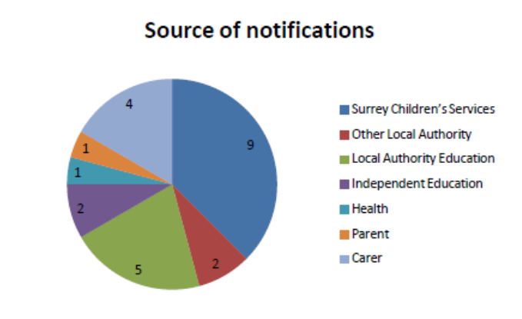
Source: Surrey County Council

- This is an interesting example, because it has identified a significant issue – referral routes – from which learning can be derived, and goes beyond DfE requirements for reporting data. North Yorkshire adopts a similar approach.
- Only a small number of local authorities and/or LSCBs publish the annual report on private fostering. Ofsted was sent reports by some other authorities as part of this research but others did not reply. There is no current requirement for these annual reports either to be sent to the DfE or published; this is to be regretted because it would involve little extra work and might help improve the quality of private fostering arrangements.
- It is clear that the annual reporting process represents a significant missed opportunity to improve private fostering work.

What works in promoting awareness of private fostering?
- There is very little evidence from authority annual reports or inspection that general campaigns of ‘awareness-raising’ have any impact outside of professional circles. Local authority staff have come to understand that ‘campaigns’ tend to yield greater results from professionals, but have been confused by competing directives:
‘Awareness-raising in 2011–2012 focused on both professionals and the voluntary sector, who may come in contact with children who are privately fostered. The Local Safeguarding Children’s Board requested that awareness-raising should also be targeted at parents, carers and members of the general public. The Minister for Children and Families, Tim Loughton, stated in a round table meeting with Local Authorities and BAAF in July 2012 that the focus of awareness-raising should be on professionals. The communication strategy reflects this for 2012–2013.’
- There are a number of examples where apparently well-resourced campaigns led to no referrals from the general public:
‘Planning for a publicity campaign this year began in October when we met with the Marketing department and shared ideas. There was some delay in their delivery of materials for publicity so that the publicity campaign did not begin until January to April 2012. This consisted of a video screen message in the city centre, a full-page Express and Star advert in January, a City People article in February and Wolf radio campaign and advice clinic every Friday in April. Three referrals have been received since the campaign began. As these came from other professionals it is unclear whether they were prompted by the publicity.’
‘The National Awareness Raising Campaign in February 2010 was widely used with a feature on the front page of the CYP website; information sent to all schools in the area for sharing with parents; information provided to staff via the CYP Staff Matters magazine and to all managers via the Departmental Managers’ Network. The outcome of the campaign was disappointing with no referrals arising during the period, although the emphasis was changed this year away from the possibility of legal action for failure to report, to raising the awareness of the support available to families.’
‘The outcome of the significant work undertaken has resulted in enquiries that are not private fostering arrangements.’
- As a result, the latter authority is shifting to a strategy based around key points of contact with professional services:
‘Looking to the future we recommend that efforts focus more on alerting other professionals than the general public. There is little to motivate carers to come to us and a campaign based around possible fines would be very negative.’
- Schools are vital. Another authority noted that ‘the very few queries that we have come from schools’. Wolverhampton decided to focus on two specific ‘gateways’:
- registration of children with GPs
- the school admissions process, especially for pupils joining mid-way through the year.
- Southwark has also noted the school admissions process as the ‘most likely’ route of identifying children from abroad. However, neither of these steps would guarantee disclosure of alternative family arrangements, although they increase the chance of identifying cases. Indeed, in one authority:
‘Action plans identify [awareness-raising] as a consistent priority and managers are very aware that there are still failures, even with social care professionals, to recognise private fostering arrangements and to notify them promptly...’
- In Bournemouth, inspectors noted that none of the four ‘mainstream’ cases had been identified by schools or health professionals.
- In Suffolk the inspector found that ‘some excellent work has been undertaken with the schools admissions service to get a question incorporated into the admissions form about whether the child is privately fostered.’ In addition: ‘Specific training has been provided to designated teachers, school nurses and health visitors, as part of their induction.’ This yielded results in Norfolk, where inspectors found that ‘renewed impetus is clearly having some impact since current private fostering cases have been referred by school staff, a Family For Action worker and a Child and Adolescent Mental Health Service (CAMHS) worker’.
- Good responses can be gained from targeting specific professional groups with awareness-raising, but these need to be supported with clear ‘gatekeeping’ procedures and private fostering social workers should quality assure these processes.

Disqualification and prosecution
- The offences in relation to failure to notify the local authority of a private fostering arrangement are set out in section 70(1) of the Children Act 1989. The offences are criminal in nature, with those who fail to notify the LA without reasonable excuse being liable to a fine upon conviction (of a maximum of £5,000). In practice, criminal convictions appear to be unusual as there is a fear that aggressive approaches may lead to greater secrecy among illegal carers.
- From available sources it would appear that actual action is very rare. Often, cases can be managed to a satisfactory alternative, as the Gloucestershire LSCB’s report for 2011–12 explained:
‘There have been no disqualifications or requirements imposed on any arrangements in the last year, although through a proactive assessment period, two unsuitable arrangements were encouraged and supported to find alternative solutions.’
- Of the authorities inspected, one reported that it had handled one disqualification prohibition in the previous year.

Difficulties of the work
- Local authorities find the work onerous and, given the small volumes involved, disproportionately consuming of their time:
‘Many of the children who have come to the notice of the team have come from overseas and it has not always been possible to contact parents.’
‘One carer described how contact with a child's mother in Africa had been sought by the PF service through International Social Services and she had been contacted. The PF service have given the mother in Africa a mobile phone to allow her contact with her son. Another privately fostered young person had been given a laptop by the PF service to allow them to have Skype contact with their brother in Canada.’
- The challenge of this proved too much for one inadequate authority:
‘In some cases the whereabouts of the parents of the children in private fostering arrangements are not known. There is no evidence that work has been undertaken to find them.’
- In one authority, the ending of the local youth service had removed one point of contact for referrals:
‘There is one part-time worker allocated to the private fostering task and there are no back-up arrangements in place to cover days the worker does not work or is taking annual or sick leave. The private fostering task has not been protected and the worker has been deployed in other roles.’
- Those authorities who experience influxes of language college students find it a challenge to manage the seasonal pattern of work. In Bournemouth, additional social workers need to be hired to cover this period and inspectors found that the quality of assessment work was too varied.

Appendix: categories
The 2010 report for DfE identified categories as follows:
- African and Caribbean children with parents and family abroad
- children attending language schools
- children sent to the UK for educational purposes – ‘better life’ children
- local children living apart from their families due to parental problems
- ‘sofa surfers’
- unaccompanied immigrant children
- black, white and minority ethnic children with parents working or studying in the UK
- children brought in from abroad with a view to adoption
- children from Chernobyl brought over by charities
- children ‘on the edge of care’
- adolescents and teenagers temporarily estranged from their parents
- children at independent boarding schools who do not return home for holidays and are placed with host families
- children subject to safeguarding who cannot return home
- children whose parents are serving in the armed forces
- other (not African or Caribbean) black and minority ethnic children
- trafficked children
- UK-born children involved in vocational activities
- UK-born children whose parents are working abroad
- UK-born children whose parents are working away in the UK.
Despite the availability of this list, no attempt appears to have been made to categorise in this way for official purposes. This list needs further refinement to effectively differentiate between groups and remove obvious overlaps, for example ‘sofa surfers’ and ‘temporarily estranged’.

No simple answers: report of the DCSF advisory group on private fostering 2008–1010 (DCSF-00198-2010), Department for Children, Schools and Families, March 2010, p 18; www.education.gov.uk/childrenandyoungpeople/safeguardingchildren/a0068804/private-fostering.
Notifications of private fostering arrangements in England: 31 March 2013, Department for Education, July 2013: https://www.gov.uk/government/publications/notifications-of-private-fostering-arrangements-in-england-31-march-2013
No simple answers, Department for Children, Schools and Families, 2010; www.education.gov.uk/childrenandyoungpeople/safeguardingchildren/a0068804/private-fostering.
Fostering service report, April 2011–March 2012, Wolverhampton City Council.
Safeguarding Children Board: private fostering annual report for Trafford SCB, Trafford 2012.
Herefordshire Safeguarding Children Board Annual Report 2011–12.
Ofsted inspection evidence, Leicester.
Private fostering annual report, 2011–12, Surrey County Council. .
Ofsted inspection evidence, Norfolk.
No simple answers, Department for Children, Schools and Families, 2010, p 20; www.education.gov.uk/childrenandyoungpeople/safeguardingchildren/a0068804/private-fostering.
Ofsted inspection evidence, Suffolk inspection.
Suffolk County Council Private Fostering Arrangements report, Ofsted, 2013.
London Borough of Havering LSCB Private Fostering Report, March 2012.
Ofsted inspection evidence, name of LA withheld.
Private fostering annual report 2009–10, South Gloucestershire Council.
Annual report on private fostering, North Yorkshire County Council, 2012.
Ofsted inspection evidence, Bury.
Ofsted inspection evidence, Trafford.
Ofsted inspection evidence, Plymouth.
Private fostering: annual report for year ending 31 March 2011, Torbay Children’s Services, 2011; www.torbay.gov.uk/index/yourservices/fis/supportandadvice/tscb-holding-2011/tscb/abouttscb/tscbannualreports.htm.
Ofsted inspection evidence, Essex.
Gloucestershire Safeguarding Children Board Annual Report 2011–12.
Ofsted inspection evidence, Bournemouth.
Ofsted inspection evidence, Bournemouth.
Private fostering: annual report for year ending 31 March 2011, Torbay Children’s Services, 2011; www.torbay.gov.uk/index/yourservices/fis/supportandadvice/tscb-holding-2011/tscb/abouttscb/tscbannualreports.htm.
Ofsted inspection evidence, London Borough of Ealing.
South Gloucestershire Council, Department for Children and Young People, Annual Report on Private Fostering, July 2009 – June 2010.
North Yorkshire County Council annual report on private fostering, 2012.
North Yorkshire County Council annual report on private fostering, 2012.
Private fostering annual report, Warrington Borough Council, 2011.
Ofsted inspection evidence, Plymouth.
Private fostering annual report, Wolverhampton Borough Council, 2011–12.
Ofsted inspection evidence, London Borough of Ealing.
Ofsted inspection evidence, Essex.
Ofsted inspection evidence, Wigan.
Private fostering: annual report for year ending 31 March 2011, Torbay Children’s Services, 2011; www.torbay.gov.uk/index/yourservices/fis/supportandadvice/tscb-holding-2011/tscb/abouttscb/tscbannualreports.htm.
Ofsted inspection evidence, Leicester.
Ofsted inspection evidence, Trafford.
Private fostering annual review, Southwark Borough Council, 2010–11.
Private fostering annual review, Southwark Borough Council, 2010–11.
Private fostering annual report, Wolverhampton Borough Council, 2011–12.
Annual report on private fostering, North Yorkshire County Council, 2012.
Ofsted inspection evidence; name of LA withheld.
Ofsted inspection evidence, northern local authority.
Ofsted inspection evidence, northern local authority
Ofsted inspection evidence, London borough inspection.
Ofsted inspection evidence, London borough inspection.
Ofsted inspection evidence, Suffolk.
Ofsted inspection evidence, shire authority.
Ofsted inspection evidence
The national minimum standards for private fostering, Department for Education and Skills, 2005, p 16; http://webarchive.nationalarchives.gov.uk/20130802165131/http:/www.education.gov.uk/childrenandyoungpeople/safeguardingchildren/a0068804/private-fostering.
Ofsted inspection report, Plymouth.
Private fostering annual report, 2011–12, Surrey Children’s Service.
Private fostering annual report, Wolverhampton City Council, 2011–12.
South Gloucestershire Council, Department for Children and Young People, Annual Report on Private Fostering, July 2009 – June 2010.
Ofsted report, Bury.
Ofsted report, Bury.
Ofsted inspection evidence, Bury.
London Borough of Southwark private fostering annual report.
Suffolk County Council Private Fostering Arrangements, Suffolk County Council, 2013.
Ofsted inspection evidence, Bournemouth.
Both quotations are from Ofsted inspection report, Suffolk.
Ofsted inspection report, Norfolk.
Gloucestershire Safeguarding Children Board Annual Report 2011–12.
Private fostering annual report, Suffolk County Council, 2012
London Borough of Southwark private fostering annual report, 2011
Ofsted inspection evidence, Plymouth.
Ofsted inspection report, London Borough of Havering.
Ofsted Inspection Report, London Borough of Havering.

