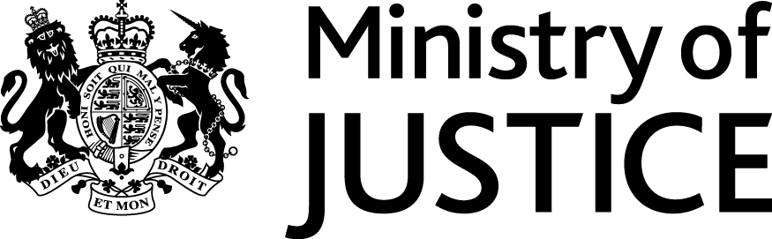
 | Our Reference: 449-16 FOI 106936 |  | January 2017

Freedom of Information Request

You asked for the following information from the Ministry of Justice (MoJ):

I’m happy for you to select offences you think most appropriate for consistency.
Could you let me know what categories they are and if I need to submit another FOI to cover this.

Which was a clarification of the below request:

Could you please tell me how many people were convicted of sex offences against children (under 18) in England and Wales in the years:
- 2011-12
- 2012-13
- 2013-14
- 2014-15
- 2015-16
Your request has been handled under the Freedom of Information Act 2000 (FOIA). Please accept my apologies for the delay in this response.

I can confirm that the department holds the information that you have asked for and
the attached table provides the number of offenders found guilty at all courts of sexual offences against children from 2011/12 to the period between April and December 2015.

With regard to the information you have requested for 2016, under section 44(1)(a) of the FOIA we are not obliged to provide information if there are prohibitions on disclosure ‘by or under any enactment’. In this case, the information you are seeking is prohibited by the Statistics and Registration Services (SRS) Act 2007 and the Pre-release Access to Official Statistics Order 2008.

The information you have requested is a subset of the Criminal Justice Statistics data held in its final form which we routinely publish. It is intended for publication in summer 2017. As such we are required to consider your request in a manner compliant with the Pre-release Access to Official Statistics Order 2008 further to sections 11 and 13 of the (SRS Act 2007.

The MoJ is obliged under section 13 of the SRS Act to continue to comply with the Code of Practice for Official Statistics (the Code) for statistics designated as National Statistics. Section 11(3) of the SRS Act regards the Pre-Release Access to Official Statistics Order as being included in the Code. Protocol 2 of the Code reflects the requirements of the Pre-Release Access to Statistics Order. Specifically, it requires producers of official statistics to ensure that no indication of the substance of a statistical report is made public, or given to the media or any other party not recorded as eligible for access prior to publication. I can confirm that the MoJ does publish information on findings of guilt for sexual offences against children for 2016, as part of National Statistics. Therefore, to now disclose as part of your FOI request, will violate the provisions of section 13 of the SRS Act and the Pre-Release Access Order to Official Statistics 2008 and as such engages the exemption under section 44(1)(a) of the FOIA.

Additionally, we are not obliged to provide information that is intended for future publication under the terms of section 22 of the FOIA. Data for 2016 is due to be published on the MoJ website in summer 2017.

Please note that whilst quarterly court proceedings and convictions headline data are published on the MoJ website and are currently available up to end March 2016, these data are subject to revision as later quarters are published, and are finalised only when the annual publication is made publicly available. To ensure consistency of data released to users, further breakdowns (in this case by specific offences under certain legislation) of 2016 Quarter 1 (January to March) data are not available until the annual criminal statistics publication is published.

