Further education and skills inspections and outcomes

This release contains:
- final data for the most recent inspection outcomes as at 31 August 2016
- final data for inspections conducted between 1 September 2015 and 31 August 2016

There has been a 51% increase in the number of further education and skills inspections conducted this year. | The introduction of short inspections has enabled Ofsted to inspect 410 further education and skills providers between 1 September 2015 and 31 August 2016; a 51% increase compared with 2014/15.
The proportion of general further education colleges judged good or outstanding has declined by 6 percentage points. | The most recent inspection outcomes for general further education colleges have declined from 77% judged good or outstanding as at 31 August 2015, to 71% as at 31 August 2016.
Figure 1: Proportion of providers judged good or outstanding for overall effectiveness at their most recent inspection, by provider type
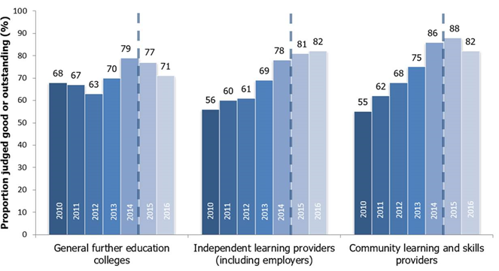

1. Figures for 2015 onwards are not comparable to previous years. A different methodology has been used to calculate the percentage of providers judged good or outstanding, with providers that ceased to be funded or closed during the year no longer included.
The proportion of community learning and skills providers judged good or outstanding has declined for the first time since 2010. | The most recent inspection outcomes for community learning and skills providers have declined from 88% judged good or outstanding as at 31 August 2015, to 82% as at 31 August 2016.
Contents
Acknowledgements 2
Key findings 3
In-year inspection outcomes 3
Most recent inspection outcomes 4
General further education colleges 5
Independent learning providers (including employer providers) 6
Community learning and skills providers 6
Revisions 7
Notes 7

Acknowledgements

Thanks to the following for their contribution to this statistical release: Marc McGreavy and Francesca Thompson.

Key findings

In-year inspection outcomes

Between 1 September 2015 and 31 August 2016, 410 further education and skills providers were inspected. This was a 51% increase compared with the number of inspections conducted in 2014/15. This year’s inspections included 108 colleges, 161 independent learning providers (including employer providers) and 93 community learning and skills providers. Ofsted also contributed to the inspections of 42 prisons and young offender institutions, where the reports were published between 1 September 2015 and 31 August 2016.

Ofsted’s inspectors were able to visit more providers this year through the introduction of short inspections for previously good providers, under the new Common Inspection Framework. During 2015/16, 286 providers were risk assessed to receive a full inspection and 124 providers received a short inspection. The short inspections resulted in 113 providers remaining good, with 11 short inspections converting to a full inspection. From these converted inspections one provider improved to outstanding, four remained good and six declined to requires improvement.

Figure 2: The number of short inspections and their outcomes

The outcomes from full and short inspections conducted between 1 September 2015 and 31 August 2016, found 6% of further education and skills providers to be judged outstanding, 62% good, 24% requiring improvement and 8% inadequate. The proportion judged good or outstanding was 19 percentage points higher than the previous year. More previously good providers were inspected this year and more remained good at inspection (see Figure 3).

Figure 3: Proportion of previously good further education and skills providers that improved, stayed the same or declined at their next inspection

Number of providers in brackets

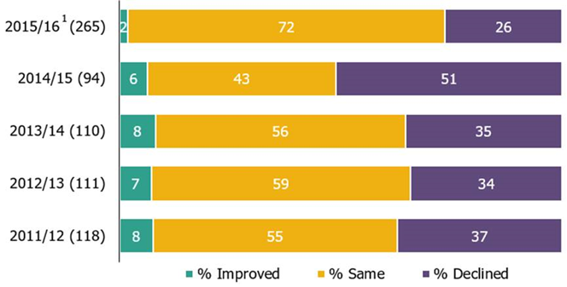

- 2015/16 includes both full and short inspections.
- Percentages are rounded and may not add to 100.

Most recent inspection outcomes

Despite the higher in-year outcomes, there has still been a decline in the proportion judged good or outstanding for some parts of the sector, particularly for general further education (FE) colleges and community learning and skills providers. This happens when more providers decline to requires improvement or inadequate, than improve to good or outstanding. Previously good providers that remain good have a positive impact on the in-year profile of inspection judgements, but they do not change the profile of the most recent inspection outcomes.

As at 31 August 2016, the percentage of further education and skills providers judged good or outstanding at their most recent inspection was 81%.

Figure 4: Most recent overall effectiveness of further education and skills providers, as at 31 August 2016

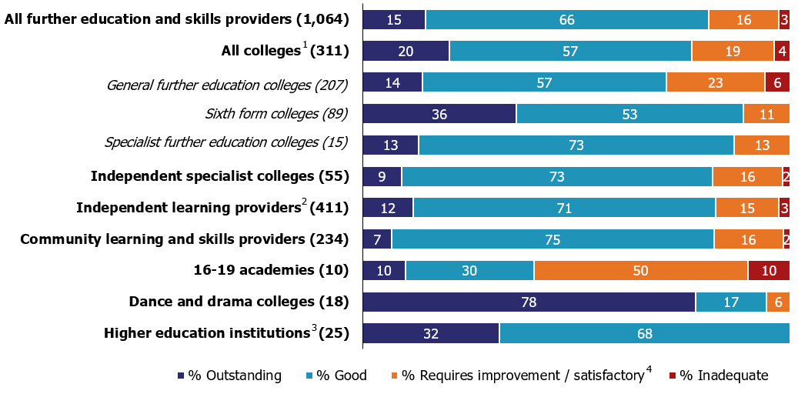

- Includes general further education colleges, sixth form colleges and specialist further education colleges.
- Includes employer providers.
- Inspection of further education provision only, not provider as a whole.
- Prior to 1 September 2012, providers with an inspection outcome of grade 3 were judged as satisfactory.
- Percentages are rounded and may not add to 100. Where the number of providers is small, percentages should be treated with caution.

General further education colleges

The proportion of general FE colleges judged good or outstanding at their most recent inspection has declined by six percentage points, from 77% as at 31 August 2015 to 71% as at 31 August 2016.

Over the same period, the number of open and funded general FE colleges has decreased from 215 to 208. This decrease of seven was caused by the addition of two new providers and the loss of nine providers that merged, eight of which were previously judged good. This reduces the total number of colleges reported on and the number of colleges judged to be good or outstanding.

Although the mergers have had an effect on the proportion of good or outstanding colleges declining (of around two percentage points), the bulk of the decline has been caused by the number of previously good or outstanding colleges declining to requires improvement or inadequate. During 2015/16, 21 colleges that were previously good or outstanding declined to requires improvement or inadequate, with just nine colleges improving to good. The greater number of colleges declining, rather than improving, caused the proportion judged good or outstanding to drop by around four percentage points.

Independent learning providers (including employer providers)

The proportion of independent learning providers (including employer providers) judged good or outstanding increased by two percentage points, from 81% as at 31 August 2015 to 82% as at 31 August 2016.

When excluding employer providers, there were 403 independent learning providers open and funded as at 31 August 2016. The proportion judged good or outstanding increased from 80% as at 31 August 2015 to 83% as at 31 August 2016. This improvement predominantly came from more providers improving to good or outstanding than declining.

However, for the smaller group of employer providers, the proportion judged good or outstanding declined by five percentage points over this same period, from 84% to 80%. As employer providers are smaller in number, 75 as at 31 August 2016, their decline had a smaller impact on the proportion judged good or outstanding for the overall group. Part of this decline was caused by all three new employer providers being judged to require improvement at their first inspection.

Community learning and skills providers

The proportion of community learning and skills providers judged good or outstanding at their most recent inspection has declined by six percentage points, from 88% as at 31 August 2015 to 82% as at 31 August 2016.

This decline has been almost entirely caused by previously good local authorities and not for profit organisations declining to requires improvement or inadequate when inspected this year.

Revisions

The June 2016 statistics reported on inspections carried out between 1 September 2015 and 29 February 2016. There were six inspections that took place during this period that were not published at the time of reporting. These inspections have now been published and are included in the underlying data published alongside this report.

Of those six inspections there were: three general FE college inspections, with one judged to be outstanding, one good and one requiring improvement; one community learning and skills provider inspection, judged to be good; a short inspection of an independent learning provider that remained good; and a short inspection of a sixth form college that remained good.

These revisions would have had the following impact to the in-year statistics:
- The proportion of good or outstanding sixth form colleges increased by two percentage points, to 71%.
- Both the general FE colleges and the overall ‘colleges’ proportion judged outstanding increased from 0% to 2%.

Notes

- As at 31 August 2015 and 31 August 2016, the most recent inspection outcomes included providers wholly or partly funded by the Skills Funding Agency or the Education Funding Agency at that point in time. For 31 August 2014 and before, the most recent inspection outcomes included: 1) providers wholly or partly funded by the Skills Funding Agency or the Education Funding Agency at that point in time, and 2) providers who had lost funding or closed during the corresponding reporting year.

- Short inspections of previously good providers can either confirm that the provider is still good overall, or the lead inspector can choose to convert the inspection to a full inspection where: there is insufficient evidence to confirm that the provider remains good; there are concerns that there is evidence that the provider may no longer be good (which may include concerns about safeguarding); or if there is sufficient evidence of improved performance to suggest that the provider may be judged outstanding. As a result of the converted inspection the provider could improve, decline or remain the same.

- The quality report for these official statistics contains an explanation of the methodology used and the relevant inspection frameworks, along with other useful information, such as where to find previously published further education and skills Official Statistics. It is available from:

https://www.gov.uk/government/statistics/further-education-and-skills-inspection-outcomes-as-at-31-august-2016

  - In 2016, the National Statistician published new guidance covering management information and official statistics. This guidance can be accessed here: https://gss.civilservice.gov.uk/blog/2016/06/management-information-guidance/

If you have any comments or feedback on this publication, please contact Sarah Pearce on 03000 130 632 or Sarah.Pearce@ofsted.gov.uk

© Crown copyright

You may re-use this information (not including logos) free of charge in any format or medium, under the terms of the Open Government Licence. To view this licence, visit http://www.nationalarchives.gov.uk/doc/open-government-licence/ or write to the Information Policy Team, The National Archives, Kew, London, TW9 4DU or e-mail: psi@nationalarchives.gsi.gov.uk

^{&2} Calculations have been made using unrounded numbers; the figures quoted are correct.

