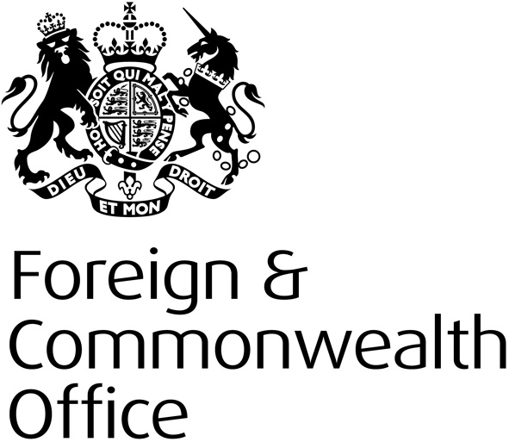

FCO
INTERNATIONAL LEADERS PROGRAMME
STRATEGY

FY 2016/17

Protocol Directorate

Programme Name | International Leaders Programme
SRO | Julian Evans
Programme Manager | Sheila O’Connor/David Naylor

Programme Overview
What is the Programme seeking to achieve?
To connect and engage with up and coming leaders from the Emerging Powers, selected partners (G7, EU and Australia) and ODA eligible countries, through an inward visits programme (four visits in 2016/17) and subsequent engagement, including a regional overseas event, as part of an alumni that offers an on-going opportunity for participants and an easily accessible ‘Soft Power’ tool for the UK.

To create a dynamic network of talented, influential people, working across key areas (Government, media, academia, business etc) providing mutual benefit to participants, their countries, and the UK. A long-term investment in the UK’s relationships with individuals, who have an understanding of the UK, that will positively impact on HMG objectives.

Four Year Goals
These are the longer term outcomes you are expecting to deliver
How will you know when these have been achieved – what is your “measure of success”
Participants are rising to positions of major influence within their countries / fields (i.e. how successful is the programme in identifying / supporting future leaders. Measured through career trajectory + surveys / alumni follow up).

UK is more prominently positioned in leaders’ engagement plans and decision making than before participation (feedback from surveys; through FCO posts, press articles).

We attract consistently high quality / high potential candidates onto the programme, from a diverse range of backgrounds and countries (quality measure based on feedback from a range of senior stakeholders; statistics kept on participants, countries, professions)

We create a sustainable and mutually beneficial network of influencers - building lasting relationships between group and between alumni and the UK (measured by % of alumni regularly / engaging with the group, UK posts/other contacts. Feedback from posts, alumni. Measured annually)

Group visits and personalised visit programmes generate specific outcomes in support of UK / posts’ and participants’ objectives (measured on a case by case basis, through posts / alumni).

Foreign Policy Priorities
Which FPP will you help deliver and how
Please note any Priority Outcomes that your Programme will help deliver
The International Leaders Programme supports a range of FCO objectives – in particular

- To use our global diplomatic network to protect and promote UK interests worldwide. To retain and build up the UK’s international influence in specific areas in order to shape a distinctive British foreign policy geared to the national interest.

- Use soft power as a tool of UK foreign policy. Promoting British values and human rights and contributing to the welfare of developing countries and their citizens.

- Strengthen the UK’s governmental ties with countries across the world to support UK prosperity and security.

Outcomes will be in the form of medium to longer term benefits for UK’s Security and Prosperity priorities, delivered through a closer relationship, with better knowledge and understanding, between the UK and partner countries.

There are also potential shorter-term outcomes to be gained from individual visits. E.g. posts will identify specific objectives per participant (e.g. whether in promoting trade or investment, or increasing understanding of / shifting perceptions on issues of major importance to the UK).

Thematic and/or Geographic Priorities and Objectives
Please provide detailed, focussed information to ensure well targeted project proposals
Theme/Geographic Area | Objective | Focus Issues and Indicators of Success
Soft Power  Emerging Powers (each visit includes approx 15 participants, from different countries)  Traditional Allies’ (G7, EU + Australia)  ODA recipient countries | What objectives will you seek to achieve during the FY?  Progress towards four year objectives (see above)  Participants are rising to positions of influence.  Grow alumni network so they remain actively engaged with the programme / UK / posts and each other.  Depending on the visitor - specific post objectives, including greater engagement.  We attract a consistently high quality and diversity of visitors  To generate Soft Power for UK & shape opinions of the UK | Which issues will you focus on for delivery through projects? How will you know when these have been achieved – what are your “indicators” or “measures of success” for each target area.  A range of indicators, from surveys of participants to wider public opinion – demonstrating a shift in perceptions of the UK and issues of importance to the UK.  Posts’ feedback showing participants are in positions of greater influence.  Measurement of numbers, quality, diversity  Reporting from posts on specific achievements / objectives. Twice yearly updates on engagement with participants  Overseas alumni event focussed on specific issues to further bonds made in London and expand network to wider groups.

