6th Floor
157 – 197 Buckingham Palace Road
London

SW1W 9SP
The Rt Hon Jeremy Hunt MP
Secretary of State for Health
Richmond House
79 Whitehall
London SW1A 2NS
6 February 2015

Dear Secretary of State

REFERRAL TO SECRETARY OF STATE FOR HEALTH
Proposed closure of Jarrow Walk-in Centre
South Tyneside Council

Thank you for forwarding copies of the referral letter and supporting documentation from Cllr Rob Dix, Chair, South Tyneside Council Overview and Scrutiny Coordinating and Call-in Committee (OSC) on behalf of South Tyneside Council. NHS England (North) provided initial assessment information. A list of all the documents received is at Appendix One.

The IRP has undertaken an initial assessment, in accordance with our agreed protocol for handling contested proposals for the reconfiguration of NHS services. In considering any proposal for a substantial development or variation to health services, the Local Authority (Public Health and Wellbeing Boards and Health Scrutiny) Regulations 2013 require NHS bodies and local authorities to fulfil certain requirements before a report to the Secretary of State for Health may be made. The IRP provides the advice below on the basis that the Department of Health is satisfied the referral meets the requirements of the regulations.

The Panel considers each referral on its merits and concludes that this referral is not suitable for full review because further local action by the NHS with the Council can address the issues raised.

Background
The Jarrow walk-in Centre (WIC), based at Palmer Community Hospital in Jarrow, opened in April 2010 as part of the Equitable Access to Primary Care programme. The service operates seven days a week from 08.00 – 20.00. Attendances at the WIC have consistently exceeded plans with more than 27,000 attendees in 2013/14, some 9,000 more than planned. The contract for providing care from the WIC with Northern Doctors Urgent Care was due to expire in May 2015 but has been extended, currently until October 2015.

In response to growing pressure on both the WIC and the Accident & Emergency (A&E) Department at South Tyneside General Hospital, South Tyneside Clinical Commissioning Group (CCG) has been working with health and social care stakeholders to develop an improved urgent and emergency care service for the people of South Tyneside. This includes the development of a single point of access for all unplanned care needs to ensure that the patient is seen by “the right professional at the right time”.

The intention to develop a “streamlined urgent care service with a single point of access” was first proposed in 2011 during the development of South Tyneside CCG’s five year commissioning plan for 2012-17. The proposal was included in subsequent rounds of commissioning planning with stakeholder involvement and engagement taking place throughout, including meetings with key partners during 2013 and 2014.

A formal public consultation on the proposal ran from 28 May 2014 to 31 August 2014 having been extended beyond 22 August 2014 following discussions with the OSC. The consultation involved three public surveys as well as a series of public meetings, meetings with interested bodies including council area forums and discussion groups with hard-to-reach audiences. The process was overseen by the Consultation Institute and reviewed positively.

In October 2014, North of England Commissioning Support published a report on the outcome of the consultation. 855 responses were received to the self-completion survey. The on-street and door-to-door survey had 960 respondents and a 167 respondents completed a young people’s survey. Overall, the majority of survey respondents agreed with the proposal for a “one stop shop” urgent care service, provided alongside A&E, to help people with a minor injury or ailment. Concerns were raised about access to the South Tyneside General Hospital site due to the limited public transport services and the availability and cost of parking at the hospital. GP access was considered to be a problem for many with concerns expressed about how to access treatment if the Jarrow WIC closed.

The consultation outcome report listed six issues requiring “review and robust plans to address concerns if the plans are to go ahead:
- Improving GP access to ensure local people can get an appointment when they need it, minimising the need for a walk-in centre and meaning patients have less need to travel to South Tyneside General Hospital to be seen the same day by a health professional
- Educating the public about when and how to access each service, ensuring the best use of NHS resources and meaning patients get the right treatment at the right time from the right professional
- A reinvigorated marketing campaign to promote the minor ailment service operating in community pharmacies and the role that pharmacists can play in helping providing quick access to advice and over-the-counter medication
- Ability to travel to South Tyneside General Hospital quickly and cost effectively
- Minimising the cost of parking at South Tyneside General Hospital for those who can drive
- Understanding the conditions with which young people are attending the walk-in centre and ensuring they are fully aware of other services available to them”.

The governing body of the South Tyneside CCG met on 20 November 2014 to consider a final report on the consultation and to consider three options:
- Option 1: Status quo – leaving the WIC in one part of the borough and A&E in another
- Option 2: Continue with Jarrow WIC and development of an acute hub model on the hospital site
- Option 3: Relocation of the Jarrow WIC to be incorporated into the acute hub on the hospital site
Option 3 was endorsed by the governing body with caveats about continuing to work on access to GPs, progress pharmacy work with the minor ailments scheme, address the problems of transport and parking at the hospital site and to test how the move towards the acute hub is fit for purpose.

The OSC Chair wrote to the Chief Officer of South Tyneside CCG to notify him of a meeting of the OSC on 3 December 2014 to consider referral of the proposals to the Secretary of State. The Chief Officer replied acknowledging the notification on 2 December 2014. The OSC Chair, on behalf of the Council, wrote to the Secretary of State on 10 December 2014 to refer the matter for his consideration.

Basis for referral
The referral documentation attached to the Council’s letter of 10 December 2014 states that:

“South Tyneside Council requests that the Secretary for State for Health considers our concerns about the plans to close Jarrow Walk-in Centre in May 2015 as part of a wider proposal by South Tyneside Clinical Commissioning Group to develop a new urgent Care Hub on the site of South Tyneside General Hospital.

The grounds for this referral are that we consider the proposal will not be in the interests of the Health Service in South Tyneside.”

IRP view
With regard to the referral by the South Tyneside Council, the Panel notes that:
- There is common agreement that urgent care services in South Tyneside are not being used in the way that is intended - 65 per cent of A&E attendees at South Tyneside General Hospital do not require treatment
- The Council supports the development of an urgent care hub based on the South Tyneside General Hospital site but opposes the closure of the Jarrow WIC until such time as issues of GP access, enhanced pharmacy services, travel and car parking are addressed
- The Council also expresses concern about the impact of the proposals particularly on Jarrow and Hebburn residents unless primary care access is significantly improved
- The consultation report by North of England Commissioning Support identified similar issues that needed to be addressed if the proposals are to proceed
- The Council is seeking “a more realistic timescale” for the implementation of the proposals that will allow time for the enhancement of family health services and mitigation against the loss of the Jarrow WIC

Advice
The IRP offers its advice on a case-by-case basis taking account of the specific circumstances and issues of each referral. The Panel does not consider that a full review would add any value. Further local action by the NHS with the Council can address the issues raised.

The Council’s grounds for referral are that the proposals are not in the interests of the health service locally. It has not referred on grounds of a flawed consultation process either with itself or more widely. The Panel’s advice is offered on that basis.

One of the key aims of walk-in centres when they were first introduced was to relieve pressure and reduce demand on A&Es. Since its opening, the Jarrow WIC has seen a consistent increase in demand for its services but there has not been the anticipated decrease in A&E attendances at South Tyneside General Hospital.

Evidence provided by both the OSC and local NHS suggests that people use the WIC and A&E for conditions that could be treated by their GP or practice nurse or with advice from a pharmacist or the 111 telephone service. A 2013-14 audit found that some 65 per cent of A&E attendees at South Tyneside General Hospital received oral or written advice but did not require treatment. Jarrow WIC data for the same year found that 55 per cent of attendees were aged 30 or under. Only 12 per cent of attendees were 61 and over. Poor access to GP services has been cited as one of the reasons for these unanticipated patterns of usage but as the consultation document states “Whatever the reasons, we know that the current way local urgent care services in South Tyneside are organised is not helping patients understand where to go, or sign post to the right service for the right level of care, or provide an obvious and easily-accessible alternative to A&E”.

The IRP agrees that urgent care services in South Tyneside could usefully be reorganised to ensure that patients are seen by the right professional at the right time and that NHS resources are used better to meet the needs of local residents.

The Council has confirmed its agreement with the principle of an urgent care hub. The main question now appears to be one of addressing outstanding implementation issues within an appropriate timescale. The North of England Commissioning Support consultation outcome report outlined six issues to be addressed if the proposals are to go ahead. The Panel considers that these represent a fair summation of the issues involved and concerns raised. The construction of an integrated care services hub due to open on the South Tyneside site in 2016 can only be an added complication.

The local NHS has confirmed to the IRP that the Jarrow WIC will not close until the urgent care hub at South Tyneside Hospital is open, currently scheduled for October 2015. From the information provided by the NHS, the IRP agrees with the Council that it is not clear how the issues highlighted by the consultation outcome report are being or will be addressed sufficiently within that timescale – notably how the health care needs of the current 27,000 attendees at the WIC will in future be met through improved GP access, pharmacy services and services at the new hub.

The CCG, NHS England and the Council should agree a timetable and programme of work for resolution of the outstanding issues that allows for the transfer of walk-in services from Jarrow to the South Tyneside General Hospital. In particular, all three parties should be confident that local primary care health services capacity in Jarrow and Hebburn is sufficient to mitigate for the change.

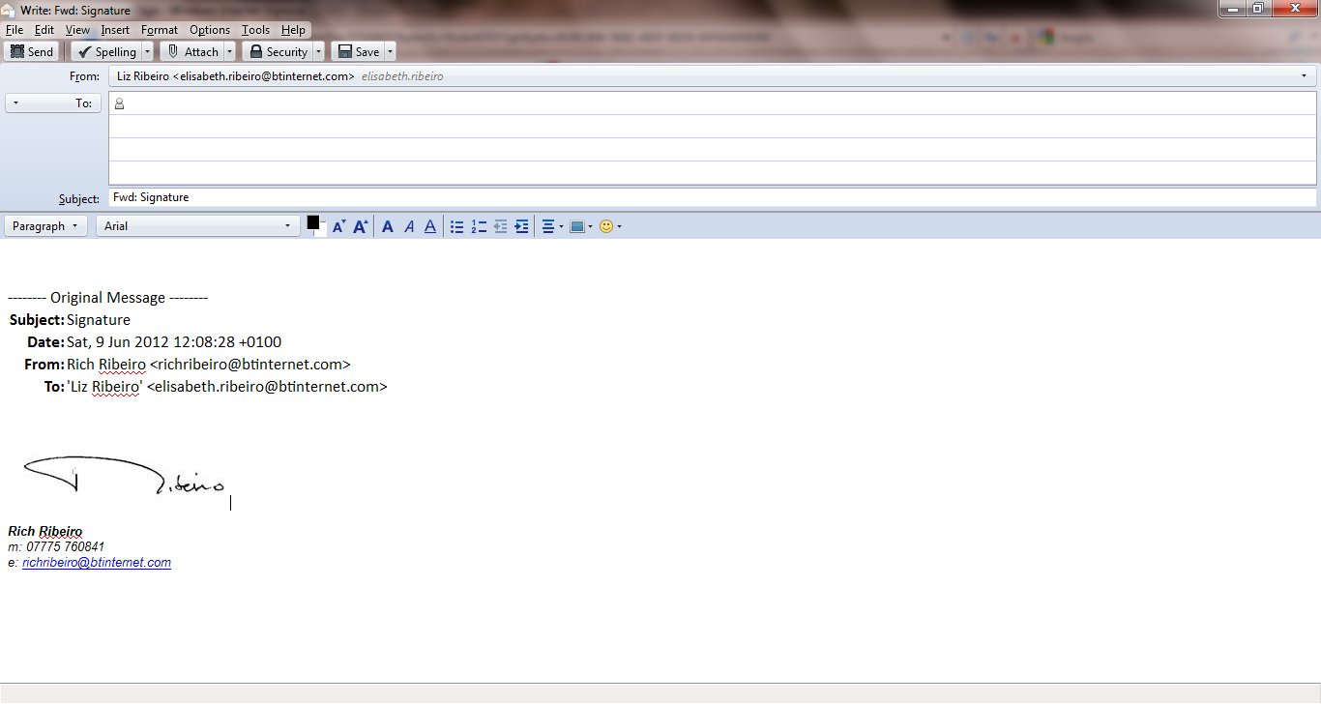
Yours sincerely

Lord Ribeiro CBE
Chairman, IRP

APPENDIX ONE

LIST OF DOCUMENTS RECEIVED

South Tyneside Council
- Letter of referral from Cllr Rob Dix, OSC Chair, to Secretary of State for Health, 10 December 2014
Attachments, supporting documentation containing:
- Referral document
- Consultation document
- Minutes of OSC, council and area council meetings, 12 June – 7 October 2014
- Consultation feedback report
- Minutes of OSC meeting, 3 December 2014

NHS
1 IRP template for providing initial assessment information
Attachments:
2 Transport and accessibility review
3 Consultation feedback report
4 Pre-engagement timeline
5 Link to consultation website
6 Draft minutes of South Tyneside CCG meeting, 20 November 2014
7 Report to South Tyneside CCG meeting, 20 November 2014
8 Equality analysis
9 Four tests assessment
10 Public statement on outcome of consultation
11 Letter from Cllr Rob Dix to Dr David Hambleton, Chief Officer, South Tyneside CCG, 25 November 2014
12 Letter from Dr David Hambleton to Cllr Rob Dix, 2 December 2014
13 South Tyneside urgent care map

Additional information
1 Phone call and letter, Mrs R Slater, local resident
2 Phone call and email, Cllr G Kilgour, Fellgate and Hedworth
3 Phone call, Rev’d R Merrin, Grange Road Baptist Church and Chair of Big Local Central Jarrow partnership board
4 Email and attachments, Stephen Hepburn, MP for Jarrow
5 Letter and attachments, Mr W Flynn, Secretary, Jarrow Constituency Labour Party

