INDEPENDENT REPORTING COMMISSION – PEN PICS OF NEWLY APPOINTED COMMISSIONERS

Mitchell B Reiss
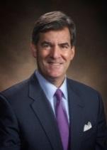

Mitchell B Reiss is a former United States Special Envoy for Northern Ireland who is currently President and CEO of the Colonial Williamsburg Foundation in Virginia. He previously served on the US National Security Council, the US Council on Foreign Relations and has held positions with the Ford Foundation, the Cambridge Institute for Applied Research, Lawrence Livermore National Laboratory and Los Alamos National Laboratory.

Monica McWilliams
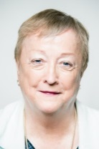
Monica Williams is a Northern Irish academic and former politician. She is a graduate of Queen’s University Belfast and the University of Michigan and became Professor of Women’s Studies and Social Policy at the University of Ulster. She co-founded the Northern Ireland Women’s Coalition and was elected as one of two NIWC Members of the Legislative Assembly in Northern Ireland in 1998. She is a former Chief Commissioner of the Northern Ireland Human Rights Commission and in 2011 was one of five persons appointed to a Prisons Reform Oversight Group advising the Northern Ireland Department of Justice.

John McBurney
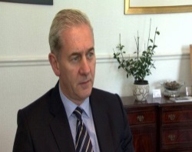
John McBurney is a well-known solicitor in Northern Ireland. He qualified in 1979 and carries a wealth of experience in major litigation, commercial transactions, conveyancing and estate management. He established his Co.Down practise, John McBurney Solicitors, with the intention of seeing it develop through the enthusiasm of his dedicated team of young lawyers.

Tim O’Connor
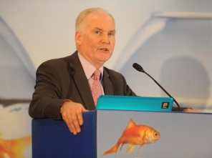
Tim O’connor is a native of Kileedy in West Limerick. After a two-year stint as a teacher, he joined the Civil Service in Dublin in 1974, moving to the Department of Foreign Affairs (DFA) in 1979. Most of his DFA career was spent working on the Northern Ireland Peace Process and was part of the Irish Government Negotiating Team for the Good Friday Agreement. He has also served terms as Director of the Africa Unit and of the Human Rights Unit in the DFA. His foreign postings included the Embassies of Ireland in Bonn and Washington DC and from 2005-2007 he served as the Consul General of Ireland in New York, USA. He served as Secretary General to President Mary McAleese at Aras an Uachtarain from 2007 to 2010. Since retiring from the Civil Service in 2010, Tim has been dividing his time between his own advisory business and voluntary work, both in the public sector and with NGOs.

