This document was archived in February 2016 because it is no longer current.

Outstanding achievement for pupils learning English as an additional language: Greet Primary School

URN: 103204
Local authority: Birmingham
Date published: 17 September 2012
Reference: 120286
Brief description

Pupils learning English as an additional language do exceptionally well at Greet Primary School because the outstanding teaching they receive throughout the school is complemented by high-quality support and a language-rich curriculum. As a result, pupils develop highly advanced writing skills.
Overview – the school’s message

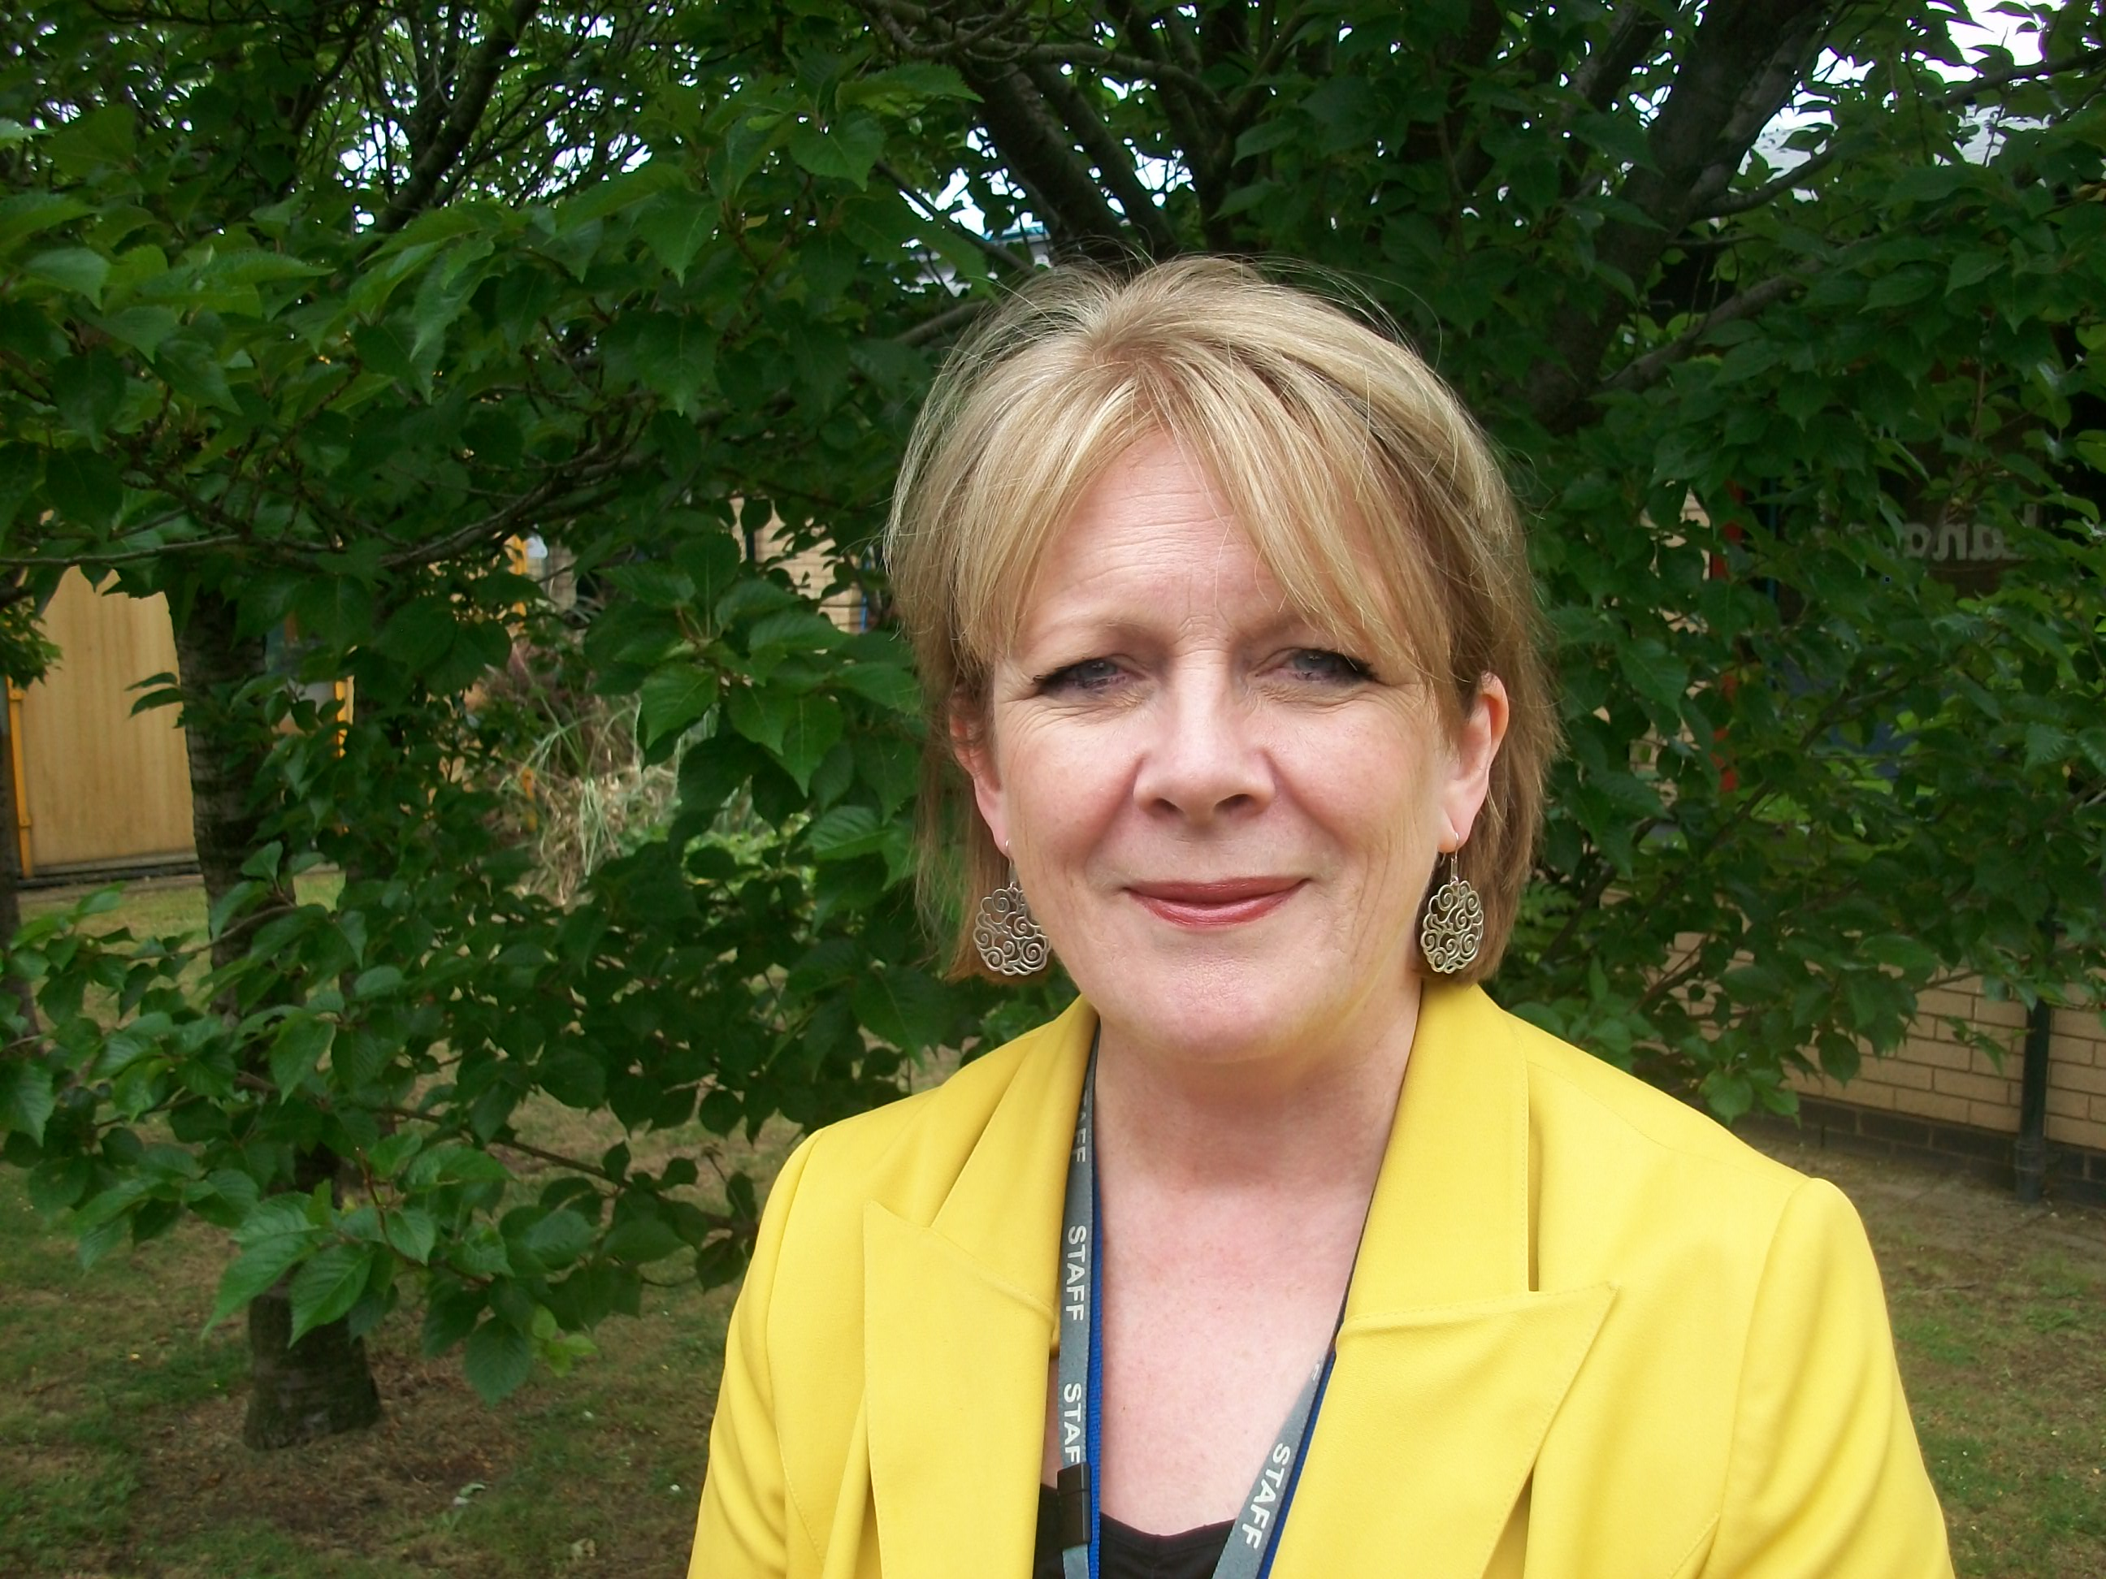
‘Since almost all of our pupils speak English as an additional language, we have to ensure that all teaching responds to their needs and supports their learning. We use a range of strategies to access the curriculum which, dependent on the learner’s age and stage of English acquisition, include oral rehearsal prior to writing, pre-tutoring, use of home language, visual cues, practical work and paired or group work. As a result of this consistent approach, our pupils progress quickly from very low attainment on entry to achievement at or beyond national standards in English and mathematics by the end of
Year 6.
All teachers are regarded as teachers of English as an additional language and the support staff, in particular, play an important role in challenging and supporting the pupils. We are careful to distinguish English as an additional language from special educational needs and our approach is flexible to allow children to move to higher level groups if their progress starts to accelerate.’
Pat Smart – headteacher
The good practice in detail

‘This is an outstanding school that successfully combines outstanding achievement, extremely high standards of care and lots of fun!’ said Ofsted in its last inspection report and if you visit the school you can see why.
Achievement
Pupils make outstanding progress across the school. From attainment on entry well below expectations, pupils have caught up by the time they leave to be at least in line with national standards in English and mathematics and often beyond. The most recent test results in English at the end of Key Stage 2 were just above the national average, including the proportion who achieved the highest possible level. Greet Primary School bucks the national trend for attainment of pupils who receive free school meals and gaps between various groups are often narrower than nationally. The achievement of different groups is monitored closely through the school’s Equalities Policy and shows that no group is left behind. The focus is on rapid progress and high expectations. Since the last inspection, standards in writing, in particular, have significantly improved. In the words of one pupil, ‘Teachers push us hard to prepare us for the future.’
Greet Primary School bucks the national trend for attainment of pupils who receive free school meals.
Teaching groups
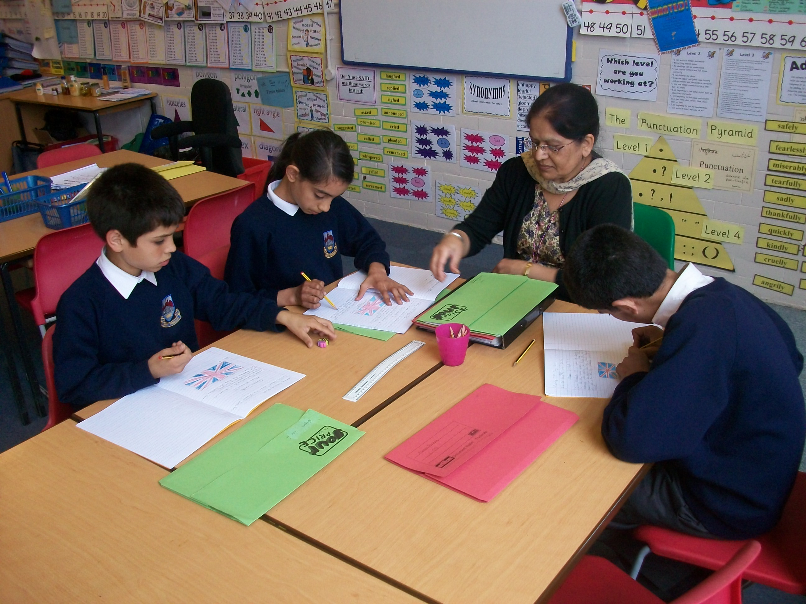
From Year 1 onwards, pupils are allocated to age-related teaching groups based on their current level of attainment. Teaching assistants take responsibility for the progress of a group of about six pupils within a class. These groups are flexible, allowing pupils to move up or down at any time as all groups follow the same programme of work at their own level. Pupils working at the lowest levels of attainment are in smaller groups to ensure that they receive more intensive support.
A high proportion of the teaching assistants are bilingual and are able to speak many of the languages spoken by pupils learning English as an additional language. According to the school’s curriculum statement, ‘Bilingualism is viewed as a huge asset and we value and promote the importance of pupils’ home languages.’ One of the strategies teaching assistants employ is pre-tutoring pupils in their home language before the start of a lesson so that pupils will know what is expected of them when the activity is introduced. Buddies who speak the same home language are attached to new arrivals. A recent new arrival says: ‘It was great having people who could speak Urdu to me as I couldn’t speak English at first.’
All teachers and support staff are responsible for teaching English as an additional language.
All teachers and support staff are responsible for teaching English as an additional language. While there is a specialist coordinator there is no distinction between teachers and support staff as to whether they are mainstream or English as an additional language support staff – they are all language teachers.
Performance management of teaching assistants
Teaching assistants receive the same degree of support and challenge as teachers and attend the pupil-progress meetings between teachers, line managers and phase leaders. They hold data for the target group that they have been allocated and are then held to account for the progress those pupils have made. In addition to attainment data, teaching assistants keep portfolios of evidence concerning the progress of their pupils. They are set challenging targets linked to pupils’ progress.
Teaching assistants receive the same degree of support and challenge as teachers...They are set challenging targets linked to pupils' progress.
Initially, portfolios were developed to celebrate the work of teaching assistants and to value their role but they have been developed as a performance management tool to record evidence that shows how targets have been achieved. Now teaching assistants are sharing this approach with neighbouring schools which are following their example.
Writing experiences for pupils from Nursery onwards
From Early Years onwards, there is a focus on establishing pupils’ independence. Workshops for parents and carers in Nursery promote the value of parents and carers using their first language with their children at home and the educational as well as cultural benefits of bilingualism. Throughout their time in school, pupils are encouraged to continue developing their literacy skills in their home language so that they can transfer their literacy skills to acquire English.
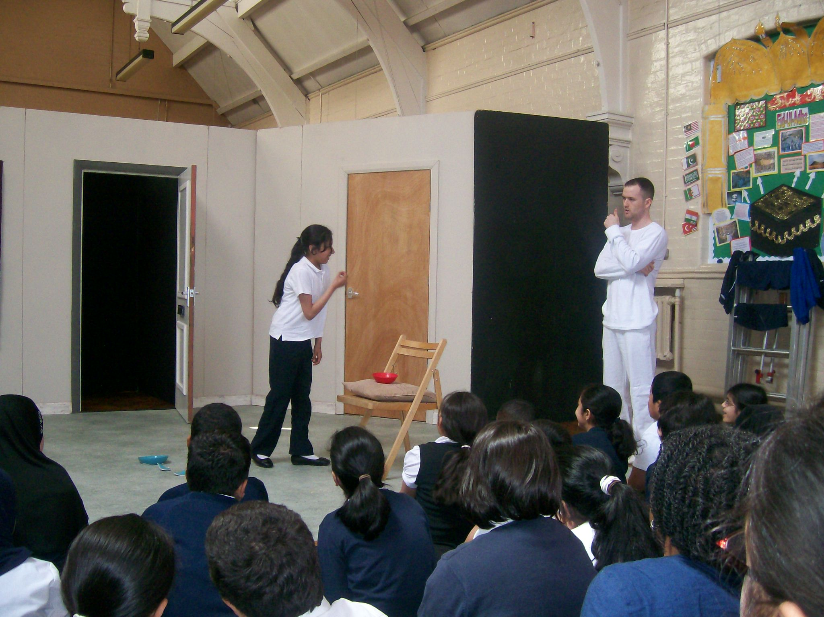
By the end of the first year in Reception, pupils can write for a range of different purposes and audiences – for example completing entries in their learning journals and writing postcards independently. How is this achieved? First, by ensuring that children, including those who have not been to Nursery, settle quickly into established routines. Pupils are allocated to a teacher or teaching assistant to ensure continuity and opportunities are in place for writing on a daily basis. As pupils continue their journey through school, the striking feature is not only the sheer quantity of work, often filling several literacy exercise books in a school year, but the quality of their written work, the consistency in the way it is laid out and neat handwriting - whatever the ability of the pupil. As one pupil said, ‘Literacy is a focus of our work every day.’ Unity of purpose across the school leads to a consistent approach to writing and high standards of presentation while at the same time, approaches are tailored to the needs of the individual learner. Pupils have visual prompts to help them understand timetables and success criteria. Teachers help pupils by modelling sentences and then providing structures for them to have a go, leading to independent writing.
The whole curriculum is based around language and draws on pupils’ experiences. This promotes their understanding and the celebration of festivals and assemblies makes them feel valued. In addition they are given access to new experiences they would otherwise not have at home. Written activities are for a real purpose and as the school’s document The Writing Process states: ‘Writing is put in context wherever possible which gives a purpose to pupils’ work.’ For example, a business enterprise project was linked to a production of Peter Pan where pupils took responsibility for everything – setting up a board of directors, overseeing the box office, advertisements, the programme, costs, bids for money, and props.
Assessment
From an early age, pupils know their targets and the level they are working at. Pupils want to do well and always aspire to the next level, however challenging it maybe. Consequently some pupils are aiming for Level 6 in their literacy by the end of Year 6 having joined school speaking very little English. Lack of English does not hold pupils back – if they show a talent for mathematics, for example, this is identified early on through the home language where possible, to ensure that they do as well as they can. Even pupils who have been in the school for just a couple of years can achieve above the expected level of mathematics for their age. Pupils identified as gifted and talented are expected to achieve beyond national expectations.
The school’s background

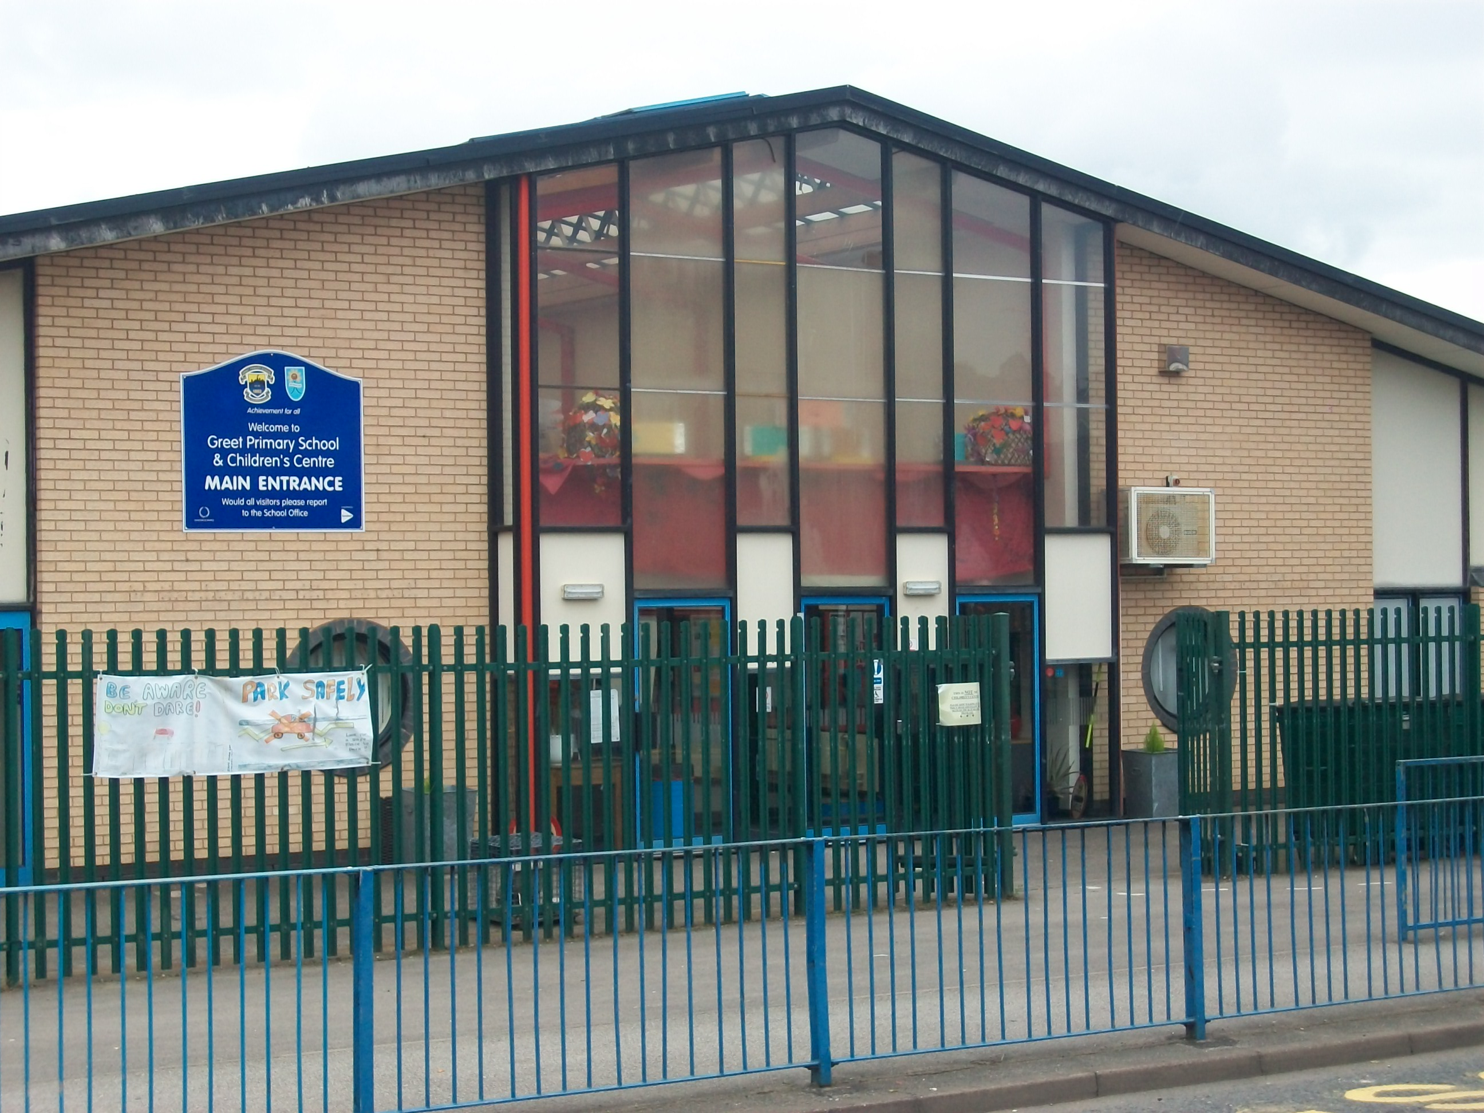
Greet Primary School is a growing school of well above average size, situated in the heart of Birmingham. The school is federated with a neighbouring primary school. Almost all pupils are from minority ethnic groups, the largest group being Pakistani Mirpuri. A large majority speak English as an additional language.

