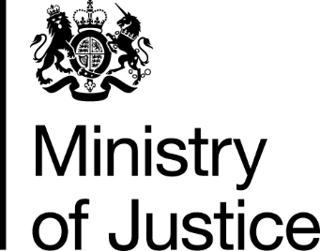
 | Our Reference: 605-16 FOI 108437 |  | November 2016

Freedom of Information Request

You asked for the following information from the Ministry of Justice (MoJ):

I am doing an extended project for my access course at college and wondered if there was a way at getting sentencing statistics based on gender for men and women that have committed the same crime to see the difference. I would appreciate it if you could send over some recent statistics so I could include these in my project.

Your request has been handled under the Freedom of Information Act 2000 (FOIA).

I can confirm that the department holds some of the information that you have asked for. However, the information that is held is exempt under section 21 of the FOI Act because it is reasonably accessible to you, and I am pleased to inform you that you can access it via the following links.

The number of offenders found guilty and sentenced at all courts, in England and Wales, from 2005 to 2015 (latest figures available), can be found in the Criminal Justice Statistics Outcomes by Offence section in the latest annual Criminal Justice Statistics publication. A wider offence list for those offences contained in the ‘offence’ drop down list is contained in the ‘offence group classifications’ further down the page the link provides. You will note the drop down box for gender.

https://www.gov.uk/government/statistics/criminal-justice-system-statistics-quarterly-december-2015

Section 21 of the Freedom of Information Act exempts disclosure of information that is reasonably accessible by other means, and the terms of the exemption mean that we do not have to consider whether or not it would be in the public interest for you to have the information.

