Copy No:
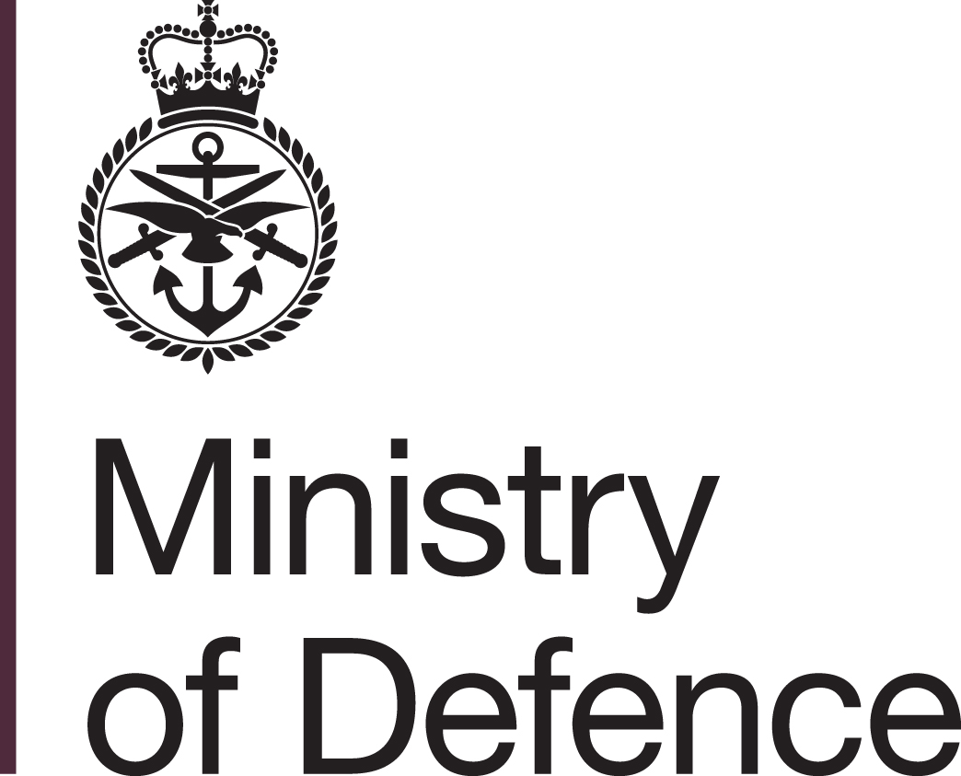




XXXXX PT

Vanilla
Airworthiness Strategy

File Reference
 | Name | Staff Title | Signature | Date
Originated By:
Approved By:

THIS DOCUMENT IS THE PROPERTY OF HER BRITANNIC MAJESTY’S GOVERNMENT, and is issued for the information of such persons only as need to know its contents in the course of their official duties. Any person finding this document should hand it in to a British Forces unit or to a police station for safe return to the Security Officer – DE&S, MOD Abbey Wood, BS34 8JH, with particulars of when and how found. THE UNAUTHORISED RETENTION OR DESTRUCTION OF THE DOCUMENT IS AN OFFENCE UNDER THE OFFICIAL SECRETS ACT 1911-1989. (When released to persons outside government service, this document is issued on a personal basis and the recipient to whom it is entrusted in confidence within the provisions of the Official Secrets Act 1911-1989, is personally responsible for its safe custody and for seeing that its contents are disclosed only to authorised persons).

DISTRIBUTION

Position | Organisation | Location | Copy No
 |  |  | 1
 |  |  | 2
 |  |  | 3
 |  |  | 4
 |  |  | 5
 |  |  | 6
 |  |  | 7
 |  |  | 8
 |  |  | 9
 |  |  | 10
 |  |  | 11
 |  |  | 12
 |  |  | 13
 |  |  | 14
 |  |  | 15
 |  |  | 16
 |  |  | 17
 |  |  | 18
 |  |  | 19
 |  |  | 20
 |  |  | 21
 |  |  | 22
 |  |  | 23
 |  |  | 24
 |  |  | 25

AUTHORISATION

This Airworthiness Strategy describes how the Type Airworthiness Authority (TAA) intends to comply with Military Aviation Authority (MAA) Regulatory Publications (MRP) requirements to manage airworthiness through appropriate arrangements for safety management, use of recognised standards, competence of staff and independent assurance. It will also outline the key airworthiness activities through life, covering the establishment of Type Airworthiness, assurance of production quality, the continued airworthiness of the Type in-service and the assurance of those aspects of Continuing Airworthiness for which the Vanilla Project Team (PT) will have responsibility. This Strategy remains a ‘living document' that will be reviewed on an annual basis and prior to key project stages (and confirmed at the annual 2-star Airworthiness Review) to reflect new regulation, organisational change, changes within the project and experience.

DOCUMENT AMENDMENT RECORD

Version | Details of Amendment | Date

DOCUMENT REVIEW RECORD

Date of Review | Name | Comments

CONTENTS

LIST OF ABBREVIATIONS

AAMC | Alternative Acceptable Means of Compliance
ACAS | Assistant Chief of the Air Staff
ADs | Airworthiness Directives
ADS | Air System Document Set
AE | Air Engineering
ALARP | As Low As Reasonably Practical
AMC | Acceptable Means of Compliance
AOF | Acquisition Operating Framework
AP | Airworthiness Pillar
AOA | Aircraft Operating Authority
ARC | Airworthiness Review Certificate
ASIMS | Air Safety Information Management System
ASSG | Air Systems Steering Group
ASSWG | Air Systems Safety Working Group
AUWG | Air Users Working Group
CA | Combat Air
CAE | Chief Air Engineer
CAAMG | Combat Air Airworthiness Management Group
CAM | Continuing Airworthiness Management/Manager
CAME | Continuing Airworthiness Management Exposition
CAMO | Continuing Airworthiness Management Organisation
CDM | Chief of Defence Materiel
Cdr | Commander
Cert | Certification
CIWG | Combined Integrity Working Groups
CoM(Air) | Chief of Material (Air)
DAEMS | Defence Aviation Error Management System
DAOS | Design Approved Organisation Scheme
DASOR | Defence Air Safety Occurrence Report
DAT | DE&S Airworthiness Team
DCS | Design Change Statement
DDH | Delivery Duty Holder
DE&S | Defence Equipment & Support
DH | Duty Holder
DLOD | Defence Lines of Development
DO | Design Organisation
DQAFF | Defence Quality Assurance Field Force
EASA | European Aviation Safety Agency
FW | Fixed Wing
HSW | Health & Safety at Work
ISA | Independent Safety Auditor
ISO | International Standards Organisation
ITE | Independent Technical Evaluation
Ltd | Limited
LoAA | Letter of Airworthiness Authority
LTC | Local Technical Committee
MAA | Military Airworthiness Authority
MAOS | Maintenance Approved Organisation Scheme
MCoA | Military Certificate of Airworthiness
Mil | Military
MO | Maintenance Organisation
MOD | Ministry of Defence
MOR | Mandatory Occurrence Report
MPS | Mechanical & Propulsion Systems
MRCOA | Military Registered Civil Owned Aircraft
MRP | MAA Regulatory Publications
MRMO | Military Registered Military Owned
MTC | Military Type Certificate
NH | Neighbourhood (Abbey Wood)
OC | Operating Centre
ODH | Operational Duty Holder
OEM | Original Equipment Manufacturer
OLM | Operational Load Measurement
PDS | Post Design Services
PI | Propulsion Integrity
PSEP | Project Safety & Environmental Panel
PSWG | Project Safety Working Group
PT | Project Team
PTL | Project Team Leader
QMS | Quality Management System
RA | Regulatory Article
RPO | Resident Project Officer
RtL | Risk to Life
RTS | Release to Service
RTSA | Release to Service Authority
RTSR | Release to Service Recommendation
S&ADS | Structures & Aircraft Design Standards
SB | Service Bulletin
SDH | Senior Duty Holder
SEAR | Safety and Environmental Airworthiness Review
SEMS | Safety & Environmental Management System
SI | Structural Integrity
SMP | Safety Management Plan
SMS | Safety Management System
SOI | Statement of Operating Intent and Usage
SQEP | Suitably Experienced & Qualified Personnel
SysI | Systems Integrity
TAA | Type Airworthiness Authority
TC | Type Certificate
TCR | Type Certificate Report
TCH | Type Certificate Holder
TL | Team Leader

INTRODUCTION

Aim

- This Airworthiness Strategy articulates the TAA’s intent for ensuring that the Vanilla project delivers and sustains an airworthy system through life. It will form a documented agreement between the TAA and the OC Director.

Vanilla Air System Description

- Vanilla is a collaborative project with (detail other nations) to develop a ................. aircraft and supporting infrastructure that can fulfil the following roles: ............ The Air System will be based upon (an existing Civil type) and will comprise ............

Section 1 – OVERALL Project Safety and AIRWorthiness Management

- Overview. Vanilla project safety requirements span the CADMID cycle and encompass a variety of airworthiness activities. The MAA Glossary (MAA02) defines airworthiness as "a technical attribute of the system that enables it to be operated throughout its lifecycle without significant hazard to people”. From this it follows that the TAA is primarily responsible for: ensuring an airworthy type design, procuring conforming equipment, establishing the operating limitations and maintenance arrangements necessary to sustain the system and developing and maintaining the Equipment Safety Assessment which supports the ODH’s Air System Safety Case.
- Safety Management System. The TAA generated project-specific Safety & Environmental Management Plan (SEMP) which will set out the PT's arrangements for managing safety throughout the life of the project. It will also detail the key stakeholder relationships, in particular with the partner nations, the Capability Sponsor, the RTSA and the ODH, and explains how those will be managed. Within DE&S, 2-star oversight of the project, including its safety management, is achieved through periodic, project-specific Safety, Environmental and Airworthiness Reviews (SEARs). As the project develops, the Vanilla PT, leading on the Equipment and Logistics DLODs, will also engage with the Operating community through a Combined Test Team and a Capability Integration Working Group so that safety considerations are addressed in a holistic manner across all DLODs. The RTSA and ODH will be represented in project safety committees and the Equipment Safety Assessment and associated reports will be made available to them to inform their decision making.
- Recognised Standards. It is intended for the Vanilla project to deliver a single Air System design which is acceptable to all partner nations; hence, a single set of Design and Qualification standards will be agreed (by the partner nations) at the earliest opportunity. As the Air System is based on a Civil design, the standards will be mapped against Def Stan 00-970 and, where the latter standard is found to be more stringent, the PT will in the first instance engage with the partner nations to achieve compliance. If that fails, the team will engage with the MAA to determine whether an alternative standard would be acceptable. Consideration of whether a Civil design standard is acceptable will take account of the usage spectrum and operating environment for the component or system, given that military-registered aircraft are generally flown to different flying rules to civil aircraft (Fly 2000 versus EASA rules for example) and are not generally flown by operators who fly under the constrained processes of a civil air operator’s certificate. In the case of MRCOA, this means that the TAA must ensure himself that any civil modifications that are added to a military registered aircraft by an EASA Part J approved organisation, are suitable for military usage given that the Part J approval is to scheme and fit modifications for use in the civil air operator’s environment to be flown to civil rules. The TAA must also seek confirmation that the Design Organisation for the Type is content with usage to the military SOIU. The PT will need a strategy for analysing and agreeing modifications, including major modifications which would need to be referred to the certification authority for military registered aircraft; the MAA. Where standards will apply only to the UK - for example, if the UK adopts a national support strategy - then the PT will comply with MAA Regulatory Publications; this will apply in the case of the Continuing Airworthiness Management Organisation (CAMO) and it may apply to approved maintenance organisations. Safety requirements will be flowed down through contracts to Designers and, at the appropriate stage of the project, to other organisations that provide services or support that have an impact on Air System safety and airworthiness. The objective will be to achieve full compliance with the MRP; waivers, exemptions and AAMC will only be considered where there is a demonstrable need and an equivalent level of safety can be demonstrated.
- Competence. A SQEP TAA who has been endorsed by the MAA will be appointed by the DE&S OC Director. He may delegate some of his authority to named individuals whom he has assessed as SQEP, using Letters of Airworthiness Authority (LoAA). The PT will contract only with competent organisations; in particular, it will be essential for all Design activity to be within the scope of an approval issued to the contractor by the MAA or approved by a military regulator with whom the MAA has a Mutual Recognition Agreement that covers design approvals. As Vanilla is based upon a Civil Type, it may be cost-effective to contract for maintenance with an organisation holding an EASA Part 145 approval but, in such a case, the organisation will be required to qualify for the issue of an approval for the maintenance of military aircraft through the Maintenance Approved Organization Scheme (MAOS), in accordance with the MRP Part 145 Supplement - Requirements Document.
- Independence. Some independent assessment of submissions from Designers may be carried out by the PT, where it has the technical skills to do so. In other cases, one or more ITE providers will be appointed who will provide independent assurance that the Designer’s technical arguments are sound and properly executed. Specific attention will be given to the requirement for specialist support in relation to Programmable Elements (PE), the combination of Software and/or Complex Electronic Hardware (CEH), and meeting the certification requirements. ITE support will be engaged at an early stage of the project in order to ensure that evidential requirements can be included in the Certification Plan. An ISA will also be appointed who, through a series of safety audits iaw Def Stan 00-56, will provide assurance that safety management activities are being correctly discharged. The TAA will need to articulate how the safety management requirements of Def Stan 00-56 have been ‘tailored’ to meet his specific project requirements.

Section 2 – Establishing Type airworthiness

- Requirements Definition. Through early engagement with the Sponsor the TAA will influence the Vanilla URD and project plan in order to ensure that airworthiness and safety requirements are recognised, included and funded. In particular, the TAA intends to ensure that the requirement to contract with competent organisations, use recognised standards to support design activities, establish safety requirements and processes and seek independent assurance are recognised, funded and form a central part of the procurement strategy.
- Certification. Type Certification is a key activity in establishing Type Airworthiness that seeks to ensure that the product is designed to appropriate airworthiness standards. These standards are derived from one hundred years of aviation design experience and can be found in Def Stan 00-970 for UK military aircraft and in EASA Civil Standards for civil design types. By working to an agreed Certification Plan and developing a comprehensive safety argument underpinned by evidence, the TAA intends to demonstrate that the Vanilla system is safe when operated iaw a defined support policy and set of operating limitations. The Vanilla PT will engage with the MAA and Designers to complete Phases 1-3 of the Military Air System Certification Process (MACP), leading to an agreed Type Certification Basis (TCB) and Certification Plan. The Plan will define the evidential requirements and form the basis of the Certification activity during the assessment and development phases of the project. In due course, the TAA will submit a Type Certification Exposition and apply to the MAA for the issue of a Military Type Certificate, and will subsequently submit Release to Service Recommendations (RTSR) to the RTSA.
- PT Development. As the Vanilla project matures, the composition of the PT will be adjusted to ensure that it has the human capital to deliver its tasks. In particular, SQEP personnel will be recruited to support the TAA to: work in liaison with partner nations; develop the Airworthiness Strategy; update the SEMP; establish the TCB; define contract conditions required to comply with the MRP; develop an Integrated Test, Evaluation & Acceptance Plan (ITEAP); establish a Combined Test Team (CTT) comprising Industry, PT and FLC personnel; manage the configuration of Design and Qualification evidence; review ITE and ISA reports; identify operating limitations and develop RTSR; and initiate Training Needs Analysis for PT staff and MOD employees within the in-service support solution. It will also be necessary to arrange for appropriate MOD witnesses to agreed tests iaw the Certification Plan and establish key on-site staff such as the RPO and DQAFF.

Section 3 – production

- The TAA’s intent for production is to ensure that the components procured and spares supplied throughout the system’s operational life conform to the relevant design standard. Some procurement will operate through the prime contractor; in this case the TAA will ensure that the contract stipulates appropriate production quality standards and requires the contractor to manage the quality of any sub-contracted work. Other spares will be sourced through existing MOD procurement channels and be supplied as GFE; in this case the TAA will create an Internal Business Agreement with the relevant PT to ensure that any project-specific quality requirements are flowed down in contracts to suppliers. DQAFF will be tasked on a risk basis to provide limited independent verification that production organisations are delivering compliant equipment. The TAA may issue LoAAs to DQAFF members in order to enable concession decisions to be made locally.

Section 4 – MAINTAINING Type Airworthiness

- Once Vanilla enters service, Type Airworthiness will be maintained through-life by ensuring strong links exist between the ODH(s), TAAs and Design Organisations. The TAA will manage the boundary between Type and Continuing Airworthiness. The PT will expand the SEMP to include processes and resource requirements for maintaining Type Airworthiness including: Type configuration management and modification processes; establishing and continually improving maintenance policy; management of the Air System Document Set; structural, engine and systems integrity management; Operational Loads Measurement and/or Operational Data Recording; fault reporting and corrective action systems; reviewing feedback in DASORs and DAEMS; and engagement with the CAMO. Later in the life-cycle , Ageing Aircraft and Systems Audits will be carried out. Data generated through in-Service operation will be used to validate design assumptions and, in particular, to refine hazard assessments, update the equipment Hazard Log and update the Equipment Safety Assessment. Most of the processes above will be enacted in concert with the partner nations and be delivered collaboratively; this is expected to include maintenance of certain records including the Type Design Record, the Static Type Record, the Fatigue Type Record and the Master Drawing Set. All Type records will be retained for the life of the project plus a further 5 years.

section 5 - Continuing airworthiness

- Although the ODH is accountable for Continuing Airworthiness, the TAA, who invariably controls the contract on the Design Organisation / Prime Contractor, will inevitably need to undertake activities on behalf of the ODH, and is responsible for doing this, as defined in the Duty Holder's Continuing Airworthiness Management Exposition. In particular, the PT will act as the Contracting Authority and will, therefore, be required to contract for support from competent organisations. As a minimum, this will include the provision of Post Design Services from MAA-approved Designers and maintenance activities from maintenance organisations that are Mil Part 145 approved.

DISPOSAL

- The TAA's intent for disposal is to ensure that the Type Design Records are comprehensive and accessible in order to support any decision to sell systems on. In order to do so:
  - Effective record keeping of decisions relating to airworthiness will be implemented at the commencement of the project and maintained through life.
  - All records of such decisions and supporting information that constitute the airworthiness audit trail will be retained for a minimum of 5 years after the last system is decommissioned.
- If there is a decision to scrap all, or parts of, Vanilla Air Systems then the TAA will ensure that the Type Design Records identify all hazardous materials that exist within the system.

RA 1220(1) – Project Team Airworthiness and Safety (Airworthiness Strategy).
RA 1013(1) – DE&S Air Systems Operating Centre Director – Provision of Airworthy and Safe System.

