
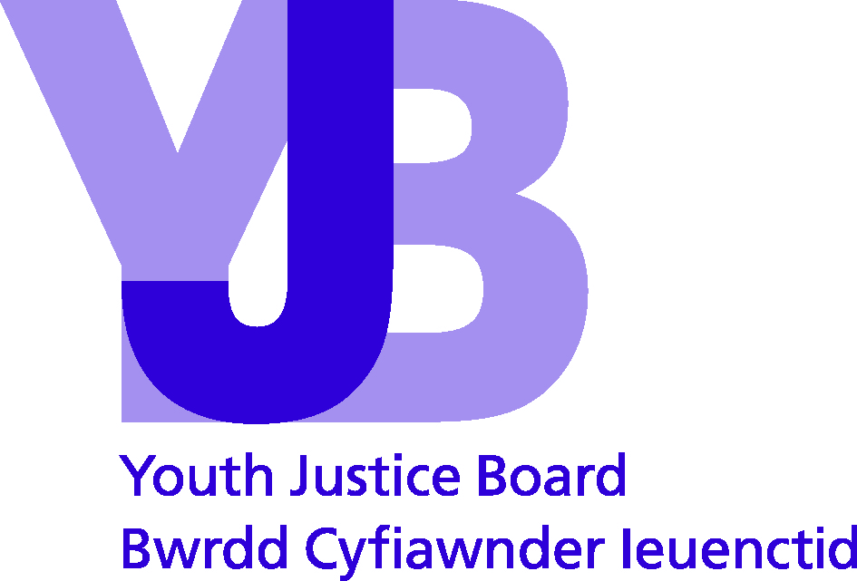

Young Person

Young person’s name:
Date of birth:
Date of completion:

Custody:
 |  | Yes | No
Have you been in custody before?
If yes, what was the hardest thing about it?
…………………………………………………………………………………………………………………………………………

…………………………………………………………………………………………………………………………………………………

…………………………………………………………………………………………………………………………………………………

What would have made your time in custody better?
…………………………………………………………………………………………………………………………………………

…………………………………………………………………………………………………………………………………………………

…………………………………………………………………………………………………………………………………………………

…………………………………………………………………………………………………………………………………………………
 |  | Yes | No | Maybe
I am worried about going to custody
I am worried about other young people giving me a hard time in custody
My family will visit/write to me if I go to custody

© Youth Justice Board for England and Wales 2014
The material featured in this document is subject to copyright protection under UK Copyright Law unless otherwise indicated. Any person or organisation wishing to use YJB materials or products for commercial purposes must apply in writing to the YJB at ipr@yjb.gsi.gov.uk for a specific licence to be granted.

Young Person

Young person’s name:
Date of birth:
Date of completion:

Review:
What things in your life have got better?

…………………………………………………………………………………………………………………………………………

…………………………………………………………………………………………………………………………………………………

…………………………………………………………………………………………………………………………………………………

…………………………………………………………………………………………………………………………………………………
Have any things in your life got worse? If yes, which things?

…………………………………………………………………………………………………………………………………………

…………………………………………………………………………………………………………………………………………………

…………………………………………………………………………………………………………………………………………………

…………………………………………………………………………………………………………………………………………………
What things would you still like to change?

…………………………………………………………………………………………………………………………………………

…………………………………………………………………………………………………………………………………………………

…………………………………………………………………………………………………………………………………………………

…………………………………………………………………………………………………………………………………………………
What's been good about coming to the YOT so far?

…………………………………………………………………………………………………………………………………………

…………………………………………………………………………………………………………………………………………………

…………………………………………………………………………………………………………………………………………………

…………………………………………………………………………………………………………………………………………………

What's been bad about coming to the YOT so far? Why has it been bad?

…………………………………………………………………………………………………………………………………………

…………………………………………………………………………………………………………………………………………………

…………………………………………………………………………………………………………………………………………………

…………………………………………………………………………………………………………………………………………………

Think about the things you have been doing at the YOT. What is helping you sort out problems in your life?

…………………………………………………………………………………………………………………………………………

…………………………………………………………………………………………………………………………………………………

…………………………………………………………………………………………………………………………………………………

…………………………………………………………………………………………………………………………………………………
Is there anything else you would like the YOT to help you with?

…………………………………………………………………………………………………………………………………………

…………………………………………………………………………………………………………………………………………………

…………………………………………………………………………………………………………………………………………………

…………………………………………………………………………………………………………………………………………………

© Youth Justice Board for England and Wales 2014
The material featured in this document is subject to copyright protection under UK Copyright Law unless otherwise indicated. Any person or organisation wishing to use YJB materials or products for commercial purposes must apply in writing to the YJB at ipr@yjb.gsi.gov.uk for a specific licence to be granted.

Young Person

Young person’s name:
Date of birth:
Date of completion:

End of Intervention:
What things in your life have got better?

…………………………………………………………………………………………………………………………………………

…………………………………………………………………………………………………………………………………………………

…………………………………………………………………………………………………………………………………………………

…………………………………………………………………………………………………………………………………………………
Have any things in your life got worse? If yes, what?

…………………………………………………………………………………………………………………………………………

…………………………………………………………………………………………………………………………………………………

…………………………………………………………………………………………………………………………………………………

…………………………………………………………………………………………………………………………………………………
What's been good about coming to the YOT?

…………………………………………………………………………………………………………………………………………

…………………………………………………………………………………………………………………………………………………

…………………………………………………………………………………………………………………………………………………

…………………………………………………………………………………………………………………………………………………
What's been bad about coming to the YOT? Why has it been bad?

…………………………………………………………………………………………………………………………………………

…………………………………………………………………………………………………………………………………………………

…………………………………………………………………………………………………………………………………………………

…………………………………………………………………………………………………………………………………………………

Think about the things you have been doing at the YOT. What helped you sort out any problems in your life?

…………………………………………………………………………………………………………………………………………

…………………………………………………………………………………………………………………………………………………

…………………………………………………………………………………………………………………………………………………

…………………………………………………………………………………………………………………………………………………

 |  | Yes | No | Sometimes
I worry about what might happen after I finish at the YOT
I know where to get help if I need it in the future
Who will help you with any problems you have after you leave here?

…………………………………………………………………………………………………………………………………………

…………………………………………………………………………………………………………………………………………………

…………………………………………………………………………………………………………………………………………………

…………………………………………………………………………………………………………………………………………………
What other help do you think you will need? How can the YOT help you get this?

…………………………………………………………………………………………………………………………………………

…………………………………………………………………………………………………………………………………………………

…………………………………………………………………………………………………………………………………………………

…………………………………………………………………………………………………………………………………………………

© Youth Justice Board for England and Wales 2014
The material featured in this document is subject to copyright protection under UK Copyright Law unless otherwise indicated. Any person or organisation wishing to use YJB materials or products for commercial purposes must apply in writing to the YJB at ipr@yjb.gsi.gov.uk for a specific licence to be granted.

Young Person

Young person’s name:
Date of birth:
Date of completion:

Working with Probation:
What do you think the difference will be between the YOT and Probation?

…………………………………………………………………………………………………………………………………………

…………………………………………………………………………………………………………………………………………………

…………………………………………………………………………………………………………………………………………………

…………………………………………………………………………………………………………………………………………………
 |  | Yes | No
Are you worried about moving from the YOT to Probation?
What is it that you are worried about?

…………………………………………………………………………………………………………………………………………

…………………………………………………………………………………………………………………………………………………

…………………………………………………………………………………………………………………………………………………

…………………………………………………………………………………………………………………………………………………
 |  | Yes | No
Would you like to know more about what happens when you move to Probation?
If yes, what would you like to know?

…………………………………………………………………………………………………………………………………………

…………………………………………………………………………………………………………………………………………………

…………………………………………………………………………………………………………………………………………………

…………………………………………………………………………………………………………………………………………………
© Youth Justice Board for England and Wales 2014
The material featured in this document is subject to copyright protection under UK Copyright Law unless otherwise indicated. Any person or organisation wishing to use YJB materials or products for commercial purposes must apply in writing to the YJB at ipr@yjb.gsi.gov.uk for a specific licence to be granted.

Young Person

Young person’s name:
Date of birth:
Date of completion:

Bail:
 |  | Yes | No | Maybe
My family/carers will help me keep my bail conditions
My friends might make it hard for me to keep my bail conditions
I will stay at … enter address below … whilst on bail

…………………………………………………………………………………………………………………………………………

…………………………………………………………………………………………………………………………………………………

…………………………………………………………………………………………………………………………………………………

What can the YOT do to help you keep your bail conditions?

…………………………………………………………………………………………………………………………………………

…………………………………………………………………………………………………………………………………………………

…………………………………………………………………………………………………………………………………………………

…………………………………………………………………………………………………………………………………………………

© Youth Justice Board for England and Wales 2014
The material featured in this document is subject to copyright protection under UK Copyright Law unless otherwise indicated. Any person or organisation wishing to use YJB materials or products for commercial purposes must apply in writing to the YJB at ipr@yjb.gsi.gov.uk for a specific licence to be granted.

Young Person

Young person’s name:
Date of birth:
Date of completion:

Custody Review:
What are you working on while you are here? For example, what are the main things in your sentence plan?

…………………………………………………………………………………………………………………………………………

…………………………………………………………………………………………………………………………………………………

…………………………………………………………………………………………………………………………………………………

…………………………………………………………………………………………………………………………………………………
What is going well?

…………………………………………………………………………………………………………………………………………

…………………………………………………………………………………………………………………………………………………

…………………………………………………………………………………………………………………………………………………

…………………………………………………………………………………………………………………………………………………
What things do you need to improve? How can you do this?

…………………………………………………………………………………………………………………………………………

…………………………………………………………………………………………………………………………………………………

…………………………………………………………………………………………………………………………………………………

…………………………………………………………………………………………………………………………………………………
What things here have helped you? How?

…………………………………………………………………………………………………………………………………………

…………………………………………………………………………………………………………………………………………………

…………………………………………………………………………………………………………………………………………………

…………………………………………………………………………………………………………………………………………………

What things here haven't helped you? Why?

…………………………………………………………………………………………………………………………………………

…………………………………………………………………………………………………………………………………………………

…………………………………………………………………………………………………………………………………………………

…………………………………………………………………………………………………………………………………………………
Is there anything else you would like to do while you are here? If yes, what?

…………………………………………………………………………………………………………………………………………

…………………………………………………………………………………………………………………………………………………

…………………………………………………………………………………………………………………………………………………

…………………………………………………………………………………………………………………………………………………
 |  |  |  | Yes |  | No |  | Sometimes
I have had problems with other young people here
I am coping with being in custody
I know who to speak to if I need help or support
Who has been to visit you during your time here?

…………………………………………………………………………………………………………………………………………

…………………………………………………………………………………………………………………………………………………

…………………………………………………………………………………………………………………………………………………

…………………………………………………………………………………………………………………………………………………
What have you learnt during your time here?

…………………………………………………………………………………………………………………………………………

…………………………………………………………………………………………………………………………………………………

…………………………………………………………………………………………………………………………………………………

…………………………………………………………………………………………………………………………………………………
What might stop you from getting into trouble when you leave here?

…………………………………………………………………………………………………………………………………………

…………………………………………………………………………………………………………………………………………………

…………………………………………………………………………………………………………………………………………………

…………………………………………………………………………………………………………………………………………………
Is there anything else that staff here can help you with?

…………………………………………………………………………………………………………………………………………

…………………………………………………………………………………………………………………………………………………

…………………………………………………………………………………………………………………………………………………

…………………………………………………………………………………………………………………………………………………
 |  |  |  | Yes |  | No |  | Sometimes
I'm worried about what might happen when I am released
If you are worried, why is this?

…………………………………………………………………………………………………………………………………………

…………………………………………………………………………………………………………………………………………………

…………………………………………………………………………………………………………………………………………………

…………………………………………………………………………………………………………………………………………………
 |  |  |  |  | Yes |  | No
I know where I can get help after my release

© Youth Justice Board for England and Wales 2014
The material featured in this document is subject to copyright protection under UK Copyright Law unless otherwise indicated. Any person or organisation wishing to use YJB materials or products for commercial purposes must apply in writing to the YJB at ipr@yjb.gsi.gov.uk for a specific licence to be granted.

