
Health & Safety Alert 

Galliford Try Plc Group of Companies
Date: June 2014

TITLE: Broken Knee Cap RIDDOR Injury

Outline of Incident:

On Friday 30th May a subcontractor’s supervisor working for a utilities company was planning work for the connection of a 125 gas main to a 355 gas main. Part of the work required caps to be fitted to vents previously fitted on the 125 main. The IP was utilising access provided for another work area to enable him to view his proposed work area to carry out his planning.

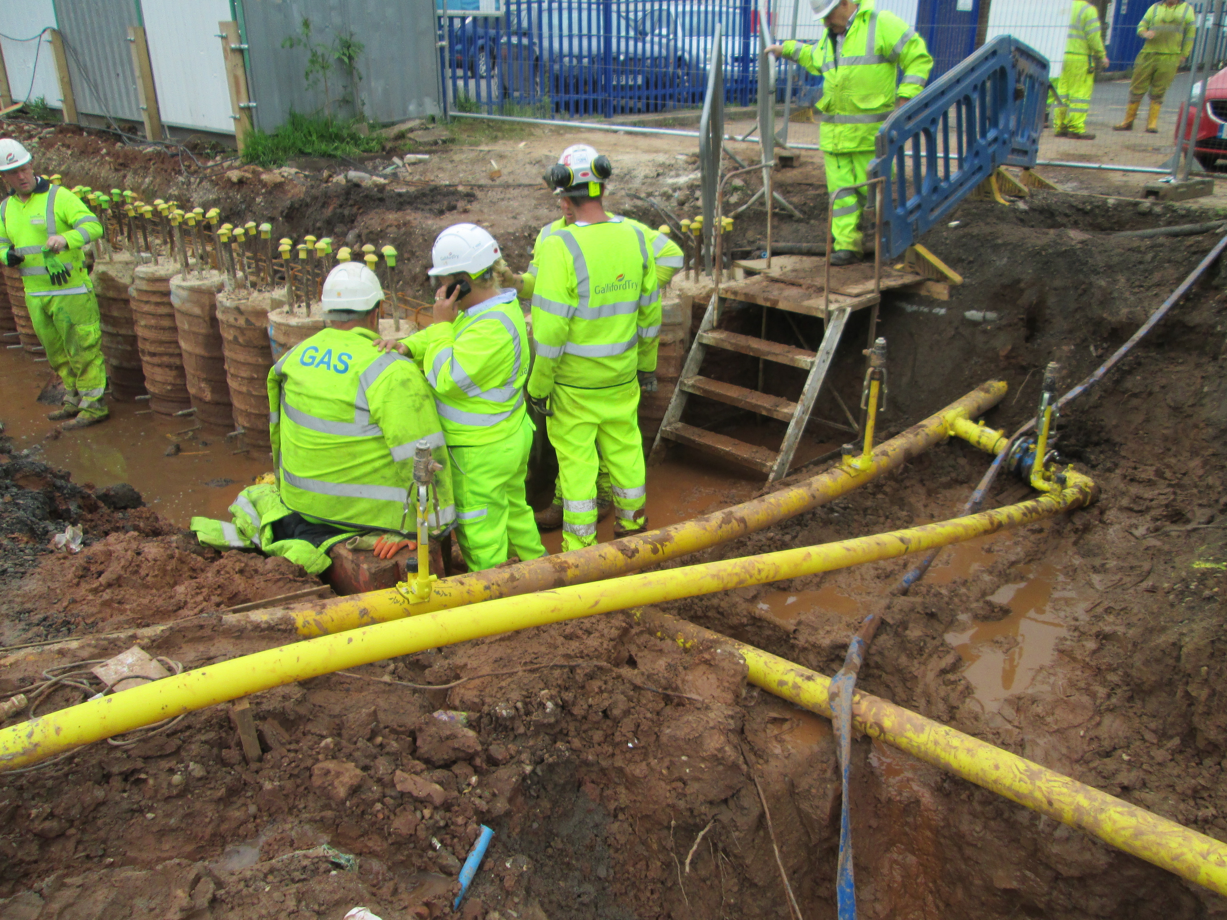
Area where IP used unauthorized access / egress route to place two further caps.
Area IP accesses to place caps onto vents
Caps already fitted to valves

Originally, the sub contractor’s gang were planning to work in a different area and had received a First 10 Minute Briefing on the works to be carried out at the original area earlier that morning. This briefing had discussed access and egress routes. However, it was discovered that a new gas main had been laid incorrectly and required some further excavation work to rectify the situation. The gang therefore moved to the new area where discussions regarding the methodology of how this would be achieved were being held at the time of the incident.

During the discussion the IP stepped up the side of the bank utilising a non-authorised access / egress route to place caps on vents and as he was stepping back down he lost footing with his right foot. The right foot then sunk in soft ground resulting in the IP overbalancing and landing on his left knee on an area of concrete blinding resulting in a broken knee cap.

Area where IP lost footing into soft backfill to trench when returning via unauthorized access / egress route

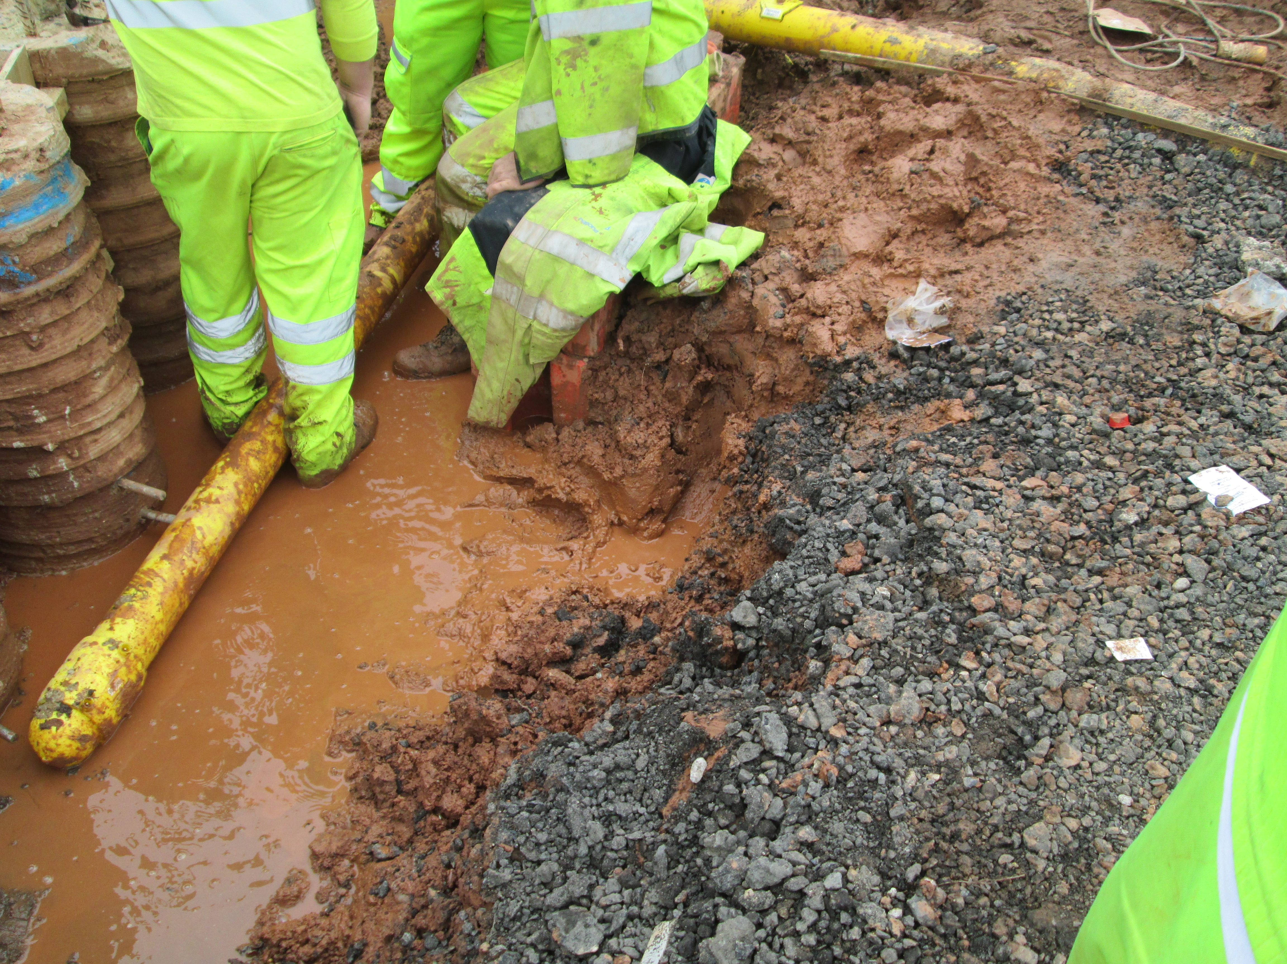
Shows part of the access / egress route

Outcome:

- The IP received immediate First Aid Treatment on site.
- The IP was removed from site via an ambulance.
- The IP was kept in hospital overnight where he received surgery on his broken left knee cap.
- The IP was released from hospital the following day to recover.
- Recovery is still ongoing and expected return to work to be at least 6 – 8 weeks.

Root Cause:

- Unexpected changes to planned works due to the main being installed too high
- Backfill to the area over the existing 355mm dia gas main had not been adequately compacted and had become soft when exposed to poor weather conditions.
- Unauthorized access / egress route used to access work area.
- Human behaviours - IP not considering the suitability of the route he took despite being briefed on the need to ensure safe means of access and egress in the First 10 minute briefing from the Works Manager.
- Unsafe system of work (no evidence of documentation Risk Assessment / Method Statement specific to task or current surrounding)

Remedial Actions:

- Access / egress to be reviewed and improved to work areas where necessary
- Demarcation between work areas to be clearly defined
- First Ten Minute briefing to ensure relevant surrounding hazards are identified and discussed and communicated to all personnel prior to commencement of works.
- Correct documentation needs to be in place prior to works being carried out.
- Ensure backfill and compaction procedures are maintained to ensure adequate ground conditions for work areas
- If any unplanned changes to works or work areas are to be performed, work needs to STOP, and review of methodology and documentation needs to take place with information briefed to all involved with work operations.

REMEMBER

“Nothing is so important that we cannot take the time to do it safely”

IF YOU ARE NOT SURE PLEASE SPEAK UP AND ASK

Name: Kelly Beesley
Project SHE Manager
Galliford Try Plc

Communication Required: (double click on box to tick action to be taken)
Toolbox Talk √ Notice Board √Supply Chain √Review of Site Activities √Information only €

Actions Completed by: ………………………………………………………….. Date ………………………………………

