Graham Review into Pre-pack Administration
Report to The Rt Hon Vince Cable MP
June 2014

Teresa Graham CBE

Contents

Contents 2
1. Foreword 3
2. Introduction 4
3. Executive Summary 6
4. Summary of Recommendations 10
5. Background 11
6. Findings of my Review 20
7. Discussion 21
8. Conclusions 52
9. Recommendations 59
Annex A: Redrafted SIP16 69
Annex B: The Review Team 76
Annex C: Stakeholders Engaged with as Part of the Review 78
Annex D: List of Recognised Professional Bodies 78
Annex E – Characteristics of Old Companies 80
Annex F – Characteristics of the Administration 84
Annex G: Priority of Distribution in Insolvency 89
Annex H – Suggested Considerations for the Pool 90
Annex I Specimen wording for pool member’s statements - positive and negative 93
Annex J Suggested Form of Wording for Viability Statement/Review 95

1. Foreword
Business rescue is a key element of an efficient insolvency regime. Viable businesses – and the jobs of those they employ – should not be lost to the economy unnecessarily. Stakeholders affected by an insolvency need to have confidence that the process is conducted objectively, without bias to any particular party and that the outcomes are the best they can be for creditors. If there is confidence in how rescue and insolvency operate, this supports lending which in turn supports growth - a central aim for this Government.
Pre-pack administration has been much criticised in some quarters in recent years. Opponents of the process have said that it lacks transparency, with deals negotiated in secret behind closed doors. Allegations have been made that the process does not result in the best value being achieved for businesses. Equally it can be an important way of preserving value. For these reasons, last year I commissioned Teresa Graham CBE to undertake an independent review of the process, as part of the Government’s wider ‘Transparency and Trust’ agenda.
I would like to thank Teresa Graham for her thorough and considered report and recommendations. I was particularly pleased to hear that her approach led to a strong level of engagement throughout the review from a range of those with different interests. This is perhaps a reflection of the high profile pre-packing has had in recent years, coupled with a desire on stakeholders’ part that the process be reformed to ensure the confidence we all want to see.

Vince Cable

2. Introduction
In the summer of 2013 Vince Cable gave a speech raising the issue of Transparency and Trust in business. Part of this speech noted the issue of pre-packaged sales in administrations (“pre-packs”) and I was asked to lead an independent review into these and their wider economic impact. This is the outcome of that review.
Every year some 250,000 businesses disappear from the Companies House register. Of those around 20,000 go through an insolvency procedure and about 600 to 700 of those are pre-packed. The pre-pack numbers are relatively small but the lack of transparency and trust in the process means that the “noise” surrounding them is far greater than should be the case.
Put the term ‘pre-pack administration’ into an internet search engine. You will find a plethora of hits and sponsored links for ‘ambulance chasers’ – dubious service providers who claim to have an answer for a company’s financial problems. That answer, these sites claim, is a pre-pack administration, allowing the rescue of an insolvent company’s business by its seamless transition into a new company. That same set of search results will also return numerous stories painting a less rosy picture of the process – critical articles attacking the process as unfair and borderline dishonest.
Pre-packing is clearly emotive but what is it? A pre-pack administration occurs when an administrator sells the business at or soon after his or her appointment, often to the existing owners/directors. All of the preparatory work for the sale is carried out in advance of formal administration and before the creditors have been told about the failure of the business.
The insolvency practitioner (and future administrator) often acts in a business advisory capacity to the company prior to the appointment. While pre-packs can bring clear benefits, such as preserving jobs, they are also perceived as lacking transparency and failing to protect creditors. Some have argued that they disadvantage competing, solvent companies in the same market.
At the start of my review, it was very apparent that many people, including me, had preconceived ideas about pre-packs. Many of those preconceptions were negative. At the same time, it was also very evident that there was little published research available based on recent data to support (or undermine) those preconceptions. For this report I have taken evidence from a very large number of people. I am grateful to all those who contributed for their candour. I also commissioned research based on a large sample of pre-packs from 2010, carried out for me by the University of Wolverhampton, in order that my recommendations could be built on a solid foundation of hard evidence.
My conclusion based on this evidence is that there is a place for pre-packs in the UK’s insolvency landscape – I do not recommend the banning of pre-packs. The benefits that pre-packing brings to the UK’s insolvency framework mean that reform of the process is worthwhile. There could - and should - be some major improvements to how they are administered.
I am a de-regulator at heart. I do not think that government should legislate other than as a last resort. I have made just six recommendations in this report, all of which require action on the part of insolvency regulators and the insolvency profession rather than government. I hope the insolvency industry embraces these measures – it is in all stakeholders’ interests, including insolvency professionals, that they are successful.
I believe that implemented as a complete package, my proposals will lead to real improvements in pre-packs; will help preserve jobs; and contribute to the UK economy as we emerge from the recession.
Finally I would like to thank the team that has assisted me with this report. Their hard work made my job all the easier.
Teresa Graham CBE

3. Executive Summary
3.1 No one wants to see legitimate businesses fail. It is not good for their owners, their employees and their families, their suppliers and customers and the UK as a whole. But the unfortunate truth is that many do, often for reasons outside of the owners’ control, such as the devastating floods we saw earlier this year. Last year 2365 businesses in the UK went into administration. Of these some 600 were subject to a pre-pack deal, where the administrator decided that the most efficient solution was to sell the business as a going concern to a purchaser located before his/her appointment. This sounds, on the face of it, like a reasonable proposition. So why have pre-packs managed to gather such a bad name?
3.2 This report looks at the brickbats thrown at pre-packs, assesses them against the facts and makes recommendations about how pre-packs, which I believe have their place in the insolvency market, can be improved for all concerned.
3.3 This report looks very carefully at all the concerns raised about pre-packs. Some are borne out by the empirical evidence; others are not. For the latter I hope the report dispels some of the myths surrounding pre-packs; for the former I make recommendations to deal with what I perceive as failings in the system.

The positives about pre-packs
Pre-packs can preserve jobs
3.4 Pre-packs ensure a company keeps trading, in contrast to a more protracted insolvency process which risks losing customers and employees. A large number of SIP16 statements refer to the preservation of employment as one of the reasons for using a pre-pack administration. Where there is a successful pre-pack and the company continues to trade jobs are secured. If the employees had been made redundant as a result of old company’s insolvency there would have been an increase in the likely preferential and unsecured creditor claims, to the detriment of the general body of creditors.

Pre-packs are cheaper than an upstream procedure

3.5 There are significant cost advantages of a pre-pack compared to an upstream (that is, before formal insolvency) procedure such as a scheme of arrangement. The costs of such schemes are larger due to the greater court and creditor involvement and are typically only undertaken by large companies. By contrast, a pre-pack administration can be undertaken outside of the court and can be done without the involvement of the unsecured creditors or only limited involvement.
Deferred consideration is, by and large, paid
3.6 Deferred consideration refers to where a purchaser pays for the business over a period of time, rather than on the date of the purchase. The high payment levels of deferred consideration seen in our research suggest that old company creditors are not unduly harmed by the presence of deferred consideration in a pre-pack deal. This is particularly the case if the agreement requires payments to be made within 6 months of the sale, where nearly 90% of cases receive full payment.
Pre-packs may bring some limited benefit to the overall UK economy
3.7 The ability to pre-pack is but one part of the UK’s restructuring and insolvency framework. Overseas companies may seek to move their ‘centre of main interests’ to the UK in order to avail themselves of the flexible restructuring, insolvency and company law framework here. These relocations are a source of inward investment to the UK and should be perceived as a positive advantage to the economy.

What needs improving about pre-packs?
Pre-packs lack transparency
3.8 The nature of pre-pack administrations leads to a lack of transparency before the sale as the parties work to secure the future of the business without risking the confidence of creditors, customers and employees. Unsecured creditors feel disenfranchised by this secrecy, particularly where the purchaser is connected to the insolvent company. Improved marketing and a fuller explanation of valuation methodology would help greatly to improve transparency, as could the voluntary introduction of an independent opinion on the deal’s outline and why it was necessary to proceed in this way, particularly in connected party cases.
Marketing of pre-pack companies for sale is insufficient
3.9 The quality of marketing of businesses that intend to pre-pack needs to improve. The evidence of our research shows that where no marketing is carried out pre-packs return less money to creditors. Improved quality of marketing may in some cases, assist the administrator in receiving a better return. It will also, and possibly just as importantly, improve creditors’ perceptions that they are getting the best deal available. This should improve confidence in pre-pack administration and in the insolvency regime more generally.

More must be done to explain the valuation methodology
3.10 According to our research, in the overwhelming majority of cases - 91% - an independent valuation was conducted as part of the pre-pack process. However these appear to be desk-top valuations only. Where there is a connected sale the purchase price often exactly matches the valuation figure. This leads to the suspicion that a purchaser has set a valuation as an indicator of how much it is prepared to pay, rather than the market value of the assets in question. The valuation was often limited to certain assets, normally the assets and property, but not the intellectual property or goodwill. More could be done to explain the valuation methodology.
No consideration is given to the future viability of the new company
3.11 The insolvency practitioner has no legal requirement to look at the future viability of the new business emerging from a pre-pack sale. His/her only legal responsibility is to the creditors of the old business. However both public perception and our research suggest that future viability, especially in the case of connected party pre-packs, is a concern for both transferring suppliers and new ones. Again I think more could be done to demonstrate the potential viability of the new business/company emerging from the pre-pack.
3.12 The regulation - and monitoring of that regulation – of pre-pack administration could be strengthened.
3.13 SIP16 has had two iterations since its introduction in 2009. The latest version is a welcome improvement but more could still be done to help eliminate bad practice.

4. Summary of Recommendations
Key recommendation 1: Pre-pack Pool. On a voluntary basis, connected parties approach a ‘pre-pack pool’ before the sale and disclose details of the deal, for the pool member to opine on.
Key recommendation 2: Viability Review. On a voluntary basis, the connected party complete a ‘viability review’ on the new company.
Recommendation 3: SIP 16: that the Joint Insolvency Committee considers, at the earliest opportunity, the redrafted SIP16 in Annex A.
Recommendation 4: Marketing: that all marketing of businesses that pre-pack comply with six principles of good marketing and that any deviation from these principles be brought to creditors’ attention.
Recommendation 5: Valuations: SIP16 be amended to the effect that valuations must be carried out by a valuer who holds professional indemnity insurance.
Recommendation 6: SIP 16: that the Insolvency Service withdraws from monitoring SIP16 statements and that monitoring be picked up by the Recognised Professional Bodies.
4.1 Should these measures fail to have the desired impact and they are not adopted as I would hope by the market, then Government should consider legislating.
4.2 To encourage take up of the proposals, Government may wish to consider taking a reserve legislative power at the earliest opportunity, in order that it can act should the behaviours outlined in this report continue.
4.3 My thinking behind each of these recommendations is given in Section 9 of this report.

5. Background
Why another review?
5.1 In 2010 the Government consulted on improving transparency and confidence in pre-packaged sales in administrations . This work led to a proposal that creditors be given a short period of notice prior to sales going ahead. This proposal was withdrawn in early 2012, as the Government was not convinced that the specific benefit of the proposal outweighed the overall benefit to business of keeping to the micro-business moratorium.
5.2 But still the disquiet over pre-packing persisted and the Government decided that a further review was required.
Terms of reference of this review
5.3 In the summer of 2013 Vince Cable MP, Secretary of State for Business, Innovation and Skills, announced an independent review into pre-pack administration. The reviews terms of reference were:
- To assess the long term impact of pre-pack deals to form a view as to whether they encourage growth and employment; and whether they provide the best value for creditors as a whole;
- To assess the usefulness of the pre-pack procedure in the context of business rescue generally, using international comparisons as and when appropriate;
- To assess whether pre-packs cause detriment to any particular groups of creditors and specifically whether unsecured creditors are disadvantaged;
- To assess whether there are any practices associated with pre-packs which cause harm.
Review team
5.4 Details of the review team are given at Annex B.

Guiding principles of the review
5.5 I am by nature a de-regulator. I believe in the principle of comply or explain. This principle avoids the inflexible ‘one size fits all’ approach. It allows individuals and companies to use an approach that best suits them, while also explaining why some areas may not apply to their business.
5.6 I do not believe that the State should legislate other than as a last resort. Equally, I do not believe that market participants should rely upon the State to sort out problems that they themselves could remedy, or at least mitigate. Suppliers and in an insolvency situation, creditors, have a responsibility to manage their own risk efficiently.
5.7 Where regulation is required it is essential that it adheres to the principles of better regulation:
- Proportionality: regulators should only intervene when necessary. Their remedies should be appropriate to the risk posed, and costs identified and minimised;
- Accountability: regulators must be able to justify their decisions, and be open to public scrutiny;
- Consistency. rules and standards should be joined-up and implemented fairly;
- Transparency: regulators should be open in their policy making, and keep interventions simple and user-friendly;
- Targeted: interventions should be focused on the problem, and minimise side effects.
Method of working
5.8 In an emotive issue like pre-packs, where debate can be heated and views polarised, it was essential that the review team spoke to as many key stakeholders as possible. Accordingly, we gathered evidence from a wide cross-section of interested parties during the review. The review team is very grateful to all those who contributed to the review. A list of all those we spoke to is given at Annex C.

5.9 As helpful - and as essential - as this qualitative information was, we needed quantitative research so that our deliberations, conclusions and recommendations would be truly representative of the pre-pack market. We commissioned research from the University of Wolverhampton to:
- Model the characteristics of the types of company that enter administration and pre-pack their business;
- Test the assertions made by stakeholders during the evidence gathering phase of the review;
- Ascertain if there were ‘patterns of harm’ shown by the data; and
- Make recommendations to aid the efficient working of the market.
5.10 A copy of the research is available at https://www.gov.uk/government/publications/graham-review-into-pre-pack-administration
Corporate insolvency in the UK
5.11 Although corporate insolvency history in the United Kingdom can be traced back to the beginnings of the concept of limited liability in the mid 19th century, the administration procedure is a relative latecomer to the statute book. The procedure was first created by the Insolvency Act 1986 (1986 Act), following recommendations in the Cork Report. That report believed that too many businesses came to an end through insolvency, despite all stakeholders benefitting more if businesses were rescued. It recommended the creation of a ‘rescue culture’ in the UK. This led to the creation of administration in the 1986 Act.
5.12 While the 1986 Act remains the foundation of insolvency legislation in Great Britain, the administrative procedures were radically reformed by the Enterprise Act 2002. This reflected concerns within the Government of the time that uptake of the rescue procedures outlined in the 1986 Act had been disappointingly low.

5.13 The Enterprise Act 2002’s corporate insolvency provisions (effective from September 2003) amended the 1986 Act’s provisions on administration by incorporating a new Schedule on the procedure into the 1986 Act. These provisions greatly streamlined the process and reduced the cost of entry into administration. These costs, which particularly related to the documents required for court proceedings, had created an economic barrier to entry into administration. This was believed to impact adversely on small and medium-sized enterprises (SMEs), as the predominantly fixed costs of a court application imposed a disproportionate burden on them. For these companies there was little other choice but to opt for liquidation, destroying any underlying value in their businesses.
5.14 The changes had a dramatic effect. The number of administrations increased to 1,602 in 2004 from 643 in 2002; a rise of some 150%. By 2007, administrations had risen to 2,512; an increase approaching 300% on 2002 figures. By contrast liquidations fell from 16,306 in 2002 to 12,507 in 2007; a fall of 23%.

What is pre-packing?
5.15 The 1986 Act’s administration provisions, as amended by the Enterprise Act 2002, do not make any reference to pre-packing. Case law had however established that pre-packing was permissible by law both for old, pre-Enterprise Act 2002, administration and the administration law that exists today. But nowhere in statute is pre-packing defined or referred to. It is however a widely understood concept. Our working definition of pre-packing is:
“Arranging the sale of all or part of a company’s undertaking before formal insolvency is entered, with the sale to be executed at or soon after the appointment of an administrator.”

5.16 Although detailed statistics on pre-packing were not kept until the implementation of the SIP16 in 2009, it is likely that pre-packing increased after the implementation of the Enterprise Act 2002’s amendments to the 1986 Act, particularly as the lower costs opened up administration generally to smaller, owner-managed companies.

Why have pre-packs become an issue?
5.17 Concern around pre-packing in the mid-2000s led to the creation of a statement of insolvency practice devoted to it (SIP16). SIPs are a series of guidance papers that set out principles and procedures that should be followed by insolvency office-holders. SIPs are agreed by the insolvency regulatory authorities and departure from the practices they describe may be considered by an insolvency practitioner’s licensing body in considering disciplinary or regulatory action.
5.18 SIP 16 requires the administrator to give details of the pre-pack to the creditors - such as the price obtained, valuation of the assets, whether the purchaser was connected etc. The notice must be sent to the creditors within seven days of the sale. It should also be sent to the Insolvency Service, which monitors compliance with the SIP and publishes regular reports on the level of this compliance.
5.19 Since the Insolvency Service’s monitoring on pre-packing began in 2009, slightly over a quarter of all administrations have been pre-packed, at a constant and stable rate each year.
5.20 The Office of Fair Trading report The Market for Corporate Insolvency Practitioners: A Market Study in 2010, while not specifically about pre-packs, referred to a number of complaints about pre-packing it had received from creditors as part of its evidence-gathering for its study. The OFT also flagged a lack of hard data on the level of pre-packing - something that is addressed in my review.

Regulating the insolvency profession
5.21 To take an appointment as an administrator, an individual must be an insolvency practitioner licensed by one of seven recognised professional bodies (see Annex D) or, until 2015, directly by the Secretary of State for Business, Innovation and Skills. As of 1 January 2014 there were 1,738 insolvency practitioners licensed in England and Wales of whom 1,355 take appointments.
5.22 Insolvency practitioners play a central role in pre-packs. They are often involved in an advisory capacity prior to the start of the administration and later more formally as the administrator. It is therefore of the utmost importance that they meet high professional standards.
5.23 When I first agreed to lead this review, I was astonished to learn there were so many regulators for such a small number of active insolvency practitioners. By comparison, the Royal Institution of Chartered Surveyors, where I chaired the Regulatory Board between 2005 and 2009, is the sole professional body for chartered surveyors responsible for some 180,000 chartered surveyors and students in the UK and globally.
5.24 All administrators are officers of the court, even where the court has not appointed them. Any creditor or member of a company can challenge at court the administrator’s conduct as regards a company if they believe he or she has acted unfairly to harm their interests. In practice this is a very costly exercise. Similarly if someone believes that an administrator has acted unethically, unprofessionally or improperly they can make a complaint to the insolvency practitioner’s recognised professional body via a complaints gateway operated by The Insolvency Service (the Gateway was created in response to the OFT market study).

5.25 That report was also one of the drivers behind the Government’s 2014 consultation on strengthening the regulatory framework through the introduction of clear regulatory objectives and to give the oversight regulator, The Insolvency Service acting on behalf of the Secretary of State, more appropriate powers to deal with poor performance, misconduct and abuse. In that consultation the Government recognised that the lack of appropriate and proportionate enforcement powers left it in a weak position and undermined the credibility of the regulatory regime.
5.26 I welcome the steps the Government is taking to strengthen the regulatory regime. Had the Government not already proposed changes to the regulatory regime, it is likely this review would have recommended that it do so.
5.27 The introduction of regulatory objectives should provide regulators with a clearer, enhanced framework within which to discharge out their activities. This is important in all insolvency processes but especially so in such a contentious area as pre-pack administrations, where much of the work to arrange a deal is done away from the gaze of creditors.
5.28 I particularly welcome two of the proposed regulatory objectives:
- encouraging an independent and competitive insolvency practitioner profession, whose members deliver quality services with transparency and integrity; and
- that promoting the maximisation of returns to creditors should be directly beneficial to those affected by pre-pack administrations.

Evidence gathering
5.29 There were two aspects to the evidence-gathering for the review. The first was going out and actually speaking to those who are affected by pre-packing: suppliers, landlords, insolvency practitioners, lawyers and many more. This qualitative information was complemented by quantitative information, commissioned from and led by Professor Peter Walton of the University of Wolverhampton.
Qualitative data
5.30 A crucial part of this evidence-gathering process was to gauge stakeholders’ perceptions of pre-packing: what do they really think of the process? These perceptions were then compared with evidence arising from the academic research commissioned on a sample of pre-packs.
5.31 Where perceptions and anecdotal evidence - negative and positive - coincided with the research data, these have informed my recommendations. Where perceptions are misplaced, I hope that the findings of that research and my review as a whole will correct any misconceptions.
Quantitative data
5.32 Anecdotal evidence provided by stakeholders has been invaluable in focusing my attention and, indeed, understanding the strength of opinion on the practice. But without hard data many of my recommendations would have struggled to gain traction with the competing interest groups in insolvency, including the Secretary of State who commissioned this review.
5.33 Accordingly, a study into the characteristics and outcomes of pre-pack administrations was commissioned. A random sample of 499 companies that entered pre-pack administrations in 2010 was selected. 2010 was chosen as the base year for this new research as this allowed time for the new SIP16 process to have bedded in and also allowed the research team to monitor the success of the purchasing company for three full years following the sale.

5.34 The researchers examined the companies’ SIP16 statements, along with records from Companies House and the Inter-Departmental Business Register to compile a rich dataset relating to these companies. The researchers repeated this exercise for 110 companies that entered administration, continued to trade and from which the business was then sold as a going concern by the administrator. This second dataset was used to make comparisons with pre-packs as a counterfactual to that data. The data gathered included:
- The characteristics of the company entering pre-pack or trading administration: industry sector; incorporation date; number of employees; and turnover;
- Details of the company’s insolvency including reasons for failure; insolvency practitioner firm and nature of appointment; IP fees; length of administration; and whether the company was liquidated or dissolved;
- Details of the company’s administration including company valuation; break-up value; whether marketing was conducted prior to the pre-pack; the purchase price and purchaser; whether the sale was made to a connected party; the extent of any deferred consideration; and employment preservation;
- Amounts owed to and dividends paid to various categories of creditors; and
- Details of any subsequent insolvency of the purchaser correct as at February 2014.
5.35 The researchers analysed the data and presented a summary report - The Wolverhampton Report. The report describes the characteristics of companies entering pre-pack and trading administration; the nature of the subsequent purchase; and failure rates of new companies. The researchers also carried out statistical analysis of the data to establish whether failure of new companies correlated with certain characteristics of old companies or the nature of the purchase. Further statistical analysis was also undertaken to investigate whether, all else being equal, the odds of failure of the new company differed between pre-packs and trading administrations.

6. Findings of my Review
6.1 Positives
- Pre-packs can preserve jobs
- Pre-packs are cheaper than an upstream procedure
- Deferred consideration is, by and large, paid (and in particular where it is due within 6 months) - old company creditors are not unduly harmed by the presence of deferred consideration in a pre-pack deal
- Where comparing like with like pre-packed new companies are, on average, more likely to succeed than business sales out of trading administrations
- Pre-packs may bring some limited benefit to the overall UK economy from overseas companies relocating their pre-pack activity to the UK
6.2 Negatives
- Pre-packs lack transparency
- Marketing of pre-pack companies for sale is insufficient
- More could be done to explain the valuation methodology
- Insufficient attention is given to the potential viability of the new company
- The regulation - and monitoring of that regulation – of pre-pack administration could be strengthened.

7. Discussion
What does a company that enters into a pre-pack look like?
7.1 Much of the concern on pre-packs is focussed on the ‘deal’ itself: what has been sold, for how much and to whom. Some also expressed worries about so called “serial pre-packing” and the long term viability of pre-pack outcomes, especially where connected parties were involved. This was reflected in much of what I was told by stakeholders. Many of my meetings were spent discussing the pros and cons of pre-packing, with examples given of what were perceived as particularly ‘good’ or ‘bad’ behaviour.
7.2 But little of what I was told focussed on the insolvent companies themselves pre-formal insolvency – what did they look like? Little could be said authoritatively on the pre-insolvency characteristics of the companies themselves because those I spoke with understandably only had their own experience to draw from. A partner in a major insolvency or law firm is very unlikely to have had much recent experience in micro-business pre-packs, for example.
Characteristics of old companies
7.3 The Wolverhampton Report provided detailed information on the characteristics of companies that entered pre-pack or trading administration in 2010. The main findings are set out in Annex E. My conclusions are that:
- I did not find evidence that ‘serial pre-packing’ was a regular occurrence: the majority of companies entering pre-pack administration were over five years old, with around half the sample aged between five and fifteen at the point they pre-packed (Figure E1). This was a younger age profile than that of the sample of trading administrations. However, we have no information on how long the incumbent management team had been in place in either sample;
- Most companies entering administration that pre-packed can be categorised as ‘micro’ or ‘small’ on both employment and turnover measures (Figures E2 and E3). This was also true of the sample of trading administrations, though this latter group had a higher proportion of medium-sized companies as measured by employment;
- The main industry sectors for companies entering both pre-pack and trading administrations had some similarities – manufacturing, wholesale and retail trade, administrative and support services, and construction were all prevalent in both samples (Figure E4);
- According to information provided by administrators the most frequently cited cause of failure for the companies in the samples (pre-packs and trading administrations) was “market conditions” (Figure E5). A higher proportion of failures of trading administrations in the sample were blamed on “funding issues” and “mismanagement” than was the case for pre-packs, which instead had more frequent mentions of “one-off events” and “undercapitalisation/excessive debt”;
- Only six companies out of a sample of nearly 500 which entered pre-pack administration in 2010 had been incorporated outside the UK, of which five were part of the same group
- The profile of unsecured debt (Figure E6) was quite different for pre-packs and trading administrations: median debt for pre-packs was £565,000, compared with £960,000 for trading administrations. However, the structure of the sample of trading administrations, which contained a number of grouped companies, may have distorted these results;
- Debts reportedly owed to HM Revenue and Customs (HMRC), by contrast to the above, were fairly similar for pre-packs and trading administrations (Figure E7). However, this is based on the statements of affairs filed by directors or, in their absence, on the estimations of the administrators based on the company records. Details of claims made by HMRC, i.e. the claim made by HMRC to the administrator, in proving its debt, are not available. The information could not be quantified in the majority of cases, as the administrators only infrequently made reference to filed claims by HMRC and often these were not verified given the unlikelihood of any dividend being paid.

Details of the sale
7.4 Focusing next on aspects of ‘the deal’, from the data on pre-packs gathered by the researchers I found the following (see charts in Annex F):
- The administrators of most companies entering administration that pre-packed were appointed by the company/its directors (Figure F1);
- Most sales were completed for less than £100,000, which follows from the earlier observation that most companies that pre-packed in 2010 were micro or small (Figure F2);
- The majority of administrations that featured a pre-pack appeared to have been completed within the statutory 12-month period (Figure F3); and
- A slightly higher proportion of pre-packs ended in dissolution than in creditors’ voluntary liquidation (Figure F4).
7.5 I also found that a majority of pre-packs involved sales to a connected party, and/or deferral of payment by the purchaser; and that marketing was often done in a perfunctory manner. As these aspects were common themes in the ‘noise’ surrounding pre-packs. I will discuss them in more detail later in this section.
Support for pre-packing
7.6 Those I spoke with identified a number of features, unique to pre-pack administrations, which meant that - when used properly - they provided a key and distinct role in support of the rescue culture.
7.7 One of the main arguments used in support of pre-packing is that the secrecy preserves value in a business. Those who made this argument suggested that the absence of the ability to pre-pack would be detrimental in a number of areas:
- Suppliers - might be less willing to transact with a company in administration as they might fear that they would not receive their goods.
- Employees - staff in a company that was undergoing a trading insolvency might be fearful for their future employment prospects and might therefore look to leave to another employer.

- Lowers the cost of administration - this particularly applied to multi-site businesses where an administrator felt that a member of staff would be needed at each site. Using a pre-pack sale in such circumstances would remove the need for the administrator to have a presence at all sites.
7.8 Even having undertaken a counterfactual analysis, it is difficult for me to test these statements because they reflect actions rather than hard data. For example, it is not possible to test the unwillingness of a customer to transact with a company had it traded in administration instead of pre-packing or whether staff would have left their jobs if they had know about a potential insolvency. Secrecy is difficult to maintain, particularly in a SME.

Pre-packs preserve jobs
7.9 Employment preservation, however, is an area where I have been able to test the assertion that pre-packs are good for jobs. I was keen that the academic research should look at prospects for the old company employees of the sample companies.
7.10 A large number of SIP16 statements cited the preservation of employment as one of the reasons to pre-pack. The benefit is often reported by administrators as the preservation of the jobs themselves, but more usually as achieving a reduction in the likely preferential and unsecured creditor claims were the employees to be made redundant as a result of old company’s insolvency. This may have been because the legislation does not cite 'saving jobs' as a statutory objective but does stress that the administrator must act in creditors' interests. Saving jobs is important for other creditors, including floating charge holders, as part of what the old company would otherwise have owed to its employees would be classed as preferential and so paid in priority to floating charge creditors and unsecured non-preferential creditors.
7.11 Despite this, the information regarding employment preservation reported in the SIP16 statements was often poor. It would appear that where all of the jobs had been saved, this was reported to creditors. However, where less than 100% employment preservation had been achieved, the information given in these statements became more opaque.
7.12 The veracity of these figures cannot be confirmed and neither can the length of the ‘new’ employment. It is not possible on the data presented to provide comment on the extent of employment preservation in the 51 cases categorised as ‘some’. Nonetheless it appears that, the claim by proponents of pre-packs that they preserve jobs is a correct one.
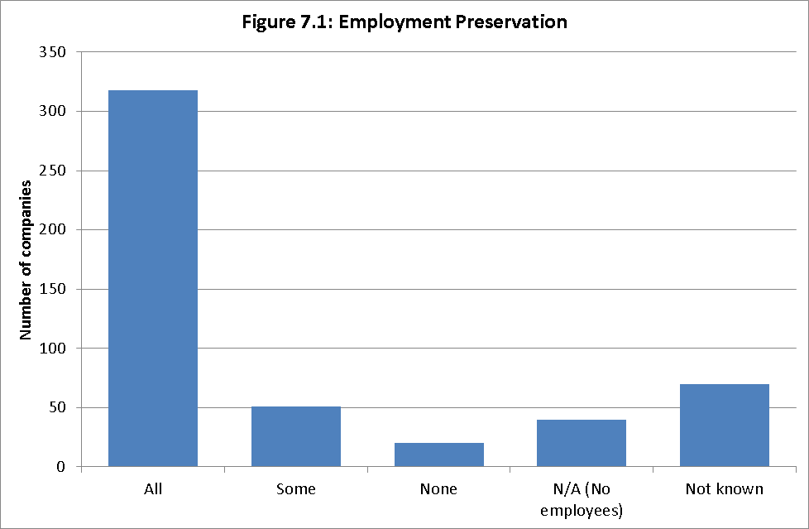
Lack of money to trade an administration
7.13 A consistent message from stakeholders was that finance to fund a trading administration has declined over the years. With no money to fund a trading administration, if a pre-pack were not possible, the most likely route for the insolvent company to take would be liquidation. Liquidation destroys value and jobs.
7.14 This claim of finance drying up may be true when compared with the early 2000s, but I do not have the data to test it. What I can say, however, is that pre-pack administrations as a proportion of all administrations have remained constant since SIP16 was implemented in 2009.
7.15 A lack of available funding to trade the company in administration was cited as an issue in a particular pre-pack case, but the data indicates that, as an industry-wide phenomenon, funding is no more an issue now than in 2009.
Cost advantage compared to an upstream procedure
7.16 Those involved in larger pre-pack deals also spoke about the significant cost advantages of a pre-pack compared to a pre-insolvency procedure such as a scheme of arrangement. Such schemes are typically only undertaken by large companies. A scheme is a compromise or arrangement between a company and its members or creditors or any class of them.
7.17 I was told that a scheme typically would cost three times more than the fees associated with a pre-pack for the same large company. Costs of a scheme are larger due to the greater court and creditor involvement. By contrast, a pre-pack administration can be undertaken outside of the court, and can be done without the involvement of the unsecured creditors or only limited involvement.
Regulatory limitations of trading insolvent
7.18 Insolvency practitioners told me that, in some regulated professions, regulated parties are unable to trade while in administration. I was told that a pre-pack provides the best available option in these cases as there is continuity and no destruction of value. I was told that, if there were not regulatory restrictions in some industries that prevented trading in administrations, it was possible that some of those companies could be traded in order to seek a better return for creditors.
I have no means of confirming or countering this claim.

Benefits to UK Plc
7.19 The UK has a strong and flexible insolvency, restructuring and company law legislative framework, underpinned by a common law legal system. This makes the UK a good place to do business in and an attractive country to relocate to. Few companies may relocate to the UK solely to pre-pack – though I have been told that this happens. Having a flexible restructuring regime, of which administration is one of a number of possibilities (and which itself has different outcomes, including pre-packing), is but one of a number of factors in an overseas company choosing to relocate to the UK.
7.20 The research carried out by University of Wolverhampton found that only 6 of the 499 companies sampled were registered overseas (and five of those were part of the same group), so incidences of relocation to the UK specifically to pre-pack are relatively few. However, I have been told by stakeholders that volumes have increased since 2010.

7.21 The table below shows the ability to pre-pack in various EU countries.
Table 7.1: Pre-packs in European Union Member States
Member State | Pre-pack (or equivalent) available? | Court approval required | Any specific rules/differentiation in relation to the size (by value) of the pre-pack | Any planned legislation to implement or regulate pre-packs
Belgium | Yes (although not specifically provided for in Belgian insolvency legislation) | Yes (in some instances, creditor approval is also required) | No | No
Czech Republic | Yes | Yes | No | No
France | Yes | Yes | Yes | No
Germany | Yes (very broadly) | No (but creditors assembly approval required) | No | Under consideration
Hungary | No | N/A | N/A | No
Italy | Yes | Yes | No | No
Luxembourg | No | N/A | N/A | Under consideration
The Netherlands | Yes | Yes | No | Under consideration
Poland | No | N/A | N/A | Under consideration
Romania | No | N/A | N/A | No
Slovak Republic | No | N/A | N/A | No
Spain | No | N/A | N/A | Under consideration
UK | Yes | No | No | Under consideration
Source: Allen & Overy

7.22 With the exception of Germany, of those countries that offer a pre-pack or an equivalent, all involve court and sometimes creditor involvement. Germany meanwhile requires approval through a creditor committee. Away from Europe, I have been told that Australia has few, if any, pre-packs, which is ascribed to its strong independence standards for insolvency practitioners and a culture based on creditor participation supported by legislation.
7.23 As shown in the grid above, many of these countries are currently considering reforms to their rules. Countries are seeking to make the most effective use of their insolvency regimes to preserve value in their insolvent, but viable businesses - the same drivers that led to the creation of the UK administration regime in 1986 and its revision in 2003.

Criticisms of pre-packs
7.24 Interestingly, an aspect of pre-packs that is considered by some to be a strength of the process - early exercise of administrator power to sell assets/business without approval of creditors - is also one of the central criticisms from those opposed to the practice.
7.25 Where a business has been pre-packed, sales are presented to the general body of unsecured creditors as a fait accompli without their being able to consider the sale. I am open to the idea that, all other things being equal, this may be a ‘necessary evil’ if it delivers the best offer for the business/assets. If, as has been claimed, knowledge of an administration can destroy value -which will never be in the creditors’ interests - the secrecy that is inherent in pre-packs may have an absolute benefit. This remains true, even when it is perceived by some (particularly creditors) not to be the case.

7.26 Some of those we spoke to stated that, if returns are to be low, they would not mind a slightly reduced return - for example a return of a couple of pennies in the pound of their debt less - if the sale and marketing process was more transparent. This is not a decision that an administrator can make under the existing insolvency law, where their every decision must be in the interests of creditors as a whole.
7.27 It should also be remembered that in many cases the unsecured creditors will be ‘out of the money’. That is, whatever is raised for the assets/business will be insufficient to pay, after expenses, the preferential creditors and the floating charge-holders and there will be no return to unsecured creditors. In such cases, this scenario would have been the same whether the business was pre-packed or the business traded by the administrator. There will, however, always be a risk that unsecured creditors’ perception, even where they had no realistic hope of receiving a return, will be adversely affected by a pre-pack deal, particularly, as I will discuss later on in this report, where the sale is to a connected party.
7.28 I spoke to several landlords and their representatives as part of my review. There is a feeling in that sector that landlords are treated poorly by the insolvency process. They feel ‘expendable’ to it and that their interests in particular are not best served by pre-packs. I was told of pre-pack cases where the sole objective seemed, to the landlords, to be a restructure of the balance sheet in order to shed unprofitable leased sites. All companies that enter administration must be insolvent but there was a feeling, from the landlords, that in some cases an insolvent state was ‘engineered’, for example, through a supposed withdrawal of parent company support, to create the necessary insolvency status.
7.29 I have a degree of sympathy with this position. Landlords are, to some extent, involuntary creditors, though not to the same extent as the Crown, which is also a regular creditor in pre-pack administrations. It is not my intention to make recommendations specifically that would affect the administrations of large, multi-site companies, which would be of interest to the landlord lobby.

7.30 Administration should be ’one size fits all’. I do not believe it helpful to make recommendations that favour one party over others. I am very conscious that the wrong procedural ‘tweak’ to these larger administrations could have unintended consequences in other, smaller, cases. However, I do encourage administrators to work fairly with landlords and for the insolvency practitioners’ regulators to be conscious of the issue.
7.31 Some stakeholders criticised the handling of retention of title claims. Broadly speaking retention of title, often referred to as ‘RoT’, is where legal ownership of goods sold on credit does not pass to the buyer until full payment has been made. An insolvency office-holder can only sell goods belonging to the insolvent company, i.e. excluding goods on RoT. Insolvency practitioners told me that ascertaining if goods are on RoT is often difficult, particularly in fast-moving situations. They also pointed out that it is in the wider body of creditors’ interest for them to challenge any RoT claims and they must act in the interests of this wider grouping. This is a very complex area with lots of competing interests at play and an increasing amount of case law. However, it is not an area confined to pre-packs so my response can only be limited. What l would observe is that, in its present complex form, RoTs have ceased to be a useful protective tool particularly for SMEs. I would welcome Government encouraging a debate on this area.
Distributions to unsecured creditors of an old company
7.32 I was told several times that unsecured creditors could expect to receive little, if anything, by way of a distribution from an insolvency. Accordingly, I was very keen for the research to gauge the range of returns to unsecured creditors from the sample of pre-pack cases from 2010. As shown in Figure 7.2, in the majority of cases no distribution was made to unsecured creditors at all.

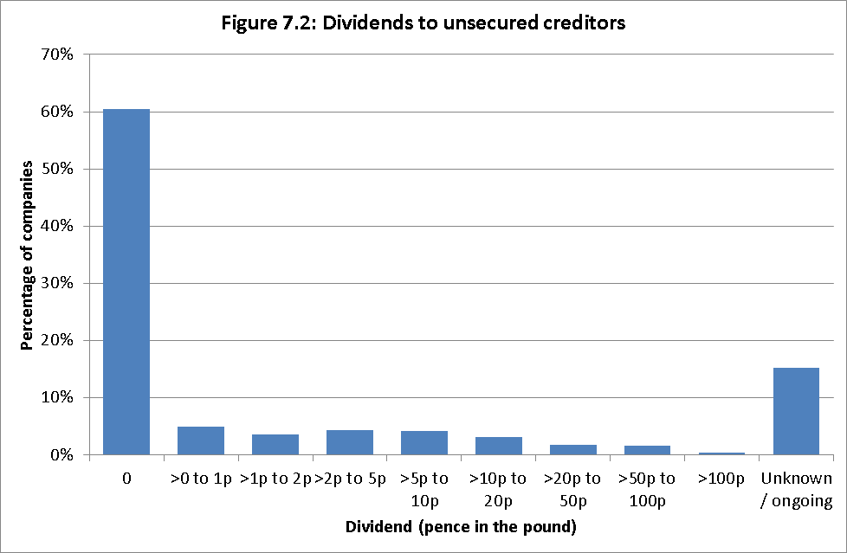

7.33 There is a statutory order of priority in insolvency (Annex G). Before any funds can pass to unsecured creditors, all the expenses need to have been paid, as do any amounts owed to preferential creditors and floating charge creditors. Assets subject to a fixed charge are applied to satisfy that fixed charge and any surplus is applied in the order of priority set out in the annex.
7.34 Where a distribution had been made in the sample, it tended to be small when compared to the overall unsecured debt figures. In the 121 cases where a distribution was made, the median payment was 4.3 pence in the pound, with the middle 50% of cases spread between 1.5 pence and 12.9 pence.
7.35 In the counterfactual of 110 trading administration cases, 56% paid no dividend to unsecured creditors and 24% paid a dividend with the dividend details of the remainder being unknown. Where a known dividend was made, the median payment was 7.0 pence in the pound.

7.36 I was surprised at these low levels of payment for unsecured creditors, particularly in the pre-pack cases. I was often told by insolvency practitioners during my review that they act in the interests of creditors and that, whatever recommendations I may eventually make, that duty should not be fettered. This data shows that unsecured creditors in particular receive only a paltry benefit from a pre-pack administration. Secured and preferential creditors, as one would expect given the statutory order of priority, fare better than the unsecured creditors but if those classes of creditors are chiefly benefiting from the administration process, it is little different from the administrative receivership process that Enterprise Act 2002 style administration was supposed to supersede.
Subsequent failure of the purchaser
7.37 One of the criticisms made against the new companies that emerge from pre-packs was that they were essentially the same business, with the only difference being that they are shorn of debt. If there were underlying problems in the business model of old company these could manifest themselves in new company leading to another failure. As shown in Annex E, the reasons for the failure of old companies are varied. Often it is an isolated event, such as a large bad debt, the loss of a key customer, floods etc rather than a cumulative set of events that may be thought less likely to occur a second time. Lightning is not likely to strike twice!
7.38 I was interested to know if there was any truth in this criticism. Do post- pre-pack new companies fail at a faster rate than other companies? Are many simply inherently unviable businesses?

7.39 The Wolverhampton research considered the incidences of subsequent insolvency of purchasers of businesses in pre-pack administrations. As the sample was drawn from cases that commenced throughout 2010 – and to avoid skewing the data - a bar of 36 months (ending January 2014) was chosen. By this point, even a December 2010 pre-pack could potentially have been operating for 36 months. The researchers were able to track the new company’s progress and any possible failure via the records that it had to file at Companies House.
7.40 The figures show that just over 5% of all pre-packs for which data can be ascertained failed within 12 months of the sale completing, with one purchaser entering creditors’ voluntary liquidation just 139 days after the pre-pack. There was a steady increase in each six month period thereafter to 36 months. By 36 months, 121 purchasers, or 25.5% of all sales, had failed.
7.41 This struck me as a high proportion of new businesses failing, each bringing about further losses for creditors and, in all likelihood, the taxpayer. But if this failure rate were no different for any other type of business, pre-packs would be no better or worse than any alternative. It was therefore important to compare these figures with a counterfactual group.
7.42 I did not think that the correct counterfactual group was start-up businesses. The post pre-pack new companies are not start-ups, even if the corporate vehicle that they operate within is new. These were established businesses, as shown in Annexe E. The majority of companies in the pre-pack sample were over five years old and the pre-packed business that emerged from them would not have been subject to the same pressures as new start-ups.

7.43 Accordingly, I settled upon business sales from trading administrations as the appropriate counterfactual. That sample showed that just fewer than 20% of businesses sold out of trading administration failed within 36 months, noticeably less than from pre-packs; however, when comparing like with like, pre-packs were more likely to succeed than business sales out of trading administrations – see paragraph 7.88 for a fuller explanation).
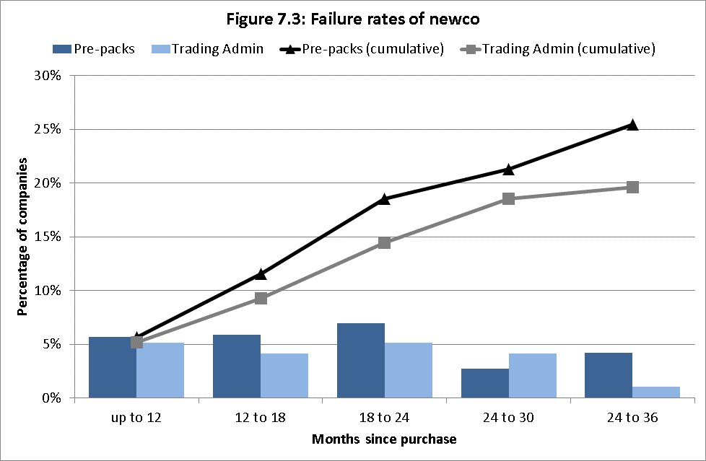

7.44 Insolvency practitioners with whom I spoke made clear to me that an administrator of an insolvent company cannot have regard to the likely survival of the new company. Their legal responsibility is with old company’s creditors. Old company’s creditors are best served by the administrator negotiating the best possible deal with the purchaser (and the administrator cannot concern him/herself with whether or not the purchaser cannot afford it). I agree with this position, however it is important that purchasers do not overstretch themselves and that this should be considered by the purchasing party in its negotiations.

Connected sales
7.45 One of the most common concerns about pre-packs that I heard time and again related to connected party pre-packs. A connected sale broadly refers to where an individual with control of the insolvent company exercises control over new company (the purchaser). It can refer to business sales where an individual is a director of either companies, or where a company exercises control both in old company and new company because of its level of share capital.
7.46 Allegations made particularly against connected party sales are:
- By perpetuating a failed business it interferes with the process of productive churn, which is the process by which the weak businesses fold and finance can be freed-up for new entrants. This is likely to be a particular problem where there is over-capacity in the sector;
- By enabling a company to resume trading shorn of many of its debts to the benefit of its existing owners, this allows it to unfairly undercut its rivals;
- It allows ‘bad businesses’ with poor business models to continue – that the pre-pack delays the inevitable and that the business will fail again, in its new corporate guise taking down more creditors on its way;
- It allows balance sheet re-engineering of businesses that may be technically rather than actually insolvent;
- The most damning allegation is that the whole thing was a sham simply to ditch debt and that a pre-pack was ‘always on the cards’ at some point.
7.47 It is easy to sympathise with the creditor who has lost a potentially large sum of money in the administration and then sees the director(s) of the old company operating the new company from the same premises. With those directors, as was said to me on several occasions, still “driving the same Rolls Royce through the factory gates.” In such situations creditors’ perceptions of pre-packing, and indeed the whole insolvency regime, will not be positive.
7.48 I am, however, reminded by something that I was told very early on in my evidence gathering process: creditors do not lose money when a company pre-packs. At that point the money has already been lost. The creditors lose that money when they offer credit to a failing business. Businesses must take responsibility for the credit that they offer their customers. They must do adequate due diligence and credit checks. Additionally there is an active credit insurance market in the UK, which businesses can use to protect against losses.
7.49 Given the high level of ‘noise’ that I had heard surrounding connected party pre-packs, I was very interested to see how prevalent the practice was.
7.50 Sales of the business and assets of the pre-packaged company to a party connected to old company dominated the sample of companies reviewed. Almost two thirds of purchasers were connected to the old company. The information relied heavily on self-reporting by the administrators in the SIP16 statements and filings at Companies House.

Table 7.2: Connected sales in pre-packs
 | Number | Proportion
Connected Sale | 316 | 63.3%
Not Connected Sale | 182 | 36.5%
Not known | 1 | 0.2%
Total | 499 | 100.0%

7.51 Of course, simply being a connected party case does not make the pre-pack in some way ‘bad’ regardless of the perception that such cases have with third parties. I cannot ignore what defenders of pre-packing, including those in favour of connected pre-packs told me. Often the connected party may be the only party willing to make the best or only offer for the business. They may see it as their livelihood and want to ‘have another go’.
7.52 ‘Having another go’ can be a good thing and something that we should encourage but only if that party has learnt from their previous mistakes. I was told of cases of ‘serial pre-packing’ – where controlling parties had been a party to a succession of pre-packs. Administration was not then being used as a rescue vehicle but a debt avoidance tactic. As I said above, the data suggests that this tactic is not widespread but where it does happen it can be shocking – one stakeholder I met described a situation where there had been eight pre-packs of the same business over a twenty-year period.
7.53 I wanted to test whether this poor perception of pre-packs was well-founded. I first considered those who had lost out - the level of distributions to unsecured creditors.
7.54 Figure 7.4 indicates that a creditor is more likely to receive no distribution at all in connected cases than in unconnected ones. Distributions paying more than 5p/£ of the unsecured creditors’ debts are also less likely in connected cases. This may be a result of a number of factors and is not necessarily a result of the connected nature of the deal. It is however an interesting statistic.
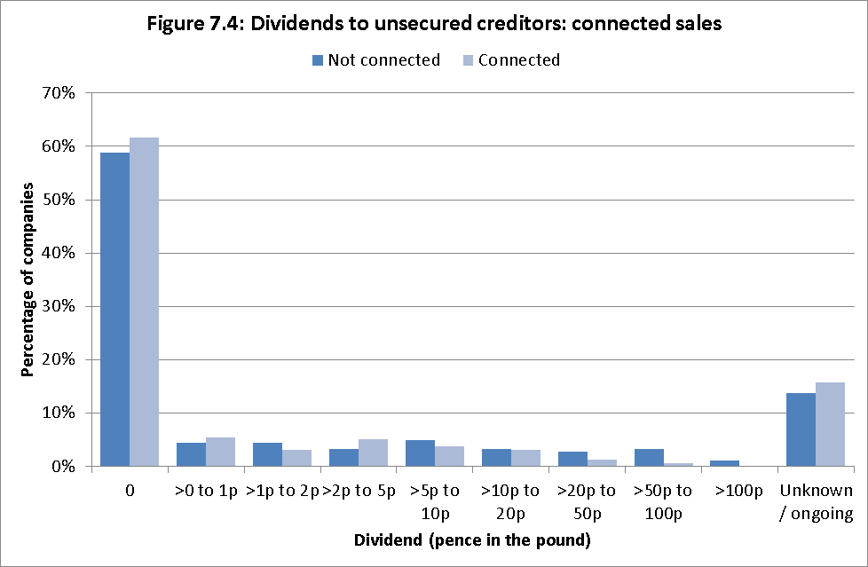

Survival rates of connected pre-packs
7.55 I then considered survival rates of connected pre-packs. I have already discussed the survival rates for all cases generally and compared them with the trading administrations’ counterfactual. I wanted to know if the failure rate in connected cases was any worse than the headline rate. If that were the case, there might be some credence to the critics of connected pre-packs.
7.56 The data show that 29% of connected pre-packs subsequently failed within three years, compared with only 16% of those that were not sold to a connected party.

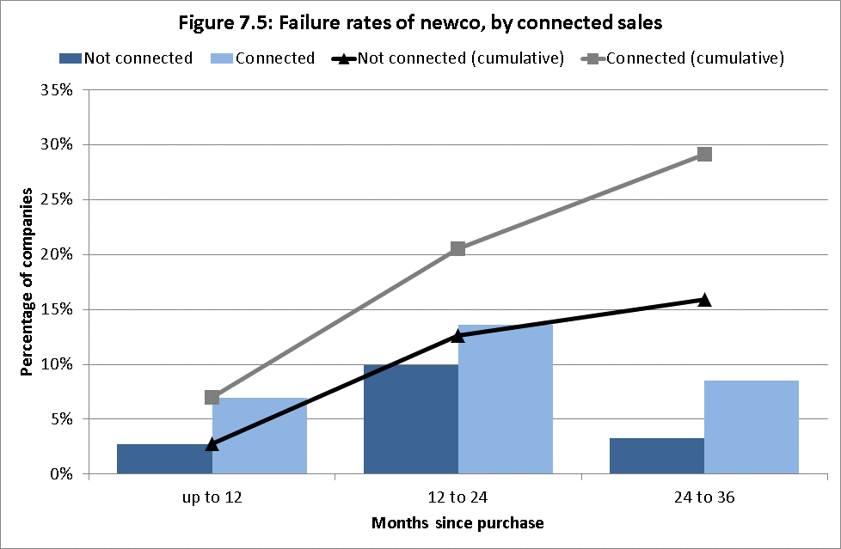
Deferred consideration
7.57 Something that is common to many connected cases was deferral of the sale price - where the purchase price for a business was not paid up front but was instead paid over the months that follow. Such deals may or may not also have an upfront cash payment. I was surprised when first told of this practice by stakeholders – of businesses essentially being bought on tick. I was very interested to find out how widespread these arrangements were - in both connected and unconnected cases - and how often these promises to pay in the future were honoured. Charts illustrating the extent of deferred consideration are included in Annex F but can be summarised as follows:
- Over half of all sales included an element of deferred consideration;
- The proportion of cases with elements of deferred consideration rose to 68% among connected cases;
- The majority of deferred consideration cases took some form of security. This was most frequently in the form of a personal guarantee from the director, though various other methods were used, including debentures, retention of title in the assets or fixed charges over property;
- In the majority of deferred consideration cases, the deferred sum was due to be paid within 12 months, most frequently between months 2 to 6 (Figure F5);
- In just over half of sales involving deferred consideration, the percentage of the purchase price that was deferred was over 70%. This included 23 purchases where 100% of the purchase price was deferred (Figure F6); and
- In 58% of cases, the cash element of the purchase price was less than the break-up value reported for the assets.

Payment of deferred consideration
7.58 This data, interesting as it was, only told me how often deferred consideration occurred and, where it did, the extent of it. What I was really interested in – and what might indicate mischief occurring – was whether or not the deferred consideration was paid.

7.59 Where deferred consideration was paid as agreed, there was arguably no harm to old company creditors in an administrator structuring a deal this way, if they believed that was the best deal for creditors (I will discuss the effects of deferred consideration on new companies later in this report). The research found the following regarding payment levels (chart F7 in Annex F illustrates these findings):
- Overall, deferred consideration was repaid in full in 79% of such purchases;
- Payment levels were consistently high across the sample, particularly where full payment was expected within 6 months (where 88% of purchasers paid in full);
- Repayment rates were slightly lower for purchases where security was taken – 77% of such cases receiving payment in full; and
- In cases where the cash element was less than the break-up value, there was a fairly high full repayment rate of 73%.

7.60 The high payment levels of deferred consideration suggest that old company creditors were not unduly harmed by the presence of deferred consideration in a pre-pack deal. This was particularly the case where the agreement required payments to be made within six months of the sale, where nearly 90% of cases received full payment.
7.61 This fact did not necessarily result in more money being paid out to unsecured creditors. Figure 7.6 shows that a dividend of any size was slightly more likely in a case with deferred consideration than one without. But it was only in distributions of up to 5p/£ where the frequency of such distributions was higher in cases with deferred considerations. For all dividends of >5p/£, this situation was reversed.

7.62 It is possible that the ability to strike a deal that includes an element of deferred consideration enables cases that would not distribute any funds at all to unsecured creditors to become cases where a small amount is distributed. Whether that is a comfort to unsecured creditors is debatable.

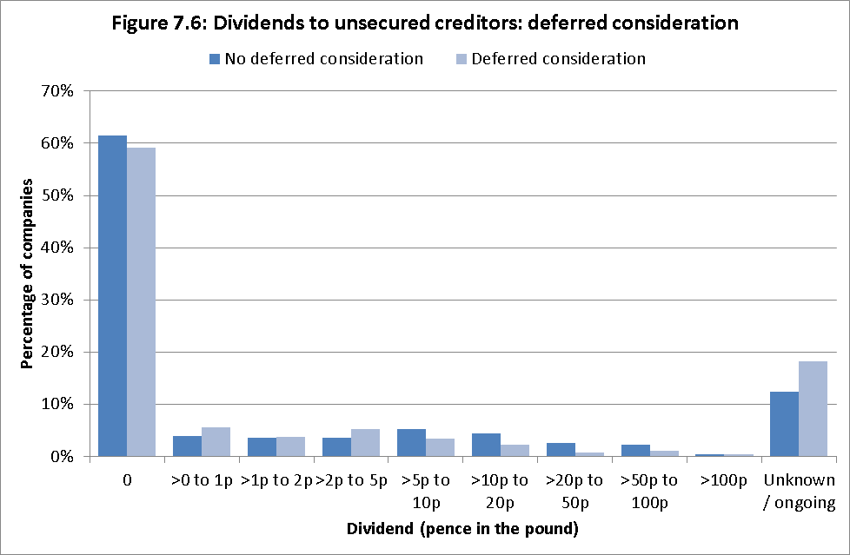

Marketing
What I was told
7.63 Creditors’ perceptions of connected pre-packs are worsened by another criticism of pre-packing made to my review - there being no, or insufficient, marketing before the sale is made.
7.64 Many stakeholders, particularly those representing creditors, told me that a major issue they had with pre-packs was the marketing of the business prior to sale. They criticised it for often being insufficient, inadequate or even non-existent. I was also told in no uncertain terms that they doubted that the best deal could be obtained for creditors without the business first having been properly marketed. How would other potentially-interested bidders be aware that the business was even available?
7.65 There was a contrary view from stakeholders from within the insolvency profession, predominantly insolvency practitioners. In some instances, I was told, marketing was simply not possible because that would generate publicity that the business was in trouble. This could have a negative impact on the business, reducing the likely value that could be obtained from its sale or even pushing it into liquidation before a pre-pack sale could be arranged. This could manifest itself in several ways:
- Key suppliers refusing to supply further materials;
- Key employees leaving the company;
- Customers ‘getting cold feet’ and not placing further business, for fear that contracts would not be completed due to insolvency.
What I found
7.66 I wanted to test these competing claims on marketing and asked my researchers to consider the extent that marketing was undertaken or not in the sample of pre-packs from 2010. Firstly, I wanted them to consider in how many cases marketing had taken place. This information was not available for the entire sample. Of the 499 cases considered complete information on marketing or the absence of it was held for 488 cases.

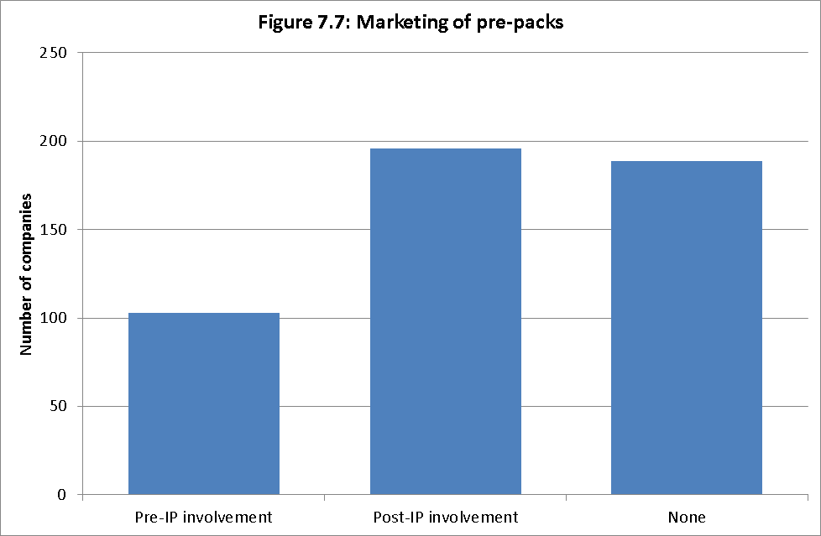

7.67 In quite a large number of cases, 103 out of the 488, the marketing was carried out by the company prior to the involvement of the practitioner. This may be fine, if the marketing is known to be open and fair, by which I mean it was not a just a one line advert for one week of a local free paper. But I would expect an insolvency practitioner, if told that the business had been marketed before their instruction, to test the adequacy of this marketing.
7.68 At the time of the sample, SIP16 on marketing required the administrator to state “Any marketing activities conducted by the company and/or the administrator”. In November 2013, SIP16 was re-issued. Marketing in the post November 2013 SIP16 has the following requirement “Any marketing activities conducted by the company and/or the administrator and the outcome of those activities or an explanation of why no marketing was undertaken”. The newer version is an improvement but I think more can still be done.

7.69 I appreciate, and creditors should appreciate it too, that where the practitioner is only instructed late in the day, perhaps after a winding-up petition has been presented, opportunities for marketing may be limited. Generally, where marketing was carried out it largely appears to have been conducted within the month prior to the pre-pack sale completing – 117 cases out of 185. However, for over a third of cases there was no clear evidence as to when the marketing was carried out or for how long.
7.70 Length of marketing, as well as who conducted it, is also important. This, too, may be influenced by external pressures on the company. Figure 7.8 shows the period over which a business was marketed.
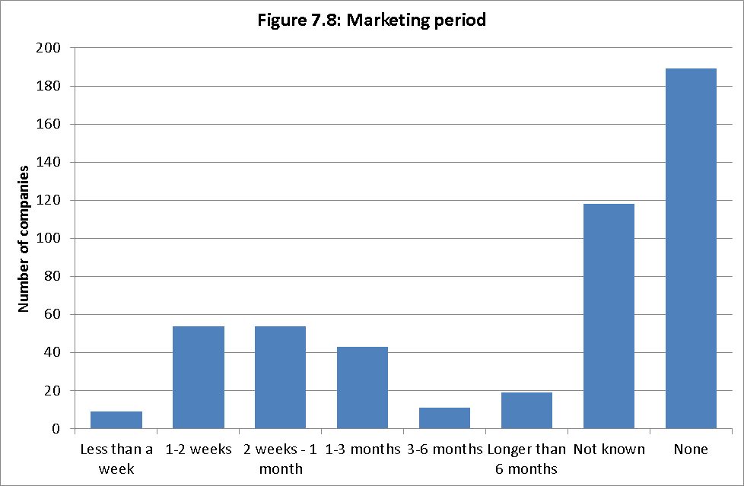

7.71 It is important to note that the data gathered on marketing is reliant on self-reporting by the administrators in the SIP16 statements. My researchers found the standard of reporting very variable and too often only limited marketing was carried out including:
- Limited enquiries made within the insolvency practitioner firm but no external marketing occurring;
- Insolvency practitioners accepting the word of the directors that there is no ready market for the business outside themselves or other connected parties, with no evidence that this assumption had been tested.
7.72 Based on what I was told by stakeholders and the academic research carried out by the University of Wolverhampton, I believe that the quality of the marketing undertaken in pre-pack cases is insufficient.
My concerns
7.73 In my view the quality of the marketing undertaken is just as, if not more, important than whether or not it was carried out in any form. The examples quoted above answered ‘yes’ more often than l would have given credit for – in my opinion they should have answered ‘no’. It is not that those avenues are wrong, or should not be considered. But they cannot stand on their own, with no other activity, and still be counted as ‘marketing’.
7.74 There may be occasions where it may be entirely proper that no marketing has been undertaken and where the administrator is certain, using their professional judgment, that the deal on the table is in creditors’ best interests. They should not be criticised for this. But they should not stretch the meaning of activity that has taken place, such as listed above, to then assert that ‘marketing’ has taken place. A lack of adequate marketing in the eyes of the person reading the SIP16 statement increases perceptions that there is something somehow ‘dodgy’ about pre-packs. This does neither the practitioner, their firm, nor their profession any credit.
7.75 As with the other snapshots on dividends that I have exhibited in my report, dividend payments were low when compared to level of marketing activity (see Figure F8 in Annex F). Even so the data showed that, in cases where no marketing had taken place there was a higher percentage of cases that paid no dividend at all to unsecured creditors.
7.76 As well as adding to the opaqueness, a lack of marketing can exacerbate the belief of creditors that the amount raised by the administrator for the sale of the business is not what that business/assets were worth. This leads us on to another criticism of pre-packing, that of inadequate valuations of assets.

Valuations
7.78 Administrators must, by law, act in the best interests of creditors. Some stakeholders told me that the valuations obtained and given by administrators in pre-packs were insufficient. Some even said that, had they not been ‘in the dark’ during the pre-pack negotiations, they would have offered more than the party to whom the business was sold. It was unclear if any of those who made such comments had ever made a complaint to an insolvency practitioner’s regulatory body.
7.79 As with other criticisms of pre-packing that I have discussed, this perception is at its strongest where the controllers of new company are connected with the controllers of old company.
7.80 The University of Wolverhampton research looked at valuations. They found that the ‘independent valuations’ described in SIP16 statements or the administrator’s statutory proposals were often desk-top valuations only. The researchers also found that it was common, where there had been a connected sale, for the purchase price to exactly match the valuation figure. This could lead to a suspicion on the part of creditors that a purchaser had set a valuation as an indicator of how much it was prepared to pay, rather than the market value of the assets in question. It was not possible to test this, years after the sale.
7.81 In the data considered by the researchers, there was rarely any explanation as to the valuation methods used by the valuers. The valuation was often limited to certain assets, normally the assets and property but not the intellectual property or goodwill. More could be done to explain the valuation methodology and where the valuation coincides with the eventual purchase price whether or not the IP has divulged the valuation to the purchaser.
7.82 The positive point to note - , with the caveats given above - is that in the overwhelming majority of cases (91%), an independent valuation was conducted as part of the pre-pack process.

Factors influencing failure of purchasers in a pre-pack
7.83 My terms of reference go wider than just the effect of the pre-pack on old company creditors. They permit me to look at the wider impact of pre-packs on the economy as a whole. On hearing the concerns of stakeholders and on reading the emerging findings of the review, that new companies were more likely to fail when exhibiting certain characteristics, I was concerned that the process of pre-packing was, essentially, repackaging ‘broken’ businesses and sending them back out into the marketplace to take on more credit before failing again. The data does show that plenty, indeed the majority, of new companies are still trading. This is an important point to note and suggests that the process does support business rescue and requests that it be outlawed completely are wide of the mark.
7.84 I did however ask the researchers specifically to investigate those factors that may be associated with subsequent failure of the purchaser, to establish if there were any patterns or trends that made failure more likely. As with the previous charts, all of the data below is based on failure at 36 months, unless stated otherwise.
Impact of sale to a connected party
7.85 As discussed at para 7.50, there is a high prevalence of sales to a connected party in pre-pack administrations at over 65%. Nearly 30% of connected sales failed within 36 months, compared with around 18% of companies failing where the purchaser was not a connected party.

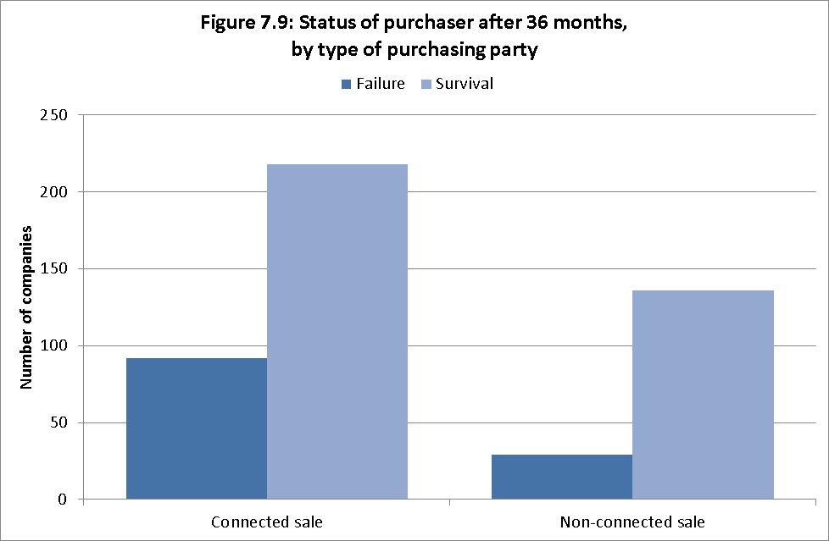
Impact of deferred consideration
7.86 As discussed in para 7.57, deferred consideration was present in a majority of pre-pack sales. While the incidence of deferred consideration is not as great as connected sales generally, the association between deferred consideration on subsequent failure of the purchaser appears to be greater. The new business in 39% of sales involving deferred consideration had failed within 36 months, compared with fewer than 10% of those not involving deferred consideration.
Combined impact of sale to a connected party and deferred consideration
7.87 The individual effects of deferred consideration and sales to a connected party do not appear to be cumulative. Compared with companies sold neither to a connected party nor with deferred consideration, failure rates for companies purchased with deferred consideration were higher whether or not the sale was to a connected party.

Statistical analysis of failure rates
7.88 The researchers tested the strength of the associations between failure rates and whether the sale was to a connected party and/or involved deferred consideration. Their statistical model suggests that, compared with sales not involving deferred consideration or connected parties:
- the odds of failure, that is, the probability of failure divided by the probability of continued trading, were over three times as high for sales to a connected party;
- the odds of failure were nearly 16 times as high for sales involving deferred consideration; and
- the odds of failure were nearly 11 times as high for sales involving both these factors.
7.89 All of these differences in the odds of failure can be considered as statistically significant.
7.90 The researchers also investigated whether there were statistically significant differences in failure rates between pre-packs and trading administrations. They found that, on average, the odds of failure were 2.4 times as high for trading administrations as they were for pre-packs, holding other variables constant. Even though at face value it appears that a higher percentage of pre-pack purchases subsequently failed than did trading administrations, this seems to be because a higher percentage of pre-packs have characteristics associated with failure (i.e. connected sales and deferred consideration). When controlling for these factors, and comparing pre-packs and trading administrations on a like-for-like basis, the data shows that the odds of failure are lower for pre-packs.

8. Conclusions
8.1 The constructive engagement and assistance I received from a broad cross-section of stakeholders, combined with the thorough data gathering and analysis from the University of Wolverhampton has highlighted areas where the pre-pack insolvency market is not working as well as it could.
8.2 I have devised a package of measures, which I will discuss below that I believe will have a tangible effect in the pre-pack space both in terms of increased returns to creditors and in a reduction in the failure rate of pre-packed new companies. Pre-packs definitely have a place in the insolvency arena, but I want to clean them up. I want to improve the perception that third parties have of them. I am not seeking to have fewer of them; just better ones.
8.3 As I said in the introduction, I am a de-regulator at heart. I do not want to increase the myriad rules and regulations that already govern insolvency procedures. My recommendations that break new ground will therefore be voluntary in nature, although I would expect compliance to be monitored. If compliance is low then government regulation may be necessary. I hope that will not be the case.
8.4 Other recommendations, aimed specifically at insolvency practitioners, build on existing provisions in SIP16 that will improve them. I see this as evolution rather than revolution.
8.5 I believe that a large majority of insolvency practitioners are honest professionals who do a good job in what can be very trying circumstances with numerous competing stakeholders to manage.
8.6 There will always unfortunately be a minority of bad apples in any walk of life but this is a regulated profession and it is the job, indeed the duty, of those regulators to stamp out poor practice where they see it.
8.7 But it is not just the regulators who have a responsibility to keep the insolvency profession compliant with its rules and regulations. Insolvency practitioners themselves must play a part. I was told by practitioners and others on several occasions that they know who the bad apples are. They should have the confidence, support and protection to report them to their regulator.
8.8 I also believe that, in some areas, practitioners are victims of a shift in the balance of power in insolvency. In certain parts of the market, commoditisation of insolvency services has taken some control, in practice if not in law, away from the practitioner. I was explicitly told by more than one practitioner that, in certain parts of the market, for certain types of deals, the administration was more akin to old-style administrative receivership – run for the benefit of the charge-holder. This is a wider issue than pre-pack administration - and therefore my review - but may be an area of interest for a future study.
8.9 Before I discuss my package of recommendations I would like to touch on those solutions suggested by stakeholders that I have considered but have decided not to proceed with.
8.10 All suggestions put to me have been very carefully considered. Where I have not taken those ideas forward as put to me, it is because I had the benefit of the empirical research that focuses attention on the sub-optimal behaviour. I am also very conscious that any recommendations that I make must not, if adopted by the Government, wreck pre-packing in the UK.
8.11 The evidence I have gathered has confirmed for me that there is a place for pre-pack administrations in the UK’s insolvency firmament. To hobble the whole process to eliminate small areas of sub-optimal behaviour seems to me to be akin to throwing the baby out with the bathwater. I accept that this position may not find favour with all those I have spoken with as part of the review but I hope everyone will find some aspect that they find addresses their concerns.
Ban pre-packs?
8.12 Some organisations that contributed to my review thought that in some if not all situations, being able to pre-pack should be banned outright. I do not agree with this thinking.

8.13 It is clear from the evidence gathered from stakeholders and from the evidence from the 2010 pre-pack sample, that in many circumstances a pre-pack administration is the best or perhaps more fairly the least worst outcome for all stakeholders in a business – including all classes of creditors. Evidence from the Wolverhampton research indicates that, when comparing pre-packs and trading administrations on a like for like basis, sales following pre-packs are more likely to succeed.
8.14 I do think that there are issues with some aspects of pre-packing, which could be improved for the benefit of all insolvency stakeholders. My proposal to Government is that my recommendations should be, in the first instance, implemented via voluntary means. I hope that, should Government agree with this approach, the market will embrace these changes. Cleaning up the perception of pre-packs is in the interests of all market participants – the new company purchasers, their advisers and not least the insolvency profession itself.
8.15 As was stated in my introduction, it is not my intention to over-regulate in this area. Over regulation and under regulation are two sides of a badly regulated coin. The aim of any regulatory system should be to regulate sufficiently to minimise suboptimal behaviour, while not stifling innovation and entrepreneurism.
Ban small pre-packs?
8.16 A variation on banning pre-packs outright that was suggested to me was banning them based on size. As was stated earlier in my report most pre-pack deals are executed for under £100,000 and, most of the old companies that pre-pack their businesses are small or micro. If the overall economic benefit to the UK from all of these sub £100,000 pre-packs does not amount to a row of beans - and in view of the criticism the process attracts - why should they be allowed to continue at the lower end of the market?
8.17 I was not attracted to this argument. Recommending the removal of a rescue process which can preserve jobs cannot be in the interests of UK plc. In addition making such an arbitrary cut would simply be open to challenge and difficult to support.

Court involvement in pre-packs
8.18 Prior to 2003, entry into administration could only be achieved by the making of an administration order by the court. The administration petition filed at court was often accompanied by a costly independent report on the company’s affairs which significantly inflated the costs of the insolvency and acted as a barrier to SMEs entering administration.
8.19 Several stakeholders suggested a role for the court as an independent arbiter in the approval of pre-pack deals. Some even suggested that out of court administration entry itself be abolished.
8.20 I have met several members of the judiciary in the course of my review. None supported a role for the court in pre-pack cases giving the following reasoning:
- The decision on whether or not to attempt a pre-pack deal is a commercial one and best left to the insolvency practitioner
- Courts act best where there is a dispute between two or more parties, but informing unsecured creditors ahead of the business being sold through a pre-pack could destroy value in the company, making this an unpalatable option. Effectively opening up the pre-pack to ex-ante unsecured creditor scrutiny could jeopardise the pre-pack itself, destroy value and prevent the rescue of the business. (Court involvement ex-post by contrast would create too much uncertainty, thereby jeopardising deals).
8.21 Accordingly, I do not think that the court’s involvement should be changed from its current role.
8.22 However, I believe strongly in the idea that there should be some degree of independent scrutiny of a deal, that maintains the secrecy, so as not to diminish value but shines a light on the deal to assist perceptions that the pre-pack being the ‘right thing’ has some merit and this has influenced my recommendations. I will develop this idea more fully in my recommendations.

Ban deferred consideration?
8.23 Had repayment rates for deferred consideration payment been low, I may have considered a recommendation restricting its use. If payments had not been made, then such deals could not be in the best interests of creditors, particularly in those cases where the upfront cash payment was less than the break-up valuation for the assets given in the statement of affairs. However, payment rates are high, particularly where payment is expected relatively early on in a case, such as full payment within six months. Old company creditors are, in a large majority of cases, not disadvantaged by administrators striking deferred consideration deals with the purchaser.
8.24 The statistical model used in the research has shown that there is a correlation between deferred consideration and failure of new company. I did consider making recommendations aimed at reducing deferred consideration. However, I could not bring myself to do this, given the likely impact on old company creditors and, possibly, an increase in liquidations, if deferring consideration was the only way open for a putative buyer to seal the deal. I could not ignore the fact that old company creditors, by the time old company had failed had no further way to mitigate their loss. New company suppliers could consider their risk in contracting with a pre-packed business and then manage that risk in a way that old company creditors could not.
8.25 I hope that some of the recommendations that are made regarding marketing and valuations will increase the purchase price paid for pre-packed businesses. If this is the case, it is reasonable to assume that buyers may wish to defer at least part of the consideration in question
8.26 Accordingly, I am not making any recommendations on the issue of deferred consideration. It is hoped that the data on successful (paid) deferred consideration given above will be of assistance to both administrators and purchasers in future negotiations.

8.27 Nonetheless, I am keen that the levels of new company failure are reduced. I hope that the recommendation on the viability review, see para 9.11, will reduce incidences of failure in all cases, including those with deferred consideration, by focusing the minds of those controlling new companies.
Prescribed Part
8.28 Prior to the Enterprise Act 2002 coming into force, parts of the debt owed to the Crown were treated preferentially by insolvency law. The Crown relinquished its preferential claim following the Enterprise Act changes. The policy aim supporting this provision was that returns to non-preferential unsecured creditors be improved. The prescribed part was set at a level estimated to realise funds for unsecured creditors equivalent to those being given up by the Crown though the abolition of its preference status. Preferential creditors still exist but are now almost exclusively sums owed to employees of the insolvent company.
8.29 It was suggested to me that the prescribed part be used as a vehicle for change. I was initially very attracted to this idea. The nature of pre-pack administrations leads to a lack of transparency before the event. I was told many times that unsecured creditors feel disenfranchised by this secrecy, particularly where the purchaser is connected to the insolvent company. I did therefore consider recommending to Government that it increase the proportions of a company’s net assets due under the prescribed part provision – in some way to act as recompense for this secrecy.
8.30 Incidences of the prescribed part in the sample data were extremely small – only 58 of the 499 cases. Consequently, any recommendation that used the prescribed part as a method of delivery would be ineffective.

8.31 In addition, the sample used by this review was small as a proportion of all corporate insolvencies in 2010 (499 out of total corporate insolvencies of over twenty thousand). It would be wrong of me, on the basis of this research alone, to say that the prescribed part policy is not working as intended and that the amount ‘given up’ by the Crown was not being passed to unsecured creditors via this mechanism. However, the research has indicated that there may be some disparity between the policy aim in 2002 and what was happening in practice in 2010. There may be merit in the Government researching in the near future whether the ultimate beneficiaries of the loss of Crown preference in 2003 are not floating charge-holders.

9. Recommendations
Key recommendation 1: Pre-pack Pool
9.1 On a voluntary basis, connected parties approach a ‘pre-pack pool’ before the sale and disclose details of the deal, for the pool member to opine on.
9.2 As described above, one of the main criticisms of pre-packs from many of those who have engaged with my review is that there is a lack of transparency with pre-pack deals. Some stakeholders said that, in some cases, secrecy is a strength of the pre-pack process.
9.3 Perceptions are that connected cases are inherently less fair to creditors. This may be the case, even where the deal offered by the connected is the best one available in all the circumstances. Often, the connected party is the party most likely to make the best offer to the administrator and therefore the creditors because they see the business as their own livelihood. As shown by the characteristics of a pre-pack data at Annex E, these companies may have been running for a number of years and an affinity with the business on the part of those controlling it cannot be dismissed. However, the data gathered by the researchers show that in many cases those negative perceptions of connected party pre-packs are well-founded. Such cases are less likely to deliver a return to creditors and the new companies are more likely to fail within their first three years. Accordingly, this recommendation is aimed solely at connected cases. Unconnected sales are not proposed to be affected.
9.4 In devising this proposal, I was very concerned that there be no loopholes that the unscrupulous could use to circumvent the measure. Accordingly I also recommend including an anti-avoidance measure to complement the creation of the pool. Rather than just covering the traditional understanding of the term ‘pre-pack’ – that is, a sale arranged prior to the administration for execution at or shortly after the appointment of an administrator - I would like to broaden it for this measure. As a result, a connected party will be able to approach the pool, if they choose to, for any sale of all or part of the business in all circumstances before creditors are made aware of the sale.
The pool will then be available for all connected parties, arranging a sale at any time.

9.5 .A ‘connected party’ is a concept well-known in insolvency law, where the subject is covered in the Insolvency Act 1986 itself. My proposal does not follow this template for ‘connected party’ but rather would extend to the following:
i) a connected party is
- a director, shadow director or company officer of the insolvent company;
- an associate of a director, shadow director or company officer of the insolvent company; and
- an associate of the insolvent (see section 249 of the 1986 Act)
who becomes:
- a director, shadow director, company officer of the new company;
- exercises control over the new company as defined in section 435(10) (subject as (iii) below)
- an associate of a director, shadow director or company officer of the new company ; and
- an associate of the new company.
ii) “Associate” means any person set out in section 435 of the 1986 Act with the exclusion of subsection (4) which relates to employees (who are not directors or shadow directors).
iii) For the purposes of determining whether any person or company has control of a company under section 435(10) of the 1986 Act, sales to secured lenders who hold security for the granting of the loan (with related voting rights) as part of the lender’s normal business activities over one third or more of the shares in both the insolvent company and the new company are not included.

9.6 The reason for this slight tweak – which I do not recommend be repeated anywhere else in the insolvency legal or regulatory framework – is to avoid causing unnecessary damage (and so lead ultimately to more business failures) to the restructuring of larger companies (and groups of companies) where a lender may have voting rights associated with their debt. The reference to lending as part of normal business activities is to prevent group companies trying to bring themselves into this exception by making an intra-group loan and taking security.
Proposal
9.7 That the connected party has an opportunity to present the deal’s outline and why it is necessary to proceed in this way to an independent person prior to administration. This will create independent scrutiny of the deal yet retain overall secrecy before the event.
Detail
9.8 A pool of experienced business people should be formed to enable independent scrutiny of a connected party pre-pack deal. Approaching the pool will be voluntary - the connected party will not have to make such an approach.
- When used, the connected party will approach the pool with details of the proposed pre-pack.
- One member of the pool will then be allocated to the case and review the supporting documentation provided by the applicant.
- There should be no prescription as to what material the pool member will require in order to comment on the deal – that will be for the party approaching them to decide.
- It is anticipated that the pool member will spend no more than half a day reviewing these documents.
- It is intended that the process be low cost and that the fee will be paid, upfront, by the connected party. The fee will also pay for the administrative costs associated with maintaining the pool.
9.9 After scrutinising the documents, the pool member will issue a statement. There will be no prescribed format for the pool member’s statement but a specimen form of words is included at Annex H.
9.10 If the pool member issues a negative statement, the deal can still proceed, though the fact that a negative statement had been made would have to be referred to in the SIP16 statement. A positive statement would also be referred to in the SIP16, bringing the fact that the deal had received some independent scrutiny to the attention of the creditors. As approaching the pool at all is voluntary the SIP16 will also state if the connected party has chosen not to approach the pool.
Key recommendation 2: Viability Review
9.11 On a voluntary basis, the connected party complete a ‘viability review’ on the new company.
9.12 A criticism of pre-packs that I heard was that businesses with fundamentally unviable business models are being allowed back into the marketplace post pre-pack, shorn of old company debts, often to fail again.
9.13 Academic research commissioned by my review and discussed above shows that a new company in a connected pre-pack is more likely to fail than a new company unconnected with those controlling the old company. The terms of reference for the review stated that I should look at the wider economic effect of pre-packing. The empirical evidence shows that there is a clear link to future failure in connected party cases. I would like to address this and by doing so seek to reduce this level of failure with my second recommendation.
Proposal
9.14 The connected party – as that term is used in Key Recommendation 1 - draw up a ‘viability review’ on new company, stating how the company will survive for at least 12 months from the date of the statement. A short narrative will also be provided, detailing what new company will do differently from old company in order that the business not fail again. The statement/narrative will be drawn up by the connected party prior to administration.

Detail
9.15 As with my first recommendation it will be completed by connected parties only, following the same definition of ‘connected’ as outlined on para 9.5 and completion will be voluntary.
9.16 Where completed, the document will then be attached to the SIP16 statement sent to all creditors by the administrator within 7 days of the sale. The administrator will not be expected to comment or express an opinion on the viability review. Where the connected party has chosen not to complete a viability review, the administrator will have to state that they had asked the connected party for the review but that it had not been completed.
9.17 I hope that the market will come to expect the review’s completion in connected party pre-packs, thereby ensuring a meaningful take-up of the proposal. The review may focus the attention of the connected party to the prospects of new company, thereby reducing the higher-than-expected failure rate of connected party new companies shown by academic research.
9.18 In the event that the new company should fail, the statement will be available to the new company’s insolvency office-holder to consider, alongside other records, when ascertaining if recovery action can be taken against the director. It may also assist the office-holder’s statutory return to the Secretary of State regarding the director’s conduct.
9.19 There will be no prescribed format for the statement/narrative but a proposed form of words is included at Annex I.

Supplementary recommendations
Recommendation 3 – SIP 16:
9.20 The Joint Insolvency Committee considers, at the earliest opportunity, the redrafted SIP16 in Annex A.

9.21 A redrafted SIP underpins and acts as a vehicle for the delivery of my package of recommendations. It is proposed that the documents required by the preceding two recommendations be sent with the SIP16 statement. The following two recommendations on marketing and valuation are additional guidelines to complement those already in the SIP which l believe will improve the perception of pre-packs when adhered to. In order to assist the JIC I have drafted a new SIP16 for it to consider, including these changes. I have taken the opportunity to include a number of more minor improvements to the SIP, mainly a tightening of the language used, which I hope all stakeholders will welcome.
9.22 The new version of the SIP introduced in November 2013 was a big step in the right direction – I think this iteration improves it still further.
Recommendation 4 – Marketing:
9.23 All marketing of businesses that pre-pack comply with six principles of good marketing and that any deviation from these principles be brought to creditors’ attention As evidenced by the researchers, some of the activities claimed as ‘marketing’ in SIP16s are severely lacking and do the insolvency profession no credit.
9.24 The claim from practitioners that there will be occasions where marketing is not possible or that marketing will itself harm creditors’ prospects is accepted to be true in some circumstances. Where this is the case, the administrator should explain, clearly, why this is the case. The original SIP16, which should have been followed in all the cases looked at in the research sample, simply required an explanation of what marketing had been done (but not any mention where (or why) it had not). The revamped SIP16 from November 2013 is to be welcomed in that it now states that an explanation of why no marketing was undertaken is required. I hope that SIP16 statements drafted since November 2013 have been of a higher standard.

9.25 I want the quality of marketing to improve. As our evidence shows, cases with no marketing return less money to creditors. Improved quality of marketing will, in some cases, assist the administrator in receiving a better return. It will also, and possibly just as importantly, improve creditors’ perceptions that they are getting the best deal available. This will improve confidence in pre-pack administration and in the insolvency regime more generally.
9.26 Where marketing is carried out, it should conform to broad ‘good principles of marketing’. I suggest these are:
- Broadcast rather than narrowcast – the business should be marketed as widely as possible proportionate to the nature and size of the company – its purpose is to make the business’s availability known to the widest group of potential purchasers in the time available, via whatever media is likely to achieve this outcome.
- Justify the media used – the statement to creditors should not simply be a list of what marketing has been undertaken. It should fully explain the reasons underpinning the marketing and media strategy adopted.
- Ensure independence - where the business has been marketed by the company prior to the practitioner being instructed, this must not be used as a proxy to avoid further marketing. The practitioner should always bear in mind that he/she is independent of the company and must satisfy him/herself as to the adequacy of the marketing undertaken throughout the period under review.
- Publicise rather than simply publish - marketing should be undertaken for an appropriate length of time commensurate with satisfying the practitioner that the best deal has been sought. Creditors should be informed of the reason for the length of time settled upon.
- Connectivity - include online communication alongside other media by default. The internet offers one of the widest populations of any medium. If the business isn’t marketed via the internet, this should be justified.

- Comply or explain – particularly with sales to connected parties, where the level of interest by the public and the business community is at its highest, the administrator must satisfy all creditors by explaining fully his/her marketing strategy to achieve the best outcome for all creditors.
Recommendation 5 – Valuations:
9.27 SIP16 be amended to the effect that valuations must be carried out by a valuer who holds professional indemnity insurance.
9.28. Valuations are another area of SIP16 that was improved in 2013. The revised SIP replaced a need to list “any valuations obtained of the business or the underlying assets” to a requirement to gave the names, qualifications and confirmation of the independence of the valuers, the valuations themselves, a summary of the basis of the valuation adopted and a rationale for its use and an explanation of any variance in the sale price from those valuations.
9.29 The SIP16s from 2010 used in the research would have been under the original SIP16. It is therefore unsurprising that the researchers found the information on valuations to lack transparency and consistency. It is to be hoped that the information forwarded to creditors in current pre-packs regarding valuations are much more transparent than those witnessed by the researchers.
9.30 However, the review recommends one further improvement to SIP16 requirements – that the valuer instructed to value the business/assets carry professional indemnity insurance (‘PII’) and, where this is not the case, that they explain their reasons for choosing a valuer without such insurance.
9.31 The reason for this recommendation is that issuers of PII place their own stringent checks on those who apply cover. Creditors of an insolvent company can be better satisfied that a valuation executed by someone with such cover will represent a fair value for the business/its assets. Where no such cover is held, the administrator should be transparent with the creditors to explain the reason for his/her choice of a non-PII covered valuer.

Recommendation 6 – SIP16
9.32 That the Insolvency Service withdraws from monitoring SIP16 statements and that monitoring be picked up by the Recognised Professional Bodies.
9.33 SIP16 was a bold and important first step taken by the profession in order to address public concerns on pre-pack administrations. As well as to creditors, administrators also had to send the completed SIP16 statements to the Insolvency Service. The Insolvency Service then reported on compliance with the SIP, publishing its results each year 2009-2013.
9.34 In the five years since monitoring commenced, the Insolvency Service has done a good job, in both ensuring compliance with the SIP and in publishing the results, shedding some light on this practice where previously there had been none.
9.35 However, I believe that, five years on, scrutiny of the SIP16 statements is a matter best left to the RPBs. l believe that they are best placed to do this having the right level of practical experience to further improve compliance rates as well as to monitor compliance with the SIP and my suggested new SIP16, should the JIC amend it in line with the recommendations of this review as part of their role in regulating those insolvency practitioner that they license.
9.36 I believe that the statements required under SIP16 are an ideal delivery mechanism to get the viability review and the pool member’s opinion, when undertaken, to the creditors. This statement is already sent to creditors, and so requiring an enclosure will be a minimal burden on practitioners.
If the measures do not work
9.37 Should these measures fail to have the desired impact and they are not adopted as I would hope by the market, then Government should consider legislating.
9.38 To encourage take up of the proposals, Government may wish to consider taking a reserve legislative power at the earliest opportunity, in order that it can act should the behaviours outlined in this report continue.

9.39 As stated above, it is hoped that the market will adopt these proposals and that legislation should not be required. The Review therefore recommends that any such reserve power bestowed upon Government by Parliament should be time-limited (a ‘sunset clause’).

Annex A: Redrafted SIP16
There follows a suggested draft for a new SIP16, based on the version currently in force but which incorporates the recommendations of this report. It has been prepared to assist the Joint Insolvency Committee but should not be taken by readers as a ‘new SIP16’. As my report recommends, it is for the JIC to consider at its earliest opportunity.

STATEMENT OF INSOLVENCY PRACTICE 16

PRE-PACKAGED SALES IN ADMINISTRATIONS

INTRODUCTION
- The term ‘pre-packaged sale’ refers to an arrangement under which the sale of all or part of a company’s business or assets is negotiated with a purchaser prior to the appointment of an administrator and the administrator effects the sale immediately on, or shortly after, his appointment.
- The particular nature of an insolvency practitioner’s position in these circumstances renders transparency in all dealings of primary importance. Creditors and other interested parties should be confident that the insolvency practitioner has acted professionally and with objectivity; failure to demonstrate this clearly may bring the practitioner and the profession into disrepute.
- It is equally important that the insolvency practitioner is seen to be acting fairly in the interests of all creditors, both unsecured and secured and is able to show this clearly to those parties.
PRINCIPLES
- An insolvency practitioner should recognise the high level interest the public and the business community have in pre-packaged sales in administration. This interest will be heightened where the directors/owners of newco are the same, or are connected with, the directors/owners of the oldco.
- An insolvency practitioner should differentiate clearly the roles that are associated with an administration that involves a pre-packaged sale (that is, the provision of advice to the company before any formal appointment and the functions and responsibilities of the administrator). The roles are to be explained to the directors and the creditors.
- The insolvency practitioner should aim to provide creditors with sufficient information to enable them to form a reasoned view of the appropriateness of the pre-pack procedure. They should look to demonstrate that they have acted with due regard for creditor interests and to minimise any negative perceptions, particularly arising from connected party transactions

KEY COMPLIANCE STANDARDS
Preparatory work
- An insolvency practitioner should be clear about the nature and extent of the role of adviser in the pre-appointment period. When instructed to advise the company the insolvency practitioner should make it clear that the role is not to advise the directors, who should be encouraged to take independent advice. This is particularly important in circumstances where the directors are likely to acquire an interest in the business and/or assets of the pre-packaged sale.
- An insolvency practitioner should bear in mind the duties and obligations which are owed to all creditors in the pre-appointment period. They should be mindful of the potential liability which may attach to any person who is party to a decision that causes a company to incur credit and who knows that there is no good reason to believe it will be repaid. Such liability is not restricted to the directors.
- An administrator should keep a detailed record of the reasoning behind both the decision to undertake a pre-packaged sale and any alternatives considered and discounted.
- In order to provide comfort to all classes of creditor that the most beneficial valuation has been obtained, such valuations should be carried out by independent valuers carrying professional indemnity insurance.
- Where there is any deviation from 10 above this must be explained to creditors in the pre-pack statement
Marketing
- Marketing a business is an important element in ensuring that the best available price is obtained for it in the interests of all creditors, and will be a key factor in providing reassurance to creditors. All such marketing should conform to the following principles. Any reason for deviation from any of these principles must be explained by the administrator in the statement to creditors.
- Broadcast rather than narrowcast – the business should be marketed as widely as possible proportionate to the nature and size of the company – the purpose of the marketing is to make the business’s availability known to the widest group of potential purchasers in the time available, via whatever media is likely to achieve this outcome.
- Justify the media used – the statement to creditors should not simply be a list of what marketing has been undertaken. It should fully explain the reasons underpinning the marketing and media strategy adopted.

- Ensure independence - where the business has been marketed by the company prior to the practitioner being instructed, this must not be used as a proxy to avoid further marketing. The practitioner should always bear in mind that he is independent of the company and must satisfy himself as to the adequacy of the marketing undertaken throughout the period under review.
- Publicise rather than simply publish - marketing should be undertaken for an appropriate length of time commensurate with satisfying the practitioner that the best deal has been sought. Creditors should be informed of the reason for the length of time settled upon
- Connectivity - include online communication alongside other media by default. The internet offers one of the widest populations of any medium. If the business isn’t marketed via the internet, this should be justified
- Comply or explain – particularly with sales to connected parties where the level of interest by the public and the business community is at its highest, the administrator must satisfy all creditors by explaining fully his marketing strategy to achieve the best outcome for all creditors
After appointment
- When considering the manner of disposal of the business or assets as administrator, an insolvency practitioner should be able to demonstrate that the duties of an administrator under the legislation have been fulfilled.
Disclosure
- An administrator should provide all creditors with a detailed narrative explanation and justification of why a pre-packaged sale was undertaken and what alternatives were considered and discounted, to demonstrate the administrator has acted with due regard for their interests. The administrator should include a statement explaining the statutory purpose pursued and confirming that the transaction enables the statutory purpose to be achieved and that the sale price achieved was the best reasonably obtainable in all the circumstances. The information disclosure requirements should be included in the explanation unless there are exceptional circumstances, in which case the administrator should explain why the information has not been provided. If the sale is to a connected party it is deemed very unlikely that considerations of commercial confidentiality would outweigh the need for creditors to be provided with this information.
- The explanation should be provided with the first notification to creditors and in any event within seven calendar days of the transaction. If the administrator has been unable to meet this requirement they must provide a reasonable explanation for the delay. The statement provided by any pre-pack pool member approached by the purchasing party and any viability review prepared by that party should also be given in the administrator’s statement of proposals filed at Companies House.
- The administrator should be mindful that, if creditors have had to wait until, or near, the statutory deadline under paragraph 49 Sch B1 Insolvency Act 1986 for his proposals to be issued, there may be some confusion on the part of creditors when they do receive them, the sale having been completed some time before. Accordingly, when a pre-packaged sale has been undertaken, the administrator should seek the requisite approval of his proposals as soon as practicable after his appointment and, ideally, they should be sent with the statement regarding the sale. The 8 week deadline imposed by Schedule B1 should not be used as a proxy for “as soon as reasonably practicable”. If the insolvency practitioner has been unable to meet any of these requirements he must explain the reasons for the delay.
- The Insolvency Act 1986 permits an administrator not to disclose information in certain limited circumstances. This Statement of Insolvency Practice will not restrict the effect of those statutory provisions.

Effective from 1 XX 2014
Connected Party Transactions
As stated in paragraph 4 interest is heightened where the owners/managers of the purchaser are connected to the owners/managers of the insolvent company.
The practitioner should ascertain whether the connected party has approached the pre-pack pool. Where they are unaware of the pool, he should inform them of its existence and purpose and encourage them to approach the pool
The practitioner should inform the connected party about the voluntary provision enabling them to submit a ‘viability review’ relating to newco.

Information disclosure requirements
The following information should be included in the administrator’s explanation of a pre-packaged sale, as far as the administrator is aware after making appropriate enquiries:
Initial introduction
The source of the initial introduction to the insolvency practitioner (to be named) and the date of the administrator’s initial introduction.

Pre-appointment considerations
The extent of the administrator’s involvement prior to the appointment.
The alternative courses, both within formal insolvency and outside it, of action that were considered by the administrator with an explanation of possible financial outcomes, with particular reference to the higher level statutory administration purposes not being followed by the administrator.
Whether efforts were made to consult with major creditors and the outcome of any consultations. If no effort to consult was made, explain the reasons for this.
Why it was not appropriate to trade the business and offer it for sale as a going concern during the administration.
Details of requests made to potential funders to fund working capital requirements. Where no such requests were made explain why this was so.
Details of registered charges with dates of creation.
If the business or business assets have been acquired from an insolvency practitioner within the previous 24 months, or longer if the administrator deems that relevant to creditors’ understanding, the administrator should disclose both the details of that transaction and whether the administrator, administrator’s firm or associates were involved.
Marketing of the business and assets
Marketing activities conducted by the company and/or the administrator and the outcome of those activities. Reference should be made to the ‘principles of marketing’ at paragraph 12. Any divergence from these principles must be highlighted to creditors, with the reasons for such divergence.
Valuation of the business and assets
The names and professional qualifications of any valuers/advisors and confirmation that the administrator has seen evidence to confirm their independence and that they carry appropriate levels of professional indemnity insurance. Any divergence from these principles must be highlighted to creditors, with the reasons for such divergence
The valuations obtained of the business or the underlying assets. Where goodwill has been valued, an explanation and basis for the value given
A summary of the basis of valuation adopted by the administrator or his valuers/advisors.
The rationale for the basis of the valuations obtained and an explanation of the sale of the assets compared to those valuations.
If no valuation has been obtained, the reason for not having done so and how the administrator was satisfied as to the value of the assets.
The transaction
The date of the transaction.
Purchaser and related parties
- The identity of the purchaser.
- Any connection between the purchaser and the directors, shareholders or secured creditors of the company or their associates.
- The names of any directors, or former directors (or their associates), of the company who are involved in the management or ownership of the purchaser, or of any other entity into which any of the assets are transferred.
- In transactions impacting on more than one related company (e.g. a group transaction) the administrator should ensure that the disclosure is sufficient to enable a transparent explanation (for instance, allocation of consideration paid).
- Whether any directors had given guarantees for amounts due from the company to a prior financier and whether that financier is financing the new business.
Assets
- Details of the assets involved and the nature of the transaction.
Sale consideration
- The consideration for the transaction, terms of payment and any condition of the contract that could materially affect the consideration.
- Sale consideration disclosed under broad asset valuation categories and split between fixed and floating charge realisations and the method by which this allocation of consideration was applied
- Any options, buy-back agreements, deferred consideration or other conditions attached to the contract of sale.
- Details of the security taken by the administrator in respect of any deferred consideration. Where no such security has been taken, the administrator’s reasons for this and the basis for his decision that none was required.
- If the sale is part of a wider transaction, a description of the other aspects of the transaction.

Connected Party transactions only
Where the sale has been undertaken to a party connected with the insolvent company the following additional details should be included in the statement
Pre-pack Pool
The administrator should include in the statement –
- whether the ‘pre-pack pool’ has been approached and the opinion given by the pool member and the date of that opinion.
- whether the pre-pack pool has been approached and its opinion disregarded by the connected party, or
- whether the pre-pack pool has not been approached
Viability Review
- The administrator should ask the connected party to complete a viability review
- Where completed the administrator must attach it to the pre-pack statement.
- Where this has been requested but not received, the administrator must notify creditors of this in the pre-pack statement
n.b for pre-pack pool and viability review purposes only the connected parties are –
i)
- a director, shadow director or company officer of the insolvent company;
- an associate of a director, shadow director or company officer of the insolvent company; and
- an associate of the insolvent (see section 249 of the 1986 Act)
who becomes:
- a director, shadow director, company officer of the new company;
- exercises control over the new company as defined in section 435(10) (subject as (iii) below)
- an associate of a director, shadow director or company officer of the new company ; and
- an associate of the new company.
ii) “Associate” means any person set out in section 435 of the 1986 Act with the exclusion of subsection (4) which relates to employees (who are not directors or shadow directors).
iii) For the purposes of determining whether any person or company has control of a company under section 435(10) of the 1986 Act, sales to secured lenders who hold security for the granting of the loan (with related voting rights) [as part of the lender’s normal business activities] over one third or more of the shares in both the insolvent company and the new company are not included.

Annex B: The Review Team
Review Leader - Teresa Graham CBE FCA HonFRICS
Teresa graduated from Newcastle University in 1977 (awarded a Fellowship in 2012). She joined the Newcastle upon Tyne office of a Big 4 accountancy firm as a student accountant and transferred to the firm’s Department of Privatisation Services in London in 1989. From December 1986 to August 1987, she was seconded to the UK Government’s Enterprise and Deregulation Unit reporting directly to Lord Young, the Secretary of State for Employment and then Trade and Industry. In March 1988 she was appointed to the Government’s Deregulation Advisory Panel for a two year term but continued to work for more than two decades through many Government administrations. She was first female winner of the “Young Accountant of the Year Award” for 1988 in recognition of her contribution to the small firms sector, her profession and work with Government.
Teresa joined Baker Tilly in 1989 and during her time there she headed up their Business Services Department covering audit and tax.
She is currently Chairman of the Administrative Burdens Advisory Board of HMRC and a member of their Office of Tax Simplification. She is also immediate past Chair of the Regulatory Board of the Royal Institution of Chartered Surveyors receiving an honorary membership in recognition of her contribution to the Institution.
Her publications include a major piece of work on litigation and compensation for the Lord Chancellor, an independent review for the Chancellor of the Exchequer on the Small Firm’s Loan Guarantee Scheme and a ground breaking study for the Prime Minister, “Less is More”. She was also a member of the Financial Reporting Council Group which produced “Louder Than Words” – a study into the complexity of corporate reporting.
She now works independently, focusing on her two passions – strategic advice to ambitious, growing businesses, liberating these businesses from the fetters of red tape and “Head of Parties and Fun” at The Lexi Cinema (www.thelexicinema.co.uk), a social enterprise, digital, boutique cinema in North London covenanting 100% of its profits to a charity in South Africa called The Sustainability Institute Trust (www.sustainabilityinstitute.net). She holds a number of appointments, including non-executive, mentoring and advisory roles in growth businesses.
Teresa was awarded a CBE in the 2007 New Years Honours list for public service.
She is the 2007 Laureate under the ICAEW Award for Outstanding Achievement awarded annually to a member of the Institute who has made an outstanding contribution in any field of endeavour.

Independent Advisor – Alastair Keir
Alastair Keir is an independent adviser in finance, business and regulation, with 30 years’ experience of working at senior levels in banking and industry. He has a particular interest in the interface between business and government and in effective models of regulation and the consumer interest.
He currently holds a number of roles with public bodies, charities and regulatory organisations including the RICS global regulatory board, the CAA consumer panel and St Mungo’s Broadway. He also provides strategic advice to small and medium sized businesses, drawing on his past experience of 20 years in corporate banking and business advisory roles.
Alastair is a Member of the Chartered Institute of Bankers and a Member of the Institute of Directors. He graduated from University of London, Queen Mary College in 1978.
Review Secretariat
Paul Mayo, Steven Chown, John Perrett (all Insolvency Service)

Annex C: Stakeholders Engaged with as Part of the Review
The following is a list of organisations that I have met and/or corresponded with as part of the review. It should be noted that some of these organisations kindly arranged wider meetings with their members, in order that I could cast my net even wider when seeking views. For example, as a result of engaging with insolvency/accountancy organisations, I was able to meet representatives of large, medium and small insolvency practitioner firms – people who actually deal with insolvent companies on a day to day basis. Similarly, with the support of legal representative organisations, I was able to speak with a number of law firm partners. The British Bankers Association kindly facilitated meetings with the banking and business community.

Asset-based Finance Association
Association of British Insurers
Association of Chartered Certified Accountants
Chief Registrar Baister
British Bankers’ Association
British Jewellers’ Association
British Print Industry Federation
British Private Equity and Venture Capital Association
British Property Federation
Chartered Accountants Ireland
City of London Law Society
Confederation of British Industry
HM Revenue and Customs
Insolvency Lawyers Association
Insolvency Practitioners Association
Insolvency Service
Institute of Chartered Accountants in England and Wales
Institute of Chartered Accounts in Scotland
Institute of Credit Management
Isonomy Ltd
Mr Justice Norris
Pension Protection Fund
R3
Mr Justice David Richards
Road Haulage Association
Royal Institution of Chartered Surveyors
Professor Prem Sikka

Annex D: List of Recognised Professional Bodies
The Chartered Association of Certified Accountants
The Institute of Chartered Accountants in England and Wales
The Institute of Chartered Accountants of Scotland
The Institute of Chartered Accountants in Ireland
The Insolvency Practitioners Association
The Law Society of Scotland
The Law Society

Annex E – Characteristics of Old Companies
The charts below provide summary information on the characteristics of companies which entered pre-pack and trading administration in 2010, based on the data collected by the University of Wolverhampton. My conclusions from this analysis are in Section 7
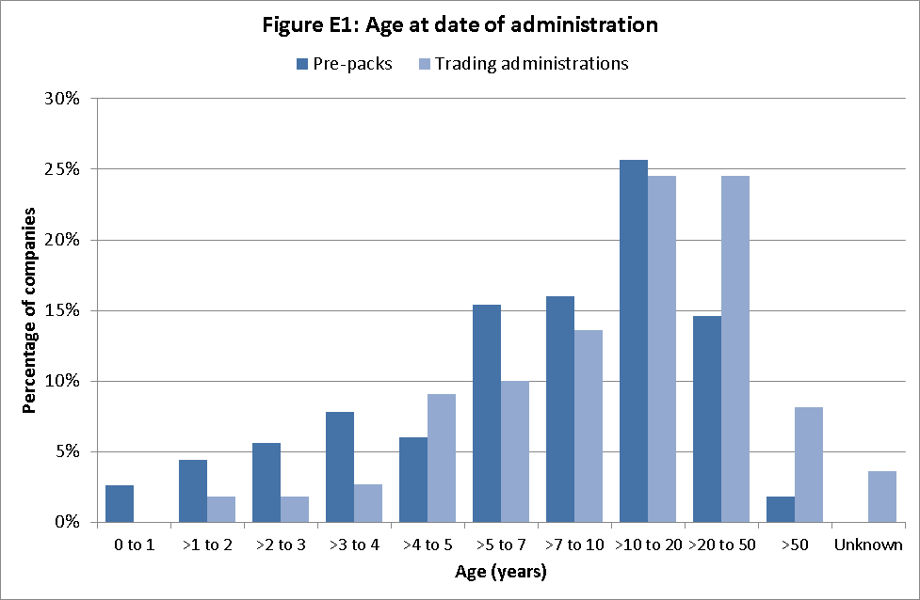
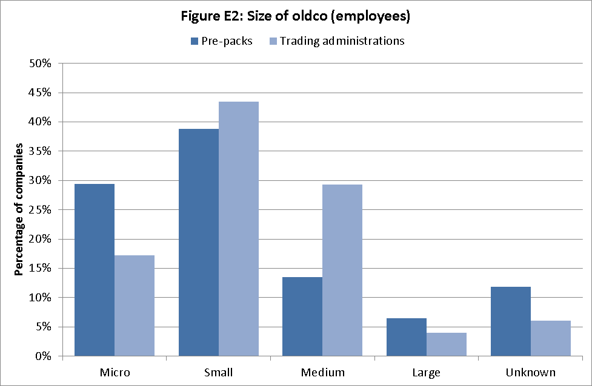

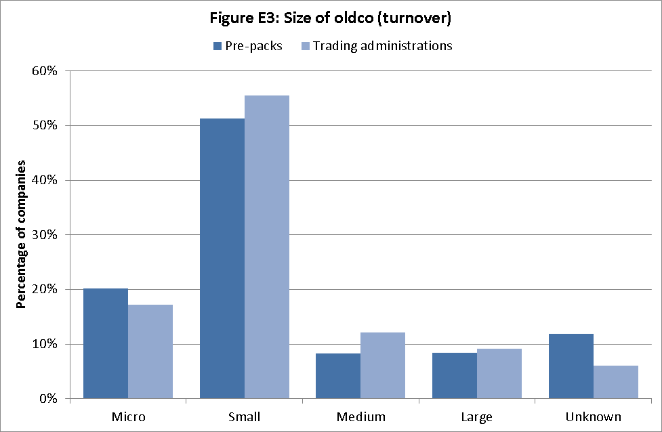

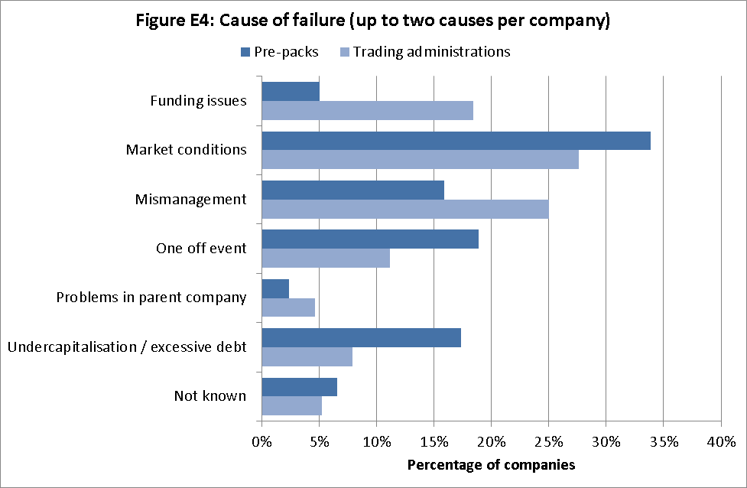

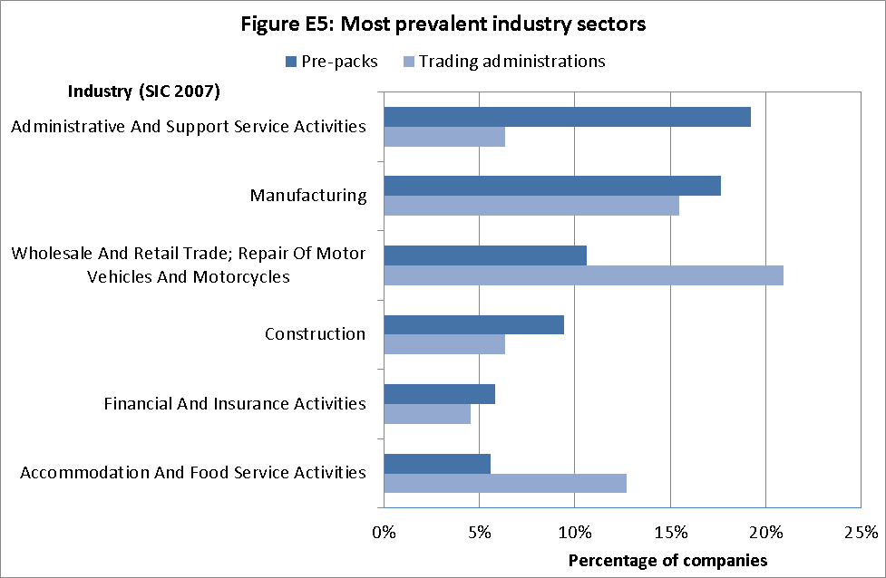
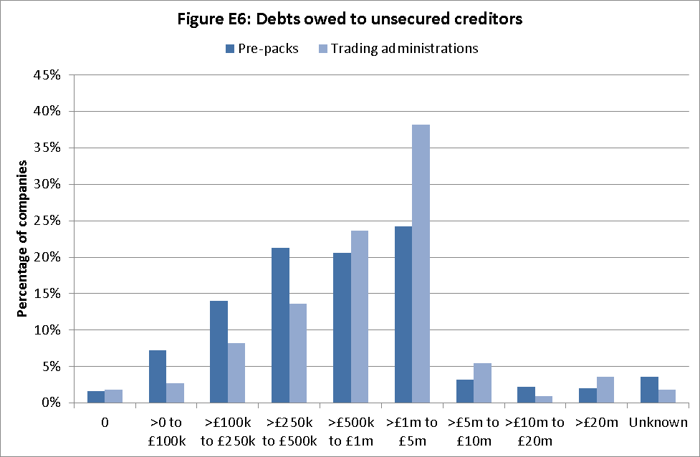

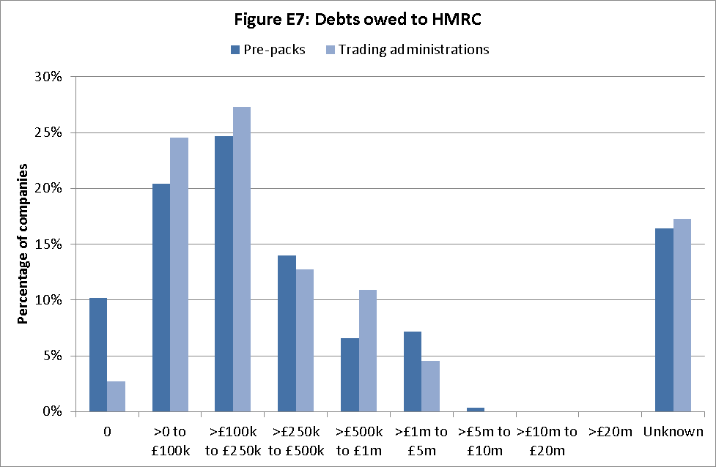

Annex F – Characteristics of the Administration
The charts below provide summary information on aspects of the pre-pack administration: how the administrator was appointed; the duration of the administration; the purchase price; and other charts which complement my analysis in Section 6.

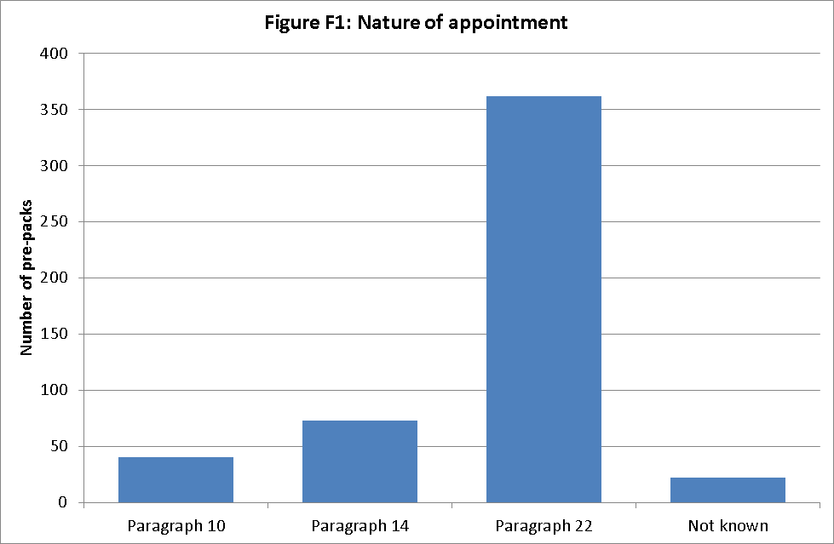

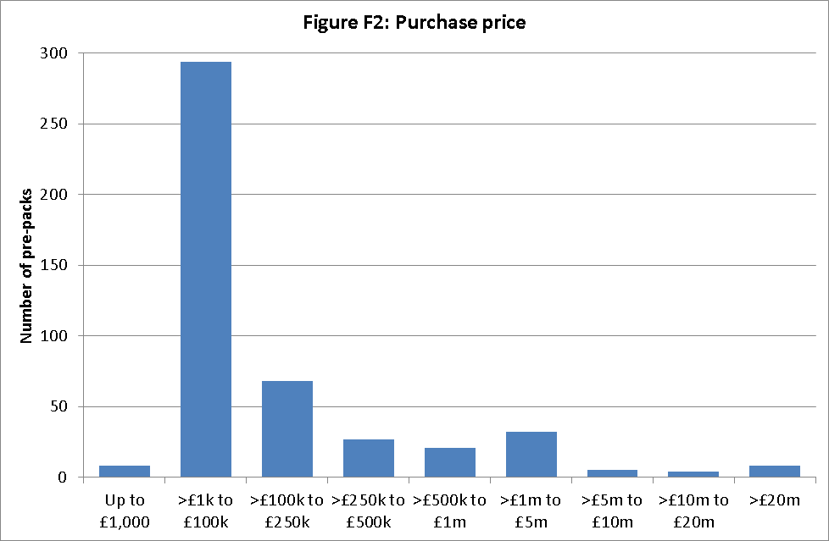

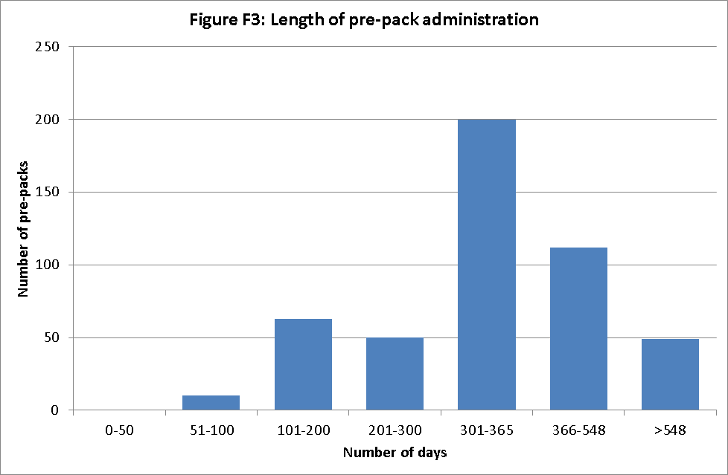

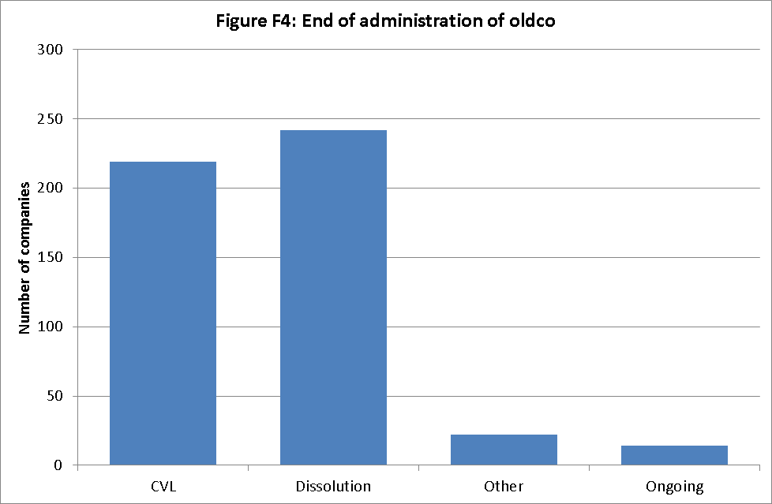

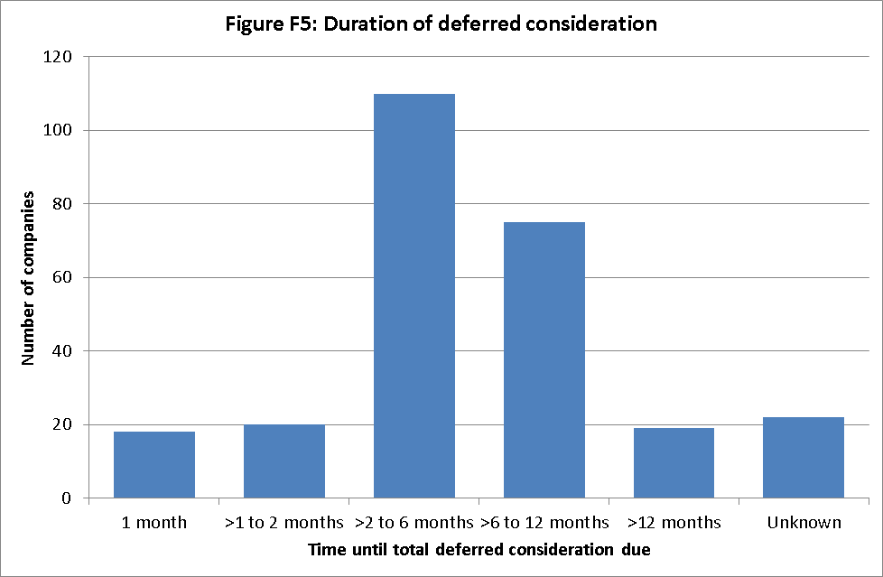

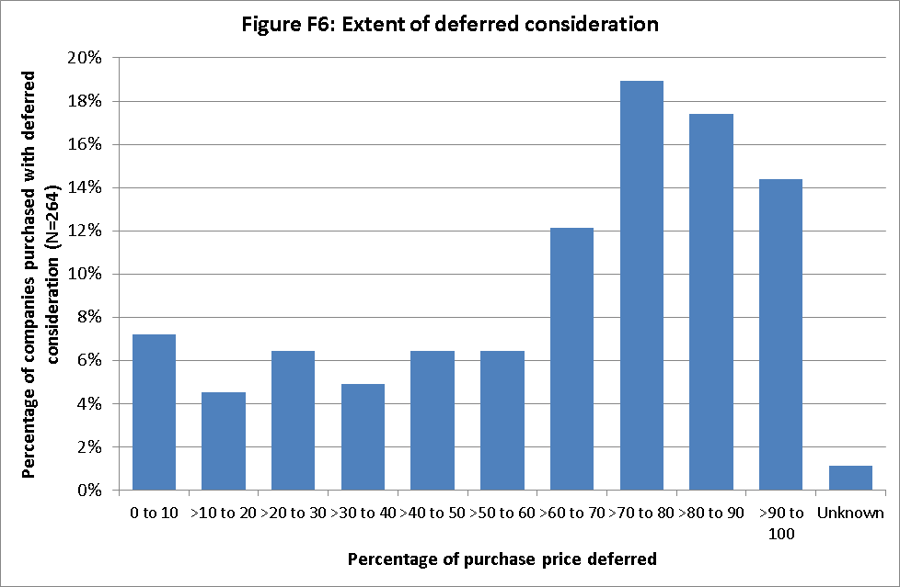

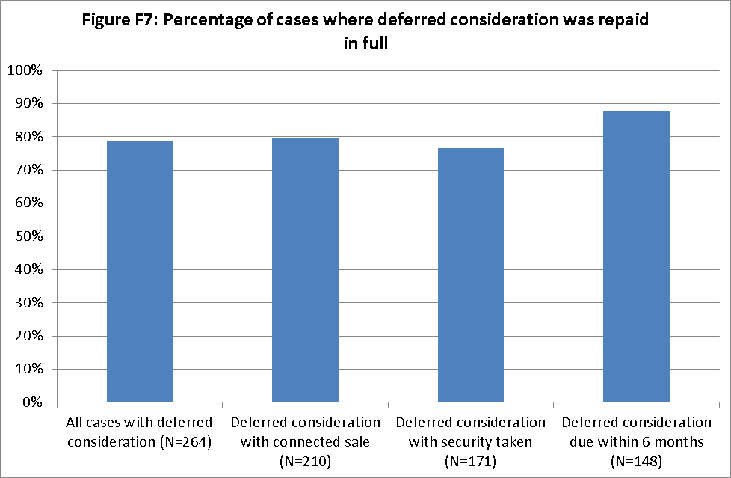
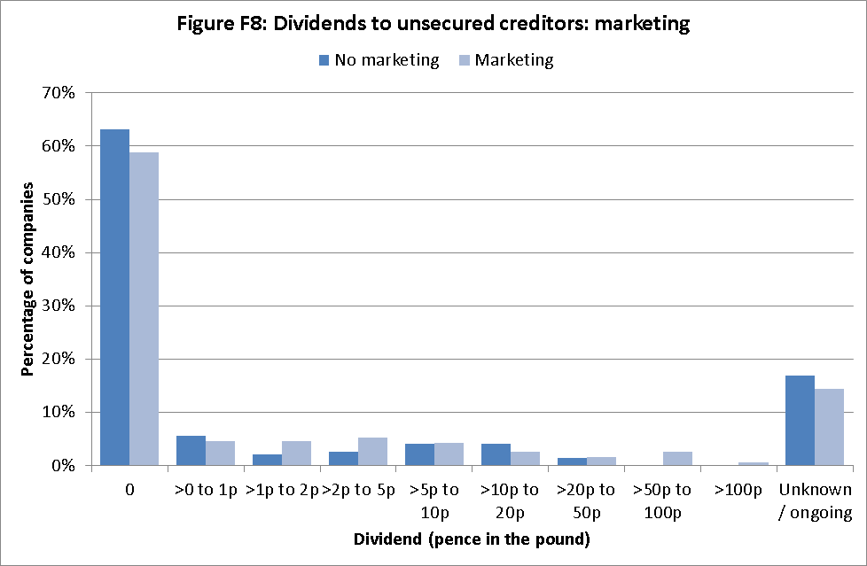

Annex G: Priority of Distribution in Insolvency
Expenses of the insolvency procedure

Preferential creditors

Floating chargeholders

Unsecured creditors

Shareholders (members)

Prescribed part
Each stage must be paid in full before any funds pass to the following level (other than relating to the prescribed part)
In certain cases, a ‘prescribed part’ of a company’s property, which would otherwise be realised for the benefit of the floating chargeholder, is instead made available to the unsecured creditors.

This is subject to a maximum of £600,000
Fixed chargeholder (less expenses of realisation of fixed charge assets)
A fixed chargeholder can only be paid from the assets subject to its charge, with any shortfall unsecured (or, if the charge had a floating element, alongside other floating chargeholders)

Annex H – Suggested Considerations for the Pool
I appreciate that the Pool is a new concept, without precedent in UK insolvency practice. It may therefore assist readers to include, as a starter for ten, some further suggestions on detail that the Government and the party running the organisation of the pool could consider when designing its structure
Secretariat
- I envisage that the pool will be administered by a small secretariat, which will control membership of the pool – selection, training , monitoring and evaluation
- It will allocate cases to members on a strict rotation basis when approached by a connected party
- A pool member would not act if there was any conflict of interest, particularly if they were connected in some way to the person approaching the pool
- This secretariat will play no active role itself in considering the papers submitted by the connected party
- The costs of the secretariat will be met from the fee paid by the connected party
- I expect that all communications between the connected party, the secretariat and the pool member will be carried out via electronic means, in order to further reduce costs. I do not envisage face to face meetings requiring a country-wide presence
- The secretariat would publish details of the pool opinion and viability review.
The secretariat would monitor performance standards for the pool based perhaps on a mix of:
  - Turnaround time
  - Positive bilateral feedback from directors
  - Unsolicited feedback from professionals involved; or from creditors
Pool Members
- Skills: I envisage the pool members will be experienced business people, selected from a wide range of industries and disciplines, possibly nominated to the secretariat by organisations such as the CBI, EEF, IOD etc. as well as trade representative organisations

- Information sent to pool member: Sufficient information will need to be provided in order for the pool member to be in a position to pass an opinion. However, I do not envisage the pool member being inundated with information – information overload does not equate to ‘transparency’
- Time: I expect that the allocated pool member will spend perhaps no more than half a day looking at the papers presented to him/her by the connected party
- Speed of response I expect the case turnaround (period between the connected party’s approach to the secretariat and the secretariat issuing the pool member’s response) to be short, so as not to delay any future transaction. I see this process as happening alongside negotiations that already take place (speaking to lenders, advisers etc), rather than something that happens after all those negotiations have taken place (which would then cause an unnecessary delay)
Liability of pool members
The pool must be structured in such a way as to avoid liability attaching to the pool member giving his/her opinion (as this would deter membership, which I very much want to avoid).
I believe that this can easily be achieved by the connected party approaching the pool with a ‘hold harmless’ style letter. It will be for the organisation running the pool’s secretariat to specify a form of words but I expect it to at least include the following –
- specify who the pool member was and what it is intended they do and specify who the connected party is and how they are connected
- that the pool member is performing his/her function at the behest of the connected party
- the process that will be followed
- the conditions that the work is carried out under, including –
  - the payment of a fee (and understanding that no work be carried out until this is paid in full)
  - A declaration that all the material submitted to the pool member was up to date and accurate with no blame attaching to the pool member if the information subsequently proves to be inaccurate
  - Acknowledgement on the part of the connected party that no legal liability can or will attach to the pool member as a result of any opinion that he/she gives and any effect that this does (or does not) have
- Signature of the connected party

This is not an exhaustive list (and I have not taken legal advice in regard to it) but I hope that it is a useful starting point for those who are appointed to put the flesh on the bones of the pool.
Cost
- I believe strongly that there be full cost recovery for the pool, i.e. the fee paid by the applicant pays for the costs (secretariat) and also the time of the pool member (I suggest that the latter will be a fixed fee and not time based)
- The pool function needs to be efficient such that running costs are kept low, in order that it not deter connected parties approaching the pool. As stated in the main body of the report, a connected party might be the best person to whom to sell the business.
Forecast demand
Pre-packs have been a reasonably constant percentage of total administrations since the Service began monitoring SIP16s – around a quarter of all administration cases. Administrations themselves have been reasonably constant in recent years: c2500 in 2012, c 2300 in 2013. Connected cases are around 65% of all pre-pack cases, so – 2300 * 25%*65% = 374 cases pa that could go to the pool.
Success criteria for the Pool concept could include:
- reduced noise around pre-packs
- operational efficiency
- full cost recovery has been achieved
- providing a “seal of approval” which helps persuade creditors that the pre-pack has been subjected to some form of independent scrutiny
- a feeling that the creditors interests and concerns were factored into the early/earliest discussions that anticipated a pre-pack

Annex I Specimen wording for pool member’s statements - positive and negative
THE POOL MEMBER – specimen wording 1
This statement has been given by me as a member of [formal name of the pool], at the request of [the connected part(y/ies)].
Statement
I have reviewed the evidence provided by the connected part[y/ies]. This consists of:
[Evidence item 1
Evidence item 2
…]
Based on my review, I have not found anything to suggest that the grounds in the statement are unreasonable.
For the avoidance of doubt, I express no view on whether [Newco] is, or will in future remain a going concern. This is a matter for the [connected parties]. Neither do I express a view on the decision of the administrator of [Oldco] to enter into the pre-pack. This is a matter for the administrator.
The administrator of [Oldco] will make this finding public by [describe mechanism]. The administrator’s duties, however, relate to [Oldco and its creditors], not to [Newco] or its creditors or future creditors (or any other person). The administrator’s duties are not affected by this statement.
Referral to [formal name of the pool] is a voluntary process and no liability attaches to me or to [formal name of the pool] as a result of this statement.

THE POOL MEMBER – specimen wording 2
I have reviewed the evidence provided by the connected part[y/ies] consisting of
[Evidence item 1
Evidence item 2
…]

Based on my review, the evidence I have found is not sufficient to support the statement of reasonable grounds.
For the avoidance of doubt, I express no view on whether [Newco] is, or will in future remain a going concern. This is a matter for the [connected parties]. Neither do I express a view on the decision of the administrator of [Oldco] to enter into the pre-pack. This is a matter for the administrator.
The administrator of [Oldco] will make this finding public by [describe mechanism]. The administrator’s duties, however, relate to [Oldco and its creditors], not to [Newco] or its creditors or future creditors (or any other person). The administrator’s duties are not affected by this statement.
Referral to [formal name of the pool] is a voluntary process and no liability attaches to me or to [formal name of the pool] as a result of this statement.

Annex J Suggested Form of Wording for Viability Statement/Review
THE CONNECTED PARTY AND THEIR VIABILITY REVIEW – specimen wording
[I/We] [name(s)] acknowledge that [I am/we are] [Newco]’s connected part[y/ies] [I/We] have formed an opinion, based on reasonable grounds, that [Newco] is a going concern and will remain a going concern for at least 12 months from [date], the date of this statement. [I am/We are] aware that this statement will be a matter of public record, be made available to creditors and may be taken into account in any future proceedings.
[I/We] also acknowledge that [Oldco] is not currently a going concern. [I/We] explain below the reasonable grounds which form the basis of [my/our] opinion that the prospects of [Newco] differ from those of [Oldco], beyond the discharge of debt.
*(Please state reasons for the reasonable grounds (as a guide around 500 words would be considered appropriate)
[I/We] confirm that, in giving this opinion, where [I/we] have considered it necessary to be advised, [I/we] have sought independent advice.
n.b where the company name is cited, the company number must also follow

Connected party cases are those cases where the controllers of the new company (post pre-pack) are connected with those who controlled the insolvent company. Commonly, this is where the directors of both companies are the same.
http://www.insolvency.gov.uk/assets/insolvency/docs/insolvency%20profession/consultations/prepack/pre-pack%20consultation%2031march%2010.pdf
http://www.insolvency.gov.uk/assets/insolvency/docs/insolvency%20profession/consultations/prepack/responses/26-01-12%20written%20ministerial%20statement.doc
Report of the Review Committee on Insolvency Law and Practice (1982) Cmnd 8558
Comparing change to 2007 as avoids the impacts on numbers of insolvencies of the recession in 2008, which impacts case numbers significantly after that.
Research from Dr Sandra Frisby in 2007 indicated that the increase in pre-packing commenced before the Enterprise Act changes came into force. Her research indicated that the rise started in May 2003. A preliminary analysis of pre-packaged administrations, Dr Sandra Frisby, University of Nottingham, 2007
Current SIP16 - http://tiny.cc/e1yn7w ; SIP16 1/1/2009-31/10/2013 http://tiny.cc/b5yn7w
14 days 1/1/2009 – 31/10/2013
Most recently, p8-10, 2013 Annual Review of Insolvency Practitioner Regulation http://tiny.cc/e78kfx
http://www.oft.gov.uk/shared_oft/reports/Insolvency/oft1245],
http://tiny.cc/izhrex
Strengthening the regulatory regime and fee structure for insolvency practitioners https://www.gov.uk/government/uploads/system/uploads/attachment_data/file/280880/Strengthening_the_regulatory_regime_and_fee_structure_for_insolvency_practitioners.pdf
It must be borne in mind that reducing the cause of failure of a company, given in a SIP16 statement or administrator’s proposals, to a small number of categories as shown in the chart is unavoidably subjective.
I have been told by stakeholders that many more have relocated for this reason since.
Under Part 26 of the Companies Act 2006
Or any administration procedure
The UK’s insolvency system was ranked 7th in the world by the World Bank in its most recent ‘Doing Business’ report http://doingbusiness.org/rankings
A substantially similar result to a pre-pack can be obtained through security enforcement – such a route does not require court approval.
In addition, a substantially similar result to a pre-pack can be obtained through security enforcement – such a route does not always require court approval. The Luxembourg and Netherlands security enforcement cases are pre-arranged restructurings where the unsecured creditors of the parent company which is transferred can be left with claims against an empty shell and are something of a hybrid between a sale as a going concern and a pre-pack.
Wellard, Mark & Walton, Peter (2012) A comparative analysis of Anglo-Australian pre-packs: can the means be made to justify the ends? International Insolvency Review – pg.16
Other than payments made by virtue of the prescribed part – s176A Insolvency Act 1986. This does not include a small number of cases where a subsequent liquidation or in 14 cases the administration itself, is on-going and there remains a possibility, though it is by no means certain that a distribution will be made to unsecured creditors. Any distributions that have been made in a subsequent creditors’ voluntary liquidation are included in these figures.
As these are monies owed to employees – and in most cases, all employees are transferred into the new business – many cases will not have preferential creditors.
For the purposes of this report, a purchaser is deemed to have failed if it has entered into a formal insolvency process (including administration, liquidation and company voluntary arrangement (“CVA”)) or if steps have been taken to strike the company off the Register of Companies. Data on whether or not the newco had failed was available for 475 of the 499 recorded transactions. It was generally not possible to ascertain subsequent failure where the purchaser was either an individual (though some instances of bankruptcy were apparent from the administrators’ reports and have been included) or partnership or an overseas company
The data was collected on 1/2/2014. It is worth noting that as at 1 February 2014, 158 purchasers had failed.
See sections 249 and 435 of the Insolvency Act 1986
I am aware of at least two trade associations who will not permit pre-packed business to re-join the trade association (that oldco had been a member of) following the pre-pack.
For the purposes of s249 Insolvency Act 1986
The Insolvency Service’s review of SIP16 statements from 2010 stated that 72% of pre-packs were connected. The difference in proportions between that report and this may be a result of application of different criteria to judge the degree of connection.
Deferred consideration, for the purposes of this report, does not include earn-out or anti embarrassment clauses – where additional payments need to be made if newco performs in a certain way - for example if its profits are above a certain level, a proportion need to be paid to the oldco administrator
Administrations are supposed to complete within 12 months, although this can be extended by the creditors by a further six months alone or by the court. It is therefore not surprising that the large majority require full payment within 12 months
Median 71%, interquartile range 47% to 86%
Something also recorded by the Insolvency Service’s annual figures on SIP16s
This failure to pay deferred consideration can be put down to a number of factors, the most common being the subsequent failure of the purchaser (28/43 cases).
Unless the non-payers had paid less than the break-up value of the assets at the time they stopped paying.
Purchase price was also found to be a factor in failure rates after 36 months for pre-packs, specifically, whether the price paid was less than £1.5 million. The results reported control for this variable.
The requirement for secrecy would not necessarily preclude a creditor representative being informed of the pre-pack and objecting to the pre-pack at court if the general body of unsecured creditors were not informed.
Albeit overall payment rates are still low.
S176A Insolvency Act 1986
Administration, creditors’ voluntary liquidation, compulsory liquidation, receivership and company voluntary arrangement.

