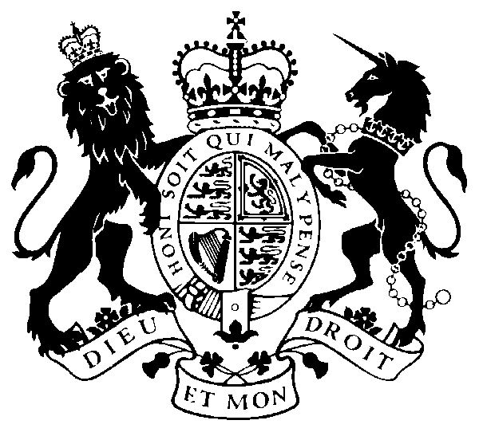
DEPUTY PRIME MINISTER

70 WHITEHALL, LONDON SW1A 2AS

Mental Health Hero Awards
Nomination Form

Thank you for taking the time to nominate someone as a Mental Health Hero in your area. We are looking for people who are changing lives through one or more of the following:

1. Helping to break the stigma around mental health
2. Inspiring others in addressing or overcoming mental health problems
3. Making it easier for people to access mental health support and advice
4. Supporting people experiencing mental health problems to stay in, or return to, work
5. Pioneering new or innovative ways of supporting people with mental health problems and/or their families

Please complete the form below and return to cathy.mussert@cabinetoffice.gov.uk by Tuesday 27th January 2015.

Name of person nominating:

Email:

Telephone Number:

Address:

Name of person to be nominated:

Area where they are based:

Based on the five criteria set out above, why do you think this person should win a mental health hero award (500 words max):

