|  |  |
| --- | --- |
| **Official Statistics Release** | |
| Policy area: | Adoption agencies quality assurance and data forms 2012-13 |
| Theme: | Education, children’s services and skills |
| Published on: | 26 November 2013 |
| Coverage: | England |
| Period covered: | 1 April 2012 - 31 March 2013 |
| Status: | **FINAL** |
| Issued by: | Office for Standards in Education, Children’s Services and Skills (Ofsted) 125 Kingsway London WC2B 6SE |
|
|
|
| Statistician: | Adam King |
| Public enquiries: | enquiries@ofsted.gov.uk |
| Press enquiries: | pressenquiries@ofsted.gov.uk |
| Link to official statistics release web page: | [www.ofsted.gov.uk/resources/20130022](http://www.ofsted.gov.uk/resources/20130022) |
| Publication medium: | Ofsted website |
| Publication frequency: | Annually |
| Next publication date: | Autumn 2014 |

**Introduction**

Adoption services are provided by local authority (LA) adoption agencies and voluntary adoption agencies (VAAs). Having parental responsibility for looked after children, LAs plan whether adoption is in a child’s best interests and will then make arrangements for a child to be adopted. A VAA is a not-for-profit organisation that places children for adoption. The focus of all adoption agencies is on placing children successfully into adoptive families who the agency recruits, assesses, prepares and supports, so they will meet the children’s needs and enable them to develop and achieve throughout their lives.

This is the second national publication of data collected by Ofsted from adoption providers. The data were collected in April-June 2013 and are used to inform the inspection of adoption provision.

These official statistics report on the numbers and profile of adopters and children, in both LA adoption agencies and VAAs, covering the period between 1 April 2012 and 31 March 2013. It also gives data relating to recruitment activity of adoptive families, adoption support, complaints and inter-country adoptions.

These statistics are based on data supplied by LA adoption agencies and VAAs. Ofsted will publish these data annually and the next release is currently scheduled for autumn 2014.

Contents

Response rates 3

Key findings 4

Methodology 12

Additional information 13

Glossary 14

Response rates

* Responses were received from all 152 LAs in England. A total of 12 LAs have five joint arrangements[1], whereby adoptive families were shared across member authorities and it was not possible to distinguish the families across individual authorities. However, all activity has been captured representing a 100% return rate from LAs. Three of the joint arrangements provided data on children for each member authority and submitted a combined return for adopters and adoptive families. Two of the shared services reported joint figures for both adopters, adoptive families and children.
* Of the 44 VAAs, 10 registrations were not eligible to submit data: seven registrations (owned by three organisations) provided adoption support functions only; two registrations were head offices that had no delivery functions; one registration was in the process of resigning during the data collection. Furthermore, the analysis and statistical release excludes data which related to two registrations which were based in Wales. The 32 returns in this dataset, therefore, represented a 100% response rate of eligible VAA registrations in England.
* Of the three LAs that did not submit data for 2011-12, but did submit data for 2012-13, children who were subject to an adoption plan and also the number of approved adoptive families accounted for 2% each of the total LA figures at 31 March 2013. Of the four VAAs that did not submit data for 2011-12, but did submit data for 2012-13, children who were placed for adoption during 2012-13 accounted for 8% of the total placements with VAAs. Similarly, the number of approved adoptive families at 31 March 2013 in these four VAAs accounted for 9% of the total VAA number of families. Overall, we estimate that approximately 3% of the total numbers in the dataset may be attributed to the slightly higher response rate this year.

Key findings

**Children and young people**

* On the 31 March 2013, a total of 10,177 children were subject to an adoption plan. A sixth of the children (1,684) had not yet had placement orders granted. Just under half of the children (4,682) were waiting to be matched to adoptive families, whilst a third of children (3,458) were placed but the final adoption order had not been made. (A1.1-1.5)

**Chart 1**

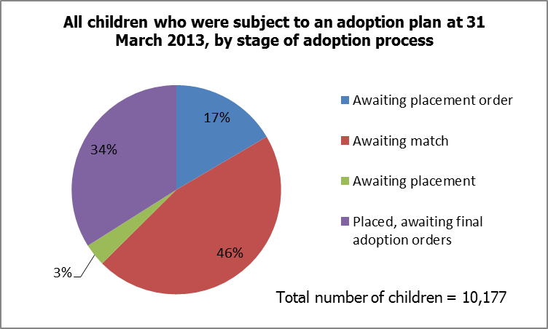

*Source: Quality assurance and data form A1.1-1.5*

* Adoption placements commenced in 2012-13 for 4,767 children. A large majority of children (70%, 3,325 children) were placed in families approved by the LAs who were responsible for the children, whereas 16% (779 children) were placed with families approved by other LAs and 14% (663 children) were placed with families approved by VAAs. (A4.1-4.3)
* A total of 3,782 children were reported as subject to final adoption orders during 2012-13, an increase of approximately 300 children from last year’s published DfE figure[2]. A very large majority (84%, 3,175) were adopted by families approved by LAs, whilst 16% of children (607) were adopted by VAA approved families. (A1.8)
* Children who were disabled (539) represented 5% of the children subject to an adoption plan on 31 March 2013. (A1.1)
* The proportion of children who were waiting to be matched to adoptive families was higher among disabled children than for all children; of 539 disabled children subject to an adoption plan on 31 March 2013, 323 disabled children (60%) were waiting to be matched to adoptive families, whereas 46% of all children subject to an adoption plan were waiting to be matched on 31 March 2013. (A1.1, A1.3)
* Disabled children (142) represented 4% of the children subject to a final adoption order, with very little difference in the proportion of disabled children adopted by families approved by LAs and VAAs. (A1.8)
* Very few children (3%) were reported to have experienced a disruption of adoption placement in 2012-13. In total, of the 4,767 children who were placed for adoption during 2012-13, disruptions affected 148 children. (A2.1-2.3, A4.1-4.3)
* There was very little difference between the proportions of disruptions within families approved ‘in house’ by LAs, by other LAs and by VAAs. Of 3,325 children who were placed by LAs using their own approved adoptive families, disruptions affected 94 children (3%). Of 779 children who were placed by LAs using families approved by other LAs, disruptions affected 32 children (4%). Of 663 children who were placed with VAAs, 22 children (3%) experienced a disruption. (A2.1-2.3, A4.1-4.3)
* During 2012-13, there were a total of 118 disruptions in adoptive families which affected 148 children. This was similar to the number of disruptions of placements reported in the previous year at 105. (A2.1-A2.3, 2011-12 England A)
* There were 955 sibling groups (2,071 children) who were placed for adoption in the year 2012-13. This was an increase of 40% on the 680 sibling groups who were placed during 2011-12. (A3.1-3.3, 2011-12 Local Authority A3.2-3.3)
* Although the number of sibling groups placed for adoption has substantially increased, the proportion of groups who were placed together has remained the same. Of the 955 sibling groups, 82% (786 groups) were placed together, 13% (126 groups) were placed apart in line with their assessment and 5% (43 groups) were placed apart despite the assessment to be placed together. (A3.1-3.3)
* Overall there were 4,767 children whose placements commenced during the year ending 31 March 2013. 2,071 children were reported within placements that commenced for sibling groups, from which it is possible to infer that, of the children placed in the year, 57% were single children and 43% belonged to a sibling group. (A4.1-4.3, A3.1-3.3)
* Of the 3,782 children who were subject to final adoption orders during 2012-13, 3% (121 children) were aged 11 months or younger, 27% (1,005 children) were aged between 12 to 23 months, 50% (1,890 children) were aged two to five years old and 20% (766 children) were older than five. (A6.1-6.4)
* The age profile of the 607 children adopted in 2012-13 by families approved by VAAs was very similar compared to 2011-12.[3] (A6.1-6.4, 2011-12 Voluntary G2.1-2.4)
* Over a third of children (220) adopted in VAAs were aged five or older at the granting of the final adoption order during 2012-13. Almost half the children (289) were aged between two and five years old. (A6.1-6.4)
* In contrast, as indicated in Chart 2 below, for the families approved by LAs, the proportion of children aged five or older adopted was lower than among VAAs; the difference was accounted for by a higher proportion of children aged 12 to 23 months old. (A6.1-6.4)

**Chart 2**

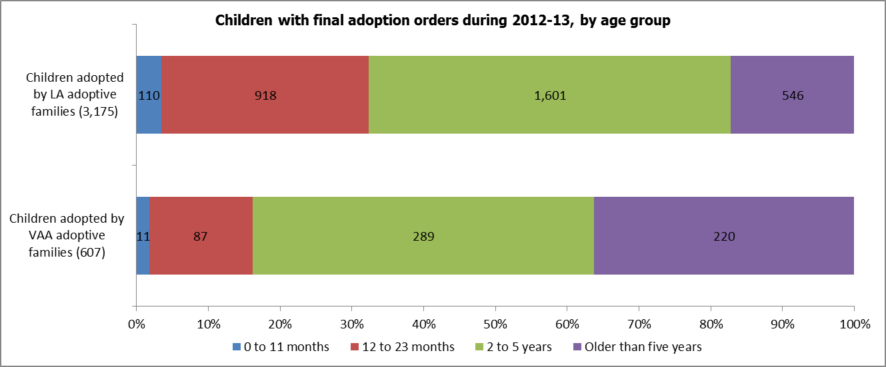

*Source: Quality assurance and data form A6.1-6.4*

**Adoptive families**

* Overall, the number of approved adoptive families has increased by 18%, from 4,263 at 31 March 2012 to 5,011 at 31 March 2013; a net increase of 748 families. (B1.1, 2011-12 England B1.1)
* Of the 5,011 approved adoptive families as at 31 March 2013, over half of the families (55%) had children in placement, 7% of families were matched to children and 38% of families were approved and waiting to be matched to children, or ‘available’. (B1.1-1.4)

**Chart 3**

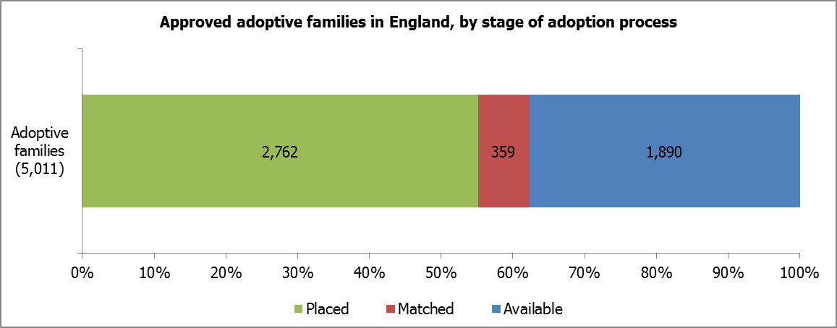

*Source: Quality assurance and data form B1.2-1.4*

* Of the 5,011 approved adoptive families as at 31 March 2013, 84% (4,195) had been approved by LAs and 16% (816) had been approved by VAAs. (B1.1)
* Of the children subject to final adoption orders and adopted, during 2012-13, 84% (3,175) were adopted by LA approved families and 16% (607) by VAA approved families. (A1.8)
* As shown in Chart 4 below, the largest number of adoptive families was in the North West region, with 623 families accounting for 15% of the 4,195 total families who were approved by LAs. However, this region had the lowest proportion of ‘available’ families, 172 families (28%) were waiting to be matched to children. The North East region had the smallest number of approved adoptive families. (B1.2-1.4)

**Chart 4**

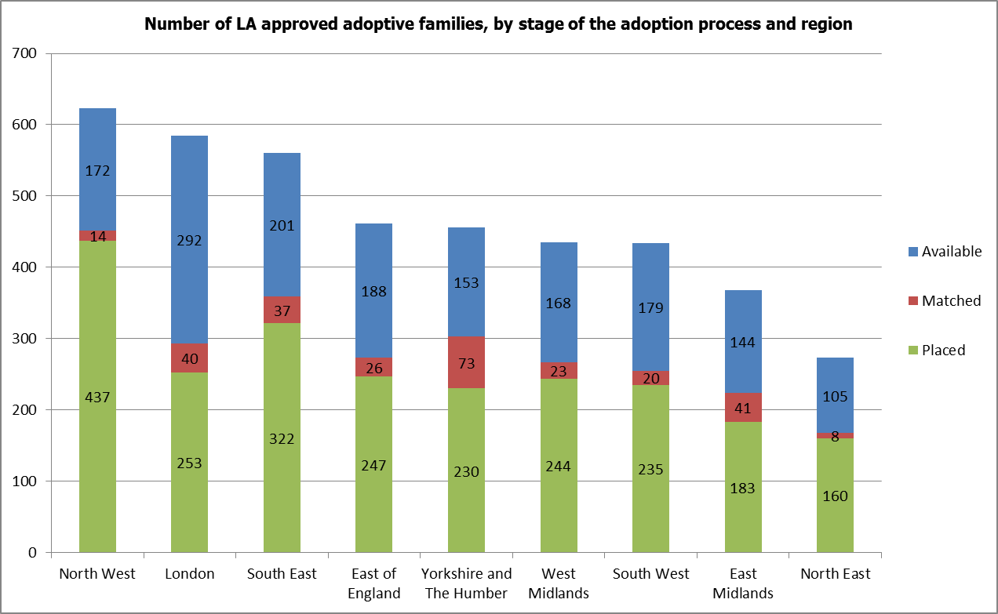

*Source: Quality assurance and data form B1.2-1.4*

**Table 1**



* Final adoption orders were granted for 3,120 adoptive families during the year ending 31 March 2013. Of these families, 2,650 (85%) were within LAs and 470 (15%) were within VAAs. (B1.5)
* In 2012-13, 405 foster carers were approved to adopt the child/children they were fostering. This was a 45% increase on the number reported for the previous year, at 280. (B1.9, 2011-12 England B1.7)
* For adoptive families who were matched during 2012-13, the proportion of adoptive families who waited less than three months to be matched to children was substantially lower among VAAs compared to LAs: 15% and 42% respectively. The proportion of adoptive families who waited longer than 12 months to be matched, however, was very similar across VAAs and LAs: 10% and 9%. (B3.1-3.6)

**Chart 5**

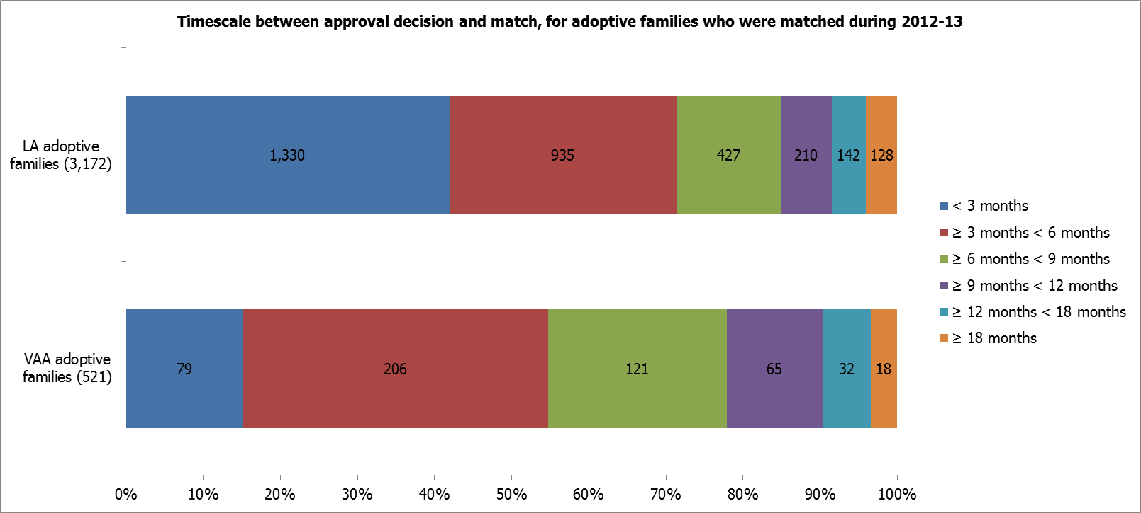

*Source: Quality assurance and data form B3.1-3.6*

**Recruitment of adopters**

* There were 27,080 initial enquiries recorded during 2012-13. Applications were received from 5,173 prospective adoptive families, from which we may infer that approximately one in five enquiries progress into applications from people wishing to adopt. There was, however, considerable variation in the data. (B2.1-2.2)
* The number of applications that were approved had increased by 34% compared to the previous year. During 2012-13 a total of 4,093 applications were approved, whereas during 2011-12 there were 3,048 applications approved. (B2.5)
* Application outcomes in 2012-13 were very similar to 2011-12. Approvals (4,093) accounted for 87% of applications that were concluded, whilst 12% were withdrawn (580) and 1% were refused (33). (B2.5-2.7)
* The number of applications that were still being processed on the 31 March has also increased by 19% in 2012-13, but lower than the 31% increase from the previous year. There were 2,982 applications that were still in progress on 31 March 2013, compared to 2,515 applications that were still in progress and brought forward into the year on 1 April 2012. (B2.3-2.4)
* Data were collected on timescales between application and approval decision, for prospective adoptive families, as an indication of the length of time taken for assessment processes. A higher proportion of adoptive families were assessed within six months in LAs; 29% compared to 15% among adoptive families in VAAs. (B4.1-4.6)

**Chart 6**

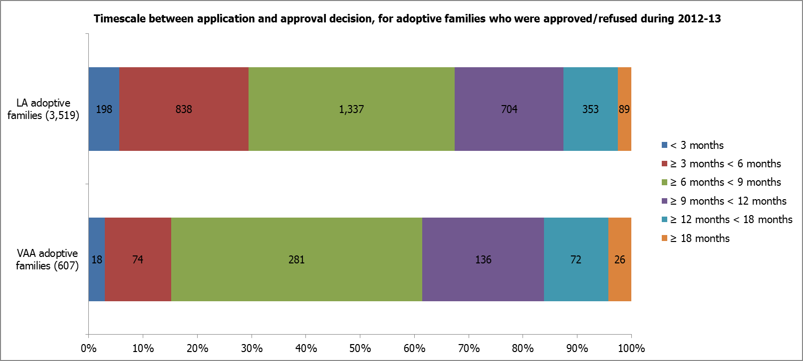

*Source: Quality assurance and data form B4.1-4.6*

**Characteristics of adopters**

* Ethnicity data were collected for the 9,501 individuals who were approved to adopt. As at the 31 March 2013, most approved adopters (90%, 8,547) were White. Other ethnic groups were represented as follows: 4% (354) Asian or Asian British; 3% (313) Black or Black British; 2% (166) Mixed; and 1% each for any other ethnic group and refused or unknown (68 and 53 respectively). (C1.1-1.20)
* The proportion of White adopters at 31 March 2013 was higher than White children who were subject to an adoption plan and the wider looked after children cohort according to statistics published by the Department for Education (DfE), as shown in Chart 7 below. (C1.1-1.20, Looked after children national statistics[4])

**Chart 7**

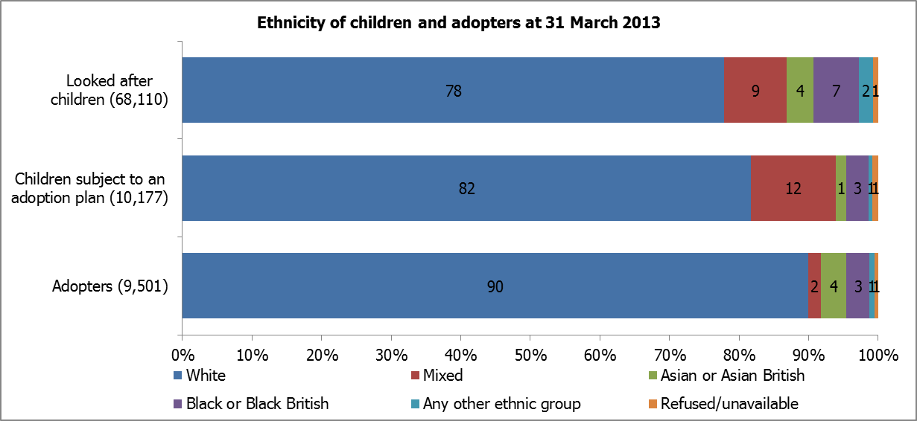

*Percentages are rounded and may not sum to 100*

*Sources: DfE looked after children national statistics; Quality assurance and data form A5.1-5.20, C1.1-1.20*

* However, the ethnic profile of adopters at 31 March 2013 was similar to the profile found among the adult resident population in England at the last census, in 2011. (C1.1-1.20, 2011 census[5])

**Table 2**



* The proportion of individuals approved to adopt who were from Black and Minority Ethnic (BME) backgrounds was 11 percentage points lower among LAs compared to VAAs. As at the 31 March 2013, 8% of individual adopters in LAs were from BME backgrounds compared to 19% of individual adopters in VAAs. (C1.1-1.20)

**Chart 8**

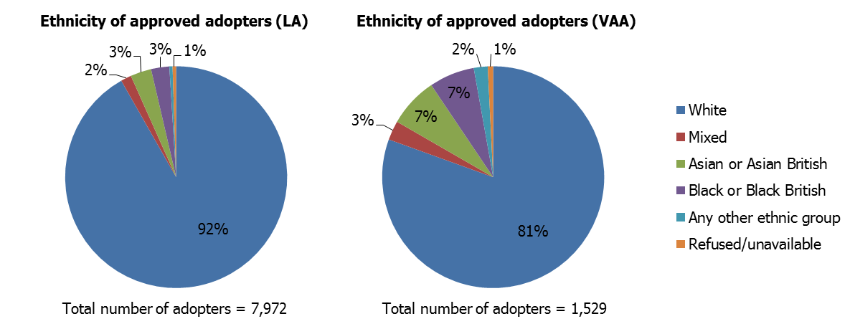

*Percentages are rounded and may not sum to 100*

* Among individuals who were approved to adopt as at 31 March 2013, the majority of individuals were Christian (64%, 6,037). Twenty per cent of individuals (1,885) had no religious affiliation, whilst 2% (216) were Muslim and 1% (89) were Hindu. Three per cent of individuals (250) were reported as having an other religion and information was not available for 10% of individuals (969). (C2.1-2.8)
* As at 31 March 2013, most individuals (90%) who were approved to adopt were heterosexual. Individuals who were lesbian (276) or gay (319) represented 3% each of the total number of adopters. Information was not available for 4% of individuals (356). (C3.1-3.6)
* Very few adopters were disabled. Of the 9,501 individuals who were approved to adopt as at 31 March 2013, 73 (1%) had a disability. (C4.1)
* As at the 31 March 2013, a large majority of approved adoptive families were married (75%, 3,743). The next largest relationship status was single at 10% (521 families), followed by male/female partnership at 9% (431 families). Civil partnerships and same sex partnerships represented 3% each, 168 and 141 families respectively. (C5.1-5.7)

**Adoption support**

* In 2012-13, 7,933 adult adoptees received adoption support, for instance birth records counselling. Local authorities provided 90% (7,165) of the support whilst VAAs provided 10% (768). (D1.5, D1.8)
* There were 3,782 children reported as adopted during the year 2012-13. For children who were adopted between 1 April 2012 and 31 March 2013, LAs received requests for post adoption support assessments from 1,122 families. Of these requests, 911 (81%) went on to have support provided during the year. Of the support provided, 83% (752) were provided by the LA and 17% (159) were commissioned to other agencies to provide the support. (A1.8, D1.1-1.3)

**Complaints and allegations**

* There were 418 complaints received during 2012-13; 96% (400) were made to LAs and 4% (18) were made to VAAs. (E1.1)
* There were 67 allegations relating to child protection made against adopters, or prospective adopters, made between 1 April 2012 and 31 March 2013; 82% (55) for LAs and 18% (12) for VAAs. (E1.3)

**Inter-country adoptions of children from outside the UK**

* Data on children’s ages at the time they entered the United Kingdom was supplied for 135 children who were placed for inter-country adoption during 2012-13. The largest number of children were aged 12-23 months, at 57 children placed. A quarter of the children placed (34) were aged 0 to 11 months. A fifth of children (21%) were aged two to five years old with 29 children placed. This was a substantially younger age profile of children compared to domestic adoptions, where 50% were aged two to five years old, and only 3% of children (121) were 0 to 11 months. (G4.1-4.4, A6.1-6.4)
* Just over two thirds (68%) of the children placed for inter-country adoption during 2012-13 were female; 94 females and 44 males. (G5)
* Local authorities placed 84 children for inter-country adoption during 2012-13 and VAAs placed 54 children. (G5)
* The three countries with the highest number of children who were placed for inter-country adoption were: Russia (30); China (20) and Pakistan (19). (G5)

Methodology

1. The data in this publication are taken from returns made to Ofsted by local authority and voluntary adoption agencies. Most of the data relate to the period between 1 April 2012 and 31 March 2013.
2. For more information on how Ofsted regulates and inspects voluntary adoption agencies, please go to the Ofsted website: <http://www.ofsted.gov.uk/resources/childrens-social-care-registration-introduction-voluntary-adoption-agencies>

Additional information

The underlying data, along with aggregated data at England, total local authority adoption agencies and total voluntary adoption agencies levels, are available in Excel format on the Ofsted website in the same location as this document: <http://www.ofsted.gov.uk/resources/adoption-quality-assurance-and-data-forms-2012-13-first-statistical-release>

The summary release also includes an overview of response rates, as shown in the table below:

**Table 2**

**Percentage of returns of the adoption quality assurance and data form 2012-13**



Ofsted received data returns from all local authority and voluntary agencies eligible to return data. However, the returns from Lambeth and Peterborough local authorities contained small inaccuracies around the number of individuals/families where placements had commenced (sections C1-3 and C5). The two local authorities were unable to rectify these inaccuracies. Their data have been included in the national and local authority datasets.

Glossary

**Adoption agencies**

The focus of all adoption agencies is on placing children successfully into adoptive families who the agency recruits, assesses, prepares and supports, so they will meet the children’s needs and enable them to develop and achieve throughout their lives. The services maintained by local authorities are described in section 3(1) of the Adoption and Children Act 2002. Local authorities place children with adoptive families recruited and approved by themselves, by other local authorities or by voluntary adoption agencies who must register with Ofsted. Adoption agencies may also provide birth records, counselling and intermediary services to adoptees and birth relatives. There are three branches of voluntary adoption agencies in Wales which are inspected by Ofsted because their head offices are in England. These are not included in this publication.

**Adoption plan**

This means that the decision has been made by the agency decision maker that the child 'should be placed for adoption' (SBPFA). Also known as the 'best interest decision'. Children are counted as subject to an adoption plan at all stages until the final adoption order is granted.

**Adoptive family**

For the purposes of these data, one 'adoptive family' includes: a couple (married, civil partnership male/female partnership or same sex partnership) who have been approved as adoptive parents; or a single person (including divorced or widowed) who has been approved as an adoptive parent.

**Approved**

The definition of approved is ‘people who have been approved as adopters by the adoption agency decision maker’.

**Disability**

Section 6 of the Equality Act 2010 defines a disabled person as someone who has a physical or mental impairment which has a substantial and long term adverse effect on his or her ability to carry out normal day to day activities. Examples include cancer, diabetes, multiple sclerosis and heart conditions; hearing or sight impairments, or a significant mobility difficulty; and mental health conditions or learning difficulties.

**Final adoption order**

This is when the courts grant the adoption order.

**Final adoption order (inter-country adoptions)**

This is the final adoption order issued by the state of origin (for a convention or designated country) or the final adoption order issued by a UK court (for a non-convention country).

**Misconduct**

Where a formal investigation into the conduct of a member of staff or a prospective adopter is undertaken which follows a voluntary adoption agency's procedures for investigating such allegations. The use of the term allegation is used for employment as well as safeguarding.

**Placed for adoption**

This is where a child is placed (i.e. living with) the adoptive family that they have been matched to.

**Requests for assessment**

Formal requests for assessment for adoption support services, rather than on-going informal assistance or initial enquiries.

**Sibling groups**

The definition of siblings includes children who are: full siblings; half siblings; step siblings who have usually been living together or where there is a connection; children of a partner or former partner of a child’s parent where the children have grown up together and consider themselves to be siblings.

**Disruptions**

Adoption placements that end before the final adoption order is made by the courts.

**Withdrawn**

The definition of withdrawn is ‘those applications that were stopped by the applicant’.

© Crown copyright

You may re-use this information (not including logos) free of charge in any format or medium, under the terms of the Open Government Licence. To view this licence, visit [http://www.nationalarchives.gov.uk/doc/open-government-licence/](http://www.nationalarchives.gov.uk/doc/open%2Dgovernment%2Dlicence) or write to the Information Policy Team, The National Archives, Kew, London, TW9 4DU or e-mail: [psi@nationalarchives.gsi.gov.uk](mailto:psi@nationalarchives.gsi.gov.uk).

1. Adoption services which were provided under joint arrangements involved the following LAs: Bedford Borough and Central Bedfordshire; Kensington and Chelsea, Hammersmith & Fulham and Westminster; Leicestershire and Rutland; Shropshire and Telford; Warrington, Wigan and St. Helens
2. This number is slightly lower than the number published by the DfE, with a net difference of approximately 200 children. DfE: Children looked after in England (including adoption and care leavers) year ending 31 March 2013, Tables: SFR36/2013, table E1 (<https://www.gov.uk/government/publications/children-looked-after-in-england-including-adoption>)
3. Data on ages of children subject to final adoption orders were not collected from LAs in 2011-12
4. DfE: Children looked after in England (including adoption and care leavers) year ending 31 March 2013, Tables: SFR36/2013, table A1 (<https://www.gov.uk/government/publications/children-looked-after-in-england-including-adoption>)
5. Office for National Statistics (ONS): 2011 census (<http://www.nomisweb.co.uk/census/2011/dc2101ew>)