Official Statistics Release
Policy area: | Children’s homes inspections and outcomes
Theme: | Education, children’s services and skills
Published on: | 18 December 2014
Coverage: | England
Period covered: | 1 July to 30 September 2014
Status: | PROVISIONAL
Issued by: | Office for Standards in Education, Children’s Services and Skills (Ofsted)  Aviation House  125 Kingsway  London  WC2B 6SE
Statistician: | Adam King
Statistician’s telephone number: | 0300 013 0020
Public enquiries: | enquiries@ofsted.gov.uk
Press enquiries: | pressenquiries@ofsted.gov.uk
Publication frequency: | Six monthly
Next publication date: | To be confirmed

Key Points

Fewer inspections and a picture of slight decline | There were 472 fewer inspections carried out, in the six months to 30 September 2014, than in the same period the previous year.  The overall picture, for those homes inspected in the period who had been previously inspected, was one of slight decline. Over half remained unchanged while 26 more homes declined than improved.
Fewer children’s homes received good or better Overall Effectiveness judgements | Between 1 April 2014 and 30 September 2014, 56% of homes received a good or better Overall effectiveness judgement; this was a decrease from the same period of the previous year (65%).
There has been an increase in the proportion of children’s homes receiving inadequate judgements | In the period 1 April 2014 – 30 September 2014, 12% of homes received an inadequate Overall effectiveness judgement which was an increase from the same period of the previous year (7%).
Local authority and voluntary-run homes received a higher proportion of good or better judgements than privately-run homes | In the period 1 April 2014 to 30 September 2014, a smaller proportion of privately-run homes (54%) received a good or better Overall effectiveness judgement than local authority or voluntary-run homes (60% for each). Private-run homes had a higher proportion of homes judged inadequate at 14%, than local authority and voluntary-run homes (both 8%).

Contents

Introduction 4

Key findings 4
Inspections and outcomes of children’s homes full inspections 4
Regional Data 7
Sector data 9
Interim inspections 10
Impact of revisions on key findings of previous release 10

Methodology 11
Additional information 12

Glossary 13

Introduction

This official statistics release reports on published children’s homes inspections that occurred between 1 July 2014 and 30 September 2014 under the Care Standards Act 2000. These statistics are based on provisional data and are subject to change. Much of the report refers to the period 1 April 2014 to 30 September 2014 in order to give a picture of the year to date, but it should be noted that there have, so far, been fewer inspections this year compared to 1 April 2013 to 30 September 2013.

Where charts, tables or maps are referenced in this report, they can be found in the accompanying summary spreadsheet published in the same location as this report.

Key findings

Inspections and outcomes of children’s homes full inspections

June to September 2014.

- Provisional statistics indicate for the most recent quarter, ending 30 September 2014, there were 454 full inspections of 445 children’s homes during 1 July 2014 to 30 September 2014. Nine of the 47 homes that were initially judged inadequate in the period were inspected again within the same period. Full inspections during this quarterly period were carried out on 22% of the 2,062 children’s homes active at 30 September 2014. The 445 children’s homes inspected accounted for 23% (or approximately 2,669 places) of the total national children’s homes capacity in the period. (Summary spreadsheet table 1)

- Of the 454 inspections, 29 (six per cent) were outstanding for their Overall effectiveness; 235 (52%) were good, 143 (31%) were adequate and 47 (10%) were inadequate. (Summary spreadsheet table 2)

April to September 2014.

- Between 1 April 2014 and 30 September 2014, there were 814 full inspections, compared to 1,286 inspections in the same period the previous year; 37% fewer. (See Figure 1 below and Chart 2 in the summary spreadsheet). Ofsted uses a proportionate risk-based approach when scheduling children’s homes inspections, which means that the homes held to be of the highest risk are inspected earliest. While comparisons are usually best made between the same periods of 2013 and 2014, it needs to be noted that this approach, and the fewer homes inspected, are likely to have had an impact on the distribution of judgements. The full year data will give a clearer picture of children’s homes outcomes.

Figure 1
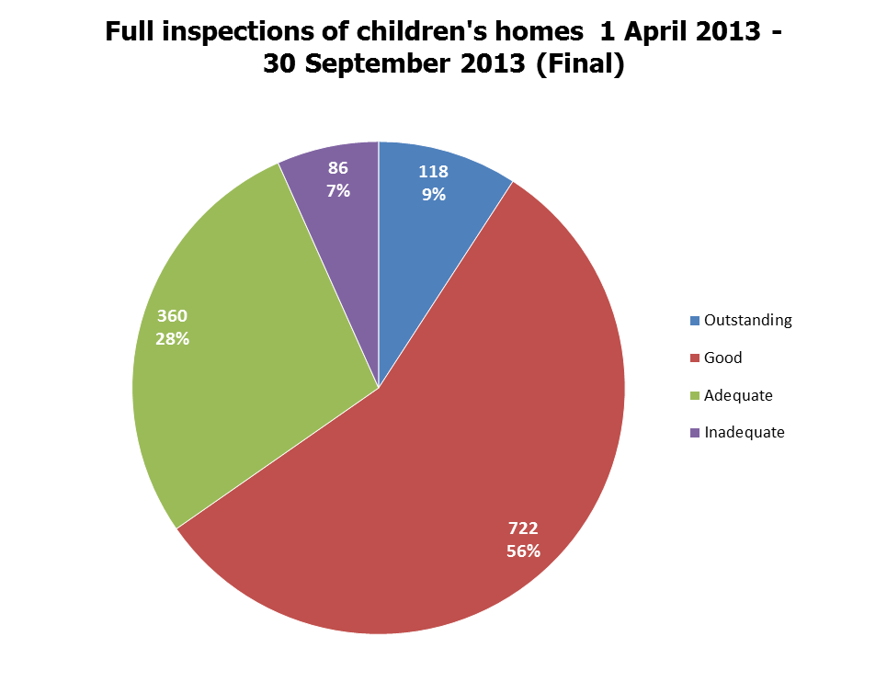

Total number of inspections = 1,286

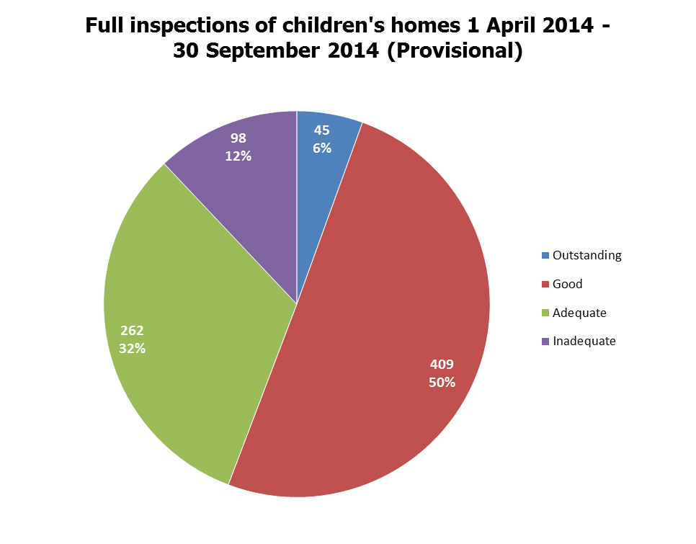
Total number of inspections: = 814

- 56% of 814 inspections resulted in a good or better Overall effectiveness judgement; this was a decrease from the same period of the previous year (65%, of 1,286 inspections).

- In the period, 12% of homes received an inadequate Overall effectiveness judgement; an increase from the same period of the previous year (7%).

- There were 692 homes that received both a full inspection since 1 April 2014 and a full inspection in 2013-14. When comparing their recent Overall effectiveness inspection judgement with their previous one, over half (55%) remained unchanged.

- Where judgements did change, there was slightly more decline than improvement: 142 homes improved and 168 declined. All four of the homes previously judged inadequate had improved, 121 (47%) of the 255 homes previously judged adequate improved, and 17 of the 388 previously previously judged good (4%) improved. Of the 45 homes previously judged outstanding, 23 (51%) declined. Of the 388 homes previously judged good, 125 (32%) declined, and of the homes previously judged adequate, 20 homes (8%) declined. An additional 71 homes were inspected in the period which had not received a full inspection in 2013-14.

Figure 2

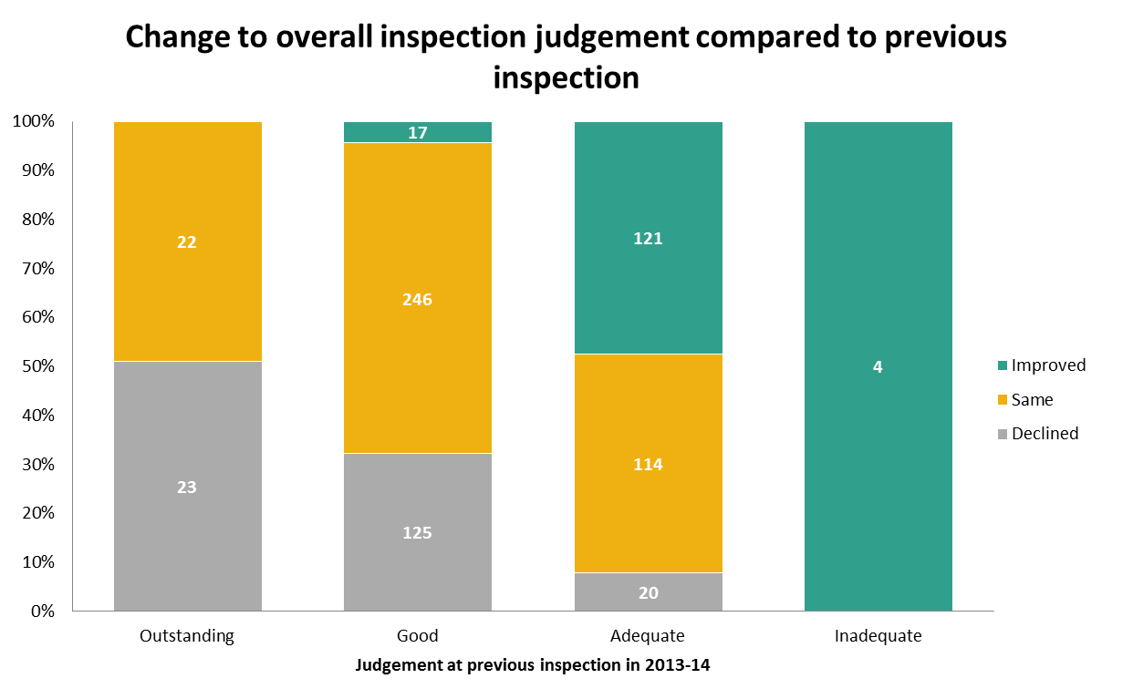

- In the period 1 April 2014 to 30 September 2014, there were 22 homes that were judged inadequate for Overall effectiveness that had been judged good or better at their previous full inspection. Three of these declined from outstanding.

- There were three homes that improved from inadequate at their previous full inspection to good.

Regional Data
- The regions with the highest percentage of homes judged good or better since 1 April 2014 were Yorkshire and The Humber (69%), the North West (62%), and the South East (60%). The regions with the lowest percentage of homes judged good or better were the South West (37%), East of England (52%), East Midlands (53%) and West Midlands (53%). The national proportion of good or better homes was 56%. (Summary spreadsheet map 1)

- There have been 433 homes inspected in the period 1 April 2014 – 30 September 2014 that had been inspected in the previous year 2013-14 and received good or better judgements. Of these homes judged good or better in 2013-14 and re-inspected since then, 135 (31%) are now rated adequate or lower. The areas of the country where this change is most prominent are the South West and the East Midlands with comparative declines of 51% and 41% respectively. The lowest proportions of decline were found in the North East (22%) and North West (24%).

- With regards to homes located in specific local authorities, Devon saw 79% (11 out of 14) homes that were judged good or better decline to adequate or lower, while in Somerset all of the six homes inspected declined. Conversely, of 18 homes inspected in Rochdale, 16 remained at good or better (89%).

Figure 3

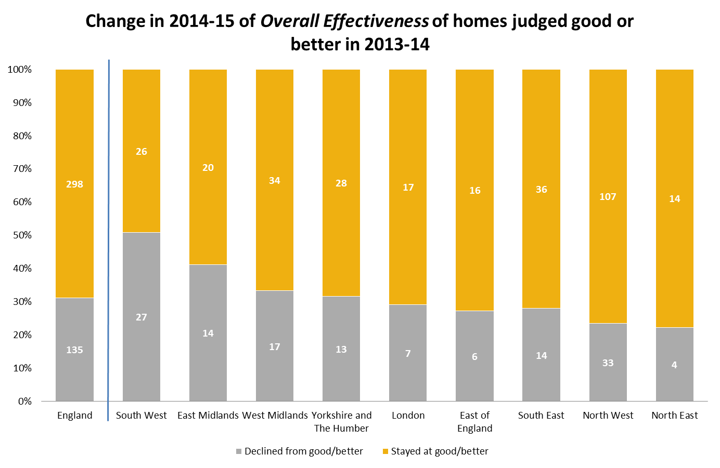

- Of 259 homes judged adequate or lower in 2013-14, and re-inspected since then, 124 (48%) are now judged good or better. Yorkshire and The Humber and the East Midlands showed the most marked improvement with 74% and 63%, respectively, increasing from adequate or lower to good or better. The lowest areas of improvement were in the South West and London where only 22% and 25% of homes located in each area improved, respectively. [See Figure 4 below].

- With regards to homes located in specific local authorities, in Birmingham 67% (six out of nine homes) and in Lancashire 58% (seven out of 12) homes had improved from adequate or lower to good or better. Conversely, in Somerset, none of the nine homes previously judged inadequate or lower had improved.

Figure 4
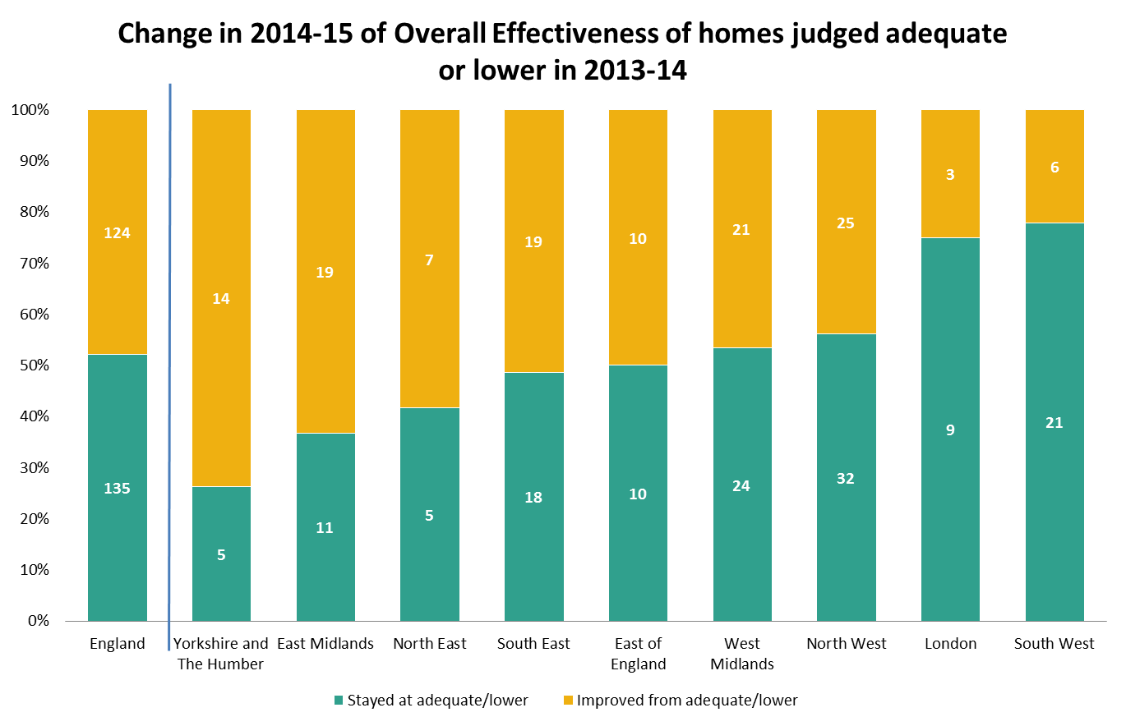

Sector data

- In the period 1 April 2014 to 30 September 2014, there were 174 inspections of local authority-run homes (including two health authority-run), 575 inspections of privately-run homes, and 65 voluntary-run homes.

- A smaller proportion of privately-run homes (54%) received a good or better Overall effectiveness judgement than local authority or voluntary-run homes (60% for each). Privately-run homes had a higher proportion of homes judged inadequate at 14%, than local authority and voluntary-run homes (both 8%). Local authority and privately-run homes received a higher proportion of outstanding judgements (5% and 6% respectively) than voluntary-run homes (3%).

- The sectorial picture, when grouped by regions, varies between the north and south of England. Between 1 April 2014 and 30 September 2014, the proportion of local authority-run homes in the South East, North East and East Midlands receiving good or better judgements was higher than privately and voluntary-run homes. In the North West, Yorkshire and the Humber, and South West regions there was only a slight difference (within five percentage points) in the performance of local authority-run and private and voluntary-
run homes. There were two regions, the East of England and West Midlands, where private and voluntary-run homes outperformed local authority-run homes by 20 and 14 percentage points, respectively. (Summary spreadsheet maps 3-5)

Interim inspections

- Between 1 July 2014 and 30 September 2014, there were 62 interim inspections. Of these 62, 19 (31%) were judged to have “improved effectiveness”, and 22 (35%) “sustained effectiveness”. However, 10 (16%) were judged to have “declined effectiveness”. Eleven (18%) did not receive an inspection outcome as children were not accommodated in the children’s home at the time of inspection. (Summary spreadsheet table 3d)

Impact of revisions on key findings of previous release

Revised data covering the period 1 April 2014 to 30 June 2014 have been released and can be found on the Ofsted website: www.gov.uk/ofsted.

- The revision of statistics relating to the 1 April 2014 to 30 June 2014 quarter from ‘provisional’ to ‘revised’ status includes outcomes relating to a further 106 inspections. These consist of an additional 96 full inspections and 10 interim inspections of children’s homes, which took place in this period and have been published since 31 March 2014.

- Of the additional 96 full inspections, 53 children’s homes received good or better Overall effectiveness judgement and 43 received adequate or lower.

- The revised version of these data have been combined with the provisional data for the most recent quarter (1 July 2014 to 30 September 2014) to produce this report.

Methodology

The data in the release are from inspections undertaken between 1 July 2014 and 30 September 2014.

Statistics relating to inspections in the most recent quarter are provisional and include inspections in the period where the inspection report was published within one month of the end of the quarter. If an inspection report is published later than one month, and less than four months, after the end of the quarter in which the inspection took place, that inspection will be included in the final release of the statistics.

Inspections and outcomes of provider settings that are not currently active are included in this statistical release and are reflected in the underlying data within the comma separated values (csv) and Excel files as ‘resigned’.

Revisions are published in line with Ofsted’s revisions policy for official statistics. For more information about the policy, please visit the Ofsted website or access the policy via the following link: https://www.gov.uk/government/publications/ofsted-standards-for-official-statistics.

For more information on how Ofsted regulates and inspects children’s social care, please go to the Ofsted website: https://www.gov.uk/being-inspected-as-a-provider-of-childrens-social-care. In its inspection of social care services, Ofsted must take account of national minimum standards published by government.

This release includes sector data. Sector data are the ownership type for each home (local authority, private, voluntary and health authority). Ofsted’s data are disaggregated into separate private and voluntary categories in the tables.

The revised inspection framework for children’s homes which began on 1 April 2012 includes a change of name of one of the judgements. The judgement ‘adequate’ has replaced the previous judgement of ‘satisfactory’. Where previously a home could receive outstanding, good, satisfactory or inadequate judgements, they can now receive outstanding, good, adequate or inadequate.

In April 2014, a new set of judgements were introduced at the interim inspection so that these have a wider focus than before and lead to inspection judgements that more clearly relate to the outcomes and progress of children and young people. These judgements are all relative to the judgement at the full inspection and are intended to give children, parents and commissioners a better understanding of how the home has performed in relation to their last judgement: either ’improved effectiveness’, ‘sustained effectiveness’ or ‘declined in effectiveness’. These judgements have replaced the old judgements of ‘good progress’, ‘satisfactory progress’ and ‘inadequate progress’.

Additional information

All the tables and charts shown in this release, along with additional analysis at regional and local authority level, are available in Excel format on the Ofsted website in the same location as this document. Underlying data are also available in Excel and csv formats.

Glossary

Children’s homes
A children’s home is defined in section 1 of the Care Standards Act 2000, and is an establishment that provides care and accommodation wholly or mainly for children. Children’s homes vary in size and nature. They fulfil a range of purposes designed to meet the different needs of those children and young people who are assessed as needing a residential care placement. Some homes, for example, provide short breaks which are needed to help support children and their family. Some residential special schools are registered as children’s homes because boarders are resident for more than 295 days per year.

Residential special schools
Residential special schools are defined in section 59 of the Safeguarding Vulnerable Groups Act 2006. They vary in size and nature. The sector includes large non-maintained special schools which make provision for very specific needs and take children as full boarders from all over the country, to smaller more local providers catering for children with a range of different special needs and disabilities who may be resident at the school only during the week. Some residential special schools are registered as children’s homes because boarders are resident for more than 295 days per year. There are also a small number of independent residential special schools who also tend to cater for children with very specialist needs.

Sector
Sector refers to the type of provider that owns the children’s home.

Local Authority
These are public bodies responsible for the children’s home.

Private
These are for-profit organisations mostly with limited company status. These can also though be individually owned children’s homes and run for profit.

Voluntary
These are mostly not-for-profit organisations, mainly with charitable status. These can also be individually owned children’s homes and run on a not-for-profit basis.

Health Authority
These are NHS Trust-run.

Secure children’s homes
Secure children’s homes are defined by section 25 of the Children Act 1989. They accommodate children and young people who are remanded or have been sentenced for committing a criminal offence. They also accommodate children and young people who are placed there by a court because their behaviour is deemed to present a significant and immediate threat to their safety or the safety of others, unless they are placed in a secure environment. Ofsted inspections are conducted in accordance with the Care Standards Act 2000 and judgements in reports are made in relation to the outcomes for children set out in the Children Act 2004. The criteria are the same as those used to inspect non-secure children’s homes.

Acknowledgements

Thanks to the following, for their contribution to this statistical release: Donna Neill, Marc McGreavy, Kathryn Kaal and Matthew Watts.

© Crown copyright

You may re-use this information (not including logos) free of charge in any format or medium, under the terms of the Open Government Licence. To view this licence, visit http://www.nationalarchives.gov.uk/doc/open-government-licence/ or write to the Information Policy Team, The National Archives, Kew, London, TW9 4DU or e-mail: psi@nationalarchives.gsi.gov.uk.

See paragraph 5 in the following document ‘Conducting inspections of children’s homes’ which can be found at http://www.ofsted.gov.uk/resources/conducting-inspections-of-childrens-homes-for-inspections-1-april-2012.
Percentages are rounded and may not add to exactly 100.
These homes are new homes, homes which have re-registered following a change of ownership, or homes that only received interim inspections in years during which they were not operational.
Includes homes that are private and voluntary-run but within the local authority boundary.
Ibid.

