 |   Prison Service Order |  | STAFF  GRIEVANCES
  ORDER
  NUMBER
  8550

This PSO/PSI has an implementation date of 30 March 2009. Please click here for the version to be used until this date.

Date of Initial Issue | 05/12/08
Issue No. | 306
PSI Amendments should be read in conjunction with this PSO

Date of Further Amendments | Amendments can be tracked by clicking here
05/12/08 | PSI 52/2008 – Introduces PSO 8550
31/03/09 | PSI 12/2009 – Introduces amended PSO 8550

EXECUTIVE SUMMARY

PSO 8550 STAFF GRIEVANCES

STATEMENT OF PURPOSE
This PSO provides all staff with clearer guidance and framework through which they can raise genuine workplace grievances that are dealt with promptly within the line, in a considerably shorter period of time.

Staff terms and conditions relating to the grievance procedure are set out in the Staff Handbook.
Further details of how the staff grievance procedure works is available on My Services.

DESIRED OUTCOME
To provide all staff with clearer guidance in line with statutory requirements and ACAS principles and retains a provision for timescales at each stage of the process. It is expected that a significant number of grievances will be resolved wholly within the line, in a considerably shorter period of time.

MANDATORY ACTIONS
All actions are mandatory unless specified otherwise. Area Managers, Governing Governors, and Heads of Group/Unit must ensure that they are aware of these and ensure that the policy is implemented and adhered to.

RESOURCE IMPLICATIONS
The emphasis of this policy is on low level consideration within the line. The consideration of an individual grievance has been revised in line with statutory provisions, recent case law and ACAS principles.

IMPLEMENTATION DATE: | 30 March 2009
(signed)

Robin Wilkinson
HR Director, NOMS

Advice on any aspect of grievance policy should be made to the HR Contact Centre in the Shared Service Centre.

STAFF GRIEVANCES

1. Introduction

2. Key Principles

3. Stage 1 – Formal Procedure

4. Stage 2 - Appeal

5 Monitoring and Recording
1 INTRODUCTION

1.1 For the purposes of this PSO, a grievance is defined as any concern, problem or complaint raised by an individual member of staff relating to his or her employment. This PSO provides a framework through which grievances can be dealt with and sets out the procedures and timeframes to be followed.

1.2 This PSO applies to all directly employed civil servants who work in the NOMS Agency, including HM Prison Service (HMPS).

1.3 This PSO does not apply to those policies where dismissal is a potential outcome, where there are already separate appeal procedures. Issues associated with the way in which a conduct and discipline issue was handled are not covered by this policy and should be addressed under the PSO 8460 – Conduct & Discipline. Similarly, where bullying, harassment and discrimination issues are prevalent, reference should be made to PSO 8010 – Equal Opportunities.

1.4 All staff should be made aware of this policy.

2 KEY PRINCIPLES

2.1 The key principle of this policy is to provide a clear and workable framework through which staff can raise genuine workplace grievances. Any member of staff who has raised a grievance will be treated fairly at all times and will not subsequently be disadvantaged in any way.

2.2 The expectation is that grievances will be dealt with at the lowest possible level within the Service.

2.3 Before moving to the formal procedure, members of staff are encouraged to raise routine queries and issues informally with a manager. Where appropriate, mediation should also be considered for resolving grievances at the earliest possible opportunity. Mediation is strongly supported by the Prison Service and Trade Unions. However, if mediation is to be used, both parties must agree to enter into the process which is confidential. Further information on mediation can be found on My Services.

2.4 Grievance proceedings and the records of them must be confidential and should not be shared unnecessarily with any third party. Managers should be aware that any grievance information held on record may be subject to the provisions of the Data Protection Act.

2.5 Any member of staff raising a formal grievance has a statutory right to be accompanied by either a trade union representative or work colleague at any subsequent meeting.

2.6 It is the responsibility of the manager hearing the grievance to ensure that any action agreed to address the grievance is undertaken.

3 STAGE 1 - FORMAL PROCEDURE

3.1 Grievances should be put in writing and should explain the nature of the grievance and how the employee thinks it should be resolved. Grievances should be raised as soon as possible following the event giving rise to the concern but in all cases within 3 months.

3.2 The person raising the grievance should normally submit the grievance to their line manager. This also applies where a member of staff raises a grievance about the actions or decisions of line managers who exercise discretion within the framework set by a Governor’s Order or other HMPS policy or procedure.

3.3 If the grievance is about the actions or decisions of someone who is outside the direct line management chain (that is, not the person’s manager or manager’s manager) and is more senior, then this person should respond to the grievance (and not their line manager). If the grievance is about the actions or decisions of someone of the same grade, then this person’s line manager should respond to the grievance. Alternatively, where it would be inappropriate to follow these guidelines, the procedure outlined in paragraph 3.4 (below) may be followed.

3.4 Where it would be inappropriate for the line manager (or the manager outlined in para. 3.3) to hear the grievance, the member of staff should initially raise the grievance with the manager’s manager to decide whether they should hear the grievance at stage 1. However, the expectation is that the Stage 1 grievance will be managed wholly within the establishment/group from where the grievance originated. A Stage 1 grievance should only be heard outside of the establishment/group where it is clear that the grievance concerns the direct actions/decisions made by the Area Manager/Director or where the grievance originated from a Governing Governor/Head of Group (further guidance on hearing Stage 1 grievance can be found on My Services).

3.5 The manager must invite the member of staff to a meeting to discuss the grievance and remind them of their right to be accompanied. This meeting must be held on a mutually convenient date within 20 working days of receipt of the written complaint by the manager.

3.6 If the member of staff wishes to be accompanied and the trade union representative or colleague is not able to attend on the proposed date another date must be arranged within 5 working days of the original date proposed wherever possible.

3.7 Following the meeting, the manager must inform the member of staff in writing of their response to the grievance and set out what action, if any, they intend to take to resolve the grievance. The manager must notify the member of staff of their right and route of appeal against the manager’s decision. Wherever possible, this should be sent in writing to the member of staff within 10 working days of the meeting.

4 STAGE 2 - APPEAL

4.1 If the member of staff is not content with the response at Stage 1, they may appeal against the decision.

4.2 The member of staff should inform the manager who considered the Stage 1 grievance of their intention to appeal. Thereafter the member of staff should set out their grounds for appeal as soon as is practicable following receipt of the Stage 1 response, and ideally within 10 working days.

4.3 The expectation is that the grievance appeal will be managed wholly within the establishment/group from where the grievance originated. A Stage 2 appeal should only involve managers from outside of the establishment/group where it was clearly appropriate for the Governor to hear Stage 1 or where the grievance was raised by a Deputy/Governing Governor or Head of Group..

4.4 Appeals will be considered by a local appeal panel chaired by a more senior manager than at Stage 1 (this will normally be the line manager of the manager who considered the Stage 1 grievance). In most instances (but only where a local agreement exists between management and the appropriate trade union) the manager will be supported by a local trade union representative. A representative from HR will also be a standing member of the panel. The trade union representative will normally be a staff member at the originating establishment/group. Information on the process can be found on My Services.

4.5 Where the appeal is being chaired by a manager who is outside of the originating establishment/group, the trade union representative must still be drawn from the originating establishment/group.

4.6 Even where a local agreement exists with the TUS, the member of staff raising the grievance can opt not to have a trade union member sitting on the appeal panel. However, the member of staff is not entitled to an alternative panel member and the panel will hear the grievance as a two-member panel.

4.7 A national protocol detailing the terms of reference, responsibilities and behaviours expected of the appeals panel has been written with national trade unions as part of this policy and is attached at Annex A. Establishments and Groups must have an agreed protocol in place outlining their local appeal panel arrangements and responsibilities including the agreement for the TUS locally to act as appeal panel members.

4.8 All panel members must act as an impartial member of the appeal panel and are bound by the national protocol and local agreements mentioned above.

4.9 The manager handling the appeal must invite the member of staff to attend a meeting to discuss the grievance and must remind them of their right to be accompanied to the meeting.

4.10 Wherever possible, the meeting should be arranged on a mutually convenient date within 20 working days of receipt of the notification of intention to appeal.

4.11 If the trade union representative or colleague accompanying the employee is not able to attend on the proposed date another date must be arranged within five working days of the original date proposed.

4.12 Wherever possible, the manager should inform the member of staff of their conclusions in writing within 10 working days of the appeal meeting setting out where applicable, what action they intend to take to resolve the grievance. If it is not possible to reply within this time the member of staff should be given an explanation for the delay including when a reply can be expected.

4.13 The decision made by the manager chairing the appeal panel is final.

5 MONITORING AND RECORDING

5.1 Managers must comply with procedures for recording receipt of grievances and monitoring their progress. Details can be found on My Services. A revised standard 19 on Staff Grievances will be issued 1n 2009 and monitored by Audit and Corporate Assurance.

5.2 The HR Policy Team will informally review the operation of this PSO, including the national protocol in 6 months time. A formal review will be undertaken in consultation with the Trade Unions 12 months from the implementation of this policy.

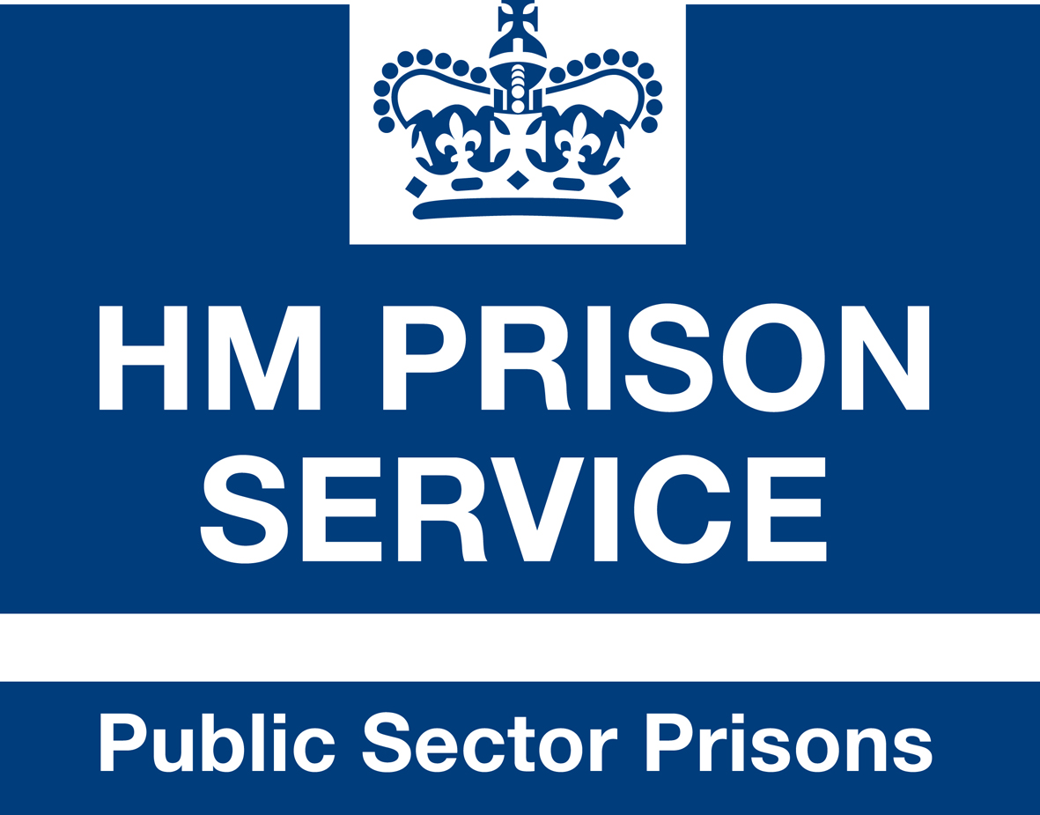

National Grievance Appeals Protocol

National Grievance Appeals Protocol

1. This protocol for grievance appeals panels should be read in conjunction with PSO 8550 – Staff Grievances. It has been drafted in consultation with the national trade unions and is nationally binding.

Terms of Reference

2. The panel must:

- ensure that staff are dealt with fairly, promptly and impartially and in accordance with PSO 8550 and this protocol.

- make decisions within the remit of nationally agreed Prison Service policy

- aim to reach a consensus wherever possible

- maintain the highest standards of confidentiality possible and must not discuss an individual’s grievance with any other party

- recognise that complete anonymity cannot be guaranteed under the Prison Service policy on Whistleblowing and Public Interest Disclosures (see PSO 8605 for further details)

- recognise that although PSO 8550 replaces the appeals procedures contained in PSO 8010 the guidance on Equal Opportunities issues continues to apply (see PSO 8010 for further details)

Roles

3. The manager must in all instances be the Chair of the grievance appeal meeting. The panel should attempt to reach unanimous or majority decision. Where the panel have been unable to reach a decision, the chair is ultimately responsible for making the final decision and will give the reasons for his/her decision in writing. The HR representative and the local trade union member on the panel will support the Chair with advice and guidance. The local trade union representative on the panel will not represent the employee who has raised the grievance.

Confidentiality

4. Breaches of confidentiality will be taken very seriously, may result in a panel member being excluded from the appeals panel process and may lead to formal disciplinary action.

Points of Principle

5. Trade Union members, can raise any points of principle which may arise out of the operation of the grievance procedure or the grievance appeal panel through the local Whitley machinery or, when raised by the Prison Governors Association, national Prison Governor Association meetings. However, in doing so they should not raise individual cases.

