
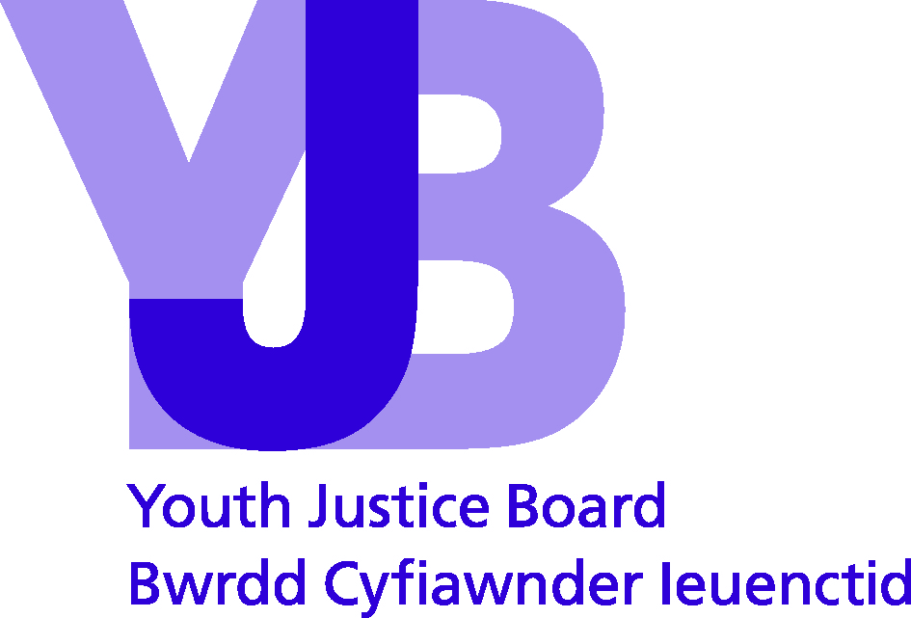

Parent/Carer

Young person’s name:
Date of birth:
Date of completion:

Bail/Remand:
 |  | Yes | No
Do you think she/he will be able to keep the bail conditions?
If no, what do you think would help him/her keep the bail conditions?

…………………………………………………………………………………………………………………………………………

…………………………………………………………………………………………………………………………………………………

…………………………………………………………………………………………………………………………………………………

…………………………………………………………………………………………………………………………………………………
 |  | Yes | No
Do you have any concerns about him/her receiving bail?
If yes, what are these concerns?

…………………………………………………………………………………………………………………………………………

…………………………………………………………………………………………………………………………………………………

…………………………………………………………………………………………………………………………………………………

…………………………………………………………………………………………………………………………………………………
 |  | Yes | No
If he/she is remanded today, is there anything that would make it difficult for you to visit?
If yes, please say why it would be difficult.

…………………………………………………………………………………………………………………………………………

…………………………………………………………………………………………………………………………………………………

…………………………………………………………………………………………………………………………………………………

…………………………………………………………………………………………………………………………………………………
 |  | Yes | No
If he/she is remanded, would he/she be able to return home afterwards?

If no, please explain why.

…………………………………………………………………………………………………………………………………………

…………………………………………………………………………………………………………………………………………………

…………………………………………………………………………………………………………………………………………………

…………………………………………………………………………………………………………………………………………………
 |  | Yes | No
Do you understand what happened at court today?
Do you understand the bail conditions/reasons for remand?

© Youth Justice Board for England and Wales 2014
The material featured in this document is subject to copyright protection under UK Copyright Law unless otherwise indicated. Any person or organisation wishing to use YJB materials or products for commercial purposes must apply in writing to the YJB at ipr@yjb.gsi.gov.uk for a specific licence to be granted.

Parent/Carer

Young person’s name:
Date of birth:
Date of completion:

Review:
 |  | Yes | No
Have you asked your child about what they are doing with the YOT?.
If yes, what have they said they like or don't like about coming to the YOT?

…………………………………………………………………………………………………………………………………………

…………………………………………………………………………………………………………………………………………………

…………………………………………………………………………………………………………………………………………………

…………………………………………………………………………………………………………………………………………………
 |  | Yes | No
Has there been any change in your child's behaviour?
If yes, what is different?

…………………………………………………………………………………………………………………………………………

…………………………………………………………………………………………………………………………………………………

…………………………………………………………………………………………………………………………………………………

…………………………………………………………………………………………………………………………………………………
If no, what is still a problem?

…………………………………………………………………………………………………………………………………………

…………………………………………………………………………………………………………………………………………………

…………………………………………………………………………………………………………………………………………………

…………………………………………………………………………………………………………………………………………………

 |  | Very | A little | Not at all
How involved with the YOT do you feel?
What could the YOT do to involve you more?

…………………………………………………………………………………………………………………………………………

…………………………………………………………………………………………………………………………………………………

…………………………………………………………………………………………………………………………………………………
What more could the YOT do to help your child?

…………………………………………………………………………………………………………………………………………

…………………………………………………………………………………………………………………………………………………

…………………………………………………………………………………………………………………………………………………

…………………………………………………………………………………………………………………………………………………
 |  | Yes | No
Are there any problems which make it difficult for you or your child to get to the YOT?
If yes, what are these problems?

…………………………………………………………………………………………………………………………………………

…………………………………………………………………………………………………………………………………………………

…………………………………………………………………………………………………………………………………………………

…………………………………………………………………………………………………………………………………………………
 |  | Yes | No
Is there anything else the YOT can do to help you as a parent or carer?
If yes, please say how the YOT could help you?

…………………………………………………………………………………………………………………………………………

…………………………………………………………………………………………………………………………………………………

…………………………………………………………………………………………………………………………………………………

…………………………………………………………………………………………………………………………………………………
© Youth Justice Board for England and Wales 2014
The material featured in this document is subject to copyright protection under UK Copyright Law unless otherwise indicated. Any person or organisation wishing to use YJB materials or products for commercial purposes must apply in writing to the YJB at ipr@yjb.gsi.gov.uk for a specific licence to be granted.

Parent/Carer

Young person’s name:
Date of birth:
Date of completion:

End of Intervention:
 |  | Yes | No
Has the support given to you or your child helped you as a parent/carer?
If yes, please state what you found helpful?

…………………………………………………………………………………………………………………………………………

…………………………………………………………………………………………………………………………………………………

…………………………………………………………………………………………………………………………………………………

…………………………………………………………………………………………………………………………………………………
If no, please state why you did not find it helpful?

…………………………………………………………………………………………………………………………………………

…………………………………………………………………………………………………………………………………………………

…………………………………………………………………………………………………………………………………………………

…………………………………………………………………………………………………………………………………………………
 |  | Yes | No
Has there been any change in your child's behaviour?
If yes, what is different?

…………………………………………………………………………………………………………………………………………

…………………………………………………………………………………………………………………………………………………

…………………………………………………………………………………………………………………………………………………

…………………………………………………………………………………………………………………………………………………

If no, what is still a problem?

…………………………………………………………………………………………………………………………………………

…………………………………………………………………………………………………………………………………………………

…………………………………………………………………………………………………………………………………………………

…………………………………………………………………………………………………………………………………………………

What do you feel has helped your child the most during their time with the YOT?

…………………………………………………………………………………………………………………………………………

…………………………………………………………………………………………………………………………………………………

…………………………………………………………………………………………………………………………………………………

…………………………………………………………………………………………………………………………………………………
What do you feel has been less helpful?

…………………………………………………………………………………………………………………………………………

…………………………………………………………………………………………………………………………………………………

…………………………………………………………………………………………………………………………………………………

…………………………………………………………………………………………………………………………………………………
 |  | Yes | No | Sometimes
I feel a bit worried about what might happen when my child finishes at the YOT
Do you think the YOT has provided your child with the services and help he/she needed?

…………………………………………………………………………………………………………………………………………

…………………………………………………………………………………………………………………………………………………

…………………………………………………………………………………………………………………………………………………

…………………………………………………………………………………………………………………………………………………
 |  | Yes | No
Would you like more information about other services that could help you or your child?
Is there anything more the YOT can do for you?

…………………………………………………………………………………………………………………………………………

…………………………………………………………………………………………………………………………………………………

…………………………………………………………………………………………………………………………………………………

…………………………………………………………………………………………………………………………………………………

© Youth Justice Board for England and Wales 2014
The material featured in this document is subject to copyright protection under UK Copyright Law unless otherwise indicated. Any person or organisation wishing to use YJB materials or products for commercial purposes must apply in writing to the YJB at ipr@yjb.gsi.gov.uk for a specific licence to be granted.

Parent/Carer

Young person’s name:
Date of birth:
Date of completion:

Custody Review:
 |  | Yes | No
Have you talked to your child about his or her time in custody?
If yes, what has he or she said they like or don't like about being in custody?

…………………………………………………………………………………………………………………………………………

…………………………………………………………………………………………………………………………………………………

…………………………………………………………………………………………………………………………………………………

…………………………………………………………………………………………………………………………………………………
 |  | Yes | No
Have you been given information about how your child is getting on in custody?
Is there anything else you would like to know or ask about your child's time in custody?
If yes, what would you like to know?

…………………………………………………………………………………………………………………………………………

…………………………………………………………………………………………………………………………………………………

…………………………………………………………………………………………………………………………………………………

…………………………………………………………………………………………………………………………………………………
 |  | Yes | No
Have you been invited to attend or contribute to planning meetings for your child in custody?
Please comment on how the YOT and custody staff have involved you whilst your child has been in custody.

…………………………………………………………………………………………………………………………………………

…………………………………………………………………………………………………………………………………………………

…………………………………………………………………………………………………………………………………………………

…………………………………………………………………………………………………………………………………………………
 |  | Yes | No
Do you have any concerns about your child whilst he/she is in custody?
If yes, what are these concerns?

…………………………………………………………………………………………………………………………………………

…………………………………………………………………………………………………………………………………………………

…………………………………………………………………………………………………………………………………………………

…………………………………………………………………………………………………………………………………………………
 |  | Yes | No
Do you have any questions about what will happen when your child is released?
If yes, please give details here.

…………………………………………………………………………………………………………………………………………

…………………………………………………………………………………………………………………………………………………

…………………………………………………………………………………………………………………………………………………

…………………………………………………………………………………………………………………………………………………
 |  | Yes | No
Is there anything else the YOT or custody staff can do to help you as a parent or carer?
If yes, please say what could be done to help you.

…………………………………………………………………………………………………………………………………………

…………………………………………………………………………………………………………………………………………………

…………………………………………………………………………………………………………………………………………………

…………………………………………………………………………………………………………………………………………………
Any other comments

…………………………………………………………………………………………………………………………………………

…………………………………………………………………………………………………………………………………………………

…………………………………………………………………………………………………………………………………………………

© Youth Justice Board for England and Wales 2014
The material featured in this document is subject to copyright protection under UK Copyright Law unless otherwise indicated. Any person or organisation wishing to use YJB materials or products for commercial purposes must apply in writing to the YJB at ipr@yjb.gsi.gov.uk for a specific licence to be granted.

