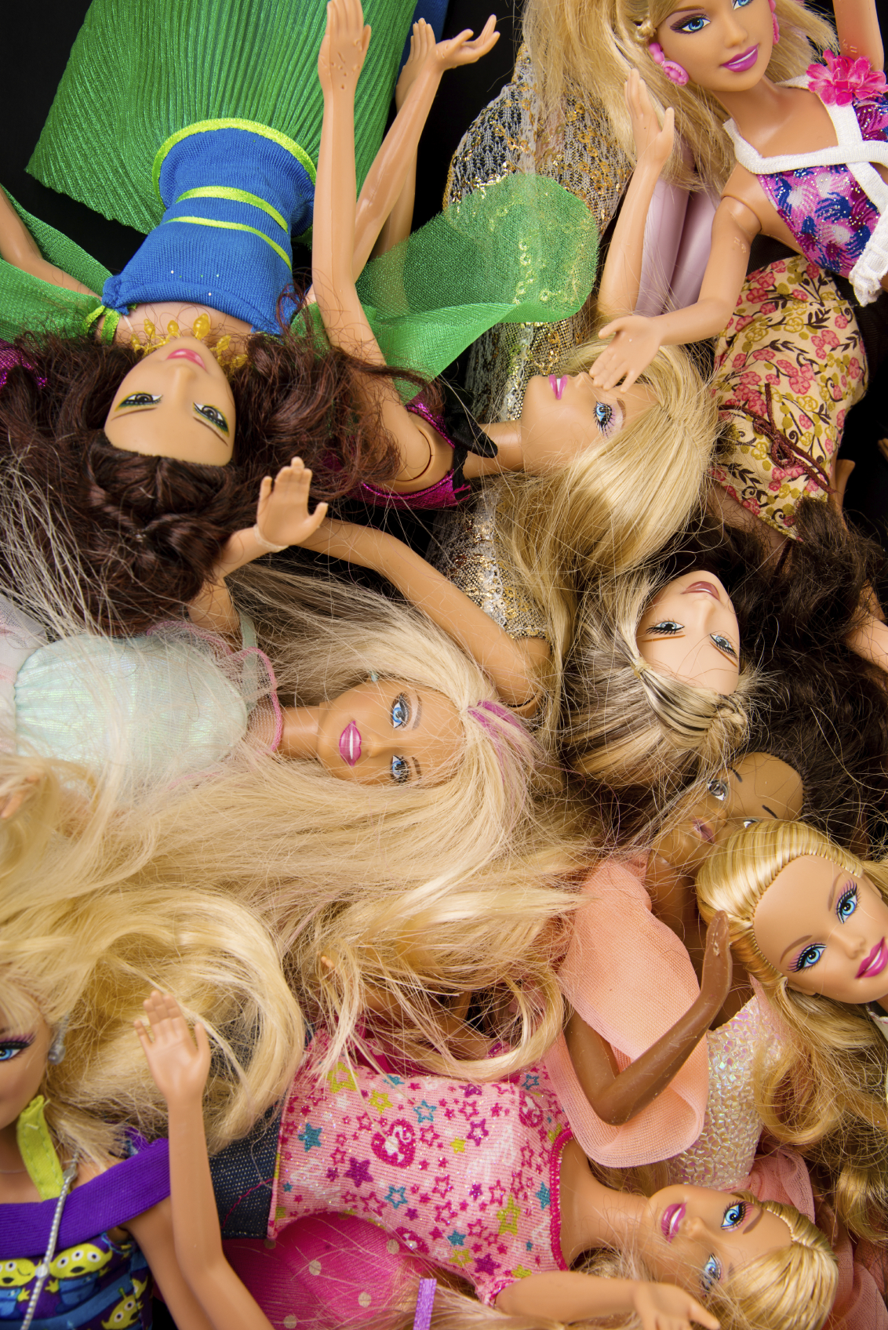
BODY CONFIDENCE
  - Findings from the
  - British Social Attitudes Survey
  - October 2014

Contents
Contents 2
Background 3
Key findings 4
Research findings 5
Satisfaction with own appearance 5
Perceived importance of appearance 5
Discussion 7
Conclusion 10
Notes 10

Background
The concept of body image relates to how people experience their body in the world, covering:
- Body confidence – how satisfied they are with their appearance, and
- Self-objectification – how much they see themselves through others’ eyes, investing their self-worth in how their appearance is judged by others1.
Body image, and particularly body confidence, is an issue of enormous public concern, especially to parents and young people. Low body confidence is a contributory factor in poor mental wellbeing, eating disorders, obesity, low aspirations and a range of risky behaviours.
In 2010 the Government launched its Body Confidence Campaign to tackle the causes and consequences of body image anxiety by:
- Responding to public concerns and facilitating public debate to promote cultural change
- Supporting effects to promote media literacy and resilience, particularly among young people
- Developing constructive relationships with industry and other stakeholders to encourage positive action and good practice.
To better understand public perceptions of body confidence and body image, the Government Equalities Office commissioned questions in the 2013 British Social Attitudes Survey.

Key findings
- A significant minority of the population is dissatisfied with their appearance; women have lower satisfaction rates than men (63% of women are satisfied with their appearance compared with three-quarters – 74% - of men).
- Women’s body satisfaction does not improve as they move toward and into midlife (63% of women aged 18-34 satisfied with their appearance, compared to 57% of women aged 35-49). Body satisfaction peaks in the years 50-64 (at 71%). In those aged over 65, 63% are satisfied with their appearance – almost the same as those aged 18-34.
- Three-quarters (77%) of adults think that society puts too much pressure on females to have a sexualised appearance, half of all adults (47%) think that ‘how you look affects what you can achieve in life’, and one-third (32%) agree with the statement ‘your value as a person depends on how you look’. Opinions did not vary significantly between men and women but were shown to be more of a concern amongst certain age groups.

Research findings

Satisfaction with own appearance
Around three-quarters (74%) of men are satisfied with their own appearance. This is significantly higher than rates reported by women (63%). Similarly, one in twenty (5%) men report being dissatisfied with their appearance compared with around one in ten (11%) women. Again, this difference is statistically significant.
However, this gender difference in satisfaction with appearance varies by age. There were no statistically significant differences in reported levels of satisfaction with appearance between men and women in either the 18-34 cohort (71% and 63%) or the 50-64 cohort (79% and 71%). However, women in the 35-49 cohort reported significantly lower levels of satisfaction with their appearance than their male counterparts (57% and 71%) as did those in the 65+ cohort (64% and 75%).
Satisfaction is relatively stable across all age groups of men. However, women in the 35-49 cohort report significantly lower levels of satisfaction (57%) compared to those aged 50-64 (71%).
Figure 1 - Proportion of people who are satisfied with their own appearance, by age and gender

Perceived importance of appearance
Three-quarters (77%) of all adults think that society puts too much pressure on females to have a sexualised appearance. Half (47%) of adults agree with the statement ‘how you look affects what you can achieve in life and one-third (32%) agree with the statement ‘your value as a person depends on how you look’. Opinions did not vary significantly between men and women.
Those in the oldest cohort were significantly less likely (70%) than those in both the 18-34 and 50-65 cohorts (79% and 80%) to agree with the statement ‘society puts too much pressure on females to have a sexualised appearance’. Those in the oldest cohort were significantly more likely to agree with the statement that ‘how you look affects what you can achieve in life’ than those aged 35-49 (53% and 43%).
Around one-third (32%) of those in the youngest cohort agreed with the statement ‘your value as a person depends on how you look’. This was significantly higher than those in 35-49 cohort (23%). Those in the oldest cohort were also significantly more likely to agree with this statement (43%) than both those in the 35-49 cohort and the 50-64 cohort (23% and 31%).
Figure 2 - Proportion of people who agree with different attitudinal statements

Discussion
These findings affirm those of other studies that have demonstrated that a large minority of the population is dissatisfied with their personal appearance (for example, that half of adults feel ashamed of the way they look, that women are more likely to be dissatisfied than men, and that there is widespread concern about the expectations placed on women in terms of physical appearance).
Of particular interest are the body satisfaction rates by age for women. They suggest that poor body image does not naturally recede alongside the self-consciousness of youth. Instead, they demonstrate that a 45 year old woman is as likely to be dissatisfied with her appearance as her 19 year old daughter.
The survey questions elicit information on body confidence (appearance satisfaction) but not on levels of self-objectification (investment of self-worth into how personal appearance is judged by others). These two elements of body image interact in a number of ways: someone who has low investment in their appearance may rate their appearance positively or negatively, and someone with high investment may also rate their appearance positively or negatively. The personal and public health consequences for those with high investment but low satisfaction pose the greatest concern, though high investment and high satisfaction can also pose risks.
It is possible, therefore, that if we also measured self-objectification we might find a different story. It may be that although midlife women report body satisfaction no higher than that of younger women, they have lower levels of self-objectification (and, indeed, lower levels of sexual objectification from those around them). In other words, they rate themselves lower, but they care less. Perhaps they are too busy coping with the demands of work and family to prioritise their physical appearance. It is also possible, though, that they do care just as much, but the responses to this survey do not provide the detail to understand why this particular age group is unsatisfied with their bodies.
This is a relatively under-explored area, but one study that explored the prevalence and nature of body image in midlife women found that 80% reported weight dissatisfaction and increased present-day dissatisfaction with their bodies in comparison to their younger years (defined as below the age of forty). Women in this age group also reported that their dissatisfaction with their bodies curtailed their day to day activities, suggesting that the prevalence and impact of low body satisfaction could be high for midlife women.
To complicate the picture further, there is a significant rise in body satisfaction in women aged 50-64. It may be that women get social permission to focus less on their appearance, and the social penalties for imperfection reduce. The age cohort 50-64 may also be reaping the combined benefits of lessening of caring responsibilities, more time/money for self-care, and a body that is still functioning reasonably well. The low body confidence of the 60+ age group may reflect the increasing infirmity and chronic conditions associated with old age, or feelings of social invisibility.
These suggestions are highly speculative and need to be explored further. But we can assume that the consequences of poor body image – lower self-esteem, more depression, poorer self-care (including less physical activity and more likelihood of weight gain), disordered eating, lower confidence and aspirations – are as damaging for midlife women as they are for younger women and girls.
These survey results also highlight the gender differences in levels of body satisfaction. The gender gap demonstrated here is not as wide as that shown in other studies, though there is growing concern that boys and men can also suffer from poor body image and its detrimental effects on health, wellbeing, aspirations and confidence. Again, however, these findings do not show us the relative importance men and women invest in their appearance, or their levels of self-objectification.
More research is needed to improve our understanding what the particular effects of poor body image are on men and boys, and how these experiences might be gendered. In particular, we need to know:
- Whether the predominant perception that body image is a woman’s issue isolates men and boys who are affected and prevents them from getting effective help and support.
- Whether men’s wider diversity of role models and gender roles may partially account for their generally higher body confidence.
- Whether rates of poor body confidence will ‘catch up’ with men and boys to the same prevalence as for women and girls.
- Whether media representations of gender and bodies influence body image in teh same way for men as they do for women.
- Whether the gendered nature of the ‘desirable body’ (i.e. powerful and muscular for men, thin and hairless for women) makes a difference to how men and women experience body confidence and its impact on their confidence and aspirations.

Conclusion
This survey demonstrates that a sizeable minority of the population is dissatisfied with their appearance, and that women are significantly more dissatisfied than men.
Men’s appearance satisfaction is relatively stable through life. Women’s body satisfaction does not rise until they reach the years 50-64, when it is at its highest.
Three quarters of adults think that society puts too much pressure on women to have a sexualised appearance, and half of all adults think that how you look affects what you can achieve in life.
Further work is needed to explore:
- What role is played by self-objectification in the body image of men and women at different life stages.
- How gender affects body image in both men and women.
- How body satisfaction, self-objectification and other psychosocial factors interrelate in the mental wellbeing of midlife women.

Notes
The British Social Attitudes Survey (BSAS) is a cross sectional survey of the general population, which has been conducted annually since 1983. The survey is conducted in Britain with adults aged 18+. The 2013 survey was split into three equally sized portions. Each ‘module’ of questions then was asked either of the full sample (3,244 respondents), or of a random third or two-thirds of the sample. The survey was conducted between June and November 2013. Significance testing was carried out at the 95% level.
More information on the government’s body confidence campaign can be found at: https://www.gov.uk/government/policies/creating-a-fairer-and-more-equal-society/supporting-pages/body-confidence-campaign.

© Crown copyright 2014 Cover Image © iStock.com/ ivanastar
You may re-use this document/publication (not including logos) free of charge in any format or medium, under the terms of the Open Government Licence v2.0. Where we have identified any third party copyright information you will need to obtain permission from the copyright holders concerned.
To view this licence:
visit www.nationalarchives.gov.uk/doc/open-government-licence/version/2
email psi@nationalarchives.gsi.gov.uk
About this publication:
enquiries womensengagement@culture.gsi.gov.uk
download http://bit.ly/ZTftq8
 | Follow us on Twitter: @Government_Women |  | Like us on Facebook:  facebook.com/GovernmentEqualitiesOffice

Burrowes, N. 2013. Body confidence: a rapid evidence assessment of the literature. Government Equalities Office.
Puhl, R. & Latner, J. D. 2007. Stigma, obesity and the health of a nation’s children. Psychological Bulletin. 133: 557-580.
Cohane, G. & Pope, H. 2001. Body image in boys: a review of the literature. The International Journal of Eating Disorders. 29(4): 373-379.
Van den Berg, P. & Neumark-SZtainer, D. 2007. Fatn ‘n’ Happy 5 years later: is it bad for overweight girls to like their bodies? Journal of Adolescent Health. 41: 415-417.
Littleton, Radecki, Britkopf, & Berenson, 2005.
Centre for Appearance Research, 2012
Algars et al. 2009; Frederick, Forbes, Grigorian & Jarcho, 2007; Krauss, Paxton & Alasker 2007; Wardle, Hease, & Steptoe, 2006.
YMCA, ComRes Poll, Attitudes to Body Image in the UK; Girlguiding UK, Girls Attitudes Survey 2011
McLaren and Kuh 2004, cited in Burrowes N, 2013, Body Image – a rapid evidence assessment of the literature, Government Equalities Office 2013.
Burrowes 2013, ibid.

