Analysis of young people in full-time education and employment
October 2014

Contents
Contents 3
Analysis of young people in full-time education and employment 4

Analysis of young people in full-time education and employment
BIS regularly conducts internal analysis of the Labour Force Survey (LFS). Using the Q2 2014 release, along with the Office for National Statistics (ONS) LFS micro-data, levels are investigated of young people who are full-time students and in employment. Results follow:
- In 2014 Q2 there were 233,000 16-17 year olds and 601,000 18-24 year olds in full-time education and employment.
- The number of young people in full-time education who are also employed aged 16-17 has been declining since 2002.
- From 2006 the number of 18-24 year olds in full-time education and employment has been steady at around 600,000.
- The proportion of 16-17 year old individuals in full-time education and employment has fallen from 30.4% in 1998 Q3 to 15.5% in 2014 Q2. Over this same period the proportion of full-time students aged 18-24 in employment has been consistently around 10% to 11%.
- Around two fifths (41%) of young people in full-time education and employment are men.

Source: ONS Labour Force Survey, seasonally adjusted data

- Around half of young people in full-time education and employment worked on a Saturday when interviewed in the Labour Force Survey in 2014 Q2.
- Just over a third of young people in full-time education and employment worked on a Sunday when interviewed in the Labour Force Survey in 2014 Q2.
- Average actual total hours worked for full-time students in employment aged 16-17 was 8.8 hours per week compared to 14.7 hours per week for 18-24 year olds in 2014 Q2.

Source: ONS Labour Force Survey micro-data

Annex A: Chart data
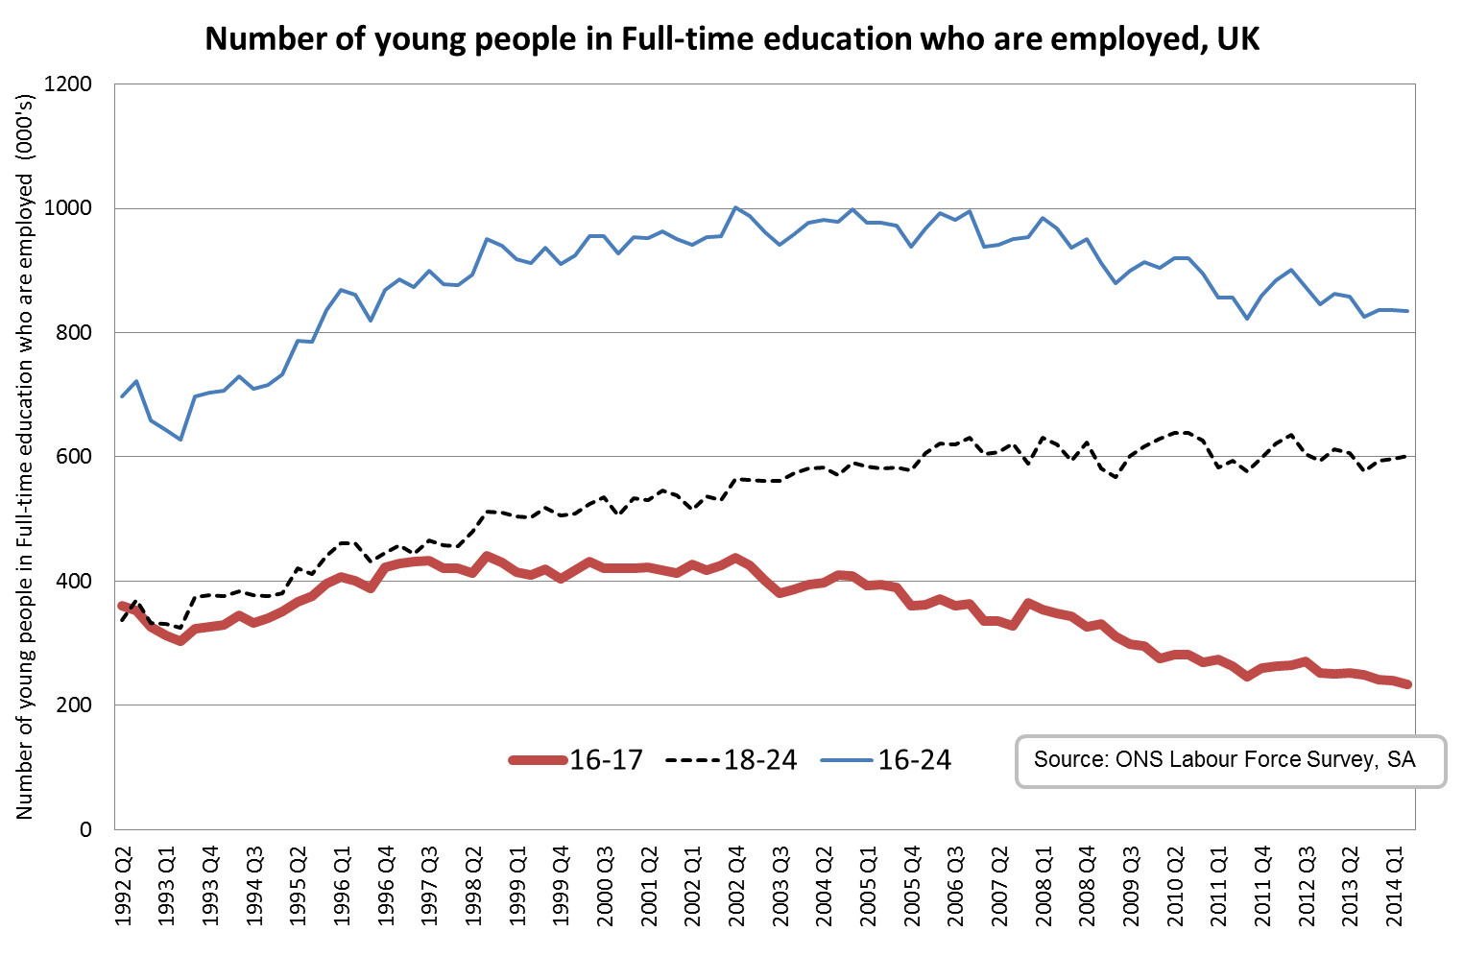

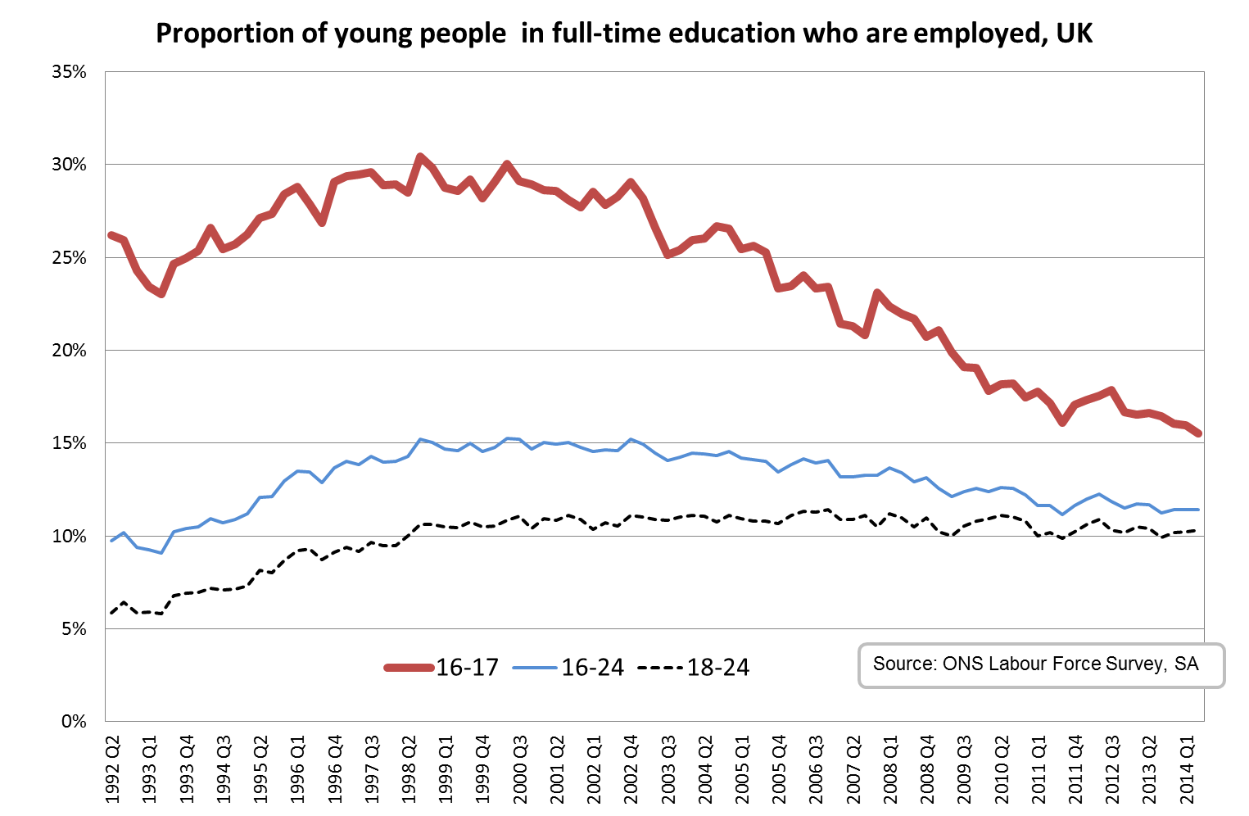
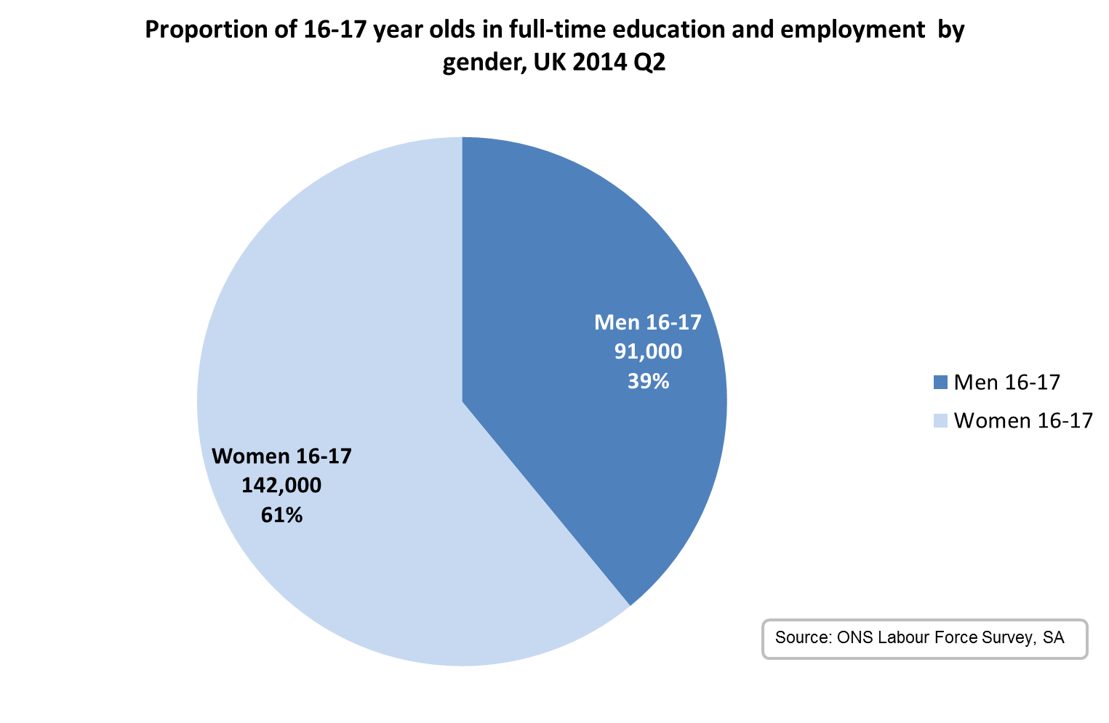

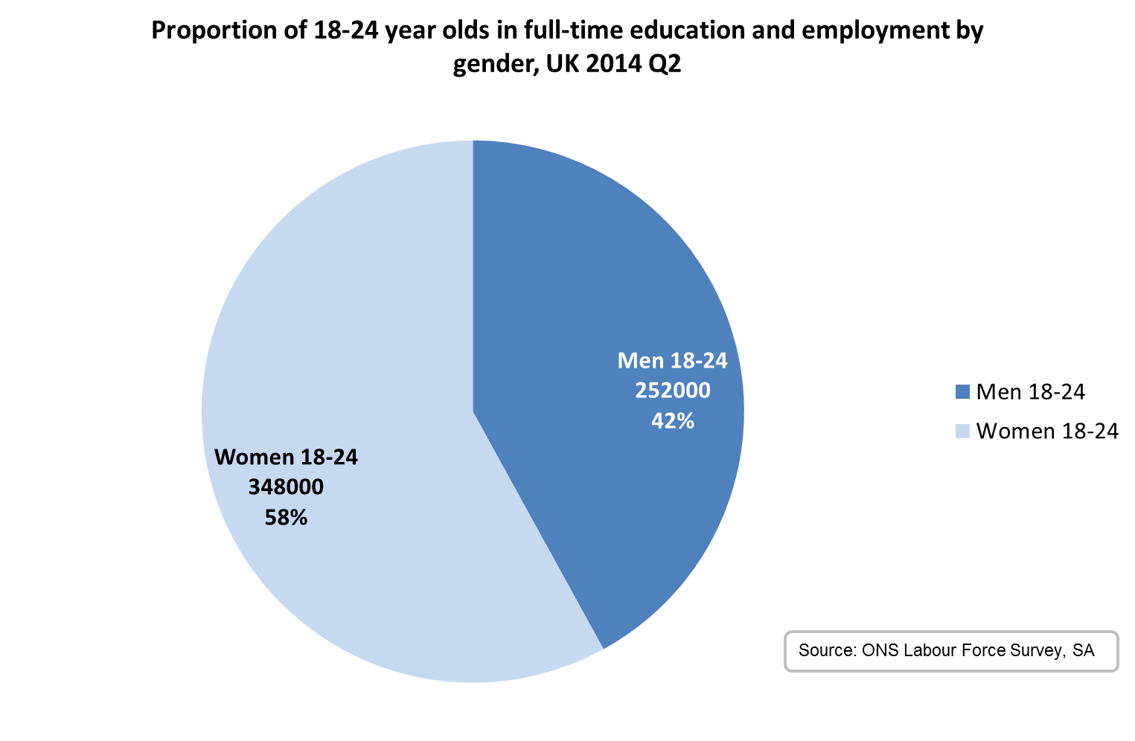
Annex B: Data tables
Number and proportion of those aged 16-17 in full-time education who are employed, UK (Q2 1992-2014)
UK 16-17 | Number | Proportion
1992 Q2 | 360,000 | 26.2%
1993 Q2 | 303,000 | 23.0%
1994 Q2 | 345,000 | 26.6%
1995 Q2 | 367,000 | 27.1%
1996 Q2 | 400,000 | 27.9%
1997 Q2 | 431,000 | 29.5%
1998 Q2 | 413,000 | 28.5%
1999 Q2 | 410,000 | 28.6%
2000 Q2 | 431,000 | 30.0%
2001 Q2 | 422,000 | 28.6%
2002 Q2 | 418,000 | 27.8%
2003 Q2 | 401,000 | 26.6%
2004 Q2 | 398,000 | 26.0%
2005 Q2 | 395,000 | 25.6%
2006 Q2 | 371,000 | 24.1%
2007 Q2 | 335,000 | 21.3%
2008 Q2 | 348,000 | 22.0%
2009 Q2 | 311,000 | 19.9%
2010 Q2 | 281,000 | 18.2%
2011 Q2 | 263,000 | 17.2%
2012 Q2 | 265,000 | 17.5%
2013 Q2 | 252,000 | 16.6%
2014 Q2 | 233,000 | 15.5%

Source: ONS Labour Force Survey, seasonally adjusted data
Number and proportion of those aged 18-24 in full-time education who are employed, UK (Q2 1992-2014)
UK 18-24 | Number | Proportion
1992 Q2 | 337,000 | 5.8%
1993 Q2 | 324,000 | 5.8%
1994 Q2 | 384,000 | 7.2%
1995 Q2 | 420,000 | 8.1%
1996 Q2 | 461,000 | 9.3%
1997 Q2 | 443,000 | 9.1%
1998 Q2 | 480,000 | 10.0%
1999 Q2 | 502,000 | 10.4%
2000 Q2 | 524,000 | 10.8%
2001 Q2 | 530,000 | 10.8%
2002 Q2 | 536,000 | 10.7%
2003 Q2 | 561,000 | 10.9%
2004 Q2 | 583,000 | 11.1%
2005 Q2 | 582,000 | 10.8%
2006 Q2 | 621,000 | 11.3%
2007 Q2 | 607,000 | 10.9%
2008 Q2 | 620,000 | 11.0%
2009 Q2 | 568,000 | 10.0%
2010 Q2 | 639,000 | 11.1%
2011 Q2 | 594,000 | 10.2%
2012 Q2 | 636,000 | 10.9%
2013 Q2 | 606,000 | 10.4%
2014 Q2 | 601,000 | 10.3%

Source: ONS Labour Force Survey, seasonally adjusted data

© Crown copyright 2014
You may re-use this information (not including logos) free of charge in any format or medium, under the terms of the Open Government Licence. Visit www.nationalarchives.gov.uk/doc/open-government-licence, write to the Information Policy Team, The National Archives, Kew, London TW9 4DU, or email: psi@nationalarchives.gsi.gov.uk.
This publication available from www.gov.uk/bis
Any enquiries regarding this publication should be sent to:
Department for Business, Innovation and Skills
1 Victoria Street
London SW1H 0ET
Tel: 020 7215 5000

If you require this publication in an alternative format, email enquiries@bis.gsi.gov.uk, or call 020 7215 5000.

BIS/14/???

