

Appendix 3:
National Governing Bodies questionnaire of competitive school sport

June 2014
Prepared by the TOP Foundation for Ofsted

1.0 National Governing Bodies of sport (NGBs) data

1.1 Introduction

This section summarises the data collected from the 26 NGBs that aims to capture the extent of competition across the representative sports and the outcomes of this. The data has been divided up into 6 sections which are outlined in figure 1.

Figure 1. An overview of the 6 sections from the NGB competitive school sport questionnaire.
A | The range of schools’ competitions provided by NGB’s for the major sports listed across all age groups (under-13 to under-19) and for girls and boys.
B | The amount of funding allocated by NGBs to each individual school sporting competition by each age group and for boys and girls.
C | Identification of the schools which won national competitions for the major sports listed over the last 10 years, across all age groups (under-13 to under-19) and for girls and boys.
D | The number of state and independent schools making it to the semi-final stages in county cup competition and national competitions over the last three years, by boys and girls teams.
E | The number of state and independent schools playing each sport regularly in schools, according to NGB statistics (at least 5 fixtures per year).
F | The number of boys and girls regularly playing each sport outside of schools, according to NGB statistics.

1.2 Method

An invitational letter was sent to 29 NGBs asking for their support with the competitive school sport investigation by completing an NGB survey. The survey was bespoke to each sport and asked for a range of data that is explored throughout this appendix.

The targeted 29 NGBs were identified and agreed by Ofsted and comprised of 39 sports which were further classified by Ofsted into major and minor school sports and Paralympic sports. In total, 26 NGBs with 35 representative sports completed and returned the NGB survey, giving a 90% response rate. Only 3 NGBs were unable to take part in the study; Amateur Boxing Association, Snow Sport England and Goalball UK.

Where information was missing in the returned NGBs survey this was sourced by the research team through phone conversations and web searching. When missing information could not be located or it was unknown or not applicable for the NGB, this was classified as “no answer provided” and relevant notes were added to the records.

Figure 2. Cohort summary for the 6 sections (n=35 sports).
Section | Complete |  | Partially complete |  | Not complete |  | No response
A | 24 | 62% | 7 | 18% | 4 | 10% | 4
B | 22 | 56% | 3 | 8% | 10 | 26% | 4
C | 23 | 59% | 1 | 3% | 11 | 28% | 4
D | 17 | 44% | 3 | 8% | 15 | 38% | 4
E | 12 | 31% | 4 | 10% | 19 | 49% | 4
F | 21 | 54% | 2 | 5% | 12 | 31% | 4

Please note that the figures above are based on all 29 NGBs being asked to complete questions for the sections relevant to their sport. In some of the sections, there is targeted analysis on just the major school sports.

1.3 Section A: The range of national schools’ competitions provided by NGBs (major school sports)

The summary information below outlines the most significant national school competitions for both girls and boys between the ages of 13 and 19 years, for each sport as identified by the NGBs. This section provides a detailed analysis of all of the competitions NGBs reported for the question, as well as a summary of the specific school competitions.
Summary of responses
All of the 15 NGBs (100%) for the major school sports either fully or partially answered the question.

13 (76%) of the 17 sports provided a full answer to the question and 4 (24%) provided a partial answer.

Summary of all competitions
The below summary incorporates information for all of the competitions the NGBs reported for their sports in the NGB survey. These competitions have been collated and analysed collectively for each individual sport. For a detailed breakdown of this data please refer to the individually submitted NGB surveys.
Type of competition

Figure 3. Type of competitions identified for the major school sports (n=16 sports).
 | Actual | % | Sports
Only school competitions | 12 | 75% | Badminton, Basketball, Cricket, Gymnastics, Netball, Rounders, Rugby League, Rugby Union, Swimming, Table Tennis, Tennis, Track and Field Athletics*
School and other competitions | 3 | 19% | Cross Country*, Football, Hockey
Only other competitions | 1 | 6% | Volleyball
Total = | 16 | 100% | -
*Note: Cross country and track and field are part of one NGB.

The majority of competitions provided by the NGBs were school competitions only (75%). Three sports (19%) provided both school and other competitions and 1 sport (6%) provided only other competitions.
Make-up of the competitions
In 11 (69%) of the sports young people competed in teams, whereas in the remaining 5 sports (31%) young people competed both individually and as a team.

Make-up of the teams

Figure 4. Make-up of teams in the competitions (n=16 sports).
 | Actual | % | Sports
School teams | 9 | 56% | Badminton, Basketball, Cricket, Gymnastics, Netball, Rounders, Rugby League, Rugby Union, Tennis
Club teams | 0 | 0% | -
County teams | 0 | 0% | -
Regional teams | 0 | 0% | -
Individuals | 0 | 0% | -
School and club teams | 1 | 6% | Volleyball
School and county teams | 2 | 13% | Cross Country*, Track and Field Athletics*
School and individual | 2 | 13% | Hockey, Table Tennis
School and regional teams | 1 | 6% | Swimming
School, county and district teams | 1 | 6% | Football
Total = | 16 | 100% | -
*Note: Cross country and track and field are part of one NGB.

For at least one of the competitions provided by each of the major school sports, young people competed for school teams. For 7 of these sports (44%), in addition to school representative teams there were club, individual, regional, county, and district teams across their competitions.

Gender of the competitions
Across the competitions listed for each of the major school sports, 12 sports (75%) provided both male and female only events (badminton, basketball, cricket, cross country, football, hockey, rugby league, rugby union, swimming, table tennis, track and field athletics, volleyball). Two sports (13%) had both male and female events and mixed events (gymnastics, tennis). Rounders had mixed and female only events and netball was the only sport with female only competitions.

Age range
The reported age range of athletes competing was provided in a variety of formats including the specific ages in years as well as squad age groups, for example, under 15s. When collating these together the cohort spanned from 9 years old through to 19 years old.

NGB talent pathway

Figure 5. Identification of sports whose national school competitions are part of their athlete talent pathway (n=13 sports).
 | Actual | % | Sports
Yes | 5 | 38% | Basketball, Cross Country*, Rugby Union, Track and Field Athletics*, Volleyball
No | 4 | 31% | Cricket, Netball, Rounders, Tennis
‘Loosely' | 1 | 8% | Badminton
Split yes and no across competitions | 3 | 23% | Hockey, Swimming, Table Tennis
Total = | 13 | 100% | -
*Note: Cross country and track and field are part of one NGB.

Five of the sports; basketball, cross country, rugby union, track and field and volleyball identified that their national competitions were part of their talent pathway, with hockey, swimming and table tennis reporting a mixture. Badminton reported that collectively their national school competition(s) are 'loosely' part of their talent pathway. Cricket, netball, rounders and tennis reported that their competitions were not part of their talent pathways.
Summary of schools’ competitions
The range of school competitions for each of the major sports as identified by the NGBs included a mix of both school and other competitions. In figure 6 only the school competitions have been presented.

Figure 6. Summary of the most significant national school team competitions identified by each of the NGBs.
Sports | Name of most significant competition(s) | Teams | Age range | Part of the talent pathway | Notes
Badminton | National Schools Championships | Schools teams only | 12-17 yrs | Loosely | Open to all secondary schools in England. The 1st round is a league format as part of School Games L2 with the winners progressing to County round, then Regional and then Finals. At the finals there are 9 schools in each age group. 36 school teams. Team size 5 or 4.
Basketball | EB National Schools Competition/ Dynamik School Competition | School teams only | 13-19 yrs | Yes | League tournaments leading to playoffs and a final four event. / Part of the School Games.
Cricket | ESCA  School National Competitions  /  Lady Taverns National Indoor | School teams only | 12-15 yrs | No | League and knockout competitions on a local county basis. School teams compete at a local level in a number of rounds to the County Finals, this leads to a Regional Final and National Final. / Allows girls in the U13 & U15 age group to play cricket indoor during the winter. There are local rounds, County Finals, Regional Finals and a Finals day at Lords Indoor School.
Cross Country* | ESAA XC Cup | School teams only | 11-15 yrs | Yes | Cup competition for school teams at Junior (u15) and Intermediate (u17) for both boys and girls. A series of county and regional finals precede the ESAA Cup.
Football | ESFA School Cups | School teams only | 13-19 yrs | No | Knock out format for boys and girls (u13/14/15/16 & u18) separate events for small schools.  Note: ISFA organise events for independent schools.
Gymnastics | BSGA National Schools Finals | School teams only | 11-19 yrs | No | These national championships take place for the separate disciplines of floor and vault (team), trampoline (team), team trio (team), tumbling (individual), and acrobatics (team).
Hockey | National Schools Championships | School teams only | 11-18 yrs | No | County rounds - 2 qualifiers for Regional Rounds - 2 qualifiers for National Round.  Mainly round robins  U14/16/18.  Indoor and outdoor.
Netball | England Netball National Schools Competition | School teams only | 13-19 yrs | No | The Competition takes place over a series of competitive rounds:  - Area Rounds (where applicable)  - County Competition Rounds x 54  - Regional Competition Rounds x9  - National Finals  U14/16/19.
Rounders | National School Championships | School teams only | 10-16 yrs | No | Regional winners progress to the championship finals, group stages leading to Knock out Semis and Finals.
Rugby League | Champion Schools Competition | School teams only | 11-16 yrs | - | Knock out from local to regional stages.
Rugby Union | NatWest Schools Cup  /  Girls Schools Festival | School teams only | 14-19yrs/  11-15yrs | Yes | Knockout. Two tier competition with a Vase for those schools that lose in the first few rounds (450 teams approx). /  Knock out with 12 teams making the festival.
Swimming | ESSA School Teams Championships | School teams only | 13-19 yrs | No | Individual school teams qualify through preliminary rounds in counties and/or divisions.
Table Tennis | ESTTA National School Team Championships | School teams only | 11-19 yrs | No | School teams qualify from 51 County School Championships in eight age groups to play in one of eight Zone Finals, winners progressing to Regional and onto the National Final. For both Boys and Girls teams at U19/16/13/11. Teams of 4 players.
Tennis | Team Tennis Schools Series (National Championships, Year 8 & 10, Senior Students) | School teams only | 11-19 yrs | No | National Champs: Regional knockout stages from March to June. National Finals in July; Year 8 and 10: League stage from April to July. Regional stages from Sep to Nov with National Finals in December; Senior Students: League stage from Oct - Dec. Regional stage from Jan to Feb. National Finals in March.
Track and Field Athletics* | ESSA Track & Field Schools Cup | School teams only | 11-15 yrs | Yes | Cup competition for school teams at Junior (u15) and Intermediate (u17) for both boys and girls. A series of county and regional finals precede the ESAA Cup Final.
Volleyball | National Championships | School & club teams | 14-18 yrs | Yes | Not a school specific competition.  1st and 2nd Round Pool Play – Finals.
*Note: Cross country and track and field are part of one NGB.

1.4 Section B: The amount of funding allocated by NGBs to run school competitions

The summary information below outlines the amount of funding the NGBs allocate to supporting and delivering competitive school sport for young people aged between 13 and 19 years for their sport.
Summary of responses
24 of the 29 NGBs (83%) across all sports either fully or partially answered the question.

From the NGBs data, 25 (71%) of the 35 sports provided a full answer, 4 (11%) provided a partial answer and 6 (17%) did not submit an answer.

Total funding allocated

Figure 7. Total amount of funding allocated by NGBs to their school sporting competition (n=21 NGBs).
 |  | Sports | Total funding (£) | Boys | Girls
1 | English Lacrosse Association | Lacrosse | £750,000* | - | -
2 | Football Association | Football | £700,000 | - | -
3 | England Athletics | Cross Country & Track and Field | £170,000 | - | -
4 | Rugby Football Union | Rugby Union | £150,000 | £140,000 | £10,000
5 | Tennis Foundation | Tennis | £90,000 | £45,000 | £45,000
6 | England & Wales Cricket Board | Cricket | £80,000 | £50,000 | £30,000
7 | Amateur Swimming Association | Swimming & Water polo | £72,000 | - | -
8 | England Basketball | Basketball | £55,000 | - | -
9 | England Hockey | Hockey | £35,000 | - | -
10 | Boccia England | Boccia | £22,000 | - | -
11 | Great British Wheelchair Basketball | Wheelchair basketball | £14,000 | - | -
12 | England Netball | Netball | £13,000 | - | £13,000
13 | Royal Yachting Association | Sailing | £12,000 | - | -
14 | Volleyball England | Volleyball & Sitting Volleyball | £10,500 | - | -
15 | English Table Tennis Association | Table Tennis & Disability Table Tennis | £8,500 | - | -
16 | British Judo Association | Judo | £6,500 | - | -
17 | Rounders England | Rounders | £3,500 | - | -
18 | British Equestrian Foundation | Equestrian | £0 | £0 | £0
19 | British Fencing | Fencing | £0 | £0 | £0
20 | British Rowing | Rowing | £0 | - | -
21 | British Taekwondo | Taekwondo | £0 | £0 | £0
 | Total = | - | £2,192,000 | £235,000 | £98,000
*Note: The English Lacrosse Association has included staffing costs in this figure.

Collectively across the 21 sports that provided funding data, there is a total of £2,192,000 allocated to school sport competitions. £1,450,000 (66%) of this is attributed to two sports; lacrosse (£750,000) and football (£700,000). The remaining £742,000 was spread out across 19 sports. Four sports reported that they provide no funds.
Funding by gender
Four of the NGBs provided a breakdown of the funding they allocate specifically by gender, all of which were for the major school sports. The data illustrates that boys’ competitions receive the highest level of funding with £235,000 (71%) compared to girls’ competitions receiving £98,000 (29%).
Funding by classification of sport
The reported NGB funding allocation can be further summarised by the classification of sports (figure 8).
Figure 8: Total amount of funding allocated to individual sports by Ofsted’s sport classification (n=25 sports).
 | n= | Actual | % | Average | Sports
Major school  sports (n=13) | 13 | £1,387,500 | 63% | £106,731 | Basketball, Cricket, Cross Country*, Football, Hockey, Netball, Rounders, Rugby Union, Swimming, Table Tennis, Tennis, Track and Field Athletics*, Volleyball
Minor school  sports (n=8) | 8 | £768,500 | 35% | £96,063 | Equestrian, Fencing, Lacrosse, Judo, Rowing, Sailing, Water polo, Taekwondo
Paralympic  sports (n=4) | 4 | £36,000 | 2% | £9,000 | Boccia, Wheelchair basketball, Sitting volleyball, Disability Table Tennis
Total = | 25 | £2,192,000 | 100% | - | -
All sports (n=25) | 25 | - | - | £87,680 | -
*Note: Cross country and track and field are part of one NGB.

On average the major school sports receive the most allocated funding from their NGBs; £106,731 per annum per sport (collectively 63% of the total funding). Overall, across the 25 sports, the average funding allocation to school sports competition is £87,680 per annum.

1.5 Section C: The type of schools winning national schools’ competitions over the last 10 years (major sports)
The summary information below outlines the schools who won the most important national school competitions for each major school sport as identified by the NGBs for the last 10 years, for young people aged between 13 and 19 years. These schools competed as school teams.
For some of this analysis the competitions for football have been separated into those for the English Schools FA who run competitions for all school types and those for the Independent School FA who run tournaments for independent schools only.
Summary of responses
All of the 15 NGBs (100%) for the major sports provided a full answer.

From the NGBs data, 16 (100%) of the 16 sports provided a full answer.

Type of competition
The majority of competitions reported by the NGBs were school competitions only (88%).
Who the competitions are open to
Fifteen of the 16 sports’ competitions (94%) were open to school teams only, 1 (6%) sports’ competition was open to both school and club teams, and 1 (6%) sports’ competition was open to school, country and district teams.

Winning school type by sport
An analysis was performed on the type of winning schools across all of the sports. Figure 9 illustrates that 56% of these were won by state schools, 43% were won by independent schools and 1% were won by other winners (unknown).

Figure 9. The type of winning schools for all sports (n=16).
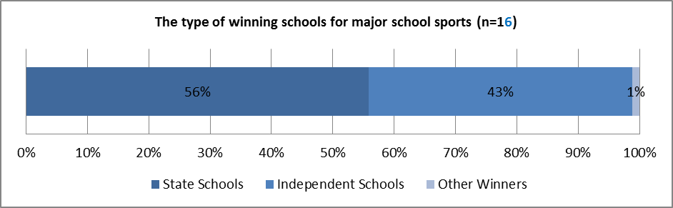
This analysis was also completed for each individual sport. Figure 10 indicates the number and percentage of state school wins, independent school wins and other winners, by sport.

Figure 10. The type of winning schools across the 16 sports (n=745).
 | Full or partial records for years: | State school wins (actual) | State schools (%) | Independent school wins (actual) | Independent schools (%) | Other winners (actual) | Other winners (%) | TOTAL SCHOOLS
Rugby League | 2013-2007 | 58 | 98% | 0 | 0% | 1 | 2% | 59
Basketball | 2013-2010 | 49 | 98% | 1 | 2% | 0 | 0% | 50
Football (English Schools FA) | 2013-2004 | 94 | 96% | 4 | 4% | 0 | 0% | 98
Track and Field Athletics* | 2013-2007 | 23 | 82% | 5 | 18% | 0 | 0% | 28
Badminton | 2013-2004 | 32 | 80% | 7 | 18% | 1 | 3% | 40
Volleyball | 2013-2011 | 8 | 80% | 2 | 20% | 0 | 0% | 10
Rounders | 2013-2004 | 18 | 69% | 5 | 19% | 3 | 12% | 26
Netball | 2013-2007 | 14 | 67% | 5 | 24% | 2 | 10% | 21
Cross Country* | 2013-2006 | 21 | 66% | 11 | 34% |  | 0% | 32
Table Tennis | 2013-2004 | 34 | 57% | 26 | 43% | 0 | 0% | 60
Rugby Union | 2013-2004 | 22 | 48% | 24 | 52% | 0 | 0% | 46
Gymnastics (floor and vault events) | 2013 | 3 | 38% | 4 | 50% | 1 | 13% | 8
Tennis | 2013-2004 | 12 | 20% | 48 | 80% | 0 | 0% | 60
Cricket | 2013-2004 | 6 | 17% | 29 | 83% | 0 | 0% | 35
Hockey | 2012-2004 | 15 | 16% | 79 | 83% | 1 | 1% | 95
Swimming | 2011-2004 | 7 | 9% | 70 | 91% | 0 | 0% | 77
Total = | - | 416 | - | 320 | - | 9 | - | 745
% of total = | - | 56% | - | 43% | - | 1% | - | -
Mean % = | - | - | 59% | - | 39% | - | 3% | -
*Note: Cross country and track and field are part of one NGB.

Figure 11. The type of winning school by each individual sport (n= 17 sports).
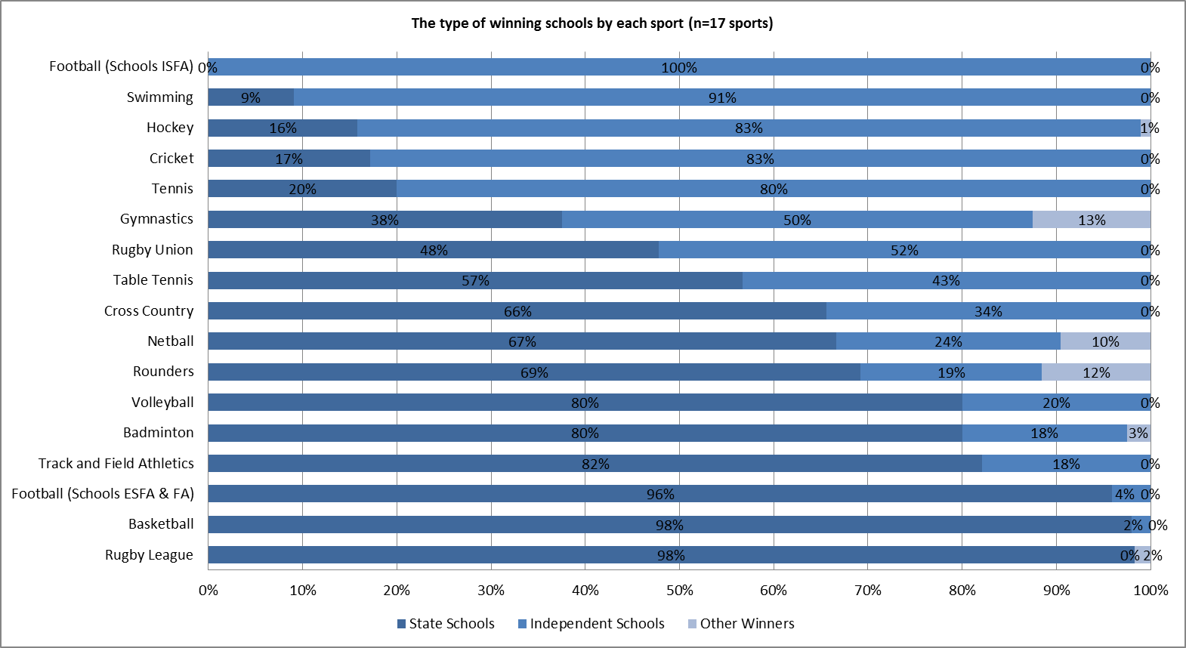

The data indicates that there were high percentages of state schools who won competitions in rugby league, basketball, football (ESFA), track and field, badminton and volleyball. Alternatively, football (ISFA), swimming, hockey, cricket and tennis all held high percentages of independent school winners.
Caution needs to be taken when comparing the data as some sports were not able to provide a complete dataset for the full 10 years. There are also variations in the number of competitions reported on by each sport.

1.6 Section D: The number of state and independent schools making it to the semi-final stages in county cup competition and national competitions
The summary below outlines the number and percentage of state and independent schools that made the semi-final stages of the county cup and national competitions across all sports for 2013, and in the case of rugby union, 2012.
Summary of responses
26 of the 29 NGBs (90%) across all sports fully or partially answered the question.
From the NGBs data, 16 (46%) of the 35 sports provided a full answer, 3 (9%) provided a partial answer and 16 (46%) did not submit an answer.
Type of competition
All of the competitions in this cohort of 16 sports were school competitions only.

Successful school type by sport
An analysis was performed on the type of schools who made it to the semi-final stages in the competitions for all sports. As the English Table Tennis Association only provided a percentage of school wins for table tennis competitions instead of an actual number, the figures have been excluded from the following analysis.

Figure 12. The number of state, independent and other schools who made it to the semi-final stages of all sports competitions (n=16 sports).
 | State schools (actual) | State schools (%) | Independent schools (actual) | Independent (%) | Other (actual) | Other (%) | Total schools
Total = | 1,288 | 66% | 636 | 32% | 42 | 2% | 1,966

Figure 13. The number of state, independent and other schools who made it to the semi-final stages of all sports competitions (n=16 sports).
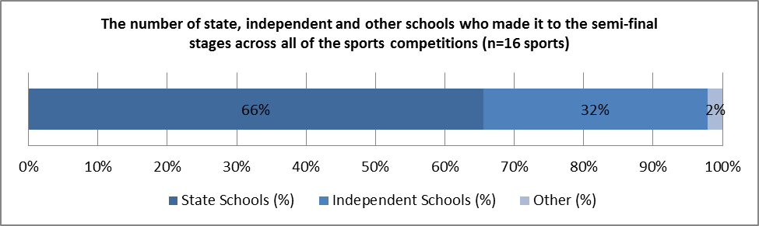

Figures 12 and 13 illustrate that 1,288 state schools made the semi-final stages across all of the sports competitions (66%), 636 independent schools achieved the same feat (32%), as did 42 (2%) other schools.

This analysis was also completed for each individual sport. Figure 14 indicates the number and percentage of state, independent and other school winners for each individual sport.

Figure 14. The number and percentage of state and independent schools who made it to the semi-final stages of each sports competition (n=16 sports).
 | State schools (actual) | State schools (%) | Independent schools (actual) | Independent schools (%) | Other (actual) | Other (%) | Total schools
Basketball | 71 | 99% | 1 | 1% | 0 | 0% | 72
Football | 74 | 93% | 6 | 8% | 0 | 0% | 80
Judo | 592 | 83% | 82 | 11% | 40 | 6% | 714
Rounders | 9 | 75% | 2 | 17% | 1 | 8% | 12
Track and field* | 12 | 75% | 4 | 25% | 0 | 0% | 16
Wheelchair basketball | 3 | 75% | 1 | 25% | 0 | 0% | 4
Cross country* | 9 | 56% | 7 | 44% | 0 | 0% | 16
Swimming | 450 | 56% | 360 | 44% | 0 | 0% | 810
Cricket | 12 | 46% | 14 | 54% | 0 | 0% | 26
Tennis | 17 | 44% | 22 | 56% | - | 0% | 39
Equestrian | 20 | 42% | 28 | 58% | 0 | 0% | 48
Fencing | 8 | 31% | 18 | 69% | 0 | 0% | 26
Rugby union | 3 | 19% | 13 | 81% | 0 | 0% | 16
Water polo | 8 | 13% | 52 | 87% | 0 | 0% | 60
Lacrosse | 0 | 0% | 8 | 100% | 0 | 0% | 8
Rowing | 0 | 0% | 18 | 95% | 1 | 5% | 19
Total = | 1,288 | - | 636 | - | 42 | - | 1,966
% of total = | 65.5% | - | 32.3% | - | 2.1% | - | -
Mean % = | - | 50.4% | - | 48.4% | - | 1.2% | -
*Note: Cross country and track and field are part of one NGB.

Figure 14 indicates that basketball, football, judo, rounders, track and field, wheelchair basketball, cross country and swimming all had higher percentages of state school winners than independent winners. Whereas the remaining 8 sports all had higher percentages of independent school winners than state. Interestingly, for both lacrosse and rowing over 95% of school winners were independent schools.

As total numbers are not always representative, figure 15 shows the percentages of state and independent school wins for each sport to allow direct comparisons.

Figure 15. The type of schools who made it to the semi-final stages of the competitions (n=16 sports)
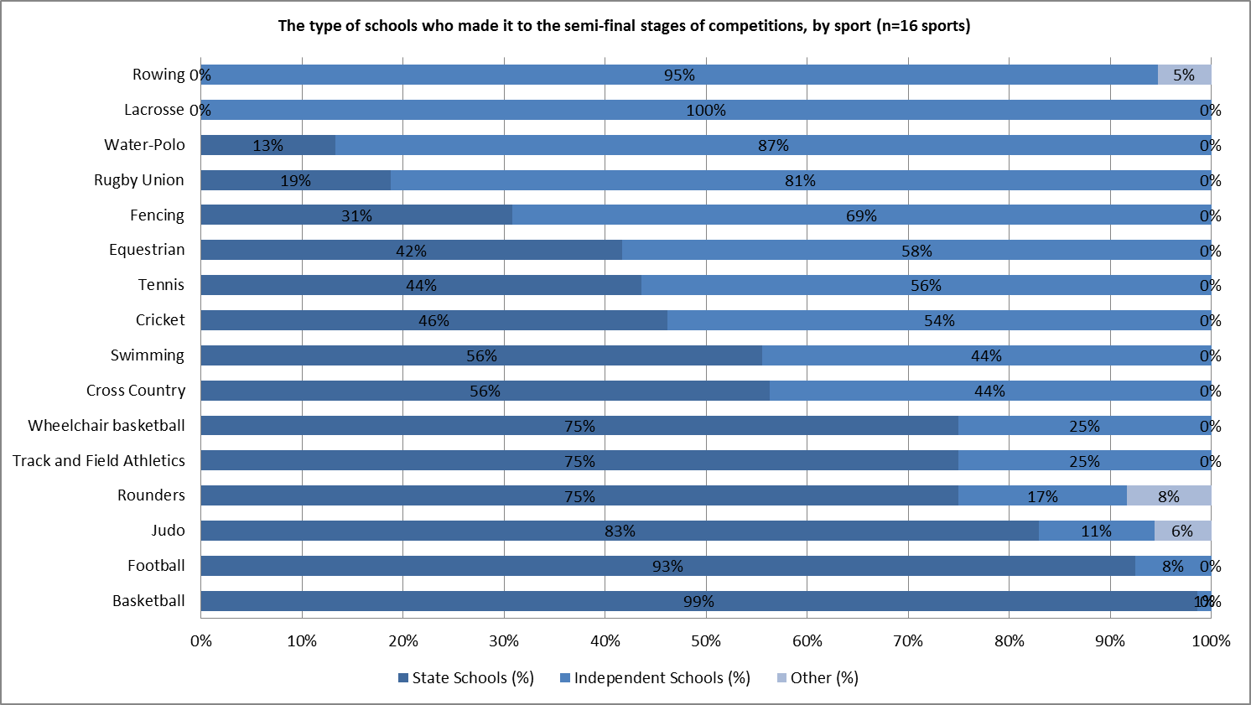

1.7 Section E: The number of state and independent schools playing each sport regularly in schools
The summary below outlines the estimated number of state and independent schools competing in each sport regularly (at least 5 fixtures per year), for young people aged between 13 and 19 years.
Summary of responses
15 of the 29 NGBs (52%) across all sports either fully or partially answered the question.
From the NGBs data, 11 (31%) of the 35 sports provided a full answer, 5 (14%) provided a partial answer and 19 (54%) did not submit an answer.
Type of school by sports participation
An analysis was performed on the type of schools who regularly compete in each sport. Figure 16 illustrates that 10,350 state schools compete in major school sports, 175 compete in minor sports and 37 compete in Paralympic sports (as classified by Ofsted), whilst 1,624 independent schools compete in major school sports, 428 compete in minor school sports and 2 compete in Paralympic sports.
Figure 16. The type of school competing in sport regularly in school for the 3 sport classifications (n=11 sports)
 | State schools (number) | State schools (%) | Independent schools (number) | Independent schools (%) | TOTAL
Major (n=6) - Basketball, Cricket, Football, Rugby Union, Table Tennis, Tennis* | 10,350 | 86% | 1,624 | 14% | 11,974
Minor (n= 4) - Equestrian, Lacrosse, Rowing, Water Polo | 175 | 29% | 428 | 71% | 603
Para (n= 1) - Wheelchair Basketball | 37 | 95% | 2 | 5% | 39
Total = | 10,562 | - | 2,054 | - | 12,616
*Note: this figure for Tennis refers to schools involved in national competitions only.

Analysis was also completed for each individual sport. Figure 17 indicates the number and percentage of state, independent and other school wins for each individual sport.

Figure 17. The type of school competing in each sport regularly in school (n=11 sports).
 | Ofsted classification | Est. number of state schools | State schools (%) | Est. number of independent schools | Independent schools (%) | TOTAL
Basketball | Major | 2,025 | 99% | 18 | 1% | 2,043
Football | Major | 2,500 | 95% | 141 | 5% | 2,641
Wheelchair Basketball | Paralympic | 37 | 95% | 2 | 5% | 39
Table Tennis | Major | 2,100 | 88% | 300 | 13% | 2,400
Cricket | Major | 1,600 | 86% | 250 | 14% | 1,850
Rugby Union | Major | 1,600 | 76% | 500 | 24% | 2,100
Tennis | Major | 525 | 56% | 415 | 44% | 940
Equestrian | Minor | 120 | 40% | 180 | 60% | 300
Rowing | Minor | 20 | 20% | 81 | 80% | 101
Water-Polo | Minor | 10 | 19% | 42 | 81% | 52
Lacrosse | Minor | 25 | 17% | 125 | 83% | 150
Total = | - | 10,562 | - | 2,054 | - | 12,616
% of total = | - | 83.7% | - | 16.3% | - | -
Mean % = | - | - | 62.8% | - | 37.2% | -

This figure illustrates that basketball, football, wheelchair basketball, table tennis, cricket, rugby union and tennis all had higher numbers of state schools competing regularly in their sport than independent schools. Whereas, equestrian, rowing, water-polo and lacrosse; all had higher numbers of independent schools playing their sports than state schools.

Figure 18 shows a breakdown of the percentages of state and independent schools playing each sport to allow direct comparisons.
Caution needs to be taken when observing the figures for rowing and wheelchair basketball as the NGBs for these sports only identified confidence levels of 1 and 5 respectively on the scale of accuracy for data (1 being not very confident and 10 being very confident).
Figure 18. The type of schools regularly competing in each of the 11 sports.
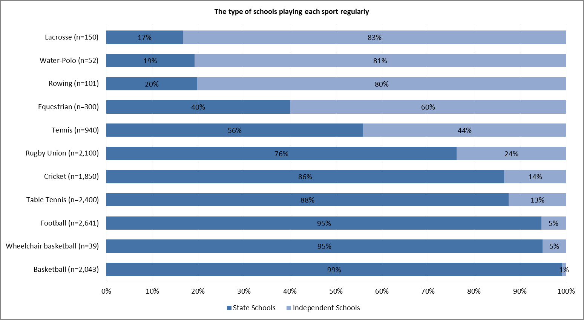
1.8 Section F: The number of boys and girls regularly playing each sport outside of schools
The summary information below outlines the number of boys and girls aged 13-19 playing each sport regularly, outside of school.
Summary of responses
20 of the 29 NGBs (69%) across all sports either fully or partially answered the question.
From the NGBs data, 21 (60%) of the 35 sports provided a full answer, 2 (6%) provided a partial answer and 12 (34%) did not submit an answer. Of those sports that provided an answer, the reported sources of this information included membership figures, the Taking Part Survey, the Active People Survey, and internal NGB data.

Total number of boys and girls regularly playing sports outside of schools
The total number of young people playing sport outside of school was reported as 1,448,276 (figure 19). Football had the highest reported number of young people playing regularly, whilst the lowest report numbers were for the disability sports. Caution needs to be taken when drawing conclusions from the overall figure and when making comparisons across sports due to the varying age groups each individual sport has referred to.

Figure 19. NGB figures for the number of boys and girls regularly playing sport outside of school.
 | NGB | Sport(s) | Gender | Total number | Boys | Girls | Actual or estimate | Data source | Ages
1 | Football Association | Football & Football (CP) | Both | 538,715 | 750 | 75 | Estimate | NGB membership survey | 13-19, U18
2 | British Gymnastics | Gymnastics | Both | 201,357 | - | - | - | NGB membership data | 0-18
3 | Rugby Football Union | Rugby Union | Both | 200,000  (116,000 played in mixed competitions) | 111,500 | 4,500 | Estimate | NGB registration data and NGB calculations | 13-19
4 | England Netball | Netball | Girls only | 100,000 | - | 24,910 | Estimate | NGB membership and programme data | 11-18
5 | England & Wales Cricket Board | Cricket | Both | 78,500 | - | - | Actual | Active People Survey 7 | 14-19
6 | English Lacrosse Association | Lacrosse | Both | 67,406 | 11,503 | 55,903 | Actual | NGB programme data | U13 to U19
7 | Badminton England | Badminton | Both | 60,000 | - | - | Estimate | NGB Data | 13-19
8 | Tennis Foundation/Lawn Tennis Association | Tennis | Both | 52,800 | - | - | Estimate | Active People Survey 7 | 16-19
9 | England Hockey | Hockey | Both | 50,272 | 23,334 | 26,938 | Actual | NGB club affiliation data | 11-15
10 | England Athletics | Cross Country & Track and Field | Both | 36,235 | - | - | Actual | NGB registration data | Not provided
11 | England Basketball | Basketball | Both | 17,865 | - | - | Actual | NGB membership data | 13-18
12 | British Rowing | Rowing | Both | 12,763 | 7,377 | 5,386 | Actual | NGB membership data | 13-19
13 | Royal Yachting Association | Sailing | Both | 7,665 | - | - | Actual | NGB programme data | 4-19
14 | British Canoe Union | Canoeing | Both | 5,912 | - | - | Estimate | Internal NGB research | 12-18
15 | British Judo Association | Judo | Both | 5,457 | - | - | Actual | NGB CRM system | 13-19
16 | British Cycling | Cycling | Both | 4,798 | - | - | Actual | NGB membership data | 13-18
17 | British Equestrian Foundation | Equestrian | Both | 3,500 | - | - | Actual | NGB membership data | u13-u19
18 | British Taekwondo | Taekwondo | Both | 2,430 | - | - | Actual | NGB database | 13-19
19 | Volleyball England | Volleyball & Sitting Volleyball | Both | 2,005 | - | - | Estimate | Sitting volleyball programme data | 11-18 years and 13-19
20 | Great British Wheelchair Basketball | Wheelchair basketball | Both | 344 | 268 | 76 | Actual | NGB Database | 13-19
21 | English Table Tennis Association | Disability Table Tennis | Both | 170 | - | - | - | NGB membership data | U19
22 | Boccia England | Boccia | Both | 82 | - | - | - | NGB membership data | u19
 | Total = | - | - | 1,448,276 | 154,732 | 117,788* | - | - | -
*Note: England Netball provided figures for just girls. When this is removed from the analysis to allow a comparison against NGBs who provided figures for both boys and girls, the total number of girls is 92,878.
Gender
Across the sports that provided a gender breakdown, boys have the highest number of young people playing regularly compared to girls, 154,732 compared to 117,788. Football (CP), rugby union, rowing and wheelchair basketball had more boys playing than girls and lacrosse and hockey had more girls playing than boys. Overall, rowing and hockey had the most balanced reported figures for each gender.
Taking Part Survey
Many of the NGBs reported using different types of data sources for their young people participation figures. The Taking Part Survey estimates the number of young people (11-15 years) participating in a range of sports. Figure 20 illustrates participation rates from 2012/2013.
Figure 20. The graph of the percentage participation rates by sport from the 2012/13 Taking Part Survey.
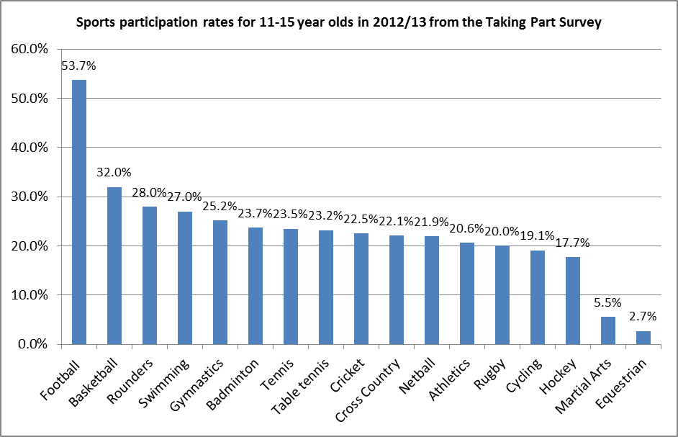

Although the Taking Part Survey data cannot be directly compared to the relevant NGB data collected, the sports have been ranked in order of the highest participation figures and then compared in figure 21 and 22.

Figure 21 and 22. The ranking of sports by reported participation figures. i) NGB survey. ii) Taking Part Survey 2012/13.
Rank | i) NGB reported figures 2013/14 to Ofsted |  | Rank | ii) Taking Part Survey 2012/13
1 | Football Association |  | 1 | Football
2 | British Gymnastics |  | 2 | Basketball
3 | Rugby Football Union |  | 3 | Rounders
4 | England Netball |  | 3 | Swimming
5 | England & Wales Cricket Board |  | 4 | Gymnastics
6 | English Lacrosse Association |  | 5 | Badminton
7 | Badminton England |  | 6 | Tennis
8 | Tennis Foundation/Lawn Tennis Association |  | 7 | Table tennis
9 | England Hockey |  | 8 | Cricket
10 | England Athletics |  | 9 | Cross Country
11 | England Basketball |  | 10 | Netball
12 | British Rowing |  | 11 | Athletics
13 | Royal Yachting Association |  | 12 | Rugby
14 | British Canoe Union |  | 13 | Cycling
15 | British Judo Association |  | 14 | Hockey
16 | British Cycling |  | 15 | Martial Arts
17 | British Equestrian Foundation |  | 16 | Equestrian
18 | British Taekwondo
19 | Volleyball England
20 | Great Britain Wheelchair Basketball Association
21 | English Table Tennis Association
22 | Boccia England

Many of the NGBs reported actual junior membership numbers and it is interesting to see how the rank of the NGB varies alongside the ranking from the Taking Part Survey. Sports like cycling which have both a governed and leisure component to their sport show a difference in ranking compared to a sport like rugby union which does not have such a large leisure element to it. Caution needs to be taken when drawing any conclusions from this information due to the different data sources used and the varied age groups referred to.

2.0 Talent data
2.1 Introduction
This section of the appendix provides a summary of the athlete talent data. It includes information of athletes on each sport’s talent pathway at a county and regional representative level, and the type of schools they attend. If a sport’s talent pathway uses a different route, a comparable cohort was asked for. Where actual data on the talent cohort was unavailable, estimation on the type of schools athletes’ attended was asked for.

The Amateur Swimming Association and the England and Wales Cricket Board asked their representative county and regional teams to complete an online talent survey as they did not hold this data.

2.2 Method
NGBs were asked to provide information on the number of state and independent school educated boys and girls selected to represent their county and regional teams over the last three years. This was reported through the NGB survey.

2.3 Summary of responses

11 of the 15 NGBs (73%) either fully or partially answered the question, 7 of which provided a more detailed breakdown.
All of the 7 sports provided data from either 2013 or 2014 except rugby union who provided data over three years from 2010-2012.

Of the 11 NGBs that answered the questions, 23,667 young people were identified as being selected to represent county or regional teams. Some sports such as badminton and netball were able to provide data on their country players, whilst others offered data on their regional or national programme players. Not enough of the sports were able to provide the data over a period of three years, so only the most recent data has been included in the analysis. The NGBs from cross country, gymnastics, rounders table tennis and track and field were unable to supply any figures for this question.
Figure 23. Summary of the NGB reported number of boys and girls selected to represent county and regional teams.
n=11 | Cohort descriptor | Total boys | Total girls | Total boys and girls | Actual data or estimate | Accuracy of data  (1-low 10-high)
Badminton | County squads U11/U13/U15/U17/U18 | 980 | 980 | 1,960 | Estimate | 6 out of 10
Tennis | Junior matrix players | 893 | 803 | 1,696 | Actual | 10 out of 10
Volleyball | Cadet and Junior men and women | 41 | 41 | 82 | Actual | 9 out or 10
Basketball | Regional squads U13, U15, U17 | 432 | 432 | 864 | Estimate | 7 out of 10
Cricket | Academy players | - | - | 162 | Actual | -
Football | Regional squads. National team at U18 (boys) and National team at U15 (girls) | 2,262 | 946 | 3,208 | Estimate | 9 out of 10
Hockey | Junior academy centre for girls & boys | 4,109 | 4925 | 9,034 | Actual | 10 out of 10
Netball | Regional performance, Regional, County and Satellite | - | 3826 | 3,826 | Estimate | 7 out of 10
Rugby League | Professional club : regional development academies, regional development centres | - | - | 1,264 | Estimate | 8 out of 10
Rugby Union | Pro clubs (men), county U18 & U15 (female) | 60 | 1,154 | 1,214 | Estimate | 8 (M) 2 (F) out of 10
Swimming | England programme swimmers | - | - | 357 | Actual | -
Total = | - | 8,736 | 13,107 | 23,667

Of the 7 NGBs that provided a more a detailed breakdown of their numbers across their county, regional or national programmes, basketball and football reported the highest number of their athletes from state schools. England Hockey did not know the type of schools of more than half of their players in this cohort.
Figure 24. An analysis of the percentage of boys and girls selected to represent county and regional teams by the type of school they attend.
N=7 | Boys attending state schools | Boys attending independent schools | Boys attending unknown schools | Girls attending state schools | Girls attending independent schools | Girls attending unknown schools
Basketball | 98% | 2% | 0% | 98% | 2% | 0%
Cricket* | 60% | 40% | 0% | 87% | 13% | 0%
Football | 100% | 0% | 0% | 100% | 0% | 0%
Hockey | 27% | 6% | 67% | 17% | 8% | 76%
Netball | - | - | - | 91% | 10% | 0%
Rugby Union | 53% | 35% | 12% | 85% | 15% | 0%
Swimming* | 81% | 18% | 1% | 72% | 27% | 1%
Mean % = | 70% | 17% | 13% | 79% | 11% | 11%
*Cricket and swimming worked with the research team to run a snap survey to determine the % of state and independent schooling of their cohorts.
England and Wales Cricket Board reported quite a big difference between the types of schools their academy players came from, but as the numbers reported are low the confidence in these figures are not high. The discrepancy between rugby union men and women may reflect the different cohorts they have selected in reporting their numbers.

END

Department for Culture, Media and Sport (2013) Taking Part 2012/13: Annual Child Report. August 2013. Statistical Release. London

