Using the natural environment to improve provision: Wolverley Church of England Secondary School

URN: 135061
Area: West Midlands
Date published: 13 June 2011
Reference: 120384
This example shows how Wolverley Secondary School engages those learners in Years 10 and 11 whose circumstances may make them vulnerable in an individually tailored programme based on working outdoors on the land. As a result, their outcomes - achievement, motivation and behaviour - have all improved significantly.
Brief description

Overview – the school’s message
‘As part of our improvement plan, following our inspection in 2008, we instigated a project to engage students whose circumstances may make them vulnerable, together with a proposal to gain ECO school status. Involving students in planning their programme and incorporating practical work which they enjoy have been transformational in terms of their behaviour and achievement.’
Richard North, Headteacher

The good practice in detail

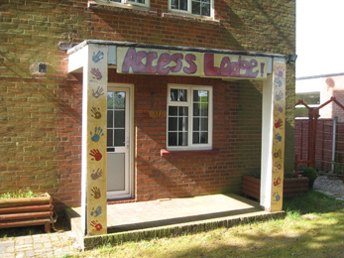
This school runs many sustainable development initiatives and embeds the principles effectively into the school’s ethos and the curriculum. The ‘Eco Code’ is well used and the school has gained the silver ‘eco award’ and is working towards the green award. The ‘Eco Council’ consists of enthusiastic students of all ages and the link Governor attends their meetings regularly. This group leads on ‘switch off’ campaigns, free trade projects and tree planting. Their views are sought and valued. Students studying for the land and environment diploma grow vegetables and work on the campus grounds, and the school has resident badgers, bats, newts and reptiles. The school weather station provides information for local residents.
Set in around 40 acres, Richard believes the school offers a unique learning environment. He says, ‘Our aim is to harness this landscape and combine it with staff expertise and ability, to plan the best type of learning experiences and to meet the needs of all our students. We achieve this through the Access Lodge.’
A small group of students from Years 10 and 11 join the Access Lodge. They are selected based on academic performance and their behaviour at Key Stage 3. The Lodge has been developed from an unused caretaker’s house and the surrounding land. Development and management of the site are largely the responsibility of the students, who follow a personalised curriculum designed around working outside with animals, plants and the land, together with additional subjects selected from the school’s options programme.
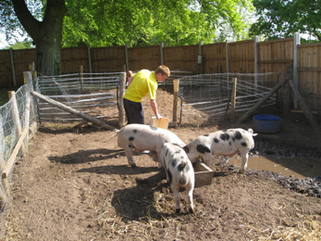
Kay Staten, the Diverse Curriculum Coordinator says, ‘The environmental focus of the programme builds on the resources and the unique environment of the school, but also meets the needs of the students, who like being outdoors, caring for animals and working on the land.’
The learning programme consists of three days at the lodge when students have lessons in functional skills; English, mathematics and information and communication technology (ICT). They also take a suite of qualifications to meet their individual needs including: ASDAN Certificate in Personal Effectiveness (COPE); Functional Skills at Level 1 or 2; Community Volunteering Awards; and the Duke of Edinburgh Award. For the remaining two days, students join the rest of their year group for the options programme. Option choices include GCSEs in physical education and resistant materials, and BTEC diplomas in construction, land and environment, and childcare, and take place at the local further education college.
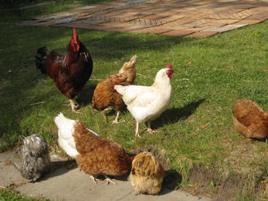
Three ‘Gloucester old spot’ pigs are recent arrivals at the school. The students built the pen and they are responsible for feeding the pigs and calculating their diet. The pigs are also part of a pioneering project in partnership with Wyre Forest Rangers for which the students have won the prestigious ‘Tryangle’ award for environment and sustainability. The students and the school are extremely proud of this achievement. The pigs will be moved to an enclosure in Wyre Forest where they are an environmentally friendly way of managing the environment; their grazing and snuffling will remove bracken and bramble, increase biodiversity and encourage butterflies.
The students also grow vegetables, keep poultry and build patios and decking. They work in the locality on gardens, which has been helpful in building a positive relationship with the local community. Year 11 pupils created a pond and reptile environments on the site, helped by local rangers.
Access Manager, Ade Hobday, says, ‘The change in attitude and behaviour of the students is fantastic; largely because the programme is based on the environment and it is shaped by the students. They love being outside and working on the land.’ The students agree. Conor Clark says, ‘We don’t have to sit in a classroom all day. We can come out and work outdoors and learn by doing. But we still have to write everything up for our portfolio.’ Reece Manning adds, ‘We also work on the nature reserve and in local gardens. We have improved the gardens in the lodge by building a pond and archways. Our latest project is to design and build a patio, where we can have lessons outdoors.’ And Harry Bannister says, ‘We will probably get more qualifications. We work harder in school on our options as well because we have chosen them.’
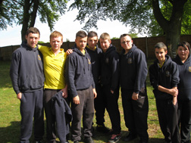
The small group learning environment and adult atmosphere at the Lodge also contributes to success. Students believe that staff have time for them and value their opinions. Deputy Head, Mark Pollard says, ‘Success is twofold. These pupils will leave with a qualification including functional skills in English, mathematics and ICT and optional qualifications, but more importantly they will leave with a sense of achievement and success. The students are also more likely to remain in education, employment or training when they leave school.’
The school’s background

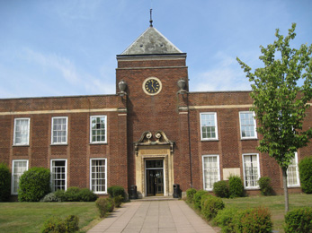
Wolverley Church of England Secondary School is of average size, with a relatively small sixth form. It opened in September 2007 as a result of a local reorganization of schools, which saw the closure of middle schools in the area and the incorporation of their pupils into newly formed primary and secondary schools. Wolverley operates on the site of a former high school. Students travel to the school from a wide geographical area. The school has a specialist designation for music and the silver ‘eco school’ award.
Are you thinking of putting these ideas into practice; or already doing something similar that could help other providers; or just interested? We'd welcome your views and ideas. Get in touch here.
To view other good practice examples, go to: www.ofsted.gov.uk/resources/goodpractice

