DCMS Ministerial hospitality, overseas travel and meetings with external organisations,
Newspapers and other media proprietors, editors and senior executives

1 April - 30 June 2014

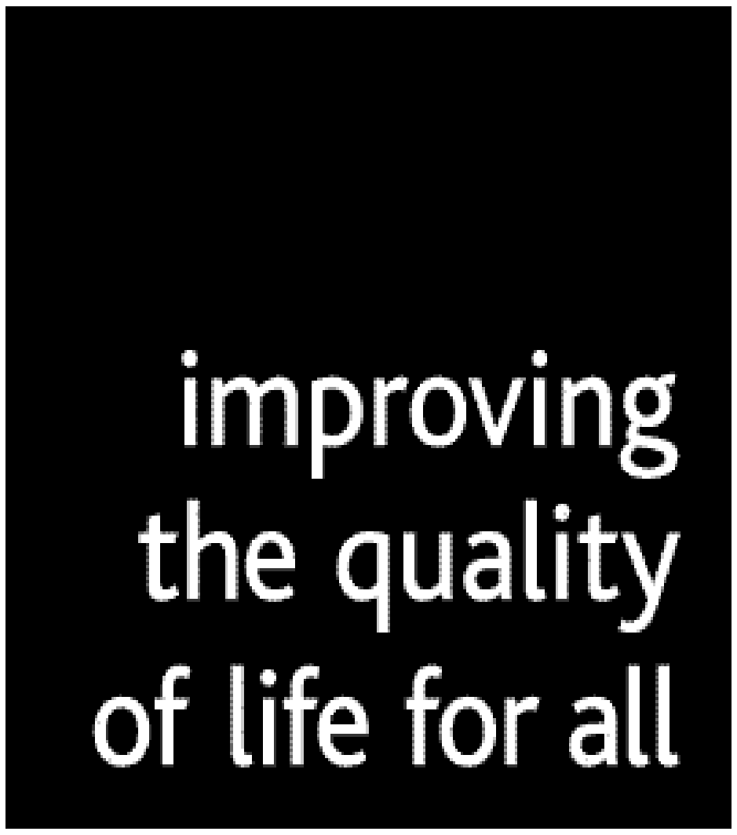

DEPARTMENT FOR CULTURE, MEDIA AND SPORT

QUARTERLY INFORMATION

GIFTS GIVEN OVER £140

Secretary of State, Rt Hon Maria Miller MP (to 8 April)
Date gift given | To | Gift | Value
Nil return
Secretary of State, Rt Hon Sajid Javid MP (from 9 April)
Date gift given | To | Gift | Value
Nil return
Minister for Sport and Tourism, Helen Grant MP
Date gift given | To | Gift |  | Value
Nil return
Minister for Culture and the Digital Economy, Ed Vaizey MP
Date gift given | To | Gift |  | Value
Nil return

GIFTS RECEIVED OVER £140

Secretary of State, Rt Hon Maria Miller MP (to 8 April)
Date gift received | From | Gift | Value | Outcome
Nil return
Secretary of State, Rt Hon Sajid Javid MP (from 9 April)
Date gift received | From | Gift | Value | Outcome
Nil return
Minister for Sport, Tourism and Equalities, Helen Grant MP
Date gift received | From | Gift | Value | Outcome
Nil return
Minister for Culture and the Digital Economy, Ed Vaizey MP
Date gift received | From | Gift | Value | Outcome
Nil return

HOSPITALITY

Secretary of State, Rt Hon Maria Miller MP (to 8 April)
Date | Name of Organisation | Type of Hospitality Received (include an asterisk against the entry if accompanied by spouse/partner or other family member or friend)
Nil return
Secretary of State, Rt Hon Sajid Javid MP (from 9 April)
Date | Name of Organisation | Type of Hospitality Received
23 April 2014 | Shakespeare’s Globe | 4 tickets to Hamlet*
6 May 2014 | Beaumont Partners | 2 tickets to Haydn’s Creation by Orchestra of Age of Enlightenment *
9 May 2014 | Asian Business Awards - Midlands | Dinner and gave speech
15 May 2014 | The Young Vic | 2 tickets to A view from the bridge*
17 May 2014 | The FA | 2 tickets FA Cup Final*
20 May 2014 | Richmond Theatre | 2 tickets Things we do for love*
27 May 2014 | Birmingham Rep | 4 tickets Khandan*
30 May 2014 | London Contemporary Music Festival | 2 tickets gala dinner*
3 June 2014 | Associated Media and Daily Mail, Viscount Rothermere and Paul Dacre | Dinner
6 June 2014 | The Executive Jungle | Lunch and gave speech
11 June 2014 | The Times, John Witherow | Breakfast
11 June 2014 | The Old Vic | 2 tickets to Clarence Darrow
15 June 2014 | English National Ballet | 2 tickets to Romeo and Juliet in the round
21 June 2014 | Global | 6 tickets Capital FM summertime Ball*
23 June 2014 | FIFA | Ticket to FIFA World Cup group match Brazil v Cameroon
24 June 2014 | FIFA | Ticket to FIFA World cup group match Costa Rica v England
28 June 2014 | PRS for Music | 2 tickets and 2 nights’ accommodation at Glastonbury*
Minister for Sport, Tourism and Equalities, Helen Grant MP
Date | Name of Organisation | Type of Hospitality Received
10 April 2014 | Kent Football Association | Ticket to Kent Women’s Cup Final *
17 May 2014 | Football Association | Ticket to FA Cup Final plus hospitality *
07 June 2014 | British Horseracing Authority | Ticket plus hospitality at Epsom Derby *
09 June 2014 | Queen’s Club | Ticket to opening day’s play at Aegon Championships *
18 June 2014 | FIFA | Ticket 2nd Group match FIFA World Cup – England v Uruguay
Minister for Culture and the Digital Economy, Ed Vaizey MP
Date | Name of Organisation | Type of Hospitality Received
01 April 2014 | Academy of St Martin in the Fields | 1 ticket to Sir Neville Mariner’s 90th Birthday Concert
02 April 2014 | Barbican | 1 ticket to English National Ballet ‘Lest we Forget’
03 April 2014 | Professor Khalili, | Lunch
13 April 2014 | Mastercard | 1 ticket Olivier Awards
01 May 2014 | Chickenshed Kensington and Chelsea Theatre | 1 ticket Chickenshed Kensington and Chelsea Summer Show and Dinner
08 May 2014 | BFI | Lunch
12 May 2014 | The Young Vic | 1 ticket to A view from the bridge
02 06 14 | The Globe Theatre | 1 ticket ‘A Midsummer Night’s Dream’
04 June 2014 | Royal Academy | 1 ticket Royal Academy Summer Exhibition 2014 Committee and dinner
12 June 2014 | The Coliseum Theatre | 1 ticket Terry Gilliam’s ‘Benvenuto Cellini’
15 June 2014 | Bloomberg Technology | Dinner – Bloomberg Technology Summit Dinner
17 June 2014 | Centre for Policy Studies | Dinner
25 June 2014 | BP | 1 ticket BP Portrait Award
25 June 2014 | ITV, Adam Crozier,  Archie Norman | 1 ticket ITV Summer Reception

OVERSEAS TRAVEL

Date(s) of trip | Destination | Purpose of trip | ‘No 32 (The Royal) Squadron’ or ‘other RAF’ or ‘Charter’ or ‘Eurostar’ | Number of officials accompanying Minister, where non-scheduled travel is used | Total cost including travel, and accommodation of Minister only  *indicates if accompanied by spouse/partner or other family member or friend
Secretary of State, Rt Hon Maria Miller MP (to 8 April)
Nil return
Secretary of State, Rt Hon Sajid Javid MP (from 9 April)
22 June to 27 June 2014 | Brazil | Attend FIFA World Cup alongside a programme of events to promote UK business, tourism and our preparations for the 2016 Rio Olympics and Paralympics, including meetings with UK and Brazilian business leaders, Brazilian tourism representatives and Brazilian students. | Scheduled | N/A | £8,110
Minister for Sport, Tourism and Equalities, Helen Grant MP
11 to 13 May 2014 | Malaysia | Tourism conference | Scheduled | n/a | £3,000
2 to 3 June 2014 | Malta | Institute of Travel and Tourism international conference | Scheduled | n/a | £517
18 to 20 June 2014 | Brazil | England World Cup Group Game; secondary activities in ministerial capacity | Scheduled | n/a | £4,368
Minister for Culture and the Digital Economy, Ed Vaizey MP
04 April 2014 | France | Culture Ministers’ working group | Eurostar | n/a | £204.00
22 to 24 April 2014 | China via Zurich | People 2 People Dialogue | Scheduled | n/a | £473.00
21 May 2014 | Brussels | Education, Youth, Culture and Sport Council | Scheduled and Eurostar | n/a | £184.80
06 June 2014 | Luxembourg | Ministerial Telecoms Council | Scheduled | n/a | £408.40

MEETINGS WITH EXTERNAL ORGANISATIONS (INCLUDING MEETINGS WITH NEWSPAPER AND OTHER MEDIA PROPRIETORS, EDITORS AND SENIOR EXECUTIVES)
Secretary of State, Rt Hon Maria Miller MP (to 8 April)
Date of Meeting | Name of Organisation | Purpose of Meeting
2 April 2014 | Hay Group | To discuss the Contestable Policy Fund Talent Project
Secretary of State, Rt Hon Sajid Javid MP (from 9 April)
Date of Meeting | Name of Organisation | Purpose of Meeting
29 April 2014 | BBC | Introductory meeting
7 May 2014 | BskyB, Jeremy Darroch | Introductory meeting
8 May 2014 | Michael Burleigh | Meeting to discuss First World War Centenary
13 May 2014 | BBC Trust, Diane Coyle | Introductory meeting
14 May 2014 | BT | Introductory meeting
14 May 2014 | BBC, Lord Hall | To discuss current projects
19 May 2014 | Talk Talk | To discuss ultrafast broadband
19 May 2014 | EE | Introductory meeting
20 May 2014 | Visit England | Introductory meeting
20 May 2014 | 14-18NOW | Introductory meeting
2 June 2014 | Telegraph, Lord Black | Introductory meeting
3 June 2014 | IPO, BPI, MPAA, BT Group, Virgin Media, TalkTalk Group, BskyB | To discuss VCAP
3 June 2014 | Pinewood Studios | To discuss current projects
3 June 2014 | Channel 4, David Abraham, Lord Burns | Introductory meeting
3 June 2014 | Stonewall | Introductory meeting
3 June 2014 | ITV, Adam Crozier, Archie Norman | Introductory meeting
3 June 2014 | Facebook & Creative Industries Council | Introductory meeting
4 June 2014 | Virgin Media | Introductory meeting
4 June 2014 | Donmar Theatre  RSC  Southbank Centre  Knowle West Media Centre  Roundhouse  Michael Grandage Co  Manchester International Festival  Royal Liverpool Philharmonic  Sadler’s Wells  Nottingham Contemporary  Bristol Old Vic  Arts Council England | Roundtable to discuss status of arts in the UK
5 June 2014 | Vodafone | Introductory meeting
5 June 2014 | Three | Introductory meeting
11 June 2014 | Arqiva | Introductory meeting
17 June 2014 | First World War Advisory Group | To discuss First World War commemorations
19 June 2014 | First World War Advisory Group | To discuss First World War commemorations
19 June 2014 | Quillam Foundation | To discuss arts, sports and culture and challenging extremism
30 June 2014 | Stonewall  The Lesbian and Gay Foundation  LGBT Consortium  Gendered Intelligence  GIRES  Camden LGB&T Forum | LGBT roundtable
30 June 2014 | Hacked off | Introductory meeting
Minister for Sport, Tourism and Equalities, Helen Grant MP
Date of Meeting | Name of Organisation | Purpose of Meeting
01 April 2014 | The Football Association | To discuss football governance
01 April 2014 | Lord Faulkner  Football Conference  Commonwealth War Graves Commission | To discuss various WWI and sporting issues
07 April 2014 | Football League  Premier League | To discuss 3G pitches
07 April 2014 | Nike | To discuss “Designed to Move” initiative
08 April 2014 | Inspired Gaming  SG Gaming | To discuss player protection
09 April 2014 | Women in Sport Advisory Board  England and Wales Cricket Board  BT Sport  Newton Investment Management  Judy Murray  BBC | To discuss sport and the media
09 April 2014 | Youth Sport Trust (YST) | To be updated on YST’s recent initiatives
10 April 2014 | Lawrence Dallaglio Foundation | To discuss sports-specific initiatives
28 April 2014 | Football Conference | To discuss 3G pitches
28 April 2014 | British Hospitality Association  Whitbread Hotels & Restaurants  Accor  BaxterStorey  Marriott UK & Ireland  Yo! Sushi  DND London | Roundtable to discuss job creation for young people in the hospitality sector
01 May 2014 | British Horseracing Association | To discuss Horserace Betting Levy
06 May 2014 | Horserace Betting Levy Board | To discuss Horserace Betting Levy
06 May 2014 | British Association of Leisure Parks, Piers and Attractions | To discuss Category D Gaming machines
06 May 2014 | Tony Kelly | To discuss football supporters’ initiative
06 May 2014 | Women’s Sport and Fitness Foundation | To discuss women in sport
07 May 2014 | Limelight Sports | To discuss sports participation
07 May 2014 | Marketing Birmingham  Destination Bristol  Bath Tourism Plus  Visit Cambridge  Leeds and Partners  Visit York  Liverpool City Region LEP  Marketing Manchester  Newcastle Gateshead Initiative  Birmingham Airport  Bristol Airport  Cambridge International Airport  Leeds-Bradford Airport  Liverpool John Lennon Airport  Manchester Airport Group  Newcastle International Airport | Roundtable to discuss regional growth opportunities
07 May 2014 | Responsible Gambling Association  Association of British Bookmakers | To discuss future of Horse Race Betting Levy
14 May 2014 | Muslim Women Sports Foundation | To discuss inclusion and diversity in sport
15 May 2014 | British Judo | To discuss judo initiatives
15 May 2014 | Ticketmaster | To discuss secondary ticketing issues
15 May 2014 | 21st Century Legacy Ltd | To discuss initiative focusing on helping young people to achieve their potential
15 May 2014 | Odgers Berndtson  Travelzoo (Europe)  Odeon/UCI Cinemas  Fuller’s Brewery  Nandos  Capricorn Associates  Odigeo  Domino’s Pizza Group  British Airways  Travelport  Virgin Airways | Roundtable to discuss tourism and hospitality sector
20 May 2014 | Institute of Travel and Tourism | Pre-brief meeting in advance of ITT international conference
20 May 2014 | Football League | To discuss 3G pitches
20 May 2014 | Football Association  Rugby Football Union  Amateur Swimming Association  British Swimming  England Squash and Racketball  England Netball  British Cycling | Roundtable to discuss sport for development and women in sport
04 June 2014 | Streetgames | To discuss girls’ sport participation
03 June 2014 | Association of British Travel Agents | To discuss outbound tourism
11 June 2014 | UK Athletics | To discuss Paralympics sports sector
12 June 2014 | Football Association | To discuss grassroots and women’s football
18 June 2014 | International Sport and Culture Association (ISCA)  Institute of Sports and Education (IEE), Brazil  Sao Paulo State Government | To discuss long-term Anglo-Brazilian partnership in sports sector
23 June 2014 | Sheppey Rugby Club | To discuss community-level sports development
23 June 2014 | Equality and Diversity Forum | To discuss ongoing equalities issues
23 June 2014 | Sport Wales | Introductory meeting to discuss sporting issues affecting both national and devolved administrations
23 June 2014 | Football League | To discuss 3G pitches
23 June 2014 | Hilton International | To discuss tourism.
24 June 2014 | Special Olympics | To discuss forthcoming Special Olympics events
24 June 2014 | Sporting Equals | To discuss diversity issues in sport
24 June 2014 | Greenhouse | To discuss charity’s initiatives in developing youth sport
24 June 2014 | Camelot | To discuss National Lottery Developments
Minister for Culture and the Digital Economy, Ed Vaizey MP
Date of Meeting | Name of organisation | Purpose of meeting
01 April 2014 | Southbank Centre | To discuss the redevelopment of the skate park
03 April 2014 | Farrells | To discuss the Farrell Review
07 April 2014 | Manchester Metropolitan University  Dr Sarah Houston, independent dance consultant  South East Arts and Health Partnership  Public Health England  British Association of Art Therapists  Reflections  Art Lift  Chelsea and Westminster Health Charity  Paintings in Hospital  Music in Hospitals  Arts Council England  Y Touring  Centre for Medical Humanities, Durham University  We do Creativity  Arts and Health East  Nottingham University  University of West England | Roundtable to discuss the relationship between culture and public health policy
08 April 2014 | UK Music | To discuss diversity in music
08 April 2014 | EE | To discuss Mobile Infrastructure Project
09 April 2014 | Digital Radio UK | To discuss current projects
09 April 2014 | British Art Market Federation | To discuss current projects
10 April 2014 | Youth Dance England  King’s Cultural Institute | To discuss developing excellence in young artists
14 April 14 | Edelman | To discuss a new industry led creative industries strategy
28 April 2014 | CREATE | To discuss the strategy and mandate of CREATE
28 April 2014 | Society of Chief Librarians | To discuss current projects
29 April 2014 | Moby Group | To discuss Afghanistan’s media industry
01 May 2014 | BT Openreach | Introductory meeting
06 May 2014 | Crafts Council | To discuss current projects
06 May 2014 | Platform | To discuss the gaming industry in Hull and Humber
06 May 2014 | Coram  Foundling  The Art Fund  Charity Commission | To review progress on membership and approval for changes to Foundling museum
07 May 2014 | Baroness Benjamin,  Channel 4, Baroness Oona King  Baroness Bonham-Carter,  Sara Hanson, Creative Diversity Network  Victory TV  Lenny Henry  Krishnan Guru Murphy  Pact  ITV, Robin Elias  BBC | To discuss diversity in film, television and the media
08 May 2014 | National Youth Theatre | To discuss NYT’s call to establish regional youth REP companies
08 May 2014 | UKTV | To view their offices and discuss their current work
08 May 2014 | Disney | To view their offices, discuss Disney’s work in the UK and copyright reform
08 May 2014 | Virgin Media | To view their offices and discuss current work
12 May 2014 | EE | To discuss Mobile Infrastructure project
14 May 2014 | BT | Introductory meeting
14 May 2014 | Garden Bridge Trust | To discuss the Garden Bridge Project
15 May 2014 | Natural Generation  PBWC Architects  Clear Flow  UKNetWeb | To discuss Superfast broadband in Cornwall
03 June 2014 | Berkeley Group  HBF  Lend Lease  Bloor Homes  Barratt  Crest Nicholson  Taylor Wimpey  Persimmon Homes  Bovis Homes | To discuss broadband in new developments
03 June 14 | IPO  BPI  MPAA  BT Group  Virgin Media  TalkTalk Group  BskyB | To discuss VCAP
03 June 2014 | Pinewood Studios | To discuss current projects
03 June 14 | Channel 4, David Abraham Lord Burns | Attended introductory meeting with SoS
03 June 2014 | Strategic Board of the Edinburgh Culture Summit | To discuss the Edinburgh Culture Summit
03 June 2014 | UKIE | To discuss next steps for the industry
03 June 2014 | ITV, Adam Crozier, Archie Norman | Attended introductory meeting with SoS
09 June 2014 | Baroness Bonham Carter,  BBC  ITV  BskyB  Channel 4 | To discuss diversity in film, media and television
09 June 2014 | ICANN | To discuss the High Level Governmental Meeting and outcome
09 June 2014 | BT | To discuss current projects
 | The Art Fund  Heritage Lottery Fund  Pension Protection Fund  Wedgwood Museum | To discuss the Wedgwood collection
11 June 2014 | BSA The Software Alliance | To discuss UK copyright laws
16 June 2014 | English Heritage  Visit England  Creative England  Arts Council England  Humber LEP  West of England LEP | To discuss strategic economic plans
16 June 2014 | Into Film | To discuss current projects
16 June 2014 | London Live | To discuss diversity
17 June 2014 | National Museums Liverpool | To discuss current projects
17 June 2014 | Design Council, Cabe | To discuss the Farrell review
18 June 2014 | Kennedy Centre | To discuss private philanthropy in England.
18 June 2014 | Rutland County Council | To discuss broadband in Rutland
19 June 2014 | BT | To see their sports studio
19 June 2014 | Newham Music Hub | To see the hub
24 June 2014 | SBTV | To discuss film and diversity
25 June 2014 | Amazon | To discuss current projects
25 June 2014 | Creative Access | To discuss current projects
25 June 2014 | Qatari Diar | To discuss current projects
25 June 2014 | EE | To discuss Mobile Infrastructure Project
26 June 2014 | Arqiva | To discuss Mobile Infrastructure Project
26 June 2014 | Telefonica | To discuss Mobile Infrastructure Project
26 June 2014 | Digital Radio UK | To discuss current projects
30 June 2014 | Yahoo | To discuss child safety online

Does not normally include attendance at functions hosted by HM Government; ‘diplomatic’ functions in the UK or abroad, hosted by overseas governments; minor refreshments at meetings, receptions, conferences, and seminars; and offers of hospitality which were declined. *indicates if accompanied by spouse/partner or other family member or friend.
Does not normally include meetings with Government bodies such as other Government Departments and Agencies, NDPB’s, Non-Ministerial Departments, Agencies, Government reviews and representatives of Parliament, devolved or foreign governments.

