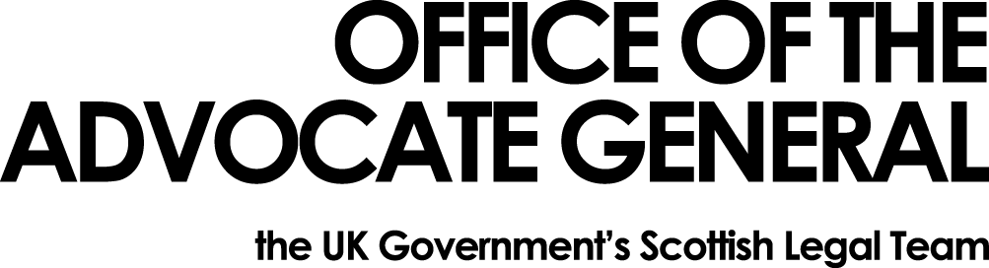
Dear [REDACTED] | Office of the Advocate General  Area G-G  Victoria Quay  Edinburgh  EH6 6QQ  Date: 19/06/2013
FREEDOM OF INFORMATION REQUEST

Thank you for your email sent on 14 May 2013.

You asked for the following information under the Freedom of Information Act 2000:

- Please specify the total amount your organisation spent on ICT products in 2010, 2011 and 2012. For the purposes of our study, ICT products include, but are not limited to: computers, screens, keyboards, laptops, printers, mobile phones, iPads and other tablets. If possible, please split this response by product, otherwise please give total annual spends for 2010, 2011 and 2012.
- Who are your 5 biggest ICT suppliers in the last 3 years and what proportion of your spend went to each supplier?
- Do you have an ethical procurement policy that deals with labour rights issues, ideally solely or as part of a broader policy? Please provide a URL link or attachment with the policy.
- Do you have staff with ethical or sustainable procurement expertise employed internally – we'd particularly like to know about whether you have a Procurement Manager with this remit, or a Sustainability Manager. What is/are their name/s and email address(es)?
- Does your organisation procure its own ICT products? If so what proportion of your spend in the last 3 years was done through setting up your own ICT contracts with suppliers?
- Does your organisation procure ICT products through a purchasing consortium. If so which is it/are they? If so what proportion of your spend in the last 3 years was done through this purchasing consortium?
- Do you procure ICT products by using framework contracts you share with others. If so what proportion of your spend in the last 3 years was done through framework contracts? Which contract did you use?
- If your process of ordering ICT products is through central government purchases, what proportion of your spend in the last 3 years was done through central government procurement? Which contract did you use?

I am writing to confirm that the Office of the Advocate General has now completed its search for information.

I have provided the information you have requested, in the attached annex.

FOIA request - ethical ICT procurement strategies
 | Question |  | Answer
1 | Please specify the total amount your organisation spent on ICT products in 2010, 2011 and 2012. For the purposes of our study, ICT products include, but are not limited to: computers, screens, keyboards, laptops, printers, mobile phones, iPads and other tablets. If possible, please split this response by product, otherwise please give total annual spends for 2010, 2011 and 2012.
 |  |  | Total amount spent in financial year 2010-11 was £169.15
 |  |  | Mobile phones - amount spent:£58.75
 |  |  | Monitors - amount spent £110.40
 |  |  | Total amount spent in 2011-12 was £1137.60
 |  |  | Mobile phones -amount spent £300
 |  |  | Laptop – amount spent £837.60
 |  |  | Total amount spent in financial year 2012-13 was £5361.40
 |  |  | Monitors £480
 |  |  | Laptops £4881.40
2 | Who are your 5 biggest ICT suppliers in the last 3 years and what proportion of your spend went to each supplier? |  | OAGs information technology is provided by the Scottish Government.
3 | Do you have an ethical procurement policy that deals with labour rights issues, ideally solely or as part of a broader policy? Please provide a URL link or attachment with the policy. |  | OAG’s information technology is provided by the Scottish Government.
4 | Do you have staff with ethical or sustainable procurement expertise employed internally – we'd particularly like to know about whether you have a Procurement Manager with this remit, or a Sustainability Manager. What is/are their name/s and email address(es)? |  | OAG’s information technology is provided by the Scottish Government.
5 | Does your organisation procure its own ICT products? If so what proportion of your spend in the last 3 years was done through setting up your own ICT contracts with suppliers? |  | No
6 | Or does your organisation procure ICT products through a purchasing consortium. If so which is it/are they? If so what proportion of your spend in the last 3 years was done through this purchasing consortium? |  | No
7 | Or do you procure ICT products by using framework contracts you share with others. If so what proportion of your spend in the last 3 years was done through framework contracts? Which contract did you use? |  | No
8 | If your process of ordering ICT products is through central government purchases, what proportion of your spend in the last 3 years was done through central government procurement? Which contract did you use? |  | All spending on IT equipment is always done through the Central Government Framework contract for ICT products.

If you are dissatisfied with the treatment of your request, you can ask OAG to conduct an internal review of its decision. The internal review will be conducted by someone other than the person who took the initial decision. Requests for internal review should be addressed to the Information Officer, Office of the Solicitor to the Advocate General, Victoria Quay, Edinburgh, EH6 6QQ.

If you remain dissatisfied with how your request has been handled by OAG following its internal review, you can complain to the Information Commissioner's Office. Details of the complaints procedure can be found here - http://www.ico.gov.uk/complaints/freedom_of_information.aspx or by writing to Information Commissioner's Office, Wycliffe House, Water Lane, Wilmslow, SK9 5AF.

Yours sincerely

[REDACTED]

