Creative Industries Economic Estimates
January 2014
Statistical Release
Date: 14/01/2014

The Creative Industries Economic Estimates are Official Statistics and have been produced to the standards set out in the Code of Practice for Official Statistics

Contents

Chapter 1: Introduction 4
Chapter 2: Key Findings 7
Chapter 3: Employment (2011-2012) 8
Employment in the Creative Economy 8
Employment in the Creative Industries 13
Chapter 4: Gross Value Added (2008 – 2012) 15
Chapter 5: Exports of Services (2009 – 2011) 21
Annex A – Creative Occupations 25
Annex B – Creative Industries 26
Annex C – Computer Games 28
Background Information 28
Glossary 34

- Introduction

These Creative Industries Economic Estimates are Official Statistics used to measure the direct economic contribution of the Creative Industries to the UK economy. An analysis of the contribution made by the Creative Industries to UK Employment, Gross Value Added (GVA) and Exports of Services has been provided in this release. The estimates have been produced using ONS National Statistics sources.

The Creative Industries were defined in the Government’s 2001 Creative Industries Mapping Document as “those industries which have their origin in individual creativity, skill and talent and which have a potential for wealth and job creation through the generation and exploitation of intellectual property”.

This release retains that definition, but uses a new methodology for determining which occupation and industry codes (in Annex A and Annex B) are classified as “creative”. This methodology makes use of a robust finding from research that having high levels of “creative intensity” – that is, the proportion of the workforce in creative occupations – separates the Creative Industries from other industries. Therefore these estimates should not be compared with estimates published in previous releases.

The methodology comprises three steps. First, a set of occupations are identified as creative. Second, creative intensity is calculated for all industries in the economy. Third, all industries with a creative intensity above a certain “threshold” are classified as Creative Industries.

Uncertainties in the data mean that it is particularly important to review industries with creative intensities around the threshold level, so that the final classification has also drawn on feedback gathered from users through consultation.

The consultation process, from which the final classification was agreed, was supported by a cross-industry collaboration overseen by the Creative Industries Council, Creative Skillset, Creative and Cultural Skills, Nesta, DCMS and a range of industry bodies.

Data sources

This release has been based on ONS data sources which use the latest occupational classification (SOC 2010) and the latest industrial classification (SIC 2007). DCMS is working with ONS on developing longer time series which span periods that use earlier classifications, which will enable historical analysis. At present, consistent data are available for these data sources for the time periods outlined below:

- Employment data for this release are taken from the Annual Population Survey (APS) for 2011 and 2012. The updated occupational coding standard (SOC 2010) was introduced to the APS in the 2011 data.

- GVA data are taken from the Annual Business Survey (ABS) for the years from 2008 to 2012 inclusive. The ABS introduced the latest industrial classification (SIC 2007) in the 2008 data.

- Exports of Services data taken are from the International Trade in Services (ITIS) survey from 2009 to 2011 inclusive. The latest industrial classification (SIC 2007) was introduced in 2009.

Terminology

Throughout the report symbols have been used to indicate whether the analysis refers to:

- The Creative Economy, which includes the contribution of those who are in creative occupations outside the creative industries as well as all those employed in the Creative Industries.

- The Creative Industries, a subset of the Creative Economy which includes only those working in the Creative Industries themselves (and who may either be in creative occupations or in other roles e.g. finance).

Creative Economy:

Creative Industries:

Statistics on Employment are provided on both bases as the data source (APS) allows this. GVA and Exports of Services are provided on a Creative Industries basis only as sources for these data are collected on an industry basis only.

Groups

To provide more detail, this release breaks down the creative sector into groups. Three groupings – by industries (SIC 2007), by occupations (SOC 2010), and by industry and occupations.

Advertising and marketing has been used as an example.

- Creative Industries groups (Annex A) attempt to consider related industries, insofar as this is permitted by the industrial classification.
Creative Industries Group | SIC 2007 | Description
Advertising and marketing | 70.21 | Public relations and communication activities
 | 73.11 | Advertising agencies
 | 73.12 | Media representation

- Creative Occupations groups (Annex B) attempt to consider related occupations, insofar as this is permitted by the occupational classification.
Creative Occupations Group | SOC 2010 | Description
Advertising and marketing | 1132 | Marketing and sales directors
 | 1134 | Advertising and public relations directors
 | 2472 | Public relations professionals
 | 2473 | Advertising accounts managers and creative directors
 | 3543 | Marketing associate professionals

- Creative Economy groups combine both of the above classifications under the same headings so that the contribution of a creative sector across the whole economy can be measured (i.e. across all elements of the “Creative Trident” described in Chapter 3).
 | Creative Industries group | Creative Occupations group
Creative Economy group:  Advertising and marketing | SIC 2007 | SOC 2010
 | 70.21 | 1132
 | 73.11 | 1134
 | 73.12 | 2472
 |  | 2473
 |  | 3543

- Key Findings

Data for three key areas of economic contribution are presented; Employment, GVA and Exports of Services.

Creative Economy Employment (2011 – 2012)

- The Creative Economy accounted for 2.55 million jobs in 2012, or 1 out of every 12 jobs in the UK.
- IT, software and computer services was the largest Creative Economy group, with employment of 791 thousand in 2012 (31% of employment in the Creative Economy).
- Employment within the Creative Economy grew by 143 thousand (6.0%) between 2011 and 2012, a higher rate than for the UK Economy as a whole (0.7%).
Creative Industries Employment (2011 – 2012)

- The Creative Industries accounted for 1.68 million jobs in 2012, 5.6 per cent of the total number of jobs in the UK.
- Employment in the Creative Industries increased by 8.6 per cent between 2011 and 2012, a higher rate than for the UK Economy as a whole (0.7%).

Gross Value Added (GVA) (2008 – 2012)

Gross Value Added (GVA) is measured in current prices (i.e. they do not account for inflation).
- GVA of the Creative Industries was £71.4 billion in 2012 and accounted for 5.2 per cent of the UK Economy.
- GVA of the Creative Industries has increased by 15.6 per cent since 2008, compared with an increase of 5.4 per cent for the UK Economy as a whole.
- GVA of the Creative Industries increased by 9.4 per cent between 2011 and 2012, higher than for any Blue Book industry sector in the National Accounts.
Exports of Services (2009 – 2011)

Exports of Services are measured in current prices (i.e. they do not account for inflation).
- The value of services exported by the Creative Industries was £15.5 billion in 2011, 8.0 per cent of total UK service exports.
- Between 2009 and 2011 the value of service exports from the Creative Industries increased by 16.1 per cent. This compares with an increase of 11.5 per cent for total UK service exports.

Chapter 3: Employment (2011 – 2012)
Employment data are taken from the Annual Population Survey (APS) for 2011 and 2012. Data for earlier years are constructed using different Standard Occupational Classification (SOC) codes and are, therefore, not comparable.
Employment figures are calculated using APS data and are the number of jobs plus the number of second jobs. Full time and part time jobs count equally and have not been converted into full time equivalents.

Employment in the Creative Economy
Employment in the Creative Economy is measured on the “Creative Trident” basis using data from the Annual Population Survey (APS). The Trident basis looks at:

- Jobs in the Creative Industries not classified as creative
- Creative Jobs in the Creative Industries
- Creative Jobs outside the Creative Industries (“embedded” jobs)
Creative Economy = 1+2+3
Creative Industries = 1+2
Figure 1: The Creative Economy, 2012

866,000 jobs
796,000 jobs
1
3
2

888,000 jobs

Source: ONS APS 2012
Key findings
In 2012, there were 2.55 million jobs in the Creative Economy. This means that the Creative Economy accounted for 1 out of every 12 jobs in the UK (30.15 million).
1.68 million of these jobs were in the Creative Industries themselves (a full list of Creative Industries can be found in Annex B), with the remaining 0.87 million jobs outside the Creative Industries.
These 0.87 million creative jobs outside of the Creative Industries include, for example, someone working in an advertising role in a financial institution.
Employment within the Creative Economy grew by 143 thousand (6.0%) between 2011 and 2012, a higher rate than for the UK Economy as a whole (0.7%).

Table 1: Employment in the Creative Economy in 2012
Creative Economy Group | "Support" jobs in the Creative Industries | Creative Jobs in Creative Industries | Creative Jobs outside of the Creative Industries | Employment in the Creative Economy
Advertising and marketing | 68,000 | 75,000 | 322,000 | 465,000
Architecture | 34,000 | 55,000 | 30,000 | 120,000
Crafts | 4,000 | 3,000 | 95,000 | 102,000
Design: product, graphic and fashion design | 43,000 | 73,000 | 50,000 | 166,000
Film, TV, video, radio and photography | 92,000 | 146,000 | 28,000 | 266,000
IT, software and computer services | 316,000 | 242,000 | 233,000 | 791,000
Publishing | 104,000 | 119,000 | 32,000 | 255,000
Museums, galleries and libraries | 68,000 | 18,000 | 22,000 | 108,000
Music, performing and visual arts | 66,000 | 158,000 | 53,000 | 277,000
Total Jobs | 796,000 | 888,000 | 866,000 | 2,550,000
Wider UK Economy Total | - | - | - | 30,150,000
Percentage Share of UK Total |  |  |  | 8.5%
Notes
1. Source, ONS Annual Population Survey 2012
2. Figures have been rounded to the nearest thousand, and therefore estimates may not sum across rows or columns to equal totals

Total employment in the Creative Economy (employment within the Creative Industries plus creative jobs in other industries) was 2.55 million in 2012. This included 1.68 million jobs in the Creative Industries as well as 0.87 million creative jobs in other industries.
The Creative Economy had employment of 2.41 million jobs in 2011, meaning that there was an increase of 143 thousand jobs (6.0%) in the Creative Economy between 2011 and 2012. This percentage increase was greater than the 0.7 per cent increase in the number of jobs in the wider UK Economy.
The increase in employment in the Creative Economy has been driven by an increase from within the Creative Industries themselves, where there has been an increase of 133 thousand jobs between 2011 and 2012.
Estimates by Creative Economy Group
IT, software and computer services was the largest of the groups covered, with creative employment of 791 thousand in 2012. This was an increase of 82 thousand jobs (11.6%) on the previous year. Of the 791 thousand jobs in this group, 558 thousand were within the Creative Industries, with the remaining 233 thousand working in IT, software and computer services occupations outside of the Creative Industries.
Music, performing and visual arts had the highest proportion of self-employed jobs. More than 7 out every 10 jobs in this group were self-employed. In total (self-employed and employees), there were 277 thousand jobs in this group in 2012, of which 224 thousand were in the Creative Industries.
Advertising and marketing had the largest number of creative workers employed outside of the Creative Industries in 2012 (322,000). 69.2 per cent of all creative employment in Advertising and marketing was outside of the Creative Industries.
Film, TV, video, radio and photography was the group which had the largest percentage increase in employment in the Creative Economy between 2011 and 2012 (14.9% or 34,000 jobs). There have been no significant decreases in employment between 2011 and 2012 for any Creative Economy group.

Table 2: Employment in the Creative Economy (2011 – 2012)
*Changes in bold indicate a statistically significant change.
 | Employment in the Creative Economy 2011 | Employment in the Creative Economy 2012 | Difference | Percentage Difference
Advertising and marketing | 468,000 | 465,000 | -3,000 | -0.5%
Architecture | 121,000 | 120,000 | -1,000 | -1.0%
Crafts | 104,000 | 102,000 | -2,000 | -1.9%
Design: product, graphic and fashion design | 151,000 | 166,000 | 16,000 | 10.4%
Film, TV, video, radio and photography | 232,000 | 266,000 | 34,000 | 14.9%
IT, software and computer services | 709,000 | 791,000 | 82,000 | 11.6%
Publishing | 236,000 | 255,000 | 19,000 | 8.1%
Museums, galleries and libraries | 113,000 | 108,000 | -5,000 | -4.2%
Music, performing and visual arts | 274,000 | 277,000 | 3,000 | 0.9%
Total Creative | 2,407,000 | 2,550,000 | 143,000 | 6.0%
UK Total Employment | 29,935,000 | 30,150,000 | 215,000 | 0.7%
Percentage Share of UK Total | 8.0% | 8.5% | - | -
Notes
1. Source, ONS Annual Population Survey (2011 & 2012)
2. Figures have been rounded to the nearest thousand, and therefore estimates may not sum across rows or columns to equal totals

Figure 2: Employment in the Creative Economy (2011 – 2012)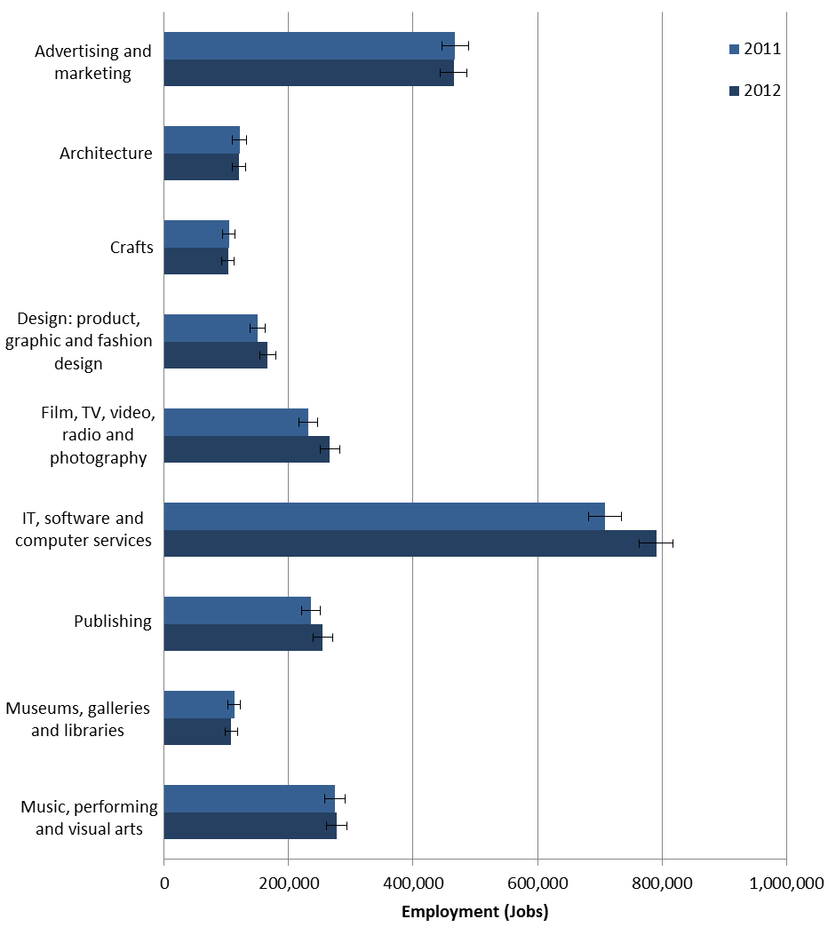
Notes:
1. Source, ONS Annual Population Survey (2011 & 2012)
2. 95% Confidence intervals are shown by the error bars. Where confidence intervals overlap data cannot be reliably compared.

Figure 2 shows the changes in employment across the Creative Economy. The increase in employment in the Creative Economy between 2011 and 2012 was driven by increases in the Film, TV, video, radio and photography; IT, software and computer services; & Publishing groups.

Employment in the Creative Industries
Employment within the Creative Industries (i.e. excluding people working in creative jobs outside the Creative Industries) was 1.68 million in 2012 and accounted for 1 out of every 18 jobs in the UK. The number of jobs in the Creative Industries increased by 8.6 per cent between 2011 and 2012.
Table 3: Employment in the Creative Industries
*Figures in bold represent statistically significant changes

Creative Industries Group | Creative Industries Employment 2011 | Creative Industries Employment 2012 | Percentage Change
Advertising and marketing | 147,000 | 143,000 | -2.8%
Architecture | 93,000 | 89,000 | -4.2%
Crafts | 9,000 | 7,000 | -19.5%
Design: product, graphic and fashion design | 100,000 | 116,000 | 16.2%
Film, TV, video, radio and photography | 209,000 | 238,000 | 13.6%
IT, software and computer services | 482,000 | 558,000 | 15.6%
Publishing | 207,000 | 223,000 | 7.5%
Museums, galleries and libraries | 90,000 | 85,000 | -5.4%
Music, performing and visual arts | 212,000 | 224,000 | 5.6%
Creative Industries Total | 1,551,000 | 1,684,000 | 8.6%
UK Total Employment | 29,935,000 | 30,150,000 | 0.7%
Percentage Share of UK Total | 5.2% | 5.6% | -
Notes:
1. Source, ONS Annual Population Survey (2011 & 2012)
2. Figures have been rounded to the nearest thousand, and therefore totals may not sum
3. Due to limitations in the industry coding, the employment for crafts on an industry basis does not fully cover the crafts sector.

Estimates by Creative Industries Group
The Creative Industries group which had the largest percentage increase in employment between 2011 and 2012 was Design: product, graphic and fashion design, where the number of jobs increased by 16.2 per cent from 100 thousand to 116 thousand.
Between 2011 and 2012, there have also been significant increases in the number of jobs in the IT, software and computer services (15.6% increase) and Film, TV, video, radio and photography (13.6% increase) groups.

Figure 3: Employment in the Creative Industries (2011 – 2012)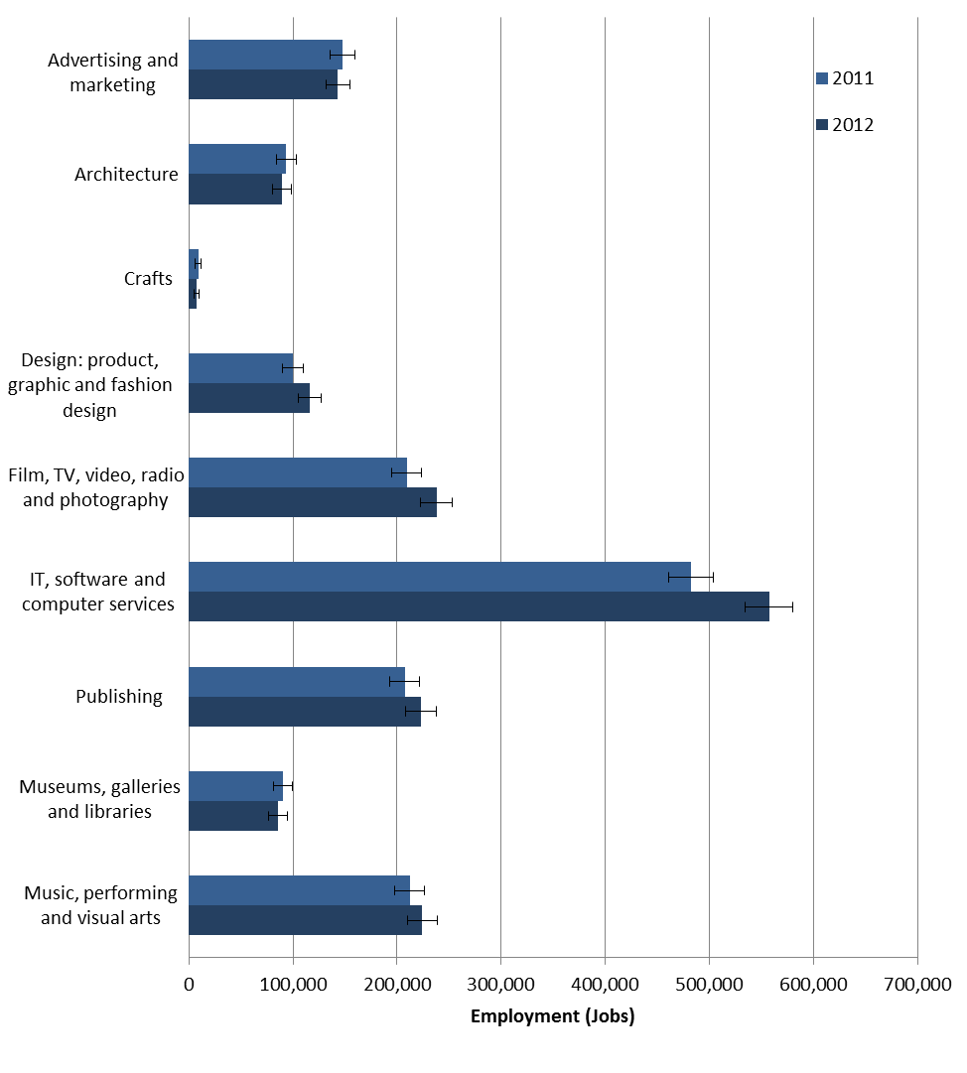
Notes:
1. Source, ONS Annual Population Survey (2011 & 2012)
2. 95% Confidence intervals are shown by the error bars, where confidence intervals overlap data cannot be reliably compared
3. Due to limitations in the industry coding, the employment for crafts on an industry basis does not fully cover the crafts sector.

Chapter 4: Gross Value Added (2008 – 2012)
Gross Value Added (GVA), calculated in current prices (i.e. not accounting for inflation) has been estimated for businesses within the Creative Industries using the Annual Business Survey (ABS). This refers to GVA which is directly attributable to the Creative Industries. To note: A GVA estimate for the wider Creative Economy has not been included, as these economic estimates do not attempt to calculate the GVA contribution of creative jobs outside of the Creative Industries.
Key findings
GVA of the Creative Industries was £71.4 billion in 2012 and accounted for 5.2 per cent of the UK Economy. In 2008, GVA of the Creative Industries was £61.8bn, and accounted for 4.7 per cent of the UK economy.
GVA of the Creative Industries has increased by 15.6 per cent since 2008, compared with an increase of a 5.4 per cent for the UK Economy as a whole.
Creative Industries GVA increased by 9.4 per cent between 2011 and 2012, a higher rate than for any Blue Book Sector. Between 2008 and 2012, only GVA of Real Estate Activities increased by more than that of the Creative Industries (29.3% and 15.6% respectively).
As a proportion of UK GVA, the Creative Industries fell from 4.7 per cent to 4.5 per cent between 2008 and 2010 and then increased to 5.2 per cent in 2012. This reflects the fact that the GVA for the Creative Industries decreased at a higher rate than GVA for the UK as a whole between 2008 and 2009, had a slightly slower recovery than the UK Economy between 2009 and 2010 and then experienced a much stronger recovery than the Economy UK between 2010 and 2012.
GVA for the Creative Industries increased by 9.1 per cent between 2010 and 2011, and by 9.4 per cent between 2011 and 2012. This compares to UK GVA which increased by 2.5 per cent and 1.6 per cent in those years respectively.
Figure 4 shows GVA indexed against GVA in 2009. This allows for straightforward comparison between GVA in the Creative Industries and the wider UK economy. The data have been indexed to 2009 as this was the lowest value for both the Creative Industries and the UK economy in the time period covered (2008 – 2012).

Table 4: GVA of the UK Creative Industries 2008 – 2012.

 | GVA (£ m)
Creative Industries Group | 2008 | 2009 | 2010 | 2011 | 2012
Advertising and marketing | 8,347 | 6,967 | 6,840 | 8,099 | 10,229
Architecture | 3,565 | 3,205 | 2,638 | 3,223 | 3,491
Crafts | 195 | 218 | 268 | 266 | 248
Design: product, graphic and fashion design | 1,856 | 1,886 | 2,049 | 2,504 | 2,491
Film, TV, video, radio and photography | 8,801 | 6,923 | 7,973 | 9,979 | 9,752
IT, software and computer services | 26,018 | 26,403 | 26,991 | 27,939 | 30,904
Publishing | 9,255 | 8,968 | 9,580 | 9,228 | 9,706
Museums, galleries and libraries | - | - | - | - | -
Music, performing and visual arts | 3,740 | 3,779 | 3,434 | 4,039 | 4,574
Total | 61,784 | 58,391 | 59,825 | 65,277 | 71,395
UK Total (ONS Blue Book, ABML) | 1,312,112 | 1,280,261 | 1,327,923 | 1,360,925 | 1,383,082
Percentage share of UK Total | 4.71% | 4.56% | 4.51% | 4.80% | 5.16%

Notes:
1. Source, ONS Annual Business Survey
2. Figures are expressed in current prices (i.e. not accounting for inflation)
3. The ABS does not fully account for GVA of Museums, galleries and libraries (see Annex D) so these data are not shown in this table
4. The ABS does not include data for micro-business so may underestimate GVA, particularly for groups including Music and Crafts where self-employment is substantial.

Figure 4: Changes in GVA indexed to 2009 = 100
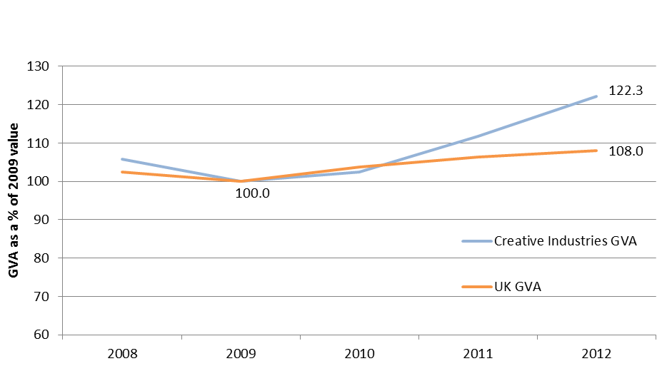
GVA in 2009 = 100
Notes:
1. Source, ONS Annual Business Survey
2. GVA (i.e. current prices, not accounting for inflation) shown as a percentage of GVA in 2009. This shows the different rates of change between the Creative Industries (blue) and the UK Economy as a whole (orange) over the past 5 years

Estimates by Creative Industries Group
GVA of the IT, software and computer services group was £30.9bn in 2012, accounting for 43 per cent of GVA in the Creative Industries as a whole. GVA for this group steadily increased between 2008 and 2011, before rising sharply by 10.6 per cent in 2012.

Table 5: Percentage change in GVA
Creative Industries Group | Percentage Change on Previous Year |  |  |  | Annual Average Increase  (2008-2012)
 | 2009 | 2010 | 2011 | 2012
Advertising and marketing | -16.5% | -1.8% | 18.4% | 26.3% | 6.6%
Architecture | -10.1% | -17.7% | 22.2% | 8.3% | 0.7%
Crafts | 11.8% | 22.9% | -0.7% | -6.8% | 6.8%
Design: product, graphic and fashion design | 1.6% | 8.6% | 22.2% | -0.5% | 8.0%
Film, TV, video, radio and photography | -21.3% | 15.2% | 25.2% | -2.3% | 4.2%
IT, software and computer services | 1.5% | 2.2% | 3.5% | 10.6% | 4.5%
Publishing | -3.1% | 6.8% | -3.7% | 5.2% | 1.3%
Museums, galleries and libraries | - | - | - | - | -
Music, performing and visual arts | 1.0% | -9.1% | 17.6% | 13.2% | 5.7%
Total Creative Industries | -5.5% | 2.5% | 9.1% | 9.4% | 3.9%
UK Total (ONS Blue Book, ABML) | -2.4% | 3.7% | 2.5% | 1.6% | 1.4%
Notes:
1. Source, ONS Annual Business Survey
2. Changes are based on current prices (i.e. not accounting for inflation)
3. ABML is the Blue Book series identifier
4. The ABS does not fully account for GVA of Museums, galleries and libraries (see Annex D) these data have not been shown in this table.

The Advertising and marketing group had the largest increase in GVA between 2011 and 2012 (26.3%). In the two years between 2008 and 2010, GVA for Advertising and marketing fell from £8.3 billion in 2008 to £6.8 billion in 2010. However, between 2010 and 2012 the group recovered to higher than its 2008 level, and by 2012 GVA of this group was £10.2 billion.
GVA for Music, performing and visual arts increased by 17.6 per cent between 2010 and 2011, and by 13.2 per cent between 2011 and 2012. This increase was preceded by a decrease of 9.1 per cent between 2009 and 2010.

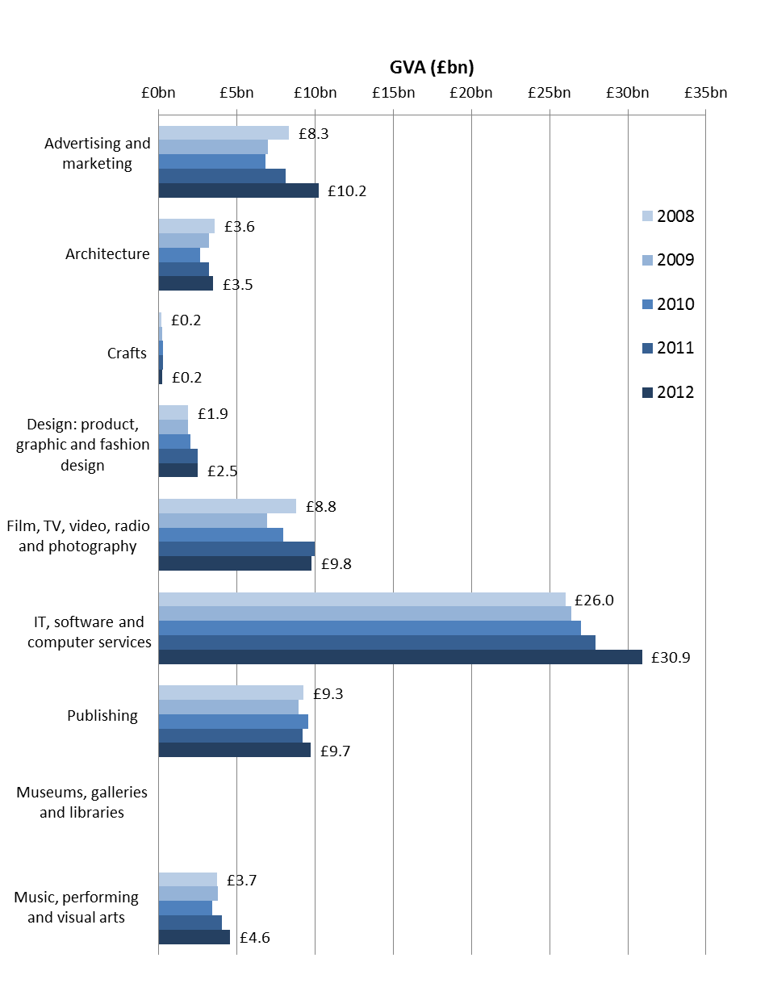
Figure 5: GVA of the Creative Industries

Notes:
1. Source – ONS Annual Business Survey(2012)
2. Current prices (i.e. not accounting for inflation)
3. The ABS does not fully account for GVA of Museums, galleries and libraries (see Annex D) these data have not been shown in this figure.
Comparisons with other Industries
This section compares the Creative Industries to the broad industry sectors in the Blue Book. The Blue Book is the best estimate of national GVA, and the most appropriate comparator. It should be noted that the Creative Industries is not separately identified in the Blue Book itself, and includes economic contributions from across a number of sectors identified in the Blue Book.
GVA of the Creative Industries increased by 15.6 per cent between 2008 and 2012. Real estate activities was the only sector in the Blue Book to have a greater increase over the same period (29.3%).
Furthermore, GVA of the Creative Industries increased by a larger percentage than any of the Blue Book sectors between 2011 and 2012. Between these two years GVA of the Creative Industries increased by 9.4 per cent. Real estate activities had the next highest increase of 7.1 per cent.

Table 6: GVA of the Creative Industries and Blue Book Sectors
Blue Book Sector or Creative Industries | Percentage Change in GVA between 2008 & 2012
Real estate activities | 29.3%
Creative Industries | 15.6%
Other services | 13.3%
Government, health and education | 12.9%
Total professional and support | 8.6%
Information and communication | 5.8%
Distribution, transport, hotels and restaurants | 3.9%
Agriculture, forestry and fishing | -0.4%
Production | -3.4%
Construction | -5.4%
Financial and insurance activities | -12.6%
Wider UK Economy Total | 5.4%
Notes:
1. Source - ONS Blue Book Dataset (2012)
2. Current prices (i.e. not accounting for inflation)

Chapter 5: Exports of Services (2009 – 2011)
Exports of Services are measured using ONS International Trade in Services (ITIS) data. These are based on a survey of just under 15,000 UK businesses, and record the value of the services which businesses export. As for GVA, this section looks at Exports of Services from the Creative Industries themselves and does not consider Exports of Services from the wider Creative Economy. Results are in current prices and do not account for inflation.
Key findings
The value of services exported by the UK Creative Industries was £15.5bn in 2011, an increase of 16.1 per cent since 2009. Over that period, service exports increased by 11.5 per cent for the UK as a whole.
IT, software and computer services accounted for 46.5 per cent of Creative Industry service exports in 2011, up from 43.5 per cent in 2009.
Exports of Services in the Creative Industries were £15.5bn in 2011, an increase of £0.8bn (5.3%) on 2010. This was a smaller increase than for Exports of Services of the UK as a whole, which grew by 6.8 per cent over the same period. Exports of Services between 2009 and 2010, however, increased by 10.2 per cent for the Creative Industries compared to 4.3 per cent for the UK as a whole.
Table 7: Exports of Services for the UK Creative Industries
Creative Industries Group | Exports (£m)
 | 2009 | 2010 | 2011
Advertising and marketing | £2,136 | £1,861 | £2,013
Architecture | £319 | £384 | £362
Crafts | - | - | -
Design: product, graphic and fashion design | £116 | £122 | £131
Film, TV, video, radio and photography | £3,826 | £4,658 | £4,257
IT, software and computer services | £5,811 | £6,286 | £7,210
Publishing | £854 | £1,032 | £1,245
Museums, galleries and libraries | - | - | -
Music, performing and visual arts | £286 | £357 | £275
Creative Industries Total | £13,351 | £14,719 | £15,503
UK Total (ONS Balance of Payments, Pink Book) | £174,444 | £182,026 | £194,463
Creative Industries as a percentage of UK Total | 7.7% | 8.1% | 8.0%
Notes:
1. Source – International Trade in Services survey (2009 – 2011)
2. Current prices (i.e. not adjusted for inflation)
3. For reasons of non-disclosure some figures in this table have been suppressed

Table 7 shows that Exports of Services from the Creative Industries increased by £2.2bn between 2009 and 2011. Over this period, the percentage of UK service exports accounted for by the Creative Industries increased from 7.7 per cent in 2009, to 8.0 per cent in 2011.
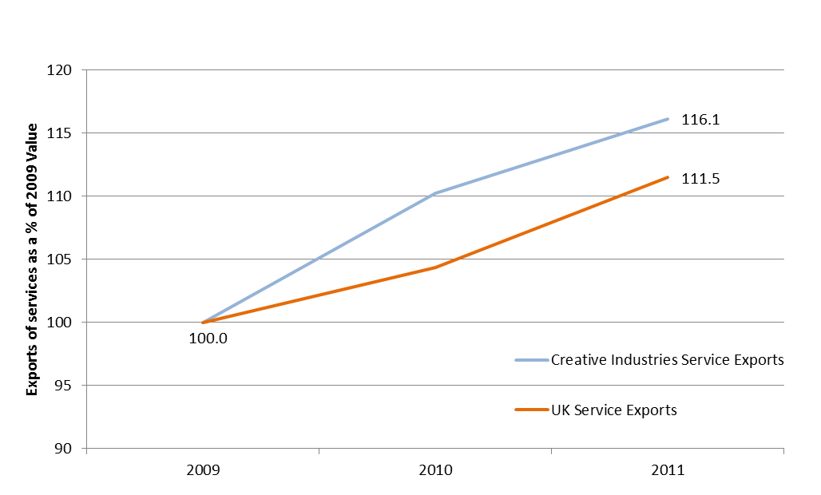
Figure 6: Changes in Exports of Services indexed to 2009 = 100

Exports of Services in 2009 = 100

Notes:
1. Source, ONS International Trade in Services survey (2009 – 2011)
2. Creative Industries Exports of Services (in current prices not accounting for inflation) expressed as a percentage of their value of in 2009. This shows the different rates of change between the Creative Industries (blue) and UK service exports as a whole (orange) between 2009 and 2011.

Estimates by Creative Industries Group
IT, software and computer services accounted for 46.5 per cent of Creative Industries service exports in 2011. Exports in the IT, software and computer services industries group increased from £5.8bn in 2009 to £6.3bn in 2010, and most recently to £7.2bn in 2011. This was an increase of 8.2 per cent between 2009 and 2010, and 14.7 per cent between 2010 and 2011.
The group which grew by the largest percentage between 2009 and 2011 was Publishing. Exports of Services for Publishing grew by 20.9 per cent between 2009 and 2010, and 20.6 per cent between 2010 and 2011. This took the value of Exports of Services for Publishing from £0.85bn in 2009 to £1.25bn in 2011.
Even without accounting for price inflation, there has been a net decrease in exports for the Advertising and marketing group between 2009 and 2011. Exports in this group were £2.1bn in 2009, and decreased to £1.9bn in 2010, before increasing between 2010 and 2011 to £2.0bn.

Figure 7: Value of Exports of Services (2009 – 2011)
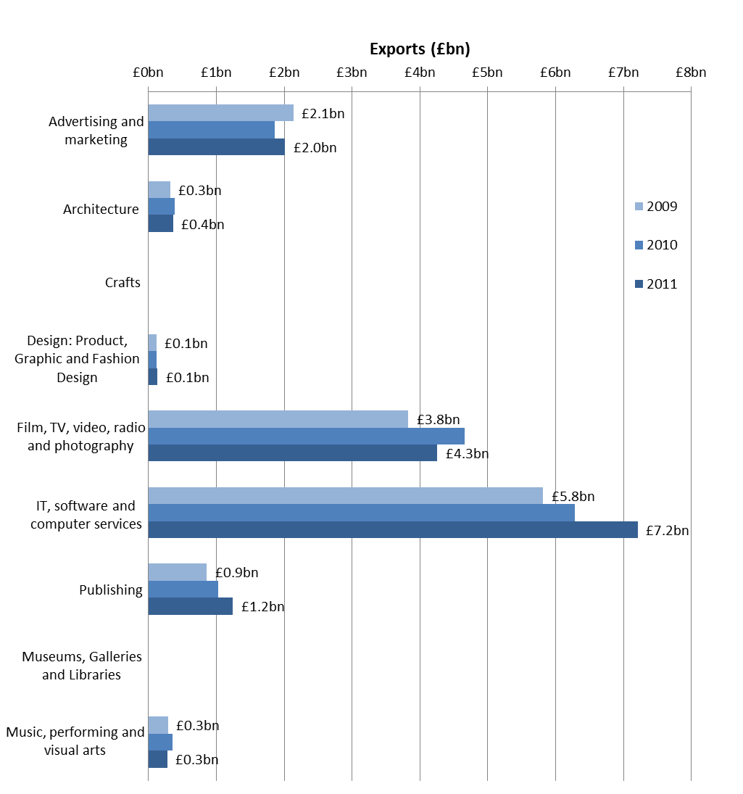

Notes:
1. Source, ONS International Trade in Services survey (2009-2011)
2. Value of Exports of Services of the Creative Industries between 2009 and 2011 in current prices (not accounting inflation).

Comparisons with other Service Exports sectors
In this section, Creative Industries Exports of Services are compared with the Pink Book. The Pink Book contains the best estimate of national Exports of Services, and is therefore the best comparator to use. The Creative Industries is not a Pink Book category itself, and includes service exports from across a number of Pink Book sectors.
Between 2009 and 2011, Exports of Services for the Creative Industries increased by 16.1 per cent. The largest increase of the Pink Book sectors was for Personal, cultural and recreational services (55.1%), which have a large overlap with the Creative Industries.
Table 8: Exports of Services of the Creative Industries and Pink Book Service Sectors
Pink Book Services Sectors or Creative Industries | Percentage Change in Exports of Services Between 2009 and 2011
Personal, cultural and recreational | 55.1%
Other business | 25.2%
Transportation | 16.3%
Creative Industries | 16.1%
Communications | 13.8%
Computer and information | 13.1%
Travel | 13.1%
Construction | 1.8%
Financial | 0.6%
Insurance | 0.2%
Royalties and license fees | -0.5%
Government | -2.8%
Wider UK Economy Total | 11.5%
Notes:
1. Source, ONS Balance of Payments Pink Book.
2. Current prices (i.e. not accounting for inflation)

Interpreting Exports of Services Data
The Balance of Payments methodology and glossary webpage includes the following documents:
An introduction to the UK Balance of Payments (PDF) to the United Kingdom balance of payments provides an overview of the concepts and coverage of the UK Balance of Payments.
The Balance of Payments Glossary document provides a list of terms used in the UK balance of payments is available on the National Statistics website.
There are also more detailed Balance of Payments Methodological Notes (PDF) available. Information on Trade in Services begins on page 13 of this document.

Annex A: Creative Occupations
Occupations used in this report are 4 digit Standard Occupational Classification 2010 (SOC) codes. Table 9 below list of contains a list of Creative Occupations.
Table 9: Creative Occupations
Creative Occupations Group | SOC (2010) | Description
Advertising and marketing | 1132 | Marketing and sales directors
 | 1134 | Advertising and public relations directors
 | 2472 | Public relations professionals
 | 2473 | Advertising accounts managers and creative directors
 | 3543 | Marketing associate professionals
Architecture | 2431 | Architects
 | 2432 | Town planning officers
 | 2435 | Chartered architectural technologists
 | 3121 | Architectural and town planning technicians
Crafts | 5211 | Smiths and forge workers
 | 5411 | Weavers and knitters
 | 5441 | Glass and ceramics makers, decorators and finishers
 | 5442 | Furniture makers and other craft woodworkers
 | 5449 | Other skilled trades not elsewhere classified
Design: product, graphic and fashion design | 3421 | Graphic designers
 | 3422 | Product, clothing and related designers
Film, TV, video, radio and photography | 3416 | Arts officers, producers and directors
 | 3417 | Photographers, audio-visual and broadcasting equipment operators
IT, software and computer services | 1136 | Information technology and telecommunications directors
 | 2135 | IT business analysts, architects and systems designers
 | 2136 | Programmers and software development professionals
 | 2137 | Web design and development professionals
Publishing | 2471 | Journalists, newspaper and periodical editors
 | 3412 | Authors, writers and translators
Museums, galleries and libraries | 2451 | Librarians
 | 2452 | Archivists and curators
Music, performing and visual arts | 3411 | Artists
 | 3413 | Actors, entertainers and presenters
 | 3414 | Dancers and choreographers
 | 3415 | Musicians
- Following consultation, five additional SOC codes have been included to represent occupations in the crafts sector.
- Further information on occupation codes proposed and the rationale for inclusion can be found in the consultation paper and in Bakhshi, Freeman and Higgs (2013)

Annex B: Creative Industries
The “creative intensity” of each 4-digit Standard Industrial Classification 2007 (SIC) code was calculated and used to inform the identification of “xreative” industries from other industries in the economy.
Table 10: Creative Industries
Creative Industries Group | SIC | Description
Advertising and marketing | 70.21 | Public relations and communication activities
 | 73.11 | Advertising agencies
 | 73.12 | Media representation
Architecture | 71.11 | Architectural activities
Crafts | 32.12 | Manufacture of jewellery and related articles
Design: product, graphic and fashion design | 74.10 | Specialised design activities
Film, TV, video, radio and photography | 59.11 | Motion picture, video and television programme production activities
 | 59.12 | Motion picture, video and television programme post-production
 | 59.13 | Motion picture, video and television programme distribution
 | 59.14 | Motion picture projection activities
 | 60.10 | Radio broadcasting
 | 60.20 | Television programming and broadcasting activities
 | 74.20 | Photographic activities
IT, software and computer services | 58.21 | Publishing of computer games
 | 58.29 | Other software publishing
 | 62.01 | Computer programming activities
 | 62.02 | Computer consultancy activities
Publishing | 58.11 | Book publishing
 | 58.12 | Publishing of directories and mailing lists
 | 58.13 | Publishing of newspapers
 | 58.14 | Publishing of journals and periodicals
 | 58.19 | Other publishing activities
 | 74.30 | Translation and interpretation activities
Museums, galleries and libraries | 91.01 | Library and archive activities
 | 91.02 | Museum activities
Music, performing and visual arts | 59.20 | Sound recording and music publishing activities
 | 85.52 | Cultural education
 | 90.01 | Performing arts
 | 90.02 | Support activities to performing arts
 | 90.03 | Artistic creation
 | 90.04 | Operation of arts facilities

The “creative intensity” of each SIC code included in these estimates is shown in Table 11 below.

Table 11: Creative Intensities
SIC | Description | Creative Intensity  (%)
90.03 | Artistic creation | 91.5
74.30 | Translation and interpretation activities | 82.2
90.01 | Performing arts | 78.8
74.20 | Photographic activities | 77.8
60.10 | Radio broadcasting | 62.7
74.10 | Specialised design activities | 62.1
71.11 | Architectural activities | 61.5
70.21 | Public relations and communication activities | 59.3
58.14 | Publishing of journals and periodicals | 58.3
90.02 | Support activities to performing arts | 56.8
59.1 | Motion picture, video and television programme activities | 56.4
32.12 | Manufacture of jewellery and related articles | 56.2
62.01 | Computer programming activities | 55.8
59.20 | Sound recording and music publishing activities | 54.1
60.20 | Television programming and broadcasting activities | 53.5
73.11 | Advertising agencies | 50.5
58.11 | Book publishing | 49.9
58.13 | Publishing of newspapers | 48.8
73.12 | Media representation | 48.3
58.21 | Publishing of computer games | 43.1
58.29 | Other software publishing | 40.8
90.04 | Operation of arts facilities | 38.4
58.19 | Other publishing activities | 37.8
85.52 | Cultural education | 34.6
62.02 | Computer consultancy activities | 32.8
58.12 | Publishing of directories and mailing lists | 31.0
91.01 | Library and archive activities | 23.8
91.02 | Museum activities | 22.5
Notes:
- Creative intensity for SIC 59.1 is calculated at 3-digit level in order to capture the whole industry as data at the 4-digit level are no statistically robust (due to low levels of employment of the 4-digit codes).
- SIC codes 91.01 and 91.02 have been included after consultation, despite having creative intensities below the 30 per cent threshold. One reason they may have a lower creative intensity is due to large numbers employed in facilities maintenance in Museums, galleries and libraries.
- SIC code 32.12 Manufacture of jewellery and related articles has been included after consultation to represent the Crafts industry, although due to limitations in the underlying SIC codes (which are agreed internationally) this clearly does not fully capture the crafts sector.
- Industry codes proposed and the rationale for inclusion can be found in the consultation https://www.gov.uk/government/consultations/classifying-and-measuring-the-creative-industries-consultation-on-proposed-changes

Annex C: Computer Games
In order to base this release on an internationally comparable basis, the statistics in this release is based on 4-digit SIC codes. However to maintain continuity with previous releases, Employment and GVA estimates have also been calculated for the computer games industry using data at the 5-digit SIC level.
The estimates for the computer games industry have been calculated for the SIC codes:
- 58.21 Publishing of Computer Games.
- 62.01/1 Ready-made interactive leisure and entertainment software development.
To note, a number of software programming companies in 62.01 Computer programming activities may also contribute to the output of computer games, as part of a range of programming activities. This is not included in these computer games estimates, but again will have been implicitly included in the IT, software and computer services group in the main estimates.
Employment
The computer games industry in the UK had employment of around 15,000 in 2012. This estimate was 18.8 per cent higher than in 2011, when there were 13,000 jobs in the computer games industry.
GVA
GVA for the computer games industry in the UK was £540 million in 2012. This represents a large increase on 2008. However, GVA was even higher in 2011, at £946 million. This might be due to re-stocking / de-stocking as the value of purchases made by the computer games industry was lower in 2011 than it was in either 2010 or 2012. Computer Games which have been developed but not released might also have contributed to this change. However, data at this level of detail are volatile and dependent on survey data and should be treated with caution.
Figure 8: GVA of the Computer Games Industry (2008 – 2012)
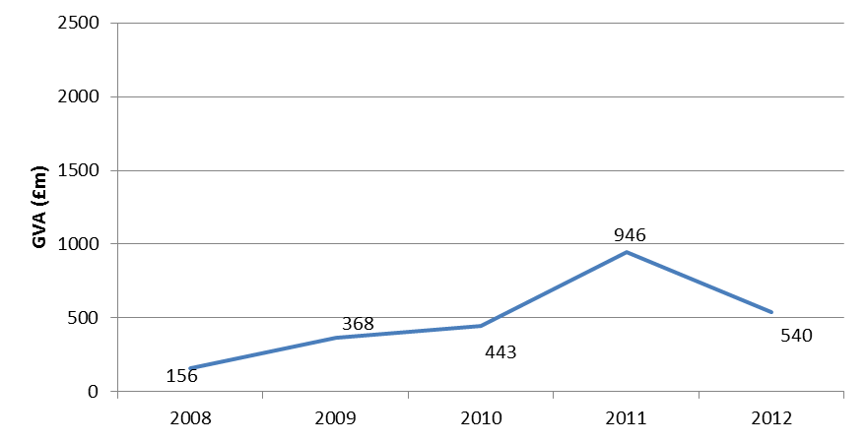

Annex D: Data limitations & further development
The research and consultation process underpinning the estimates presented in this statistical release have shown that there are a number of sectors (Crafts, Music, Fashion, Museums and Galleries) for whom the official estimates represent an imperfect measurement solution. These limitations and areas for further development are summarised below.
Industry (SIC) and Occupation (SOC) classifications: These estimates have been constructed from ONS official statistics, which for comparability rely on international classifications. However, there are substantial limitations to the underlying classifications these official statistics are based on. Specifically, the underlying international classifications do not adequately represent the Creative Industries, with sectors like: music, crafts and fashion industries particularly poorly served. Through continued industry consultation and with the ONS, the DCMS intends to make a strong case to improve these codes at the next international review cycle.
Crafts: There are substantial difficulties in adequately representing the Crafts sector due to the weaknesses in the underlying classifications that official data are based on. The DCMS is working closely with the Crafts Council, who have commissioned further research to address the problem. Five SOC codes have been included in the estimates to represent occupations in the Crafts sector (Annex A). SIC code 32.12 “Manufacture of jewellery and related articles” (Annex B) has been included to represent the Crafts industry, although this is a significant under-estimate of the scale of the true Crafts industry.
Music: While a good part of the music industry is implicitly included in the codes making up the Creative Industries Economic Estimates, the industry and occupation codes do not allow the contribution of music to be satisfactorily identified in a separate category. Occupation codes do not allow a number of roles to be identified e.g. in A&R. Even at the highest resolution of detail available in the ONS data we use, live music is counted alongside theatre in a single “Performing arts” category. There are also challenges related to capture of micro-businesses and the inaccurate classification of music businesses in the ONS business registry that underpins the Annual Business Survey on which GVA estimates in this release are produced. UK Music is currently working with the ONS and DCMS on these areas .It has used industry data from its members to separately estimate the size of the music industry in its report The Economic Contribution of the Core UK Music Industry.
Fashion: The estimates in this release are intended to measure the design element of the fashion industry. Ideally, fashion design category would be separately identified in the estimates. However, it is not possible to separate design associated with fashion from the category 74.10 “Specialised design activities” with any degree of confidence. Nor is it possible to identify in official data the full range of fashion occupations across industries. The fashion industry has taken a broader approach to measuring its activities, going beyond the design element, for example, including relevant retail activities, published in the report Value of the UK Fashion Industry.
Museums, galleries and libraries: Museums, galleries and libraries have been fully included and separately identified as categories in these estimates for the first time. While curation has always been included as a creative occupation, Museums, galleries and libraries have not been included as industries in their own right. However, it is notoriously difficult to measure the value of their output. The Annual Business Survey data used in these estimates are likely to substantially under value the sector and have not been shown separately. (For consistency with other sectors, the estimates have been included in overall totals for the Creative Industries GVA estimates.)
Inclusion of micro-businesses: The Annual Population Survey used to construct the employment estimates is a household survey so captures self-employed individuals as well as employees. Very small businesses (particularly in Sectors like the Crafts and Music) are not counted in the main ONS business surveys which we have used to calculate Creative Industries’ GVA, however. The DCMS is working with BIS and the ONS to explore the feasibility of including estimates for these businesses in future issues of this statistical release.
Time series: This release has been based on ONS data sources which use the latest occupational classification (SOC 2010) and the latest industrial classification (SIC 2007). Relatively short runs of these series are currently available which use these latest classifications. DCMS is working with ONS on developing longer consistent time series which span data that use earlier classifications.

Background Information

Format of Statistical Release:
This release is available in word and pdf format.
Accompanying Excel tables relating to this release are also available.

Previous reports:
The data covered in this release has been calculated using a new methodology using the latest industry and occupational codes (SIC2007 and SOC2010). Therefore, these estimates are not comparable to earlier reports produced on the Creative Industries. Earlier reports are still available from the following area of the DCMS website:
https://www.gov.uk/government/publications/creative-industries-economic-estimates

Next release of data:
The next update of these statistics will be published in the last quarter of 2014.
Sources:
Information presented in the Creative Industries Economic Estimates has been derived from several ONS National Statistics sources, from: the Annual Population Survey (2011 & 2012); the Annual Business Survey (2012P); & the International Trade in Services dataset (2009, 2010 & 2011).

Methodology:
Details of the “creative intensities” methodology can be found in the consultation https://www.gov.uk/government/consultations/classifying-and-measuring-the-creative-industries-consultation-on-proposed-changes

Calculation of Creative Intensities
Data from the Annual Population Survey from the past 2 years (2011 and 2012) have been combined. The number of creative jobs in each industry has been divided by the total number of jobs in that industry. Industries (SIC07) which have more than 6,000 jobs and a “creative intensity” of more than 30 per cent were considered as candidates for inclusion. Industries on the threshold of either criterion have been carefully considered through consultation.

Employment
Employment data have been sourced from the Annual Population Survey (APS). The APS database contains a large number of variables, but only a few are used in this publication. Micro-data (record level data) have been analysed using syntax programmes. First, the data have been restricted to those who are employees or self-employed (main job - inecac05= 1 or 2; second job – secjmbr = 1, 2 or 3). Next, both main jobs (SOC10M) and second jobs (SOC10S) are counted, and weighted according to the person weighting (pwta11). The number of jobs in each occupation, in each industry (main job - INDC07M; second job – INDC07S) is then counted.
Confidence intervals were constructed at the 95% confidence level according to guidance in the LFS user manual.
More information on the APS can be found here: http://www.ons.gov.uk/ons/guide-method/method-quality/specific/labour-market/labour-market-statistics/index.html

GVA
Data relating to GVA have been sourced from the provisional 2012 Annual Business Survey (ABS) for each industry, and the Blue Book Dataset for UK totals.
Information on the ABS can be found here: http://www.ons.gov.uk/ons/rel/abs/annual-business-survey/index.html
The UK total for GVA is taken from the Blue Book, as the ABS excludes financial services. The variable used is ABML.
Information on the Blue Book can be found here:
http://www.ons.gov.uk/ons/rel/naa1-rd/united-kingdom-national-accounts/index.html

Exports of Services
Export data are taken from the International Trade in Services (ITIS) dataset for 2009, 2010 & 2011. Data has been analysed and disclosure rules applied. Further information about the ITIS dataset can be found from here:
http://www.ons.gov.uk/ons/rel/itis/international-trade-in-services/index.html

The UK total for Exports of Services is taken from the Pink Book, as IT IS does not have full coverage. The variable used is KTMQ.
Information on the Pink Book can be found here:
http://www.ons.gov.uk/ons/rel/bop/united-kingdom-balance-of-payments/index.html

Contact for enquiries:
Department for Culture Media and Sport
100 Parliament Street
London
SW1A 2BQ
evidence@culture.gsi.gov.uk

The responsible policy contact for this release is Gwyn Owens.
The responsible statistician for this release is Douglas Cameron.
For general enquiries telephone: 020 7211 6000
For enquiries on this release contact: 020 7211 6014

This release was produced by Douglas Cameron, Tom Knight, Sam Tuckett and Penny Allen (DCMS). We would like to thank all members of the Creative Industries Council Technical Working group for their invaluable advice.

The UK Statistics Authority
This release is published in accordance with the Code of Practice for Official Statistics (2009), as produced by the UK Statistics Authority. The Authority has the overall objective of promoting and safeguarding the production and publication of official statistics that serve the public good. It monitors and reports on all official statistics, and promotes good practice in this area. Details on the pre-release access arrangements for this dataset have been published alongside this release.

Glossary

Standard Occupational Classification SOC 2010
The Standard Occupational Classification, a means of classifying the occupation of a person according to the work they do and the skill level required. The latest version (SOC 2010) is available here: http://www.ons.gov.uk/ons/guide-method/classifications/current-standard-classifications/soc2010/index.html

The Standard Industrial Classification SIC 2007
The Standard Industrial Classification, a means of classifying businesses according to the type of economic activity that they are engaged in. The latest version (SIC 2007) is available here: http://www.ons.gov.uk/ons/guide-method/classifications/current-standard-classifications/standard-industrial-classification/index.html

Creative Intensities methodology
This methodology makes use of a robust finding from research that having high levels of “creative intensity” – that is, the proportion of the workforce in creative occupations – separates the Creative Industries from other industries.

The methodology comprises 3 steps. First, a set of occupations are identified as creative against criteria. Second, creative intensity is computed for all industries in the economy. Third, all industries with a creative intensity above a certain “threshold” are classified as Creative Industries.

Further explanation can be found in the consultation document and underlying papers https://www.gov.uk/government/consultations/classifying-and-measuring-the-creative-industries-consultation-on-proposed-changes

Creative Economy
The Creative Economy, which includes the contribution of all those employed in the Creative Industries as well as the contribution of those who are in creative occupations outside the Creative Industries.

Creative Industries
The Creative Industries, a subset of the Creative Economy which includes only those working in the Creative Industries themselves (and who may be in creative occupations or in other roles e.g. finance).

Gross Value Added
Gross Value Added (GVA) measures the contribution to the economy of each individual producer, industry or sector in the United Kingdom. GVA is closely linked to the more commonly used Gross Domestic Product (GDP)

$$GVA+Taxes on products-Subsidies on Products=GDP$$

Bakhshi, H., Freeman, A., and Higgs, P. (2013) ‘A dynamic Mapping of the UK’s Creative Industries’, Nesta: London
Bakhshi et al (2013) propose criteria which can be used to assess which occupation codes should be considered creative for measurement purposes
Classifying and Measuring the Creative Industries, http://www.creativeskillset.org/research/activity/classifications/article_9067_1.asp
Higgs, Cunningham and Bahkshi (2008), “Beyond the Creative Industries: Mapping the Creative Economy in the UK”, Nesta, London
Statistical significance tests have been run at the 95% level. A significant change at the 95% level means that there is less than a 5% (1 in 20) chance that the difference observed within the sampled respondents is not also true for the population as a whole.
ABML is the name of the variable taken from the ONS Blue Book which gives a figure for UK GVA
http://www.ons.gov.uk/ons/rel/naa1-rd/united-kingdom-national-accounts/the-blue-book--2013-edition/index.html
https://www.gov.uk/government/consultations/classifying-and-measuring-the-creative-industries-consultation-on-proposed-changes
Bakhshi, H., Freeman, A., and Higgs, P. (2013) ‘A dynamic Mapping of the UK’s Creative Industries’, Nesta: London
Bakhshi et al (2013) propose criteria which can be used to assess which occupation codes should be considered creative for measurement purposes

