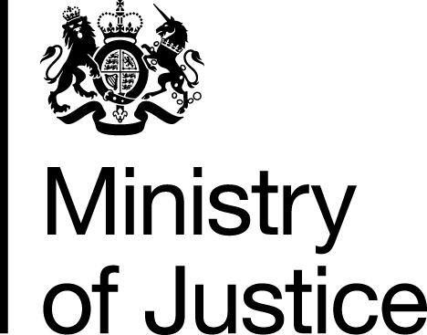 |  |  | www.gov.uk
 | FOI: 85874 |  | October 2013

Freedom of Information Request

You made a request for information from the Ministry of Justice (MoJ) entitled ‘LAA funding of private family law matters relating to domestic violence/abuse’.

Your request has been handled under the Freedom of Information Act 2000 (FOIA).

I can confirm that the department holds information that you have asked for, and I am pleased to provide this to you. I have set out each question and our response in the attached annex.

