Community Radio Consultation

13 February 2014

Contents

About this consultation…………………………………………………………………………………..3

Consultation proposals:
- Introduction…………………………………………………………………………………………….5
- Policy Background……………………………………………………………………………………7
- Policy Options………………………………………………………………………………………..12
- Legal Details…………………………………………………………………………………………. 19

Annex A – List of consultation questions……………………………………………………….21

Annex B – Map showing the location of Community Radio Stations in
England, Scotland, Wales and Northern Ireland …………………………………………….23

About this consultation:

Topic | This consultation seeks your views:  - to lift the restriction preventing some community radio stations from taking any income from on-air advertising or sponsorship if they overlap with a commercial radio licence whose coverage area includes 150,000 adults or fewer;  - on the restrictions preventing community radio stations from taking more than 50% of their annual income from on-air advertising and sponsorship, if they remain appropriate, and what, if any changes, are justifiable; and  - on the case for further licence extensions for community radio stations in the event of a decision to implement a radio switchover.  - on improving the effectiveness of the Community Radio Fund
Geographical scope | England, Wales, Scotland and Northern Ireland
Audience | This is aimed at:  - members of the community and commercial radio;  - advertisers and sponsors of radio media;  - comments from all other interested parties are also welcome.
Duration | 10 weeks. The consultation will close on 23 April 2014
Contact details | Please complete the online response form  Alternatively you can email your response to the questions in this consultation to:  Community-Radio@Culture.gsi.gov.uk  Or post your response to:  Media Directorate  Community Radio Consultation  Department for Culture, Media and Sport  Media Team  4th Floor, 100 Parliament Street  London SW1A 2BQ
Next steps | A summary of responses and a Government response on the way forward will be published in due course following the closure of the consultation.  The Government’s response will take all responses submitted to this consultation into account, and will be based on a careful consideration of the points made in consultation responses, not the number of responses received. However, points raised in responses that are out of scope of the consultation and the consultation questions will not necessarily be considered.

Introduction

- Community radio stations are run by not-for-profit organisations and to provide social gain to the communities they serve. The Community Radio Order 2004 establishes the regulatory framework and sets out the powers under which Ofcom licenses community radio stations. The regulatory framework for community radio was last amended via the Community Radio (Amendment) Order 2010.

- The first community radio stations were launched in 2005 and since then the sector has continued to grow. Over 270 stations have now been licensed, of which 211 are currently on air. Demand for community radio licences remains high and Ofcom are currently conducting a third round of licensing.

- The Community Radio sector has, in a very short space of time, shown itself to be an important and integral part of a modern radio landscape and valued by the communities they serve. However, despite the sector’s overall success, many community radio stations are struggling to build a long-term sustainable business model. The average income of community radio stations has declined year on year since 2007 due in part, to a decrease in available support from local authorities and other public bodies. To date, 33 stations licensed by Ofcom have handed their licence back, or been revoked, of which 14 never managed to launch on-air services. In many cases problems in securing sufficient funding to cover essential costs was cited as the main reason for this.

- In Connectivity, Content and Consumers: Britain's digital platform for growth, published on 30 July 2013, we announced that there would be a consultation on the current funding restrictions for community radio which would consider the extent to which the rules are unnecessary barrier to the sustainability of the sector or whether they remain necessary to secure the unique nature of community radio.

- This consultation paper seeks views on whether:

- to lift the restriction preventing community radio stations from taking any income from on-air advertising or sponsorship if they overlap with a commercial radio licence whose coverage area includes 150,000 adults or fewer;
- the restrictions preventing community radio stations from taking more than 50% of their annual income from on-air advertising and sponsorship remain appropriate and what, if any changes, are justifiable; and
- there is a case for further licence extensions for community radio stations in the event of a decision to implement a radio switchover.
- the consultation also seeks views on the operation of the Community Radio Fund; its objectives and operation and how this might be improved.

- We would welcome other views about the regulation of community areas and for suggestions for streamlining and improving the regulatory framework in which they operate.

Policy Background

- In order to gain a licence, prospective Community Radio stations need to demonstrate they meet the following characteristics:

- that the proposed service is a local service provided primarily for the good of members of the public, or of particular communities, and in order to deliver social gain, rather than primarily for commercial reasons or for the financial or other material gain of the individuals involved in providing the service;
- that the service is intended primarily to serve one or more communities (whether or not it also serves other members of the public);
- that the person providing the service does not do so in order to make a financial profit by so doing, and uses any profit that is produced in the provision of the service wholly and exclusively for securing or improving the future provision of the service, or for the delivery of social gain to members of the public or the community that the service is intended to serve;
- that members of the community it is intended to serve are given opportunities to participate in the operation and management of the service;
- that, in respect of the provision of that service, the person providing the service makes himself accountable to the community that the service is intended to serve.

- We believe that these characteristics are still important and should remain central to the requirements that Community Radio should have to meet to ensure that stations remain linked to and valued by their communities.

- When Community Radio legislation was first introduced in 2004, stations were subject to strict financial requirements. These restrictions:

- prevented community radio stations from being licensed if the service would overlap with a commercial station whose measured coverage area (MCA) includes 50,000 adults or fewer;
- stopped community radio stations which overlapped with a commercial radio station whose MCA includes fewer than 150,000 adults from taking any advertising or sponsorship;
- placed an upper limit on advertising and sponsorship of no more than 50% of a station’s annual income. In determining the appropriate amount of advertising permissible for individual stations, Ofcom were also required to consider and take into account the need not to prejudice unduly the economic viability of other commercial stations;
- prevented community radio stations from receiving more than 50% of their income from any one source.

- The underlying principle of applying funding restrictions to community radio was two-fold. First, as a mechanism to limit the commercialisation of the sector and as a result help secure the delivery of social gain. Secondly, to provide an appropriate level of protection to existing small commercial radio stations at a time when the impact of community radio stations could not be quantified. It is for this reason that the Government committed in 2010 to keep the sector under review.

- It was following such a previous review that the Government introduced the Community Radio (Amendment) Order 2010. This lifted the restrictions on community radio stations taking more than 50% of their income from a single source and removed the rule preventing the licensing of community radio stations in areas of overlap with a commercial radio station whose measured coverage area (MCA) included 50,000 adults or fewer.

- Despite these recent changes, Ofcom and the Department for Culture, Media and Sport (DCMS) have continued to receive a growing number of representations from the community radio sector reporting a decline in radio stations’ income and increasing difficulties in accessing funding. This is supported by Ofcom’s market analysis which shows a steep decline in the sector’s revenue; as shown in Figure 1 below. Ofcom’s analysis also shows that community radio stations have consistently operated on very small margins and in each of the last four years, the average expenditure of the sector has been greater than the average income. In 2011 the gap between average costs and income rose by more than 50% though in 2012 the gap narrowed. This may have been as a result of community radio stations cutting costs to remain viable.

Community radio  Average income/expenditure | 2008 | 2009 | 2010 | 2011 | 2012
Average (Mean) Income | £84,000 | £75,500  (-10.2%) | £65,750]  (-12.9%) | £60,250  (-8.3%) | £57,000  (-5.4%)
Average (Median)  Income | £53,750 | £46,750  (-15.0%) | £42,500  (-7.14%) | £40,500  (-4.8%) | £32,250  (-13.1%)
Average (Mean) Expenditure | £86,500 | £76,500 | £67,000 | £64,250 | £58,000
Average (Median)  Expenditure | £55,000 | £52,250  (5.3%) | £43,000  (-17.5%) | £41,000  (-4.9%) | £35,750  (-15.4%)
Source – Ofcom Annual Reports on Community Radio 2008-2012

Figure1

13. Median income for community stations in 2012 was £35,250 compared to a mean average of £57,000. The median figures should however be treated with some caution as the number of services eligible to submit financial reports changes each year. For example, the figures for 2011 are based on reports from 176 licensees; in 2012 from 190 licensees. However, both figures clearly show that community radio revenues have declined since 2008 and are continuing to decline (see Figure 2 below).

Community radio  Source of Income | 2008 | 2009 | 2010 | 2011 | 2012
Grants | 45% | 41% | 35% | 33% | 29%
Advertising and Sponsorship | 20% | 23% | 22% | 26% | 29%
Donations | 12% | 9% | 14% | 13% | 14%
Service Level Agreements | 11% | 12% | 9% | 10% | 7%
Other – includes education/training grants and local fundraising | 12% | 16% | 20% | 18% | 20%
Source – Ofcom Annual Reports on Community Radio
Figure 2

14. As part of the wider Communications Review DCMS in partnership with the Community Media Association and Ofcom, organised a number of workshops with representatives of the Community Radio sector in 2012. These workshops considered the restrictions on advertising and sponsorship, how best to secure the delivery of social gain given a reduction in available grant income, and licensing issues. In summary, several key issues emerged from the discussions:

- Firstly, there was a majority view across the sessions that the absolute prohibition on stations which overlap with a local commercial licence whose MCA includes 150,000 adults or fewer from taking on-air advertising or sponsorship was no longer necessary and should be removed entirely.

- Secondly, there were a range of views on the restriction preventing stations from taking more than 50% of their income in advertising and sponsorship. Although some consider the restriction to be a barrier to growth in the sector and believe the restriction should be lifted entirely, others advocated its retention as a means of preventing commercialisation of the sector, promoting diversity of funding sources, and encouraging stations to build strong partnerships with their communities. Delegates also considered whether the restriction could be applied more flexibly, for example by allowing stations a pre-determined level of income before applying a restriction, or discounting certain kinds of advertising or sponsorship from being caught.

- Thirdly, participants in the workshops were in no doubt that the delivery of social benefits remain a core and fundamental objective for stations and the sector as a whole, and considered how social gain arising from community radio could be secured in the longer-term if funding restrictions were relaxed or even removed - for example either through existing licence requirements and funding conditions, or with additional regulation.

- Finally, delegates also raised licence duration, and funding for the sector as a whole noting that the funding from Community Radio Fund has not increased in real terms since 2004

15. It was clear throughout the workshops that although there was a consensus in support of changes there was no consensus around what those might be nor how they should be implemented. It is for this reason that this consultation is seeking views on a wide range of possible options.

Policy Options

(a) Removing the prohibition on advertising and sponsorship for stations overlapping with commercial services of less than 150,000 adults

16. Community radio stations whose licensed areas overlap with the smallest commercial services are currently prevented from taking any advertising and sponsorship. The purpose of this restriction has been to provide important protections to existing small commercial radio stations. However, nearly a decade after the Community Radio Order 2004 was introduced, and with around 200 community radio stations operating across the UK, we now have a greater understanding of how these stations operate and the impact they may, or may not have, on small commercial stations. Over this period there has also been a significant relaxation in the commercial radio regulatory regime as a result of the Digital Economy Act 2010 which has reduced costs for the sector.

17. Ofcom’s Communications Market Report 2013, shows the percentage share of income generated by community radio stations from grants has fallen from 45% in 2008 to 29% for 2012 and with this figure likely to fall still further. The fall in grant income stems from the effect of the recession on the providers of grants, including central government, local authorities and the Community Radio Fund.

18. For the last two years alone, 2011 and 2012, grants fell from 38% in 2011 to 29% in 2012. With the value of on-air advertising and sponsorship revenue increasing from 26% to 29%, in cash terms an average from £15,665 in 2011 to £16,530 in 2012.

19. A breakdown of the average income, by type of station, is set out in figure 3.

Figure 3 Community Radio - Average Income, by type of community served.

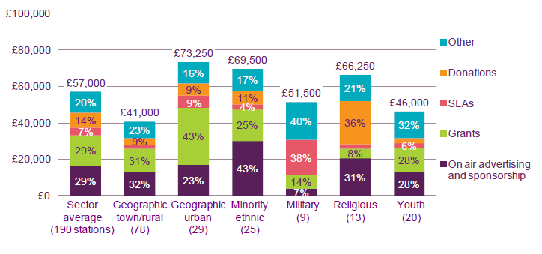

20. As the availability and value of grant funding reduces, community stations will need to develop other revenue streams. Despite a modest overall growth in the proportion of income from advertising and sponsorship, only 26 stations, less than 10% of all community radio stations, generated 50% or more of their income from commercial activity. In the 2010/11 reporting period, 37 stations reported not taking on-air advertising or sponsorship, of which 25 did so as a matter of choice or policy.

21. Commercial radio revenues meanwhile have partially recovered since the steep fall in revenues in 2008 and 2009. Revenues increased by 3.9% in 2012 helped by a return to growth (7.2%) in local radio advertising following a contraction in 2011. Commercial radio is also benefiting from relaxations in rules in sponsorship. Commercial radio generated £96m sponsorship revenues in 2012.

22. There is no detailed research in the UK showing there to be an economic impact by a community radio service on a commercial radio service however this is supported by a report from the Federal Communications Commission (FCC) in Washington D.C – Economic Impact of Low Power FM Radio -2012 which found that, on the whole, low-power FM (LPFM) radio stations – as community radio is known in the United States – generally do not have an economic impact on commercial FM radio stations and nor are they expected to do so in the future.

23. There are already requirements set out in the Broadcasting Act 1990 Section 105 (as amended by the Communications Act 2003 and modified by the Community Radio Order 2004, and further modified by the Community Radio (Amendment) Order 2010) which require Ofcom to consider the potential economic impact of licensing a community radio service on commercial radio. As the legislation directs Ofcom, if it grants a licence, to consider the terms on which it is granted, Ofcom may set a lower limit on annual income from the sale of on-air advertising and sponsorship than the 50% specified as the general limit for community radio licences.

24. We believe making changes to this rule will have little impact on small-scale local commercial stations and believe there is now an increasingly compelling strong case for the removal of the absolute rule prohibiting the taking of any revenues from advertising and sponsorship.

25. We are therefore seeking views on whether to lift the current restriction preventing stations from taking any income from on-air advertising or sponsorship if they overlap with a commercial station whose coverage area includes 150,000 adults or fewer.

Question 1- Do you agree that the restriction on community radio, whose coverage areas overlap with commercial radio licence areas with fewer than 150,000 adults in their measured coverage area, should be removed. If you disagree with this statement please substantiate with details from any available source.

Question 2- If the funding restrictions on advertising were to be reduced,
ought the requirement on Ofcom to look at potential economic impact also be reviewed. We welcome your views on this.

(b) Securing social value from community radio

26. It was always the intention that community radio should be distinct from the commercial radio sector and the BBC, with a clear focus on the people and communities that stations serve. There are a number of regulatory mechanisms which help to secure the unique nature of community radio. Most importantly each station has specific ‘key commitments’ which form part of its licence, and these are monitored on an annual basis and on an ad hoc basis by Ofcom. The funding restrictions are also part of the wider intervention to ensure that community radio stations don’t become a route to commercialisation.

27. However, we acknowledge that there is a balance to be struck between preventing the commercialisation of community stations, and restricting revenues which could be invested in delivery of social gain objectives. We are also aware that community radio stations, as do many local commercial stations, have high fixed costs and, for new stations, high set up costs. In many cases these “core costs” are the most difficult to fund in the long term. While the Government has been able to protect the level of the Community Radio Fund, comparatively to other areas of public funding, until 2015, the number of stations now licensed means a decreasing proportion of services can benefit directly from the fund.

28. While we continue to believe the principle of protecting against the commercialisation of stations remains a valid part of the sector’s regulatory framework, we also want to promote a sustainable sector which is capable of meeting its business costs, and which has the ability to grow and succeed in its delivery of social gain and the production of compelling radio content.

(C) Fixed revenue allowance

29. The Community Media Association has proposed that community radio stations should be able to take a fixed amount of income prior to any restrictions coming into force. The fixed amount (Fixed Revenue Allowance), intended to cover their business costs.

30. There are a number of ways in which this Fixed Revenue Allowance could be calculated and a number of considerations which could be taken into account, such as the variances in rural and metropolitan based stations. However, as always there is a balance to be struck between a scheme which is both fair but not disproportionality burdensome for stations and the regulator. It should also be noted that the Fixed Revenue Allowance would not prohibit further income from advertising and sponsorship, but rather that any such additional revenue would be subject to the 50% rule; only 50% of revenue above the Fixed Revenue Allowance could be from on-air advertising and sponsorship. There are two approaches, though we invite you to provide details on others for consideration.

Option 1 - a Fixed Revenue Allowance percentage of X% to be determined by the average expenditure of community radio stations at the beginning of each three year period. This would tailor the allowance to match the revenues of different stations. The main disadvantage is that it would be more complex to administer.

Option 2 - a single Fixed Revenue Allowance figure of £X across all community radio stations either set in the regulations or by Ofcom. This would exempt the first £X of qualifying revenue (i.e. income from the sale of on-air advertising and sponsorship) with the amount deductible before the calculation of the 50% reduction. This would be simpler to operate and would also benefit smaller stations to a greater extent. Some community radio would not be subject to any restriction on income from on-air advertising and sponsorship at all (depending on the appropriate figure for the Fixed Revenue Allowance). According to Ofcom figures, in 2012 26% (50) of stations surveyed (190 in total) had an annual income of less than £30,000.

Question 3 – Should there be a relaxation of the restriction preventing stations from taking more than 50% of their income from advertising and sponsorship. If your answer to this question is yes, then what should the new restriction be. How should it be determined. For example, set in regulation or set by Ofcom following consultation and reviewing periodically.

Question 4 – Of the two options noted above which do you support, and why. Include reasons why you dismiss the alternative option. We invite you to provide details on other approaches for consideration.

Question 5 – What way/s could a Fixed Revenue Allowance be fairly determined if this was to be set by Ofcom. Should this be set by Ofcom. What facts would Ofcom need to take into account in setting an appropriate level of allowance.

(d) Licence Durations

31. Community Radio Licences are issued for five years and the Community Radio Order 2010 made provision for community radio licence holders to apply for an extension to their licences for a further five years. This licence extension 'window' commences 18 months prior to the expiry date of the existing licence, and ends six months before the expiry date. The legislation says that where Ofcom receives an application for the extension of a community radio licence, it must extend the licence for such a period (not exceeding five years) as it thinks fit, providing it is satisfied on the following matters:

a) "the ability of the licence holder to maintain the service for the period of the extension;

and

b) the likelihood of a contravention by the licence holder of a requirement imposed by a condition included in the licence by virtue of section 106 of the Broadcasting 1990 Act."

32. Section 106 of the Act, referred to under b) above, says the licence shall include conditions "appropriate for securing that the character of the licensed service, as proposed by the licence holder when making his application, is maintained during the period for which the licence is in force". For community radio services this is the 'key commitments' section of each station's licence. This statutory criterion therefore requires Ofcom to consider the likelihood of a licensee breaching its key commitments.

33. Inevitably some of the early licence holders are beginning to reach the end of even this additional period of time and stations are keen to resolve questions around future licensing arrangements for community radio stations.

34. As noted in the consultation prior to the Community Radio Order 2010, there is a balance to be struck in determining the licence duration of community radio stations. There are benefits to allowing stations, which have established links with the communities and volunteers, to continue. However, due to the scarcity of the spectrum there are only a limited number of stations which can be licensed, therefore extending the licence duration of existing services prevents new stations from launching. We would welcome views on licence extensions.

Question 6 - Would you support a further 5 year extension of a licence beyond the second 5 year period. If you do not agree, please provide reasons why this should not happen.

35. Wider decisions about the allocation of radio spectrum are likely to have a significant impact on the capacity to award new licences or to extend the licences of existing services. The future licensing of community radio stations will be considered, in the context of a discussion on digital radio switchover.

(e) Community Radio Fund

36. Ofcom makes available grants, funded by DCMS, to providers of community radio, for the purposes of helping with their core running cost. These core functions include: administration, financial management and reporting, volunteer organisation and support. DCMS is committed to providing up to £427,000 in 2013/14 to support Community Radio of which £397,000 is allocated to the Community Radio Fund.

Question 7 – How can Community Radio Fund grant funding be better used.
There are no plans to alter how decisions are taken to distribute the grant however we welcome views on other ways in which the grant could be better targeted and how might this be done.

Legal details

37. Section 262 of the Communications Act 2003 empowers the Secretary of State to make such modifications as he considers necessary to certain legislation relating to radio services which are provided primarily for the benefit of the public or particular communities rather than for commercial reasons. In so doing, the Secretary of State must be satisfied that the service in question will confer significant benefits on the public or the communities for which it is provided.

38. The Community Radio Order 2004 modified Part 3 of the Broadcasting Act 1990 to allow Ofcom to grant community radio licences. The proposed legislative changes will be made using powers conferred by sections 262 and 402 of the Communications Act 2003.

Prohibiting Advertising and Sponsorship for stations >150,000

39. Paragraph 5(2) of the Schedule to the 2004 Order modifies section 105 of the Broadcasting Act 1990 by giving words which must be read into that section where a community radio licence is under consideration. Those modifications require that every licence to provide a community radio service that overlaps with any other local licence the potential audience of which includes no more than 150,000 persons who have attained the age of 15 years must contain such conditions as appear to OFCOM to be appropriate for prohibiting (i) the inclusion in that service of any remunerated advertisement, and (ii) the sponsorship of any programmes included in that service.

Securing social value from community radio

40. Any variation to the 50% limit on revenue from advertising and sponsorship would also mean that we would need to amend other parts of the Schedule to the 2004 Order. These amendments would include amending the percentage of total revenue income which could comprise advertising and sponsorship.

Please note that the Department will publish all responses in full, unless specifically requested not to do so. However, all information in responses, including personal information, may be subject to publication or disclosure under freedom of information legislation. If a correspondent requests confidentiality, this cannot be guaranteed and will be possible only if considered appropriate under the legislation.

Any such request should explain why confidentiality is necessary. Any automatic confidentiality disclaimer generated by your IT system will not be considered as such a request unless you specifically include a request, with an explanation, in the main text of your response.

Responses should be made by 23 April 2014 either by post to:

Media Directorate
Community Radio Consultation
Department for Culture, Media and Sport
Media Team
4th Floor, 100 Parliament Street
London SW1A 2BQ2

Or by email to Community-Radio@Culture.gsi.gov.uk

Appendix A, Consultation Questions
Appendix B, Map showing the location of Community Radio Stations in England, Scotland and Wales

Appendix A

Consultation Questions

Question 1- Do you agree that the restriction on community radio, whose coverage areas overlap with commercial radio licence areas with fewer than 150,000 adults in their measured coverage area, should be removed. If you disagree with this statement please substantiate with details from any available source.

Question 2- If the funding restrictions on advertising were to be reduced
ought the requirement on Ofcom to look at potential economic impact need also to be reviewed. We welcome your views on this.

Question 3 – Should there be a relaxation of the restriction preventing stations from taking more than 50% of their income from advertising and sponsorship. If your answer to this question is yes, then what should the new restriction be. How should it be determined. For example, set in regulation or set by Ofcom following consultation and reviewing periodically.

Question 4 – Of the two options noted above which do you support, and why. Include reasons why you dismiss the alternative option. We invite you to provide details on other approaches for consideration.

Question 5 – What way/s could a Fixed Revenue Allowance be fairly determined if this was to be set by Ofcom. Should this be set by Ofcom. What facts would Ofcom need to take into account in setting an appropriate level of allowance.

Question 6 - Would you support a further 5 year extension of a licence beyond the second 5 year period. If you do not agree, please provide reasons why this should not happen.

Question 7 – How can Community Radio Fund grant funding be better used.
There are no plans to alter how decisions are taken to distribute the grant however we welcome views on other ways in which the grant could be better targeted and how might this be done.

We would welcome other views about the regulation of community areas and for suggestions for streamlining and improving the regulatory framework in which they operate.

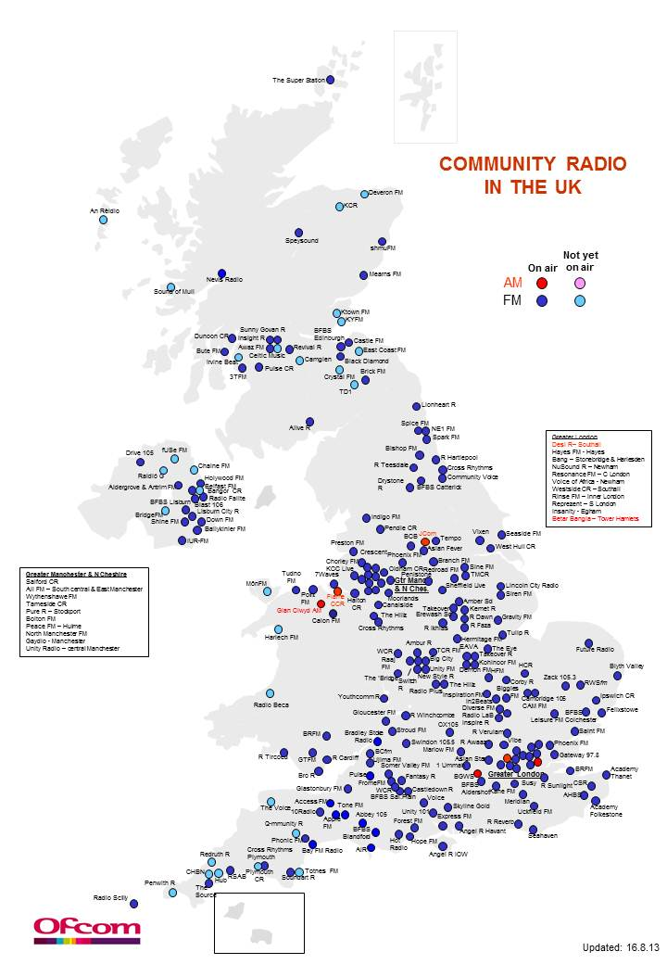

Source - Report - The Communications Market 2013, Ofcom, Figure 3.33 Average income by type of community served.
Ofcom Community Radio Fund, Guidance Notes, April 2013, Issue 11 pg 2
The legislation capable of being modified in this way is Part 3 of the Communications Act 2003 (except parts relating exclusively to television), Part 3 of the Broadcasting Act 1990 and Part 2 of the Broadcasting Act 1996.

