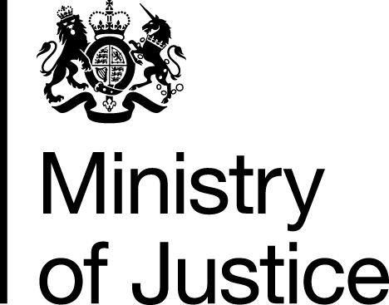 |  |  | www.gov.uk
 | FOI: 86808 |  | December 2013

Freedom of Information Request

You asked for the following information from the Ministry of Justice (MoJ):

“For the 12 month period ending on 31st October 2013 how many cases were opened and solicitors instructed on behalf of detainees in custody at the following police stations, and in each case how many of those cases arose when the detainee asked for a duty solicitor and how many were allocated on an “own client” basis.
The police stations are:
1. Swindon Gable Cross;
2. Melksham;
3. Salisbury.”

Your request has been handled under the Freedom of Information Act 2000 (FOIA).

We have interpreted your question as a request for the number of Legal Aid claims for police station attendances submitted in the last 12 month period ending on 31 October 2013. As LAA will only know about the case when the claim is received and not when the case opened.

Therefore, I can confirm that the department holds the information you have requested, and I am pleased to provide the below information.

Volume of police station attendance claims in below police stations in last 12 months (period from 01November 2013 to 31 October 2013):
 | Duty Solicitor | Own Client | Total
1. Swindon Gable Cross | 642 | 1,245 | 1,887
2. Melksham | 868 | 762 | 1,630
3. Salisbury | 520 | 470 | 990

