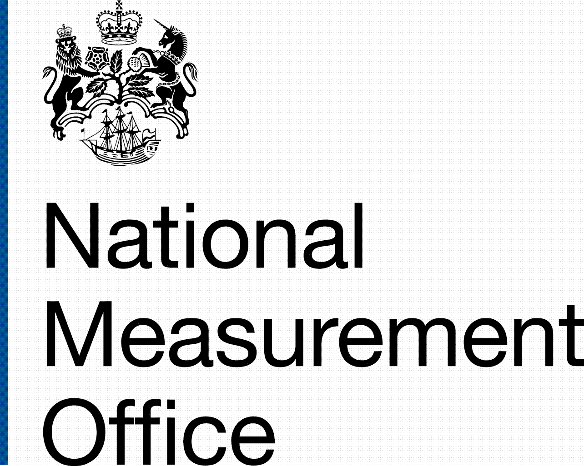

National Metrology Project 2013 – 2014
Bulk Milk Measurement

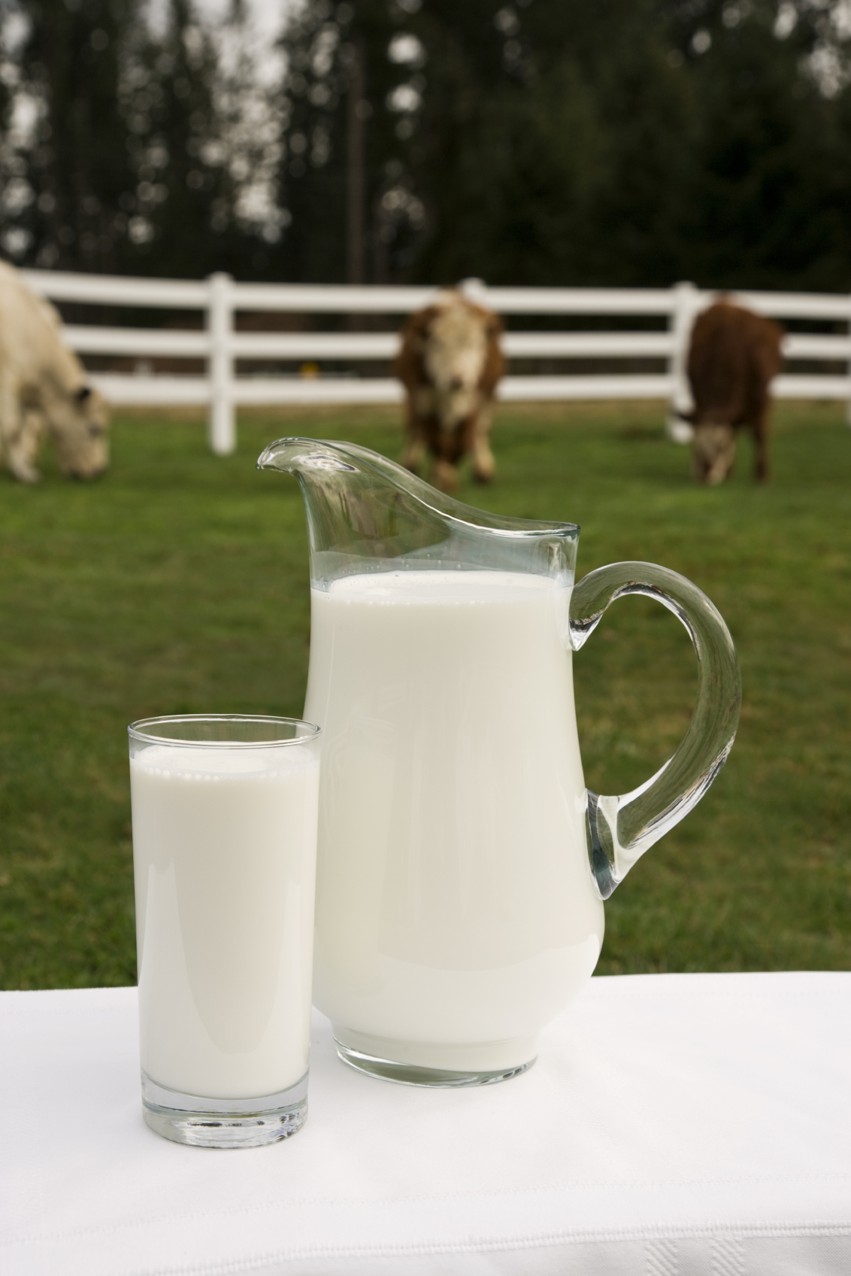

National Metrology Projects

For a number of years, Trading Standards Services have taken part in National Metrology Projects. These have been organised to add value to inspectional work which has been done by individual Trading Standards Services as part of their local responsibility. Such work, which has been undertaken across the United Kingdom has been focussed on a particular subject and has been nationally collated. This has enabled an overview to be taken of a particular business sector and of the status and condition of associated weighing and measuring instruments. It has provided specific results, so that advice can be directed, and follow up work has demonstrated the successful impact and outcome of this approach.
Previous National Projects have included the medical weighing sector, and weighbridges associated with the waste and recycling industry.

These projects had previously been organised and run by LACORS / LGR, but latterly, NMO have undertaken this co-ordinating task.

This year, the Local Government Metrology Focus Group, TSI and NMO have chosen the bulk measurement of milk from farms as the subject of the National Metrology Project for 2013 – 2014.

NMO will again be co-ordinating and collating the results of the work undertaken by Trading Standards Authorities, and will be publishing a report on the project and its findings.

Collection of milk from farms

For many years, farmers supplied milk in churns which were collected from farms by wagon and, in later years flat bed lorries, which carried the full churns to the dairy.
The churns themselves were the measures, and were calibrated and stamped as a capacity measure.

In more recent years, farmers installed bulk refrigerated tanks, and milk was collected from these by bulk tanker lorry.
The bulk tanks were calibrated and ‘ex farm measurement’ was made by means of a dipstick and a calibration chart for each individually identified tank.

Subsequently, milk collection tankers were fitted with measuring systems to measure the quantity of milk collected from each individual farm tank. The farmer is normally paid by reference to this measurement, and other quality parameters.
When the Milk Marketing Board was in existence, a code of practice was agreed for the calibration and use of such meter measuring systems.

Following the abolition of the Milk Marketing Board, milk is now collected by individual dairies / carriers, and the measurement made by the tanker mounted measuring systems is a major input into the price paid to the farmer.

Purpose of the Project

NMO would like to invite Local Authorities to participate in a project to look at measurement systems and practice, for the collection of milk from farms.
This project is designed to gain information about the way in which milk is measured in the collection chain from farm to dairy, and to consider levels of accuracy of the metrology on which milk collection, and subsequent payment, is based.

It is envisaged that the project will look at the 3 stages of the milk collection process at which metrology is central, and also at the calibration status of measuring systems used :-

- The way in which milk is stored at the farm, prior to collection, and any measurement that is made there on behalf of the farmer
- The collection and measurement of milk from the farm, and the systems used to make such measurement
- The arrival of the milk at the dairy, and any quantity measurement that is made there, such as a weighbridge check on the vehicle, to determine the total delivery carried to the dairy
- The design and construction of lorry mounted measuring systems and their calibration status.

Methodology

We envisage that some of this project work will be done at the farm milk collection point, some at the Dairy and some at the tanker depot.

- We would like to determine information on the way in which milk is stored at the farm, prior to collection, and any measurement that is made there on behalf of the farmer.

If any measurement is made by, or on behalf of, the farmer, how is it done?
Farmers may have measuring devices fitted to ‘on farm’ milk storage tanks, and make comparisons between this and uplift measurements using the tanker mounted meters.
What is the accuracy and traceability of the measurement?
How is the record of it kept?
Does it play any part in the transaction with the carrier or the purchasing dairy?

- The collection and measurement of milk from the farm, and the systems used to make such measurement.

How is the quantity of milk that is collected measured:-
If the collection is not made by measuring the collected milk with a lorry mounted measuring system, how is it done?
If the collection is made by measuring the collected milk with a lorry mounted measuring system, how is it done?
How is the quantity of milk collected confirmed with the farmer?
What it the calibration status of the measuring system used?
Does its use require any manual intervention in order to ensure that entrapped air is not measured, or is the operation of the uplift and measuring system fully automatic?
Has the farmer any concerns or experienced problems concerning measurements made of milk collections?
If the measurement by the lorry mounted meter was discounted due to doubts over the accuracy of a reading, how was the quantity of milk determined for payment?

- The arrival of the milk tanker at the dairy

When the milk tanker arrives at the dairy, is the weight of the load of the delivered milk determined or is the volume of the total load determined as the tanker is offloaded?
What weighing or measuring instruments are used to do this and what is their legal status in the measurement of the milk in connection with its purchase?
What is their calibration status?
What comparisons are made and what actions are taken when the check weighing / measurement at the dairy differs from the measurement that was made when the milk was collected from the farm? – What degree of difference would trigger action in this instance?

- The design and construction of lorry mounted measuring systems and their calibration status

This area of work would best be done at a Milk Tanker Depot.

What type of measuring instrument is used?
Is the milk measuring system in conformity with any MID Type Examination Certificate, from another EU Member State?
How is it calibrated and sealed?
How regularly is it calibrated?

Recording of results

A form for results of tests and inspections is attached, for completion in conjunction with your visits.
This is intended as an ‘aide memoire’. Not all sections will be appropriate and you may also wish to add extra information.

If you would like to take part in this project, whatever your contribution might be, please e-mail:-
michael.harvey@nmo.gov.uk

Please return completed test results sheets to Michael Harvey at the same e-mail address by the end of March 2014.
Thank you for taking part in this work

National Metrology Project 2013 – 2014
Bulk Milk Measurement
Test Results Sheets

Overview

When you return the completed Test Results Sheets, we would also like to know if there have been any issues or concerns that have been raised with your Authority in connection with the measurement of milk from farms, either before or during the project work.

Please note here any such issues or concerns:-

.

Test Results Sheets are provided for:-

- ‘On farm’ checks, including On Farm Measurement, The Milk Collection Process

- Dairy Checks, in connection with the unloading of the milk at the Dairy

- Tanker Depot Checks

Please complete as many specific areas as you can.

Not all sections will be appropriate and you may also wish to add extra information if you see fit.

Please return completed test results sheets to Michael Harvey at:-
michael.harvey@nmo.gov.uk
by the end of March 2014.
‘On Farm’ checks

Date of visit:-

Address of farm visited, and name of business selling the milk:-

Name and address of the business to which the milk is sold:-

Name and address of the business to which the milk is delivered:-

Name and address of the company who collect the milk:-

Has the farmer any concerns or experienced problems concerning measurements made of milk collections?

Does the farmer know how to raise concerns with the milk purchaser and, if so, what is the procedure for doing this?

Has the farmer ever raised any such concerns and if so, what were they and what was the outcome?

Have there been any issues raised by the farmer with the Trading Standards Service concerning the milk collection process, either on the occasion of the visit, or before?

On Farm Measurement

- We would like to determine information on the way in which milk is stored at the farm, prior to collection, and any measurement that is made there on behalf of the farmer.

What type, material and shape of tank is the farm milk tank?

Is there any method for determining the contents of the tank which is readily available, e.g. a contents measuring system or an identified dipstick and associated calibration chart?

If so, please describe the system:-

Who did the last calibration and when was it done?

When is the next calibration due?

Is a flow meter fitted to measure the volume of milk as it leaves the tank?

If so, please describe the system:-

Who did the last calibration and when was it done?

When is the next calibration due?

If none of the above scenarios apply, is there any way of determining the contents of the tank?

If any measurement is made, prior to collection of the milk, by the farm, how is a record of it kept?

Does it play any part in the transaction with the carrier or the purchasing dairy?

The Milk Collection Process

- The collection and measurement of milk from the farm, and the systems used to make such measurement.

Date of visit:-

Registration number of the collection tanker, and name of tanker operator:-

If the collection is not made by measuring the quantity milk with a lorry mounted measuring system, how is the quantity of milk collected measured?

If the collection is made by measuring the collected milk with a lorry mounted measuring system, please give details of the measuring system used:-

Make:-

Type and identification number:-

Type of measuring instrument (principle of operation)-

Is there anything to indicate that it is MID compliant, having been subject to a Conformity Declaration Procedure in another EU Member State? If so, please give details.

Sealing arrangements:-

Calibration details:–
Is the calibration status marked on the vehicle?

Who did the last calibration, when it was done and when is the next calibration due?

What is the process for making the collection and are any ‘pre-collection’ metering systems checks made?

Are any milk samples taken?

What happens to the samples?

Does the measuring system operation require any manual intervention in order to ensure that entrapped air is not measured at the start and finish of the collection, or is the operation of the uplift and measuring system fully automatic?

How is the farm advised of the quantity of milk that is collected?

Is a print out left?

What information does it contain?

If the measurement by the lorry mounted meter was discounted due to doubts over the accuracy of a reading, how was the quantity of milk determined for payment?

Dairy checks

Date of visit:-

Name and address of the Dairy to which the milk is delivered:-

Name and address of the business to which the milk is sold:-

Name and address of the company who collect the milk and carry it to the Dairy:-

Unloading of the Milk at the Dairy

- The arrival of the milk tanker at the dairy

When the milk tanker arrives at the dairy, what metrological processes take place:-

Is the weight of the total load of the delivered milk determined and recorded?

Is this always done for each load?

What weighing instruments are used to do this?

What is their legal status in the measurement of the milk?

What is their calibration status?

Are they legally compliant?
Is the volume of the total load determined as the tanker is offloaded?

Is this always done for each load?

What measuring instruments are used to do this?

What is their legal status in the measurement of the milk?

What is their calibration status?

Is the density of the milk measured?

When is this done?

What is the procedure to ensure that a comparison is made between the volume of milk measured onto the tanker, and the quantity of milk off loaded at the dairy?

What comparisons are made and what actions are taken when the check weighing / measurement at the dairy differs from the measurement that was made when the milk was collected from the farm? – What degree of difference would trigger action in this instance?

If possible, as an overall check, obtain data that enables a comparison to be made between the aggregate total volume of milk collected and the volume of milk off loaded.

This could either be a direct comparison of:-
- Total volume loaded with volume off loaded or
- Volume loaded with weight of milk off loaded and an appropriate density value, to give volume off loaded

What is the density value used in any calculation, and how was it determined?

What formal processes exist if the farmer contests the measurement of milk stated to have been collected?

How do these processes work, in practice?

Tanker Depot checks

- The design and construction of lorry mounted measuring systems and their calibration status

Date of visit:-

Name and address of Company visited:-

Do they comply with the Dairy Transport Assurance Scheme Standards?

Is any such compliance audited? If so, please check records of this, if possible.

Registration number of collection tanker:-

Make, model, type and any identification number of measuring instrument used:-

What type of measuring instrument (principle of operation) is used?

Is the milk measuring system in conformity with any MID Type Examination Certificate, from another EU Member State? If so, please give details.

Calibration details:–
Is the calibration status marked on the vehicle? If so, how is it marked?

Who did the last calibration, when it was done and when is the next calibration due?

What is the chain of traceability of the calibration:-
What instruments are used to do the calibration (e.g. Reference Meters or Coreolis Meters), and who checks them?

What processes are in place to monitor and prevent the build up of milk scale in the measuring system?

Which components on the tanker mounted measuring system are sealed, and how are the relevant components secured?

Are air release systems and any holding tanks securely sealed?

If possible, try to arrange to witness a calibration, and report on who does it, how it is done, and what equipment is used.

We would appreciate some photographs if possible.

If you have any questions, please contact:-
michael.harvey@nmo.gov.uk

Thank you for taking part in the project

