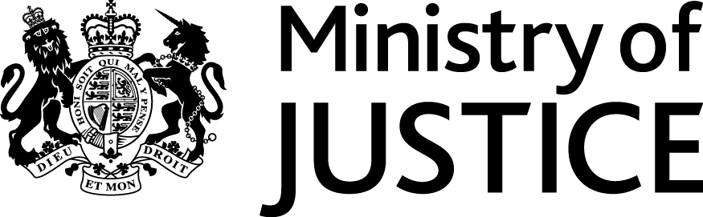 |  |  | www.gov.uk
 | Our Reference: 84454 |  | August 2013

Freedom of Information Request

You asked for the following information from the Legal Aid Agency (LAA), an Executive Agency of the Ministry of Justice (MoJ):

“Please provide details of the numbers of representation orders issued in all Nottinghamshire and Derbyshire courts over the last 5 years and provide details of the solicitors they were issued to.”

“Please provide details of the numbers of representation orders issued in Burton Magistrates Court over the last 5 years and provide details of the solicitors they were issued to.”

Your requests have been handled under the Freedom of Information Act 2000 (FOIA).

With regard to your first request, I can confirm the department has previously complied with your request for information on 6 August. Under Section 14(2) of the Act, we are not obliged to comply with any substantially similar or identical requests that we receive within a reasonable time period since complying with your original request.

In respect of your second request, I have interpreted your request for “representation orders issued” as criminal legal aid orders granted.

I can confirm that the Department holds some of the information you have asked for and I am pleased to provide this to you in the attached Annex A.

Please further note that data specifically for Burton Magistrates Court prior to 2010 does not exist.

Please be advised that the FOIA does not oblige a public authority to create information to answer a request if the requested information is not held. It does not place a duty upon public authorities to answer a question unless recorded information exists. The FOIA duty is to only provide the recorded information held.

