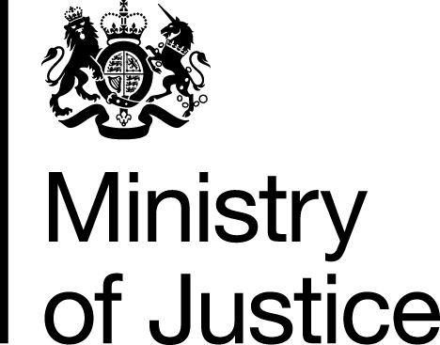 |  |  | www.gov.uk
 | FOI: 86079 |  | November 13

Freedom of Information Request

You asked for the following information from the Ministry of Justice (MoJ):

"I’m trying to track down a list of all organisations which currently hold valid civil or criminal contracts for the Legal Aid Agency, by contract type?"

Your request has been handled under the Freedom of Information Act 2000 (FOIA).

I can confirm that the department holds information that you have asked for, and I am pleased to provide this to you at Annex A.

Please note that the list shown is correct as at 4 November 2013 and is captured at firm level. Any changes to contract status notified to the Legal Aid Agency (LAA) or processed by the LAA after this date will not be captured.

