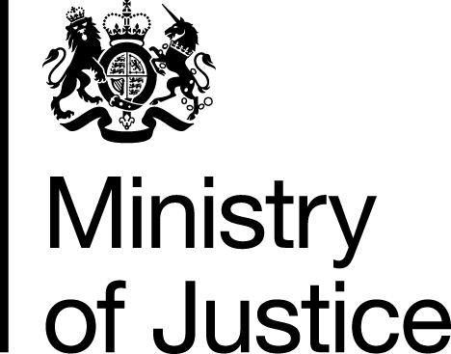 |  |  | www.gov.uk
 | FOI: 86636 |  | November 2013

Freedom of Information Request

You asked for the following information from the Ministry of Justice (MoJ):
“A document that is summarised in the Legal Aid Agency's Business Plan 2013/14. It refers to the "LAA's Governance Arrangements Document".
Your request has been handled under the Freedom of Information Act 2000 (FOIA).

I can confirm that the department holds information that you have asked for. I am pleased to provide this to you and have attached the relevant document at Annex A. The LAA’s Governance Arrangement document is a ‘live’ document; as such it is regularly updated, as agreed by the LAA Board, as arrangements change. The attached document is up-to-date as of 12th November 2013.

