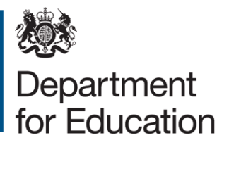

Small school supplement: terms and conditions
The Secretary of State has agreed additional support funding to primary schools of less than 210 pupils that are converting to Academy status into a multi-academy trust (MAT). This is called the “small school supplement” and is granted under section 14 of the Education Act 2002.
- The “small school supplement” is in addition to:
  - The £25,000 grant each converting school is eligible to apply for to support them in meeting expenses incurred in the conversion process, and
  - The primary chain grant that groups of 3 or more schools, where the majority of the schools are primaries, are eligible to apply for when they establish a new multi-academy trust in the conversion process.
- Primary schools of 100 pupils or less are eligible to apply for £5,000 and primary schools of between 100 and 210 pupils are eligible to apply for £2,000. The approved supplement is intended to provide additional support to the eligible school in meeting expenses associated with the conversion process.
- You should retain records to show that the grant has been used for the purposes outlined in (2) above for 6 years after the end of the financial year in which the expenditure has taken place. The books and records of the school relating to the claiming and use of grant will be open to inspection by the National Audit Office and representatives of the Secretary of State as and when they may require.
- In the event that the conversion into a MAT does not occur then any unused grant should be repaid to the Secretary of State within 10 working days of notifying us that you are withdrawing your application to convert into a MAT.
- In the event that the membership of the MAT should drop below three before conversion you must notify the Department. Should the two remaining schools still intend to convert into a MAT you may apply to the Secretary of State to keep the remaining grant confirming that it is still to be used for the same purposes as set out above. Each application will be considered on a case by case basis. Should your application be unsuccessful any unused grant should be repaid to the Secretary of State within 10 working days of the Secretary of States decision.
- When procuring goods and services for the MAT, you are required to comply with EU and UK procurement law and regulations.
Please return the completed DfE finance claim form (below) to your named contact/project lead. You will be paid the grant within 14 working days of submitting your form.

DfE Finance claim form: small school supplement
Name of claimant school:
Phase:
Number of Children on roll:
Address:

Telephone:
Email:

Please list the names of all schools in the chain:
Please enter your back account name and address below (this should be your school account and not to the Academy Trust account):

Sort code

Account number

Declaration
This grant is paid subject to the Department for Education Grant Terms and Conditions available here.
I have read the conditions relating to the provision of the grant and I agree to comply with the conditions.

Signature _____________________________________________________

Name (in capitals) ______________________________________________

Position ______________________________________________________

© Crown copyright 2014

