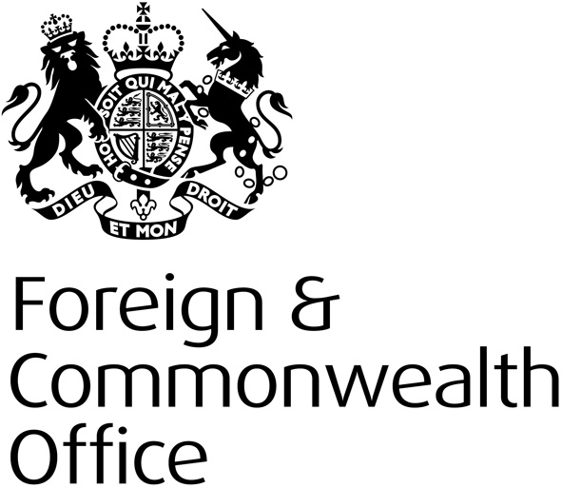
CONSULAR BIRTH AND DEATH REGISTRATION
SUMMARY OF RESPONSES TO THE CONSULTATION ON THE PROPOSAL TO USE A LEGISLATIVE REFORM ORDER TO MAKE CHANGES TO THE BRITISH NATIONALITY ACT 1981

www.gov.uk/government/organisations/foreign-commonwealth-office

Government response

We would like to take this opportunity to thank all respondents who have contributed to the consultation, and to those organisations that kindly agreed to promote the consultation with their members.

Having held a detailed consultation and taken into account all views, we have decided to proceed with our Option 1 and centralise the FCO’s consular birth and death registration service. Full consideration has been given to the results of the consultation and views on the Impact Assessment. We aim to achieve this through a negative Parliamentary Legislative Reform Order (LRO) procedure to amend the BNA, and subsequently FCO Regulations, to allow for centralisation of this service.

We appreciate that initial customer costs will increase as they will need to meet postal/courier fees, but we aim to reduce fees for registration and certified copies at the earliest opportunity, once running costs of the new centralised unit are clearer.

We understand the concern raised over the possible risk of increased documentary fraud for birth registration applications from certain parts of the world, and the removal of local knowledge and experience to counter this risk. We are working closely with our overseas network to produce local information packs that registration officers in the UK can refer to when assessing documentation received for birth registration applications. We are also investigating ways to harness the expertise of HM Passport Office’s (HMPO) counter fraud network overseas, who deal with passport applications. To further reduce risk we will encourage all applicants to apply for a full validity passport before applying for a consular birth registration. Applications for passports are dealt with by HMPO staff who assess the fraud risk.

We note one respondent’s suggestion to modify option 3 of the Impact Assessment (London to provide nationality determinations and overseas posts to make registration entries). Our view remains that this would be an administratively unwieldy process. In addition, it would not help the FCO to achieve one of its main aims of the proposal, namely to help free up staff overseas from non-urgent administrative tasks, and focus on the FCO’s primary consular function of assisting British nationals in distress overseas.

Next steps

We will proceed with Policy Option 1, i.e. to amend the BNA by means of an LRO, allowing the FCO to establish a central consular birth and death registration unit in the UK by April 2014. The LRO will be laid before Parliament in November.

