Domestic Green Deal and Energy Company Obligation in Great Britain, Monthly report

Statistical release: Experimental statistics
19 November 2013
© Crown copyright 2013
You may re-use this information (not including logos) free of charge in any format or medium, under the terms of the Open Government Licence.
To view this licence, visit www.nationalarchives.gov.uk/doc/open-government-licence/
or write to the Information Policy Team, The National Archives, Kew, London TW9 4DU,
or email: psi@nationalarchives.gsi.gov.uk.
Any enquiries or comments in relation to this statistical release should be sent to DECC’s Green Deal Statistics Team at the following email address: EnergyEfficiency.Stats@decc.gsi.gov.uk
Contact telephone: 0300 068 5202
This document is also available from our website at https://www.gov.uk/government/collections/green-deal-and-energy-company-obligation-eco-statistics

Contents
Charts 4
Executive summary 5
Introduction 5
Key points 5
Detailed Results 6
Measures installed up to end September (Table 1) 6
Green Deal Assessments, by month (Table 2, Chart 1) 6
Green Deal Plans in unique properties, cumulative totals by month (Table 3, Chart 2) 7
Cashback vouchers where payments have been made, by month of installation (Table 4, Chart 3) 9
ECO measures installed by obligation, up to the end of September (Table 5, Table 5a, Chart 4, Chart 5) 10
Measures installed through other finance routes 11
ECO brokerage, as at the end of October (Table 6, Chart 6) 12
Supply chain, as at the end of October (Table 7, Chart 7) 13
Annex A – Tables 14
Annex B – Background 25
Green Deal 25
Energy Company Obligation 26
Green Deal Cashback 26
ECO Brokerage 27
The Supply Chain 27
Annex C – Sources and Methodology 28
Experimental Statistics 28
Further Information and Feedback 29
Next Releases 29

Charts
Chart 1 - Number of Green Deal Assessments lodged, by month 7
Chart 2 - Number of Green Deal Plans in unique properties, cumulative totals at end of each month, and by stages 8
Chart 3 - Number of Cashback vouchers where payments have been made, by month of installation 9
Chart 4 - Provisional cumulative number of ECO measures installed, by obligation, at end of each month 10
Chart 5 - Provisional number of measures installed under ECO, by measure type, by obligation, up to end September 11
Chart 6 - Value of ECO brokerage contracts let, by auction 12
Chart 7 - Development of supply chain (cumulative numbers) at end of each month 13

Executive summary

Introduction
This release presents the latest statistics up to the end of October on the Green Deal (GD) and the Energy Company Obligation (ECO) up to the end of September.
For more details about the GD/ECO schemes, please see Annex B. More detailed analysis of Green Deal Assessments lodged, Cashback measures installed and provisional measures installed under ECO up to the end of June are also available in the quarterly statistical release.

Key points
- Measures installed - 311,250 measures were installed in around 273,000 properties through ECO, Cashback and Green Deal to the end of September (the latest month that we have complete data for), up from 251,655 measures to the end of August. The large majority of installed measures (98 per cent) were delivered through ECO.

- GD Assessments – 101,851 were lodged up to the end of October (Chart 1), up from 85,177 at end of September. The 16,674 GD Assessments in October was 19 per cent higher than the number in September (13,967), which in turn was seven per cent higher than the number in August.

- Green Deal Plans – 1,173 households had Green Deal Plans in progress at the end of October, compared to 954 at the end of September. Of these, 360 were ‘new’ quotes for GD Plans (quote accepted), 594 had moved to ‘pending’ (Plan signed) and 219 were ‘live’ (all measures installed), 19 per cent of all Plans (Chart 2). The large majority of Plans have started from June onwards.

- Cashback vouchers – by the end of October, 9,522 had been issued and, of these, 7,453 vouchers had been paid (following installation of measures) with a value of just over £2 million (Chart 3). The majority of vouchers paid to date were in June and virtually all have been for boiler replacements.

- ECO measures - provisional figures, which are routinely subject to further checks by Ofgem, show there were 303,795 measures installed under ECO up to the end of September (measures data takes longer to report and there is therefore an additional lag of one month). 58,497 were installed in September, 50,212 in August and 44,927 in July. 33 per cent of all ECO measures installed to date were for cavity wall insulation, 32 per cent were for loft insulation, and 27 per cent were for boiler upgrades. All solid wall insulation types accounted for four per cent (Chart 5).

- ECO brokerage - £288 million worth of contracts had been let through ECO brokerage up to end of October compared to £235 million at the end of September (Chart 6).

- GD supply chain - 112 Green Deal Providers had been authorised up to the end of October. 302 GD Assessor Organisations and the 2,687 GD Advisors they employ had been accredited up to the end of October (Chart 7).

Detailed Results
This section of the report provides the latest available information on different elements of the Green Deal and ECO. This includes the number of Assessments and Green Deal Plans, Cashback vouchers spent, measures installed through Cashback and ECO, a summary of ECO brokerage and an overview of the supply chain.

The Green Deal and ECO quarterly statistical release provides a range of analysis and further breakdowns on Assessments lodged, Cashback measures installed and provisional measures installed to the end of June.

Measures installed up to end September (Table 1)

Table 1 shows that the total number of measures installed in properties through the Energy Company Obligation, Cashback and Green Deal was 311,250 in around 273,000 properties up to the end of September (the latest month that we have complete data for), up from 251,655 measures to the end of August. The vast majority of installed measures (98 per cent) were delivered through the Energy Company Obligation. Further detailed results of each of these delivery mechanisms are within the main commentary. This does not include measures installed but financed outside the Green Deal framework, but that we will look to report on this for the first time in our quarterly release in December.

Green Deal Assessments, by month (Table 2, Chart 1)

The first step in the Green Deal process involves a Green Deal Assessor coming to the home, talking to the owner/occupier about their energy use and seeing if they can benefit from making energy efficiency improvements to their property.

The main output from this process is that a Green Deal Advice Report (using information from an Energy Performance Certificate and Occupancy Assessment) will be produced and will be lodged on a national register. The customer is then able to view the energy efficiency measures which have been recommended and understand the potential costs and savings.
For more information on the GD assessment process see here.

At the end of October there were 101,851 GD Assessments lodged in total (Chart 1). The number of GD Assessments in October was 19 per cent higher than the number in September, which in turn was seven per cent higher than the number in August.

Chart 1 - Number of Green Deal Assessments lodged, by month
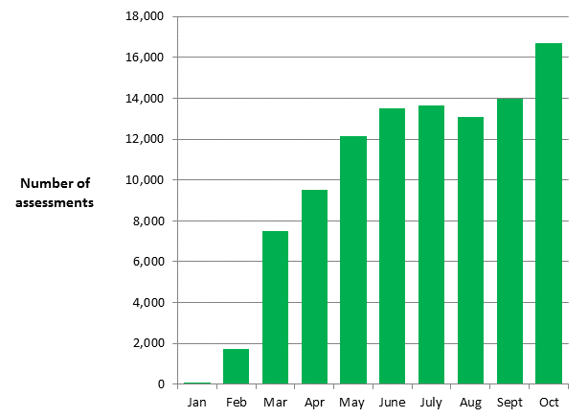

Green Deal Plans in unique properties, cumulative totals by month (Table 3, Chart 2)

Following an Assessment, for householders who choose to take on some of the recommended measures, there are a number of routes to pay for the improvements. Some customers may choose Green Deal finance to pay for part or all of their planned improvements, whilst others may choose to pay for measures out of savings or other sources of finance, and some may be part funded through ECO support.

For those who choose Green Deal finance, there are three stages in the life cycle of a Green Deal Plan for which reports are generated. In total, there were 1,173 Green Deal Plans in the system at the end of October, up from 954 at the end of September. Of these 1,173 Plans, 360 were ‘new’ quotes for GD Plans (quote accepted), 594 had moved to ‘pending’ (Plan signed) and 219 were ‘live’ (measures installed), 19 per cent of all Plans. The three reporting stages are presented in Table 3 and Chart 2 and described below:

- the first stage (a ‘new’ Green Deal Plan) is after a customer has obtained a quote from a Green Deal Provider and confirmed they wish to proceed. The Green Deal Provider has then successfully requested a Green Deal Plan record prior to signature by the customer. It is possible that more than one Green Deal Plan may be requested for each household. There were 360 households with a ‘new’ Green Deal Plan reported up to the end of October.
- the second stage (a ‘pending’ Green Deal Plan) is when a Green Deal Plan has been signed by the customer, progress is being made to install Green Deal Plan measures and the Plan is being finalised so that charging can start. There were 594 households with ‘pending’ Green Deal Plans reported up to the end of October.
- the final stage (a ‘live’ Green Deal Plan) is after the measures have been installed in the property, the information required to disclose the Plan to future bill payers has been attached to the Plan and the energy supplier has all the information required to bill Green Deal charges. At this stage the daily charge has been confirmed along with the date from when the charge will be accrued on their electricity bill. There were 219 ‘live’ Green Deal Plans reported up to the end of October having installed at least one measure in each property.
The total number of measures installed using Green Deal finance was 481 up to the end of October. Boilers accounted for 37 per cent of measures installed using Green Deal finance, photovoltaics were 16 per cent of all measures, heating controls were 15 per cent and solid wall insulation was 14 per cent (see Table 3b).
It has only been possible for Green Deal Providers to request Plans once commercial agreements between the Green Deal Finance Company and Green Deal Providers have been agreed. It took Green Deal Providers some time to prepare their businesses to bring offers to the market with Green Deal Plans being created from May onwards for the small number of GD Providers who have finalised their offer to date.

Chart 2 - Number of Green Deal Plans in unique properties, cumulative totals at end of each month, and by stages
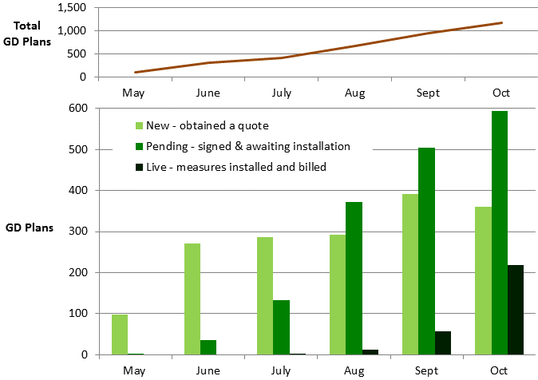

As ‘new’ and ‘pending’ Green Deal Plans lead to installation of measures and charges starting to accrue, they will be replaced as ‘live’ Green Deal Plans in future monthly releases.

Cashback vouchers where payments have been made, by month of installation (Table 4, Chart 3)

The Cashback scheme has been available since January 2013 in England and Wales. It is a financial incentive specifically aimed to encourage domestic customers to get measures installed through the Green Deal process, although it is the customers’ choice whether they decide to take out Green Deal finance or other sources of finance to fund the installation of the measures. For more information on Cashback please see the Cashback website

Table 4 and Chart 3 show that 7,453 Cashback vouchers had been paid (following installation of measures) up to the end of October with a total value of over £2 million. Although the available data on Cashback vouchers issued cannot be broken down to the same level of detail as vouchers paid, 9,522 Cashback vouchers were issued up to the end of October with a total budget committed of around £2.9m. Around 22 per cent of these issued vouchers will have not been paid yet as payment is dependent on the installation of the measures.

The majority of vouchers paid to date were installed in June. Customers only receive payments once Providers have confirmed to the Cashback Administrator that the measures have been installed and a large batch of payments were processed in June.

Chart 3 - Number of Cashback vouchers where payments have been made, by month of installation
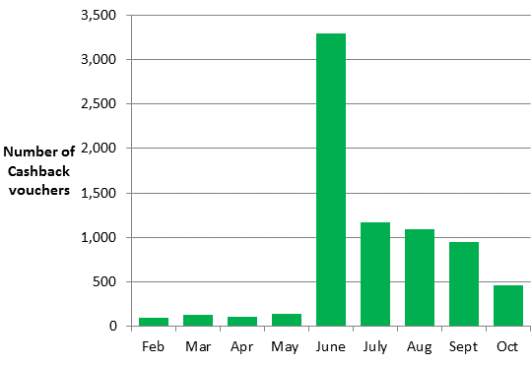
Cashback measures where payments have been made (Table 4a)

7,453 Cashback measures were installed by the end of October. More than one measure can be installed in a property and covered by a single Cashback payment. Table 4a shows that replacement boilers were the main measure where Cashback payments have been made (95 per cent of all Cashback measures installed), whilst a further three per cent were for loft insulation and one per cent for cavity wall insulation.

ECO measures installed by obligation, up to the end of September (Table 5, Table 5a, Chart 4, Chart 5)

The overall Energy Company Obligation (ECO) period runs until 31 March 2015. Information on measures installed under ECO is at a lag of a month compared to other figures presented in this release due to the time taken for information to be reported and verified. Hence, this release includes measures installed under ECO until the end of September 2013.

All measures installed under ECO are provisional until the end of the obligation period as checks are undertaken. Initial validation checks are undertaken by Ofgem in the month following receipt of data and longer-term audits are done over the obligation period (e.g. to verify the installation of the measures and the quality of installations and to ensure compliance with the ECO guidelines). Users should note that, in order to produce the most timely data possible, estimates in this report include a month of data that has yet to be through initial Ofgem validation checks (i.e. as reported by energy suppliers to Ofgem). Revisions to data are routinely included in releases and will be explained if they are large.

Table 5 shows the provisional number of measures installed under ECO and Chart 4 shows the cumulative total number of measures installed and by ECO obligation by month of installation. This shows that, of the 303,795 measures installed to the end of September, 58,497 measures were installed in September, which was around 17 per cent higher than the number of measures installed in August (50,212).

The split by obligation shows 33 per cent of measures installed under ECO were delivered through the Carbon Saving Obligation (CSO), 25 per cent delivered were through Carbon Savings Communities (CSCO) and 42 per cent were delivered through Affordable Warmth (HHCRO).

Chart 4 - Provisional cumulative number of ECO measures installed, by obligation, at end of each month
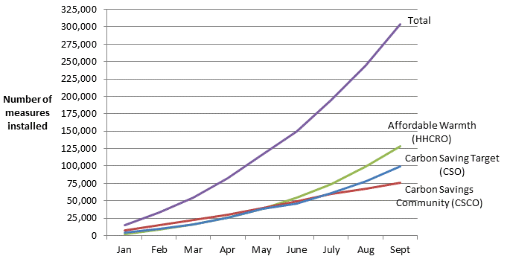
Table 5a and Chart 5 show the provisional number of measures installed under ECO, by measure type, by ECO obligation. This shows that the majority of the 303,795 measures installed under ECO were for cavity wall insulation (33 per cent), loft insulation (32 per cent) and boiler upgrades (27 per cent). Overall, 266,016 properties benefitted from one or more ECO measures being installed up to the end of September 2013 (Table 5a).

Chart 5 - Provisional number of measures installed under ECO, by measure type, by obligation, up to end September

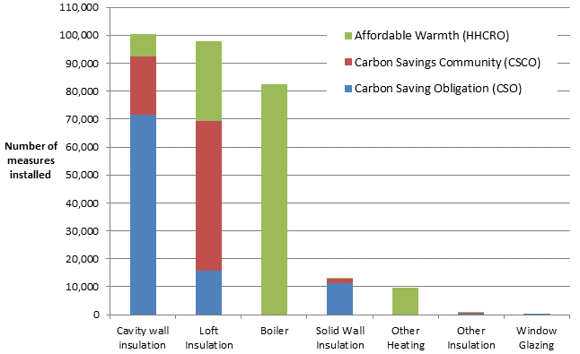

The majority (72 per cent) of the 100,378 cavity wall insulation measures installed were delivered to Hard to Treat cavity wall properties.

The majority (75 per cent) of the 97,706 loft insulation measures installed under ECO up to the end of September were top ups.

Of the 12,780 solid wall measures installed virtually all were External Wall Insulation.

Measures installed through other finance routes

The figures in Tables 3b (Green Deal) Tables 4a (Cashback) and Table 5a (ECO) do not include estimates of measures installed following a Green Deal Assessment where a measure is financed outside of GD finance, GD Cashback or ECO. Alternative sources of finance may include householder savings or loans; Local Authority funding (such as through the Core Cities or Pioneer Places schemes) and other sources.

However, research published by DECC on 17 September on householders who have had a GD assessment between 1st of April and 30th of June stated that 56 per cent of households who had a Green Deal assessment reported installing at least one recommended measure, and a further six per cent were in the process of installing measures. Overall, 81% of households who had a Green Deal assessment said they have, are getting or intend to install at least one energy saving measure.

Around a fifth of those who had installed measures, stated self-finance as a method of payment and around half of those intending to install something stated that they will finance the installation of measures themselves. Some of these households indicated that they were applying for Cashback, but these findings suggest there may be a proportion of households installing measures which we will not pick up through our data sources, although the majority who plan to have measures installed have indicated they will be doing so through the GD/ECO framework. We will review this through further research in December.

ECO brokerage, as at the end of October (Table 6, Chart 6)

The ECO Brokerage system operates as a fortnightly anonymous auction where providers can sell ‘lots’ of future measures of ECO Carbon Saving Obligation, ECO Carbon Saving Communities and ECO Affordable Warmth, to energy companies in return for ECO subsidy. Chart 6 shows that up to the end of October there have been 21 auctions, with a total value of contracts let worth £288.2 million.
Chart 6 - Value of ECO brokerage contracts let, by auction

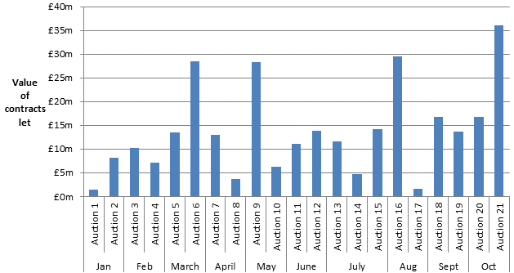

For more detail on the results of each auction, please see ECO Brokerage

Supply chain, as at the end of October (Table 7, Chart 7)

The supply chain to support the Green Deal has been developing since October 2012. This includes individual Advisors (who carry out and produce Green Deal Advice Reports) and Assessor organisations (who employ authorised Green Deal Advisors), Green Deal Providers (who quote for and arrange Green Deal Plans with householders and arrange for the measures to be installed), and Installer organisations (who install energy efficiency improvements under the GD finance mechanism). Chart 7 shows the number of organisations and individuals who have been accredited as of the end of each month.

Chart 7 - Development of supply chain (cumulative numbers) at end of each month

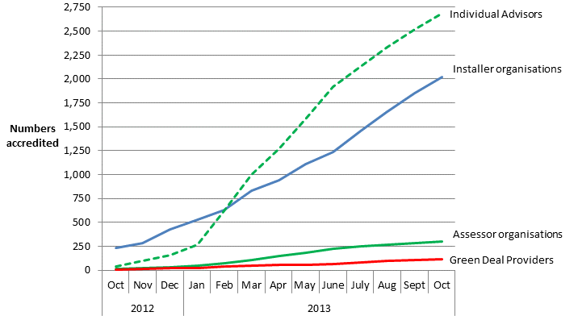

The numbers of accredited GD Assessor organisations and individual Advisors has been increasing steadily since December as individual Assessors complete their training and are accredited. At the end of October there were 302 organisations employing a total of 2,687 Advisors, compared to 48 and 270 respectively at the end of January 2013.

The number of Green Deal Providers has increased to 112 from 25 at the end of January 2013.
The number of accredited Installer organisations has increased steadily since the beginning of the year from 531 accredited at the end of January 2013 to 2,020 organisations accredited at the end of October 2013. These organisations will provide a wide range of different measures and in different geographical locations (see quarterly statistical release for more details).

The Green Deal Oversight and Regulation Body (ORB) produces publically available information on the supply chain, and the latest figures are available by using the search tool on the ORB website. There is also information available on contacts in local areas.

Annex A – Tables
Table 1: Provisional number of measures installed through ECO, Cashback or using Green Deal finance, by month of installation
 | Delivery mechanism
Installation Month ¹ | ECO | Cashback | Green Deal | Total number of measures installed ³
January 2013² | 14,658 | 0 | 0 | 14,658
February 2013 | 18,576 | 94 | 0 | 18,670
March 2013 | 21,164 | 132 | 0 | 21,296
April 2013 | 27,809 | 110 | 0 | 27,919
May 2013 | 33,853 | 145 | 0 | 33,998
June 2013 | 34,099 | 3,333 | 5 | 37,437
July 2013 | 44,927 | 1,266 | 7 | 46,200
August 2013 | 50,212 | 1,154 | 111 | 51,477
September 2013 | 58,497 | 1,010 | 88 | 59,595
Total to date | 303,795 | 7,244 | 211 | 311,250
¹ Measures installed in earlier installation months can be notified at a later date under some circumstances.
² Includes some measures installed between October and December 2012
³ Some measures may have been installed through more than one delivery mechanism and there is therefore a small level of double counting

Table 2: Number of Green Deal Assessments¹, month and cumulative total, by month
 |  | Total in Month |  | Cumulative Total
Month |  | Green Deal Assessments |  | Green Deal Assessments
January 2013 |  | 74 |  | 74
February 2013 |  | 1,729 |  | 1,803
March 2013 |  | 7,491 |  | 9,294
April 2013 |  | 9,522 |  | 18,816
May 2013 |  | 12,146 |  | 30,962
June 2013 |  | 13,517 |  | 44,479
July 2013 |  | 13,645 |  | 58,124
August 2013 |  | 13,086 |  | 71,210
September 2013 |  | 13,967 |  | 85,177
October 2013 |  | 16,674 |  | 101,851
¹ As measured by the number of Green Deal Advice Reports lodged on the central register against unique property.

Table 3: Number of Green Deal Plans^{1,2,3} in unique properties, cumulative total by month
Month |  | 'New'¹ Green Deal Plans |  | 'Pending'² Green Deal Plans |  | 'Live'³ Green Deal Plans |  |  |  | 'Total'⁴ Green Deal Plans
May 2013 |  | 98 |  | 2 |  | 0 |  |  |  | 100
June 2013 |  | 270 |  | 36 |  | 0 |  |  |  | 306
July 2013 |  | 286 |  | 132 |  | 1 |  |  |  | 419
August 2013 |  | 293 |  | 372 |  | 12 |  |  |  | 677
September 2013 |  | 392 |  | 505 |  | 57 |  |  |  | 954
October 2013 |  | 360 |  | 594 |  | 219 |  |  |  | 1,173
¹ A 'new' Green Deal Plan is after a customer has obtained a quote from a Green Deal Provider and confirmed they wish to proceed. The Green Deal Provider has then successfully requested a Green Deal Plan record prior to signature by the customer.
² A 'pending' Green Deal is when a Green Deal Plan has been signed by the customer, progress is being made to install Green Deal Plan measures (measures are installed during the ‘pending’ stage) and the Plan is being finalised so that charging can start.
³ A 'live' Green Deal Plan is after all the measures have been installed in the property, the information required to disclose the Plan to future bill payers has been attached to the Plan and the energy supplier has all the information required to bill Green Deal charges.
⁴ Total Green Deal Plans are the total number of Plan identifiers for unique properties on the Central Charge Database at the end of reporting month.

Table 3a: Number of measures installed using Green Deal finance¹ ², month and cumulative total³, by month⁴
 | Total in Month |  |  |  |  |  |  | Cumulative Total
Installation Month | Green Deal  Measures |  |  |  |  |  |  | Green Deal Measures
June 2013 | 5 |  |  |  |  |  |  | 5
July 2013 | 7 |  |  |  |  |  |  | 12
August 2013 | 111 |  |  |  |  |  |  | 123
September 2013 | 88 |  |  |  |  |  |  | 211
October 2013 | 270 |  |  |  |  |  |  | 481
¹ As measured by the number of measures installed using Green Deal finance where a Green Deal Plan is at ‘live’ stage.
² There may be a small number of measures which have also been reported under ECO or Cashback.
³ The number of measures installed using Green Deal finance in earlier installation months are subject to revision as Green Deal Plans may become 'live' after the month of installation.
⁴ The number of measures installed using Green Deal finance in any month other than the latest month are not directly comparable with the number of ‘live’ Green Deal Plans for each of those respective months. This is because some measures may have been installed in a month previous to when the corresponding Green Deal Plan went ‘live’.

Table 3b: Number of measures installed using Green Deal finance ¹ ², up to end of October 2013
Measure Types | Total number of Measures installed using Green Deal finance | Percentage of Measures
Boiler | 178 | 37
Condensing bottled LPG boiler | 1 | 0
Condensing gas boiler | 37 | 8
Condensing mains gas (not community) boiler | 138 | 29
Condensing gas boiler with flue gas heat recovery | 2 | 0
Cavity wall insulation | 7 | 2
Loft Insulation | 37 | 8
Micro-generation | 78 | 16
Photovoltaics | 78 | 16
Other Heating | 71 | 15
Heating controls | 71 | 15
Other Insulation | 45 | 9
Hot water cylinder insulation | 29 | 6
Hot water cylinder thermostat | 16 | 3
Solid Wall Insulation | 65 | 14
Total ³ | 481 | 100
¹ As measured by the number of measures installed using Green Deal finance where a Green Deal Plan is at ‘live’ stage
² There may be a small number of measures which have also been reported under ECO or Cashback.

³ The number of measures installed using Green Deal finance in earlier installation months
are subject to revision as Green Deal Plans become 'live' after the month of installation.

Table 4: Number and value of Cashback vouchers paid, month and cumulative total, by month, England and Wales only
 | Vouchers issued ¹ | Payments made ²
Installation Month | Number | Number |  | Value (£)
February 2013 |  | 94 |  | 25,380
March 2013 |  | 131 |  | 35,370
April 2013 |  | 109 |  | 29,510
May 2013 |  | 143 |  | 40,192
June 2013 |  | 3,298 |  | 895,135
July 2013 |  | 1,172 |  | 330,430
August 2013 |  | 1,094 |  | 304,176
September 2013 ³ |  | 953 |  | 265,019
October 2013 |  | 459 |  | 130,350
Total to date ⁴ | 9,522 | 7,453 |  | 2,055,560

¹ Cashback vouchers issued data cannot be broken down to the same level of detail. The 9,522 cashback vouchers issued up to the end of October equates to a total budget committed of around £2.9m.
² Numbers of Cashback vouchers paid in earlier installation months are subject to revision as Cashback redemptions can be paid in months after the month of installation.
³ The numbers of Cashback vouchers paid for measures installed in September has been revised from 471 to 953. This is due to Cashback redemptions being paid in later months.
⁴ The Cashback Exception Process has also paid 67 vouchers, totalling £36,321 for solid wall insulation and warm air heating measures where those recommended measures are not displayed on the EPC.

Table 4a: Number of measures installed with Cashback¹, up to end of October 2013, England and Wales only

 | Total number of Cashback measures delivered |  | Percentage of Measures
Boiler |  | 7,362 |  | 95
Gas Boiler |  | 7,299 |  | 94
Oil Boiler |  | 63 |  | 1
Cavity wall insulation |  | 74 |  | 1
Loft Insulation |  | 210 |  | 3
Loft Insulation |  | 210 |  | 3
Room in Roof Insulation |  | 0 |  | 0
Other Heating |  | 3 |  | 0
Electric Storage Heaters |  | 0 |  | 0
Flue Gas Heat Recovery Devices |  | 0 |  | 0
Heating Controls |  | 3 |  | 0
Warm Air Units |  | 0 |  | 0
Waste water heat recovery systems |  | 0 |  | 0
Other Insulation |  | 22 |  | 0
Draught Proofing |  | 7 |  | 0
Flat Roof Insulation |  | 1 |  | 0
Hot Water Cylinder Insulation |  | 5 |  | 0
Passageway Walk-through Doors |  | 8 |  | 0
Under Floor Insulation |  | 1 |  | 0
Solid Wall Insulation |  | 50 |  | 1
Window Glazing |  | 14 |  | 0
Double Glazing |  | 14 |  | 0
Secondary Glazing |  | 0 |  | 0
Total number of measures |  | 7,735 |  | 100
¹ More than one measure can be installed with Cashback per unique property.

Table 5: Provisional number of ECO measures installed, by obligation, by month

 | Obligation
Installation Month³ | Carbon Saving Target (CSO) | Carbon Savings Community² (CSCO) | Affordable Warmth (HHCRO) | Total number of ECO measures installed
January 2013¹ | 3,980 | 7,973 | 2,705 | 14,658
February 2013 | 5,300 | 7,189 | 6,087 | 18,576
March 2013 | 6,605 | 7,155 | 7,404 | 21,164
April 2013 | 10,111 | 7,830 | 9,868 | 27,809
May 2013 | 12,138 | 9,526 | 12,189 | 33,853
June 2013 | 8,191 | 9,868 | 16,040 | 34,099
July 2013 | 14,948 | 10,542 | 19,437 | 44,927
August 2013 | 16,686 | 7,662 | 25,864 | 50,212
September 2013 | 21,220 | 8,541 | 28,736 | 58,497
Total to date | 99,179 | 76,286 | 128,330 | 303,795

¹ Includes some measures installed between October and December 2012.
² May figure includes one measure installed under the ‘rural’ sub-obligation of CSCO June figure includes eight measures installed under the ‘rural’ sub-obligation of CSCO
July figure includes one measure installed under the ‘rural’ sub-obligation of CSCO
September figure includes 14 measures installed under the 'rural' sub-obligation of CSCO.
³ ECO measures installed in earlier installation months can be notified at a later date under some circumstances. Some notified measures can be reallocated to different ECO obligations and so are subject to change.

Table 5a: Provisional number of ECO measures installed¹, by measure type, by obligation, up to end September 2013
Measure Types² | Obligation
 | Carbon Saving Target (CSO) |  |  |  |  | Carbon Savings Community³ (CSCO) |  | Affordable Warmth (HHCRO) |  |  | Total number of ECO measures delivered |  |  | Percentage of ECO Measures
Boiler | N/A |  |  |  |  | N/A |  | 82,495 |  |  | 82,495 |  |  | 27.2
Installation of a Non qualifying boiler |  |  |  | N/A |  | N/A |  | 1,414 |  |  | 1,414 |  |  | 0.5
Repair qualifying boiler 1 year warranty |  |  |  | N/A |  | N/A |  | 8 |  |  | 8 |  |  | 0.0
Repair qualifying boiler 2 year warranty |  |  |  | N/A |  | N/A |  | 321 |  |  | 321 |  |  | 0.1
Replacement qualifying boiler |  |  |  | N/A |  | N/A |  | 80,752 |  |  | 80,752 |  |  | 26.6
Cavity wall insulation | 71,699 |  |  |  |  | 20,768 |  | 7,911 |  |  | 100,378 |  |  | 33.0
Standard CWI |  |  | 265 |  |  | 19,790 |  | 7,843 |  |  | 27,898 |  |  | 9.2
HTTC: Cavity wall insulation solution |  |  | 71,094 |  |  | 978 |  | 68 |  |  | 72,140 |  |  | 23.7
HTTC: Solid wall insulation solution |  |  | 340 |  |  | 0 |  | 0 |  |  | 340 |  |  | 0.1
Loft Insulation |  | 15,625 |  |  |  | 53,811 |  | 28,270 |  |  | 97,706 |  |  | 32.2
Loft Insulation Ceiling Level Virgin |  | 4,922 |  |  |  | 13,628 |  | 6,110 |  |  | 24,660 |  |  | 8.1
Loft Insulation Ceiling Level Topup |  | 10,687 |  |  |  | 40,173 |  | 22,092 |  |  | 72,952 |  |  | 24.0
Loft Insulation Rafter |  | 9 |  |  |  | 9 |  | 62 |  |  | 80 |  |  | 0.0
Room in Roof Insulation |  | 7 |  |  |  | 1 |  | 6 |  |  | 14 |  |  | 0.0
Micro-generation | N/A |  |  |  |  | N/A |  | 0 |  |  | 0 |  |  | 0.0
Air Source Heat Pumps | N/A |  |  |  |  | N/A |  | 0 |  |  | 0 |  |  | 0.0
Biomass Boilers | N/A |  |  |  |  | N/A |  | 0 |  |  | 0 |  |  | 0.0
Ground Source Heat Pumps | N/A |  |  |  |  | N/A |  | 0 |  |  | 0 |  |  | 0.0
Micro CHP | N/A |  |  |  |  | N/A |  | 0 |  |  | 0 |  |  | 0.0
Micro hydro | N/A |  |  |  |  | N/A |  | 0 |  |  | 0 |  |  | 0.0
Micro wind | N/A |  |  |  |  | N/A |  | 0 |  |  | 0 |  |  | 0.0
Photovoltaics | N/A |  |  |  |  | N/A |  | 0 |  |  | 0 |  |  | 0.0
Other Heating |  |  |  | 85 |  | 16 |  | 9,615 |  |  | 9,716 |  |  | 3.2
Electric Storage Heaters |  |  |  | N/A |  | N/A |  | 8 |  |  | 8 |  |  | 0.0
DHS: Biomass boiler new connections |  |  |  | 0 |  | 0 |  | 0 |  |  | 0 |  |  | 0.0
DHS: Biomass boiler upgrades |  |  |  | 0 |  | 0 |  | 0 |  |  | 0 |  |  | 0.0
DHS: CHP new connections |  |  |  | 85 |  | 16 |  | 0 |  |  | 101 |  |  | 0.0
DHS: CHP upgrades |  |  |  | 0 |  | 0 |  | 0 |  |  | 0 |  |  | 0.0
DHS: Gas/Oil boiler new connections |  |  |  | 0 |  | 0 |  | 0 |  |  | 0 |  |  | 0.0
DHS: Gas/Oil boiler upgrades |  |  |  | 0 |  | 0 |  | 0 |  |  | 0 |  |  | 0.0
DHS: heat meters |  |  |  | 0 |  | 0 |  | 0 |  |  | 0 |  |  | 0.0
Flue Gas Heat Recovery Devices | N/A |  |  |  |  | N/A |  | 0 |  |  | 0 |  |  | 0.0
Heat Recovery Ventilation | N/A |  |  |  |  | N/A |  | 0 |  |  | 0 |  |  | 0.0
Heating Controls | N/A |  |  |  |  | N/A |  | 9,607 |  |  | 9,607 |  |  | 3.2
Radiator Panels | N/A |  |  |  |  | N/A |  | 0 |  |  | 0 |  |  | 0.0
Warm Air Units | N/A |  |  |  |  | N/A |  | 0 |  |  | 0 |  |  | 0.0
Other Insulation | 481 |  |  |  |  | 152 |  | 34 |  |  | 667 |  |  | 0.2
Flat Roof Insulation | 47 |  |  |  |  | 24 |  | 0 |  |  | 71 |  |  | 0.0
Draught Proofing | 341 |  |  |  |  | 41 |  | 21 |  |  | 403 |  |  | 0.1
Hot Water Cylinder Insulation | 89 |  |  |  |  | 87 |  | N/A |  |  | 176 |  |  | 0.1
Passageway Walk-through Doors | 0 |  |  |  |  | 0 |  | 0 |  |  | 0 |  |  | 0.0
Pipework Insulation | 0 |  |  |  |  | 0 |  | 0 |  |  | 0 |  |  | 0.0
Under Floor Insulation | 4 |  |  |  |  | 0 |  | 13 |  |  | 17 |  |  | 0.0
Solid Wall Insulation | 11,236 |  |  |  |  | 1,539 |  | 5 |  |  | 12,780 |  |  | 4.2
External wall insulation: Solid brick walls, built from 1967 |  |  | 2,202 |  |  | 142 |  | 0 |  |  | 2,344 |  |  | 0.8
External wall insulation: Solid brick walls, built pre 1967 |  |  | 5,143 |  |  | 1,120 |  | 5 |  |  | 6,268 |  |  | 2.1
External wall insulation: Solid non-brick walls |  |  | 3,715 |  |  | 275 |  | 0 |  |  | 3,990 |  |  | 1.3
Internal wall insulation: Solid brick walls, built from 1967 |  |  | 23 |  |  | 0 |  | 0 |  |  | 23 |  |  | 0.0
Internal wall insulation: Solid brick walls, built pre 1967 |  |  | 109 |  |  | 2 |  | 0 |  |  | 111 |  |  | 0.0
Internal wall insulation: Solid non-brick walls |  |  | 44 |  |  | 0 |  | 0 |  |  | 44 |  |  | 0.0
Park Home External wall insulation |  |  | 0 |  |  | 0 |  | 0 |  |  | 0 |  |  | 0.0
Window Glazing | 53 |  |  |  |  | 0 |  | 0 |  |  | 53 |  |  | 0.0
Total number of measures | 99,179 |  |  |  |  | 76,286 |  | 128,330 |  |  | 303,795 |  |  | 100
Total number of unique properties ⁴ ⁵ | 83,181 |  |  |  |  | 69,685 |  | 114,155 |  |  | 266,016
¹ As reported by energy suppliers to Ofgem in their monthly returns. Please see the accompanying Methodology Note for more details.
² Please see Ofgem’s guidance for suppliers for more details on eligible measures
³ Includes 24 measures installed under the 'rural' sub-obligation of CSCO, including six standard CWI and two hard-to-treat CWI, four virgin loft insulation, 10 topup loft insulation installations and two draft proofing installations.
⁴ The addresses where 15 ECO measures were installed is unknown. As it is not known whether these are unique properties they have been excluded from this total. Also some ECO measures were installed in properties without recording the full address (i.e. blocks of flats), so there may be more unique properties than is recorded here.
⁵ The total number of unique properties by obligation does not equal the total number of unique properties overall, as some properties have measures installed under more than one obligation

Table 6: Number of ECO brokerage auctions¹ and total amount traded, by month
Month |  | Number of auctions | Total amount traded
January 2013 |  | 2 | £9.5m
February 2013 |  | 2 | £17.4m
March 2013 |  | 2 | £42.0m
April 2013 |  | 2 | £16.6m
May 2013 |  | 2 | £34.6m
June 2013 |  | 2 | £25.0m
July 2013 |  | 3 | £30.5m
August 2013 |  | 2 | £29.5m
September 2013 |  | 2 | £30.4m
October 2013 |  | 2 | £52.9m
Total to date |  | 21 | £288.2m
¹ ECO brokerage auctions are scheduled to take place on a fortnightly basis.

Table 7: Number¹ of accredited Assessor organisations, individual Advisors, Green Deal Providers, and Installer organisations, cumulative totals by month
Month² | Assessor organisations | Individual Advisors | Green Deal Providers | Installer organisations
October 2012 | 13 | 40 | 8 | 231
November 2012 | 18 | 100 | 15 | 285
December 2012 | 29 | 159 | 20 | 429
January 2013 | 48 | 270 | 25 | 531
February 2013 | 77 | 618 | 40 | 629
March 2013 | 108 | 1,003 | 48 | 831
April 2013 | 152 | 1,274 | 55 | 942
May 2013 | 182 | 1,582 | 60 | 1,108
June 2013 | 226 | 1,919 | 66 | 1,234
July 2013 | 248 | 2,129 | 79 | 1,457
August 2013 | 269 | 2,332 | 101 | 1,662
September 2013 | 286 | 2,517 | 107 | 1,853
October 2013 | 302 | 2,687 | 112 | 2,020
¹ Numbers include domestic, both domestic and non-domestic and a small number of non-domestic only participants.
² Months are approximate as they are based on numbers up to the end of the last full week in the month.

Annex B – Background

Green Deal

The Green Deal (GD) was launched on 28 January 2013 in England and Wales (and on 25 February in Scotland) and will tackle a number of the key barriers to the take-up of energy efficiency measures.

Customers having Green Deal Assessments undertaken have the choice of how they proceed. They might take the view that their home is sufficiently energy efficient, or that they want to finance work through a Green Deal Plan or that they want to use alternative funding arrangements (e.g. use of savings).

The Green Deal process for households is briefly described below:

Step 1 – Assessment – A Green Deal assessor will come to the home, talk to the owner/occupier about their energy use and see if they can benefit from making energy efficiency improvements to their property.

Step 2 – Recommendations – The assessor will recommend improvements that are appropriate for the property and indicate whether they are expected to pay for themselves through reduced energy bills.

Step 3 – Quotes – Green Deal Providers will discuss with the owner/occupier whether a Green Deal Plan is right for them and quote for the recommended improvements, including the savings estimates, savings period, first year instalments and payment period for each improvement. A number of quotes can be obtained.

Step 4 – Signing a Plan – The customer chooses to proceed with a given provider and package of measures. The owner/occupier needs to obtain the necessary consent to make improvements to the property before they can agree terms with the GD Provider of a Green Deal Plan, at which stage they enter a cooling-off period.

Step 5 – Installation – Once a Green Deal Plan has been agreed, the Provider will arrange for the improvements to be made by a Green Deal Installer. Once the installation has been completed a letter is sent to the Bill Payer and, at this stage, the Green Deal Plan goes ‘live’.

Repayments will be no more than what a typical household should save in energy costs.

Energy Company Obligation

The Energy Company Obligation (ECO) started on 1 January 2013 (although energy companies have been able to count against their targets measures delivered since 1 October 2012) and runs to 31 March 2015. It broadly takes over from two previous schemes (Carbon Emissions Reduction Target - CERT - and Community Energy Saving Programme - CESP) and focuses on providing energy efficiency measures to low income and vulnerable consumers and those living in 'hard-to-treat' properties. While ECO is not a financial target, DECC’s Impact Assessment estimated costs at around £1.3 billion a year.

There are three main ECO obligations – The Carbon Saving Obligation (CSO); Carbon Saving Communities (CSCO) and Affordable Warmth (HHCRO). The ECO Carbon Saving Obligation is estimated to be worth around £760 million per year. The Carbon Saving Community Obligation and ECO Affordable Warmth will together provide support worth around an estimated £540 million per year to low-income households and areas.

Carbon Saving Obligation - This covers the installation of measures like solid wall and hard-to-treat cavity wall insulation, which ordinarily can’t be financed solely through the Green Deal.

Carbon Saving Communities Obligation - This provides insulation measures to households in specified areas of low income. It also makes sure that 15 per cent of each supplier’s obligation is used to upgrade more hard-to-reach low-income households in rural areas.

Affordable Warmth Obligation - This provides heating and insulation measures to consumers living in private tenure properties who receive particular means-tested benefits. This obligation supports low-income consumers who are vulnerable to the impact of living in cold homes, including the elderly, disabled and families.

How do the Green Deal and ECO interact?

Following a GD Assessment there will be a range of measures which could improve the energy efficiency of the property. Some of these could be paid for through GD finance, up to the point where the expected annual cost will not exceed what a typical household should save in energy costs. However, depending on the measure or the property, other sources of finance may also be required. ECO funding could be one of these sources, for example for measures such as Solid Wall Insulation and hard-to-treat Cavity Wall insulation.

Green Deal Cashback

The Green Deal Cashback Scheme rewards the first Green Deal customers. It is a first-come, first served offer where householders can claim cash back from Government on energy saving improvements like insulation, front doors, windows and boilers with packages worth over £1000. It is available for households in England and Wales. For more information on Cashback please see the Cashback website. For more information on the separate scheme that operates in Scotland please see the relevant website.

ECO Brokerage

The ECO Brokerage system operates as a fortnightly anonymous auction where GD Providers can sell ‘lots’ of future measures of ECO Carbon Saving Obligation, ECO Carbon Saving Communities and ECO Affordable Warmth, to energy companies in return for ECO subsidy.

This market-based mechanism has been introduced to support an open and competitive market for the delivery of the ECO. Brokerage allows a range of Green Deal providers to fairly compete on price to attract ECO support and enables energy suppliers to deliver their obligations at the lowest possible cost, thereby reducing the impact on customer energy bills.

Sellers (GD Providers) can make a competitive offer on brokerage by leveraging additional sources of finance, such as part funding measures through Green Deal Finance, partnerships with local authorities, or driving down costs by economies of scale.

The Supply Chain
To understand more about the organisations and infrastructure underpinning the Green Deal, this report also includes a section summarising the trends in the number of Green Deal Advisors (and Assessor organisations), the number of Green Deal Providers and the number of Green Deal Installer organisations.

Annex C – Sources and Methodology
The estimates in this and future Statistical Release use administrative data generated as part of the Green Deal and Energy Company Obligation processes.
There are seven main sources of information:
- Landmark – who manage the national lodgement of Green Deal Assessments in England and Wales
- Energy Savings Trust (EST) – who manage the national lodgement of Green Deal Assessments in Scotland
- Green Deal Central Charge Database – which manages the recording and administration of Green Deal Plans
- Ofgem – who administer the Energy Company Obligation and collect information from energy companies on measures installed under ECO.
- The Green Deal Oversight and Regulation Body (ORB) – who administer the certification of GD organisations (including assessors, installers and providers)
- Data on ECO brokerage is publically available following each auction.
- Capita – who administer the Green Deal Cashback Scheme
This report uses data from Landmark and the Energy Savings Trust for numbers of lodged Assessments and on measures installed using Green Deal finance, data from the Central Charge Database on Green Deal Plans, data from the Cashback Scheme Administrator on Cashback vouchers issued and measures installed, data from Ofgem on ECO measures, data from the ORB for the supply chain and the published data on ECO brokerage.

Experimental Statistics
These estimates are released as Experimental Statistics which means they are official statistics undergoing an evaluation process prior to being assessed as National Statistics later in 2013. They are published in order to involve users and stakeholders in their development, and as a means to build in quality assurance during development.
More information on the methodology is included here.
As with any new data collection, there are likely to be some data quality issues to resolve as the process beds in. Therefore data in the monthly reports should be treated as provisional and subject to revision.
Any revisions will be marked in the data tables and for any significant revisions we will provide an explanation of the main reasons.

Further Information and Feedback
Any enquiries or comments in relation to this statistical release should be sent to DECC’s Green Deal Statistics Team at the following email address: EnergyEfficiency.Stats@decc.gsi.gov.uk

Contact telephone: 0300 068 5202

The statistician responsible for this publication is Matt Walker.

Further information on energy statistics is available at
https://www.gov.uk/government/organisations/department-of-energy-climate-change/about/statistics

Next Releases
All future publications of this series will be released mid-month to cover the preceding month, with publication dates available on the gov.uk website.

The next monthly publication is planned for publication at 9.30am on 19 December 2013 and will contain the latest available information on the number of Assessments and Green Deal Plans, Cashback vouchers spent, measures installed, a summary of ECO brokerage and an overview of the supply chain.

The next quarterly publication is also planned for publication at 9.30am on 19 December 2013 and will contain more detailed information on activity up to the end of September, including geographic breakdowns of Green Deal Assessments and ECO measures. We are currently investigating whether it would be suitable to publish sub-Local Authority data as part of our quarterly release series.

© Crown copyright 2013
Department of Energy & Climate Change
3 Whitehall Place
London SW1A 2AW
www.gov.uk/decc

ECO measures installed in earlier installation months can be notified at a later date under some circumstances. Some notified measures can be reallocated to different ECO obligations and so are subject to change.
Affordable Warmth is also known as Home Heating Cost Reduction Obligation (HHCRO).
Boilers are only eligible under HHCRO. A full list of measure type eligibility by obligation is published here: https://www.ofgem.gov.uk/ofgem-publications/59029/energy-companies-obligation-eco-list-measures-and-additional-information.pdf
Hard to Treat cavity wall properties are also sometimes known as ‘hard-to-fill’. This means that they cannot be insulated using the same methods and/or products as a standard cavity wall.
Where there was at least 60mm of existing loft insulation.
Unlike Advisors in Assessor organisations, individual Installers within an installer organisation do not need to register.
The Plan is a contract between the owner/occupier and the Provider – it sets out the work that will be done and the repayments.
For example, in the case of a Green Deal Plan that is regulated by the Consumer Credit Act 1974, the consumer will have 14 days to withdraw from the part of the Green Deal Plan which provides credit.

