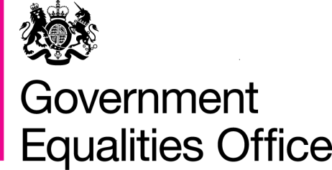

Body confidence campaign

Progress report 2013

Contents

Foreword by Jo Swinson MP 3

What is body confidence? 5

What causes low body confidence? 6

Why does body confidence matter? 7

What has the government been doing? 7

What’s next? 11

Further information on body confidence 12

References 13

Case studies from Body Confidence partners have been included throughout this report. Their inclusion does not indicate Government involvement or responsibility. They are included to illustrate the range of imaginative work being undertaken in the field of body confidence.

**Foreword by Jo Swinson MP, Minister for Women and Equalities**

[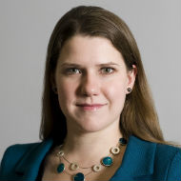](https://www.gov.uk/government/ministers/minister-for-women-and-equali)

Extreme diets that cut out whole food groups or cut out eating anything on certain days.

Getting into debt to finance cosmetic surgery procedures.

Obsessing over and pursuing impossible ideals – from a thigh gap to flawless skin.

It has become so normal, so everyday, for people to worry about what they look like that it is easy to ignore the real problems this creates. Growing up in a society where mass media is fixated on a narrowly defined image of beauty and the celebrities that embody it is damaging the outlook and self-esteem of our children and teenagers – and adults are not immune to these concerns. Of course, individuals differ in their confidence and resilience. But research shows that many people – particularly young people – are having their self-confidence corroded by the belief that their looks are the most important thing about them.

For several years I have been disturbed by the sheer amount of energy, ambition and opportunity wasted by low body confidence. That is why Lynne Featherstone and I started working on this issue back in 2008, and I am delighted to be following in Lynne’s footsteps as the Minister for Women and Equalities with responsibility for taking it forward within Government.

As a Minister in the Department for Business Innovation and Skills, I am also very aware of the critical importance of releasing women’s full potential contribution to economic growth. In order to do this we need to address the remaining structural barriers – by modernising workplaces and ensuring access to flexible, accessible, affordable childcare. However we also need to tackle the cultural barriers, which include raising girls’ aspirations and vision of all the ways in which they can be valued and fulfilled.

Another Government priority is the rising obesity crisis, which has major consequences for public health. Many individuals want to move towards a healthier weight, and it is important that they are supported and able to do this in a realistic and sustained way, and in a way which helps them to build body confidence and self-esteem. Crash diets are not the answer. Positive body confidence means people feel more comfortable taking exercise, which boosts both physical and mental health.

The Body Confidence Campaign is about changing our culture to reduce body image pressure and promote healthy attitudes to our bodies. It’s a big ambition, and it’s not something Government can achieve alone. I am particularly proud of the relationships we have developed with key players in the retail, advertising, fashion and fitness industries, as well as campaigners and activists working on these issues – some of the excellent initiatives being made possible by collaborative efforts are outlined in this report.

I know that this is an area of great concern to many young people and their parents – the high volume of emails I receive attests to that. We have a long way to go – changing our appearance-obsessed culture will not happen overnight. However I’m convinced we are beginning to make a real impact and I look forward to continuing that progress over the coming year.

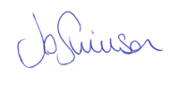

**Jo Swinson MP**

**Minister for Women and Equalities**

The Government’s Body Confidence Campaign was established in November 2010 to:

* Raise awareness of body image issues

**90% of adults would like to see a broader range of body shapes shown in advertising and the media** (YMCA, ComRes Poll)

* Work with industry to tackle causes of negative body image
* Give people tools to challenge the images they see which can impact on their self-esteem

This report provides an update on the progress we have made over the last two years.

**Almost one quarter of children aged 10 – 15 are unhappy about their appearance** (ONS, 2012)

**What is body confidence?**

We use the term body confidence to describe the extent of an individual’s positive regard for their body, their integrated sense of body and self, and the extent to which their personal value is tied up with their physical appearance. Someone with low body confidence is likely to be dissatisfied with the way they look, overestimate the importance and value of matching current cultural beauty ideals, and spending excessive time and energy being self-conscious and invested in their appearance.

**72% of girls feel strongly that too much attention is paid to the way female celebrities look**

(Girlguiding UK, 2012)

There is widespread agreement that low body confidence is a significant social and public health problem in the UK and throughout much of the rest of the world. It is hard to miss the extent of our culture’s fascination with personal appearance: our mass media delivers a daily clusterbomb of images and messages about what we should look like. There is of course nothing wrong with having ideals of beauty – every society has. It is part of the human condition to admire beauty and to have beauty idols who set a standard that most of us fall far short of.

**50% of women feel under pressure to look good at all times and 46% of women feel under pressure to lose weight** (MORI, 2010)

What is different about how we live now is that beauty ideals have become very narrowly defined and the sheer volume of idealised images, the impossibility of escaping them, their digitally enhanced manufactured nature, and the message that all women can and should aspire to look like them. Celebrity culture simultaneously lauds famous, beautiful women, and devotes itself to obsessing over and dissecting their flaws. The perceptual gap between celebrities and ‘civilians’ has narrowed, as popular culture encourages young people to aspire to ‘live the dream’ for themselves.

**What causes low body confidence?**

While popular culture is a key factor in body confidence, it does not explain why some people sustain resilience and confidence while others do not. There are a range of social, cultural, psychological and biological factors that influence body image – which is why the Body Confidence Campaign seeks to improve resilience and aspiration, as well as acting on harmful cultural messages.

**Body Dissatisfaction**

**Psychological Factors**

Low Self-esteem

Depression

Perfectionism

Need for external approval

Body comparison tendencies

Internalisation of body ideals

Appearance schemas

Objectifying the body/embodiment

**Socio-Cultural Factors**

**Cultural and social norms**

Ideal image of beauty

Importance of meeting the ideal image

**Transmitted through**

Media

Parents

Peers

Professionals

**Communication styles**

Pressure to meet the ideal

Teasing and negative commentary

Suggesting ways to meet the ideal

Sexual objectification

Fat talk

Cyber-communication

**Biological Factors**

**Genetic influences**

Body size and shape

Rate of development

Perceptual distortions

**Pubertal changes**

Gender differentiation

Rate of development (breast development, body fat)

An integrated model of putative factors related to development of body image in adolescent girls, from ‘Model influences on body satisfaction’: Paxton, S.J., McLean, S.A. & Shelton, B. (2012) . Building body image acceptance – research evidence and strategies in action. Workshop presented at University of the West of England, Bristol, May 2012.

**Why is body confidence important?**

**Case study**

Debenhams Size 16 Mannequins

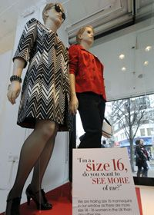

In February 2010 Debenhams piloted size 16 mannequins in its shop windows for the first time. In a move away from their usual size 10 mannequins, this trial demonstrated a wider range of body and beauty ideals being reflected on the high street. In April 2013 Debenhams released a pioneering new Look Book featuring three models over 40: an amputee, a paralympic athlete and a size 18 swimwear model.

These Debenhams initiatives have reflected the broad range of women of different shapes, sizes and ages in their shops and sent a message to the rest of the industry that many customers want to see more diverse and inclusive images from retailers.

Low body confidence is an issue that affects men, women and children. But our culture’s preoccupation with female beauty and feminine identity has a particular impact on women and young girls.

Whilst there is nothing wrong with taking pride in our appearance and wanting to look good, low body confidence has become a significant threat against young women’s health and wellbeing. It discourages them from being physically active. It is both a cause and an effect of disordered eating behaviours. It undermines individual confidence and self-esteem, diverting girls’ attention away from education, from work, from civil participation. It makes them more at risk of depression and a range of risky behaviours including drugs, alcohol, self harm and unsafe sex.[1]

The cultural pressure for bodily perfection focuses our young women on an unrelenting regime of “self-improvement”, a conviction that they have to look perfect before they are entitled to expect equality, respect and appreciation. This is an enormous waste of women’s time, talent and emotional wellbeing, sacrificed to the pursuit of looking like somebody else or a digitally modified image in the media. As a government that seeks to maximise the talents of everyone, and in particular to support women’s increased contribution to economic growth, we are very concerned about the opportunity cost associated with low body confidence.

**What has the government been doing?**

The Body Confidence Campaign was set up by Lynne Featherstone MP, then Minister for Equalities, in 2010. It is now led by Jo Swinson MP, Minister for Women and Equalities. It works with an expert advisory group drawn from across industry and the third sector to promote:

* Positive and diverse representations of appearance in the media and other cultural forms
* Individual resilience to low body confidence and media literacy

**Case study**

Diversity Network

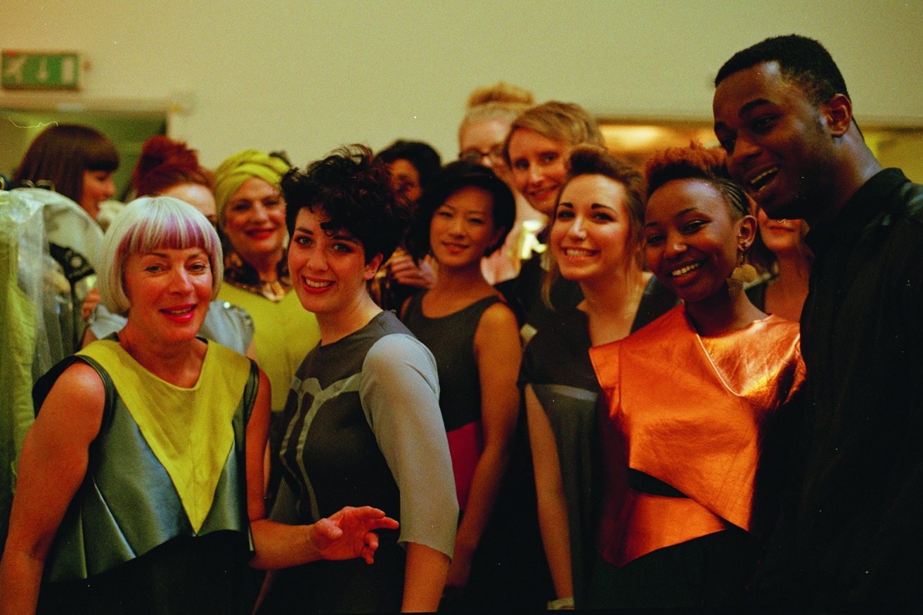

The Edinburgh College of Art and All Walks Beyond the Catwalk Diversity Network was launched by Government Minister Lynne Featherstone at Graduate Fashion Week in June 2011.

The Diversity Network promotes emotionally considerate design for a range of body shapes. It also acts as a hub for dynamic and creative research to promote design approaches for diverse body ideals, and to inspire the next generation of graduates and designers to create fashion for a wider range of body shapes, sizes and ideals of beauty.

* Young people’s aspirations and confidence in their contribution to society

This work has included:

***Youth and education***

* The government launched a [teaching pack for primary schools and a companion pack for parents](http://www.mediasmart.org.uk/) on the subject of body image. These were developed in conjunction with Media Smart, a not-for-profit organisation, and have been downloaded almost 30,000 times. Available free of charge, they have helped children understand how images in the media and advertising are altered and the impact this can have on self esteem.
* The government works with youth organisations to support their work on body image. Each year GirlGuiding UK publishes an annual [attitudes survey](http://girlsattitudes.girlguiding.org.uk/home.aspx) which provides insight into a range of themes that affect young women and girls, and this research has helped to shape our priorities on body image work.

***Physical activity, fitness and health***

* Research indicates that exercise can help to improve body image.[2] The Department for Culture, Media and Sport have hosted a series of roundtable discussions on women’s participation in sport and we are continuing our work in this area by hosting workshops on promoting sports as a lifestyle choice for young women.
* The government also works with the fitness industry to encourage sustained attendance at gyms and health centres through the promotion of healthy bodies and realistic goal-setting.

***Media and advertising***

* The government worked with the Professional Publishers Association to develop an industry award to recognise and reward best practice in the area of diverse body images in magazines. This is called the [PPA Diversity Award](http://www.ppa.co.uk/ppaawards2013/) and the first winner (Essentials Magazine) was announced at the annual PPA awards ceremony in June 2012. High profile awards such as these have helped to recognise and promote diversity within the media.

**Case study**

British Retail Consortium Good Practice Guidance



In June 2011 the British Retail Consortium launched good practice guidance for stores selling children’s clothing.

A number of large stores including George, Debenhams, Home Retail Group (Argos), John Lewis, Next, Marks & Spencer, Gap, Sainsbury's and Tesco have signed up to the guidance which ensures that children’s clothing is age appropriate, not sexualized or overtly gender stereotyped.

* The government ran a year-long series of [body confidence blogs](http://www.huffingtonpost.co.uk/jo-swinson/where-next-for-the-body-confidence-campaign_b_2376661.html) in the Huffington Post throughout 2012, featuring a range of expert voices discussing aspects of body image.
* The government worked closely with Credos, the research arm of the advertising industry, who produced the [Pretty as a Picture](http://www.credos.org.uk/Publications) report examining young women’s attitudes to media and advertising images. It demonstrated that most young women prefer more natural images in advertising. This furthered the body of research into the effect of advertising on young women and explored practical solutions to these modern issues.

***Fashion, retail and beauty***

* The government worked with All Walks Beyond the Catwalk to launch the [Centre of Diversity](http://www.allwalks.org/2012/06/centre-of-diversity/). This educational institution teaches fashion graduates to design clothes for a diverse range of body shapes, and is helping to inspire the next generation of graduates and designers to consider and celebrate a broader range of body and beauty ideals.
* The government attended several events to support industry and partners work to support body confidence. These included Curves in Couture, hosted by Models of Diversity, London Plus Size fashion weekend, and the *Endangered Species: Women* event which formed part of a series of summits held around the world to challenges the culture that encourages women to hate their bodies. These events encouraged and stimulated debate on body image in the UK and abroad.

***International debate***

* In 2012 and 2013 Lynne Featherstone gave speeches on body confidence at the United Nations Commission on the Status of Women summit in New York, and in 2013 the UK co-hosted the first United Nations Commission on the Status of Women side event called ‘Social control as a means of violence against women and girls’. This examined the interlinked subjects of body image, social control and violence and promoted the body image debate at international level.

***Other related policies***

**Case study**

BBC3’s Body Beautiful Season

[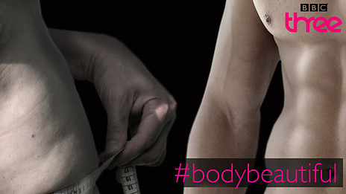](http://www.bbc.co.uk/programmes/p00ztssw/features/abo)

BBC3 broadcast the Body Beautiful Season in November 2012 on radio, TV and online, driven by the question ‘Does changing your body make you happier?’.

These BBC3 programmes aimed to raise awareness around the subject of body image as well as providing a forum for debate, with viewers able to join in the conversation using social media and a live discussion show. A number of programmes also had action lines for viewers to call for advice and support on body image issues.

* Bailey Review (Department for Education). The government has accepted analysis of Reg Bailey’s [report](https://www.gov.uk/government/uploads/system/uploads/attachment_data/file/175418/Bailey_Review.pdf), ‘Letting children be children’ into the sexualisation and commercialization of children. Action includes stricter guidelines from the Advertising Standards Authority on sexualized on-street adverts; new pre-9pm watershed guidance from Ofcom; agreement from four of the largest internet service providers on a Code of Practice, including active choice on whether to access age-restricted material; and the launch of the [ParentPort website](http://www.parentport.org.uk/) for people to make complaints about the media and advertising.
* Keogh Review (Department of Health). The Body Confidence Campaign worked with the review into regulation of cosmetic interventions, which made [recommendations](https://www.gov.uk/government/news/recommendations-to-protect-people-who-choose-cosmetic-surgery) in April 2013.
* [Call to action on obesity in England](https://www.gov.uk/government/publications/healthy-lives-healthy-people-a-call-to-action-on-obesity-in-england) (Department of Health). This document sets out the action the Government is taking to tackle overweight and obesity, and recognises the role that self-esteem and confidence may play in the choices that individuals make about their diet and levels of activity. The Campaign continues to share information with the Department on areas of common interest.
* Violence against women and girls (Home Office). The Campaign works closely with the [Violence Against Women and Girls national action plan](https://www.gov.uk/government/uploads/system/uploads/attachment_data/file/181088/vawg-action-plan-2013.pdf), recognising that each workstream shares common roots in the prevention of hostile attitudes to women.

***Other***

* The Campaign commissioned a rapid evidence review into the body of knowledge on body confidence to help frame our future work in this area. Read [Body confidence: a rapid evidence assessment of the literature.](http://www.gov.uk/government/publications/body-confidence-a-rapid-evidence-assessment-of-the-literature)
* The government has held roundtable discussions on body image with a number of different groups, including black and minority ethnic women and midwives and health visitors, as well as delivering frequent speeches and media commentary on body confidence, contributing to public awareness and responding to public concern on body image.

**What’s next?**

In 2013 the Body Confidence Campaign will continue to work across industry, government and the third sector to engage support, encourage innovation and best practice, and ensure joined-up thinking. We will also work with a range of partners on issues including:

* Developing girls’ aspirations and resilience
* Engaging senior retailers to champion body confidence
* Addressing men, particularly fathers, as supporters of girls’ body image
* Further work to develop the evidence base that underpins government work in this area.

Further information will be available on <https://www.gov.uk/geo/body-confidence>

**Further information on body confidence**

* Download our parent and teacher Media Smart packs at <http://www.mediasmart.org.uk>**/**
* Visit the government’s Campaign for Body Confidence webpages at <https://www.gov.uk/geo/body-confidence>
* Read the All Party Parliamentary Report *Reflections on Body Image* at <http://www.ymca.co.uk/bodyimage/report> and visit the Campaign for Body Confidence website at www.bodyimage.org.uk
* Visit the websites of some of our campaign partners, for example: All Walks Beyond The Catwalk at [www.Allwalks.org](http://www.Allwalks.org); B-eat (eating disorders charity) at [www.b-eat.org.uk](http://www.b-eat.org.uk); Girlguiding UK at [www.girlguiding.org.uk](http://www.girlguiding.org.uk)
* Visit the Geena Davis Institute on Gender in Media and sign up to their newsletter at <http://www.seejane.org/>
* Look at the resources on the University of the West of England’s Centre for Appearance Website at <http://www1.uwe.ac.uk/hls/research/appearanceresearch>
* ParentPort, a website run by the UK’s media regulators, allows you to share views and make complaints about things you have seen in the media: <http://www.parentport.org.uk/>

**References**

Campbell, A., & Hausenblas, H. (2009). Effects of exercise interventions on body image: a meta-analysis. Journal Of Health Psychology, 14(6), 780-793

Girlguiding UK, Girls Attitudes Survey, 2012

Hausenblas, H. A., & Fallon, E. A. (2006). Exercise and body image: A meta-analysis. Psychology & Health, 21(1), 33-47.

Littleton, H., Radecki Breitkopf, C., & Berenson, A. (2005). Body image and risky sexual behaviors: an investigation in a tri-ethnic sample. Body Image, 2(2), 193-198.

MORI Poll for International Women’s Day, 2010

ONS, Measuring National Well-being – Children’s Well-being, 2012

Reel, J., Greenleaf, C., Baker, W., Aragon, S., Bishop, D., Cachaper, C., & Hattie, J. (2007). Relations of body concerns and exercise behavior: a meta-analysis. Psychological Reports, 101(3 Pt 1), 927-942

YMCA, ComRes Poll, Attitudes to body image in the UK



[www.gov.uk/geo](http://www.gov.uk/geo)

1. Littleton, Radecki, Britkopf, & Berenson, 2005
2. Campbell & Hausenblas, 2009; Hausenblas & Fallon, 2006; Reel et al., 2007