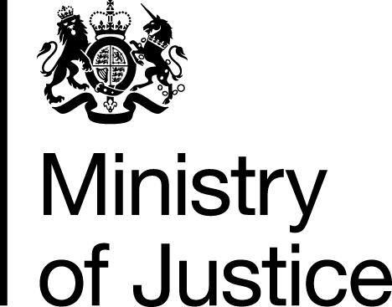 |  |  | www.gov.uk
 | FOI: 85910 |  | November 2013

Freedom of Information Request

You asked for the following information from the Ministry of Justice (MoJ):

“Can you please provide the number of criminal solicitor firms who were contracted under the general criminal contract and who submitted claims for prison law work in the year 2009/2010 and under the new contract currently in 2013 how many firms hold a contract to provide work under the prison law scope and the number who are actually providing this service. Furthermore can you provide details of total number of claims for advocacy assistance at oral discipline hearing, code 35 in the year 2011/2012 and the total number of parole oral hearing code 35 claims made for the same period. I am writing a research paper and this information will be very beneficial.”

Your request has been handled under the Freedom of Information Act 2000 (FOIA).

I can confirm that the department holds information that you have asked for, and I am pleased to provide this to you.

Table 1
 | No. of Offices contracted to undertake Prison Law | Of these contracted Offices the number that submitted Prison Law claims
Financial Year 2009/10 | 2,204 | 973
Financial Year 2013/14 to date | 571 | 263

In respect of Table 1, please note:

- The number of Offices contracted to undertake Prison Law Work excludes any Offices that withdrew from the contract within the period.

- In the Financial Year 2009/10 there were two Criminal Contracts in effect following the mid-year termination of a Contract.

- The number that submitted Prison law claims for the Financial Year 2013/14 includes claims currently submitted for April 2013 to September 2013.

Table 2

Type of Hearing | Stage Code | Matter Type 1 | No. of Claims in 2011/12
Advocacy Assistance at Oral Discipline Hearing | PRIB | 35 | 3,805
Advocacy Assistance at Parole Hearing | PRIC | 35 | 2,906
 |  |  | 6,711

